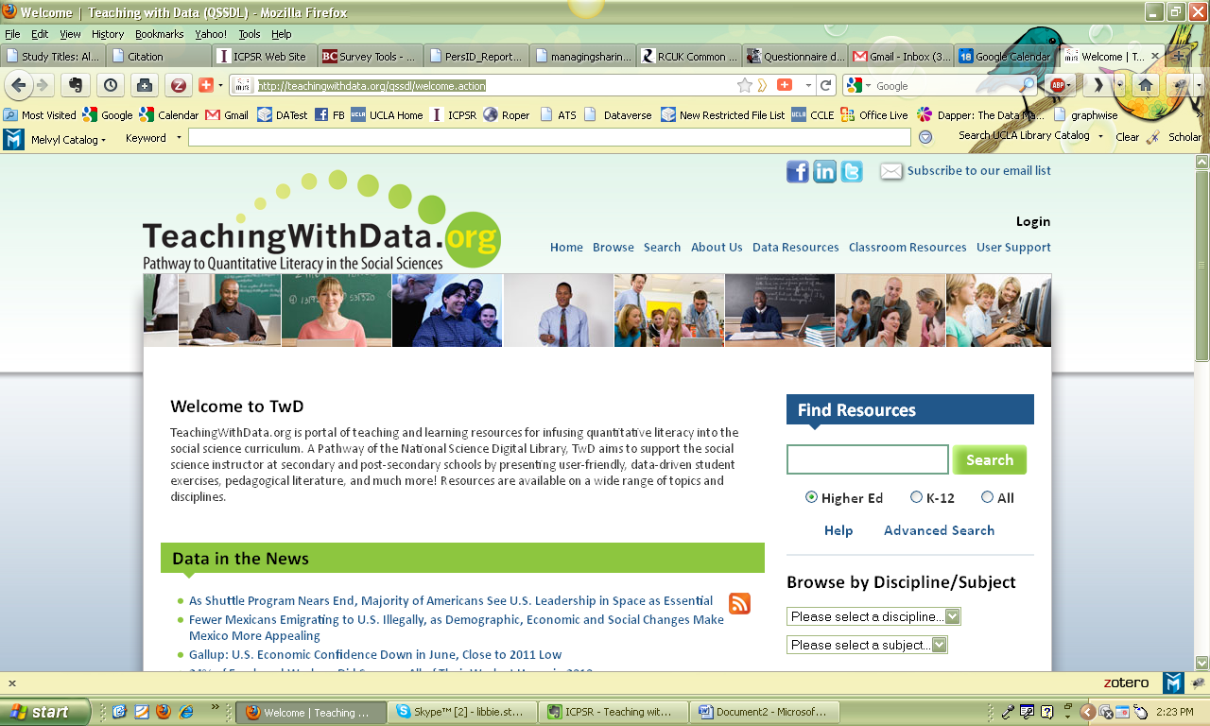



Teaching with Data.Org : A Guide for Sociology
Teaching with Data.Org is a web site devoted to providing faculty with tools to use in courses. This site gives you links to datasets, lesson plans, theoretical examples, charts, learning modules, sample assignments and more. These materials are useful in any course where you would like to incorporate digital materials into lectures (in-person and virtual), assignments, and active learning.
Teaching with Data.Org also promotes quantitative literacy based on the key competencies undergraduates should develop in the sociology major, endorsed by the American Sociological Association.
TeachingWithData.org is intended to infuse quantitative literacy throughout the undergraduate social science curriculum. By making it easier for faculty to include data analysis activities in introductory and other non-methods courses, we aim to:
- improve quantitative literacy among students, particularly students in undergraduate social science courses;
- expose students to the creativity and excitement of empirical research;
- assist instructors in the development of content by providing easier access to data, tools for analysis and visualization, and pedagogical resources;
- attract instructors in the social sciences to the National Science Digital Library (NSDL) where they will find resources provided by other pathways and affiliated services;
- collaborate with the NSDL, other libraries, and service providers as a representative of the social science fields.

We view these as transformative changes in undergraduate instruction that not only improve the teaching of quantitative reasoning but also change the way that students understand content and research in the social sciences.
- Inquiry-based Learning Slides • Inquiry-based Learning Webinar
- 2010 ASA Annual Meeting • Outreach Team


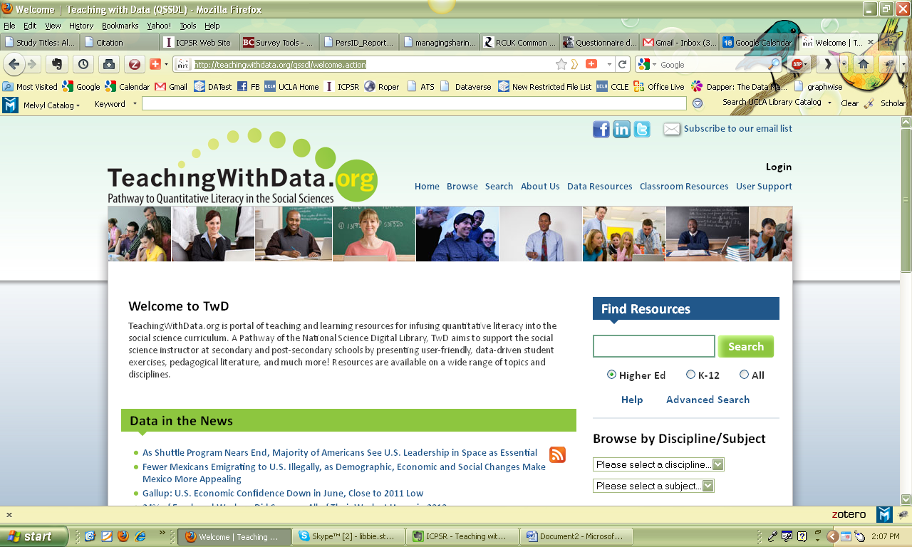
First, go to the TwD.org website at: http://teachingwithdata.org/qssdl/welcome.action
Here are examples of resources you can find for various types of materials.
Two ways to search | 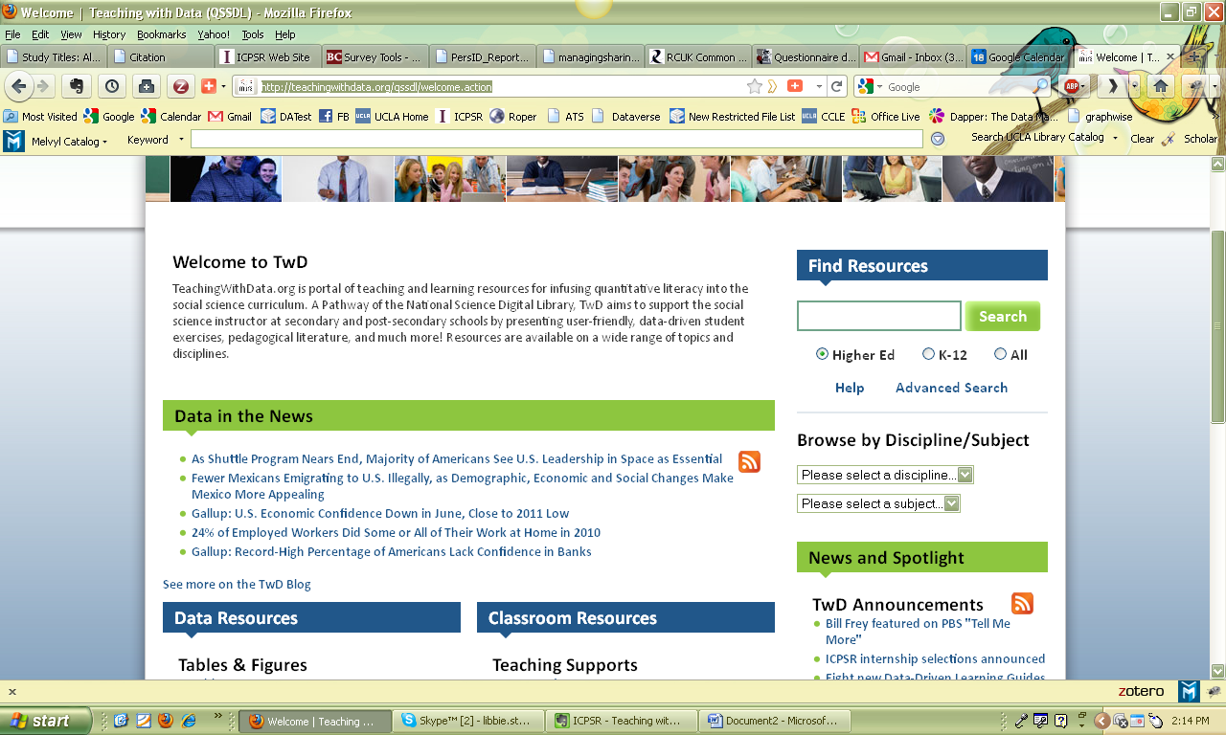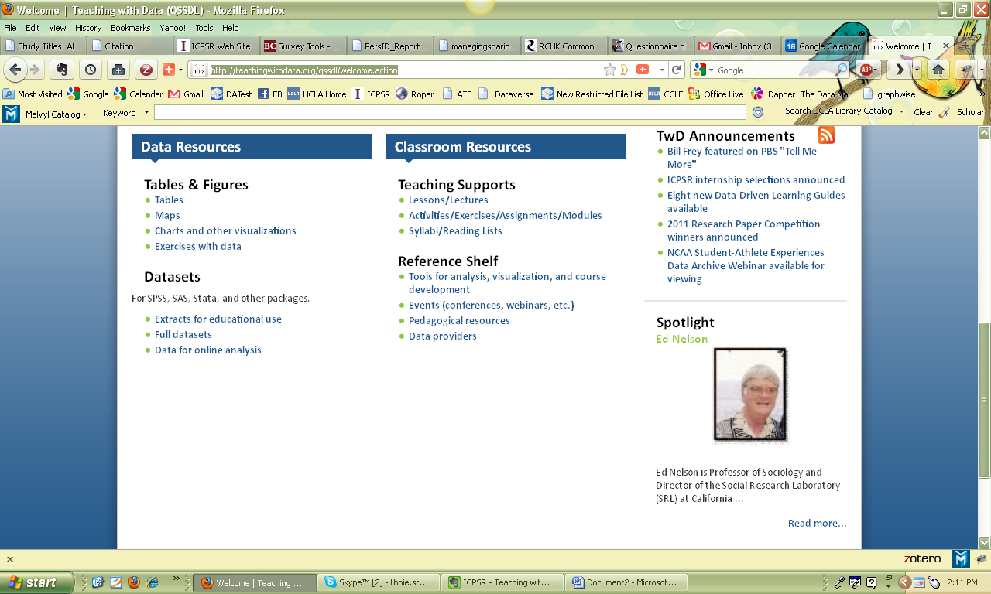  There are two ways to search the site. Use the Find Resources search box (upper right hand corner of website) or choose among Tables & Figures, Teaching Supports, Datasets, or the Reference shelf (scroll down to lower left corner of website)
 | 

Simple “Find Resources”
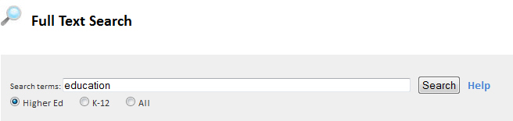 | In this example, using the Find Resources search tool pictured above, click the “Higher Ed” button and request a search for the discipline of Sociology. This takes you to the “Full Text Search” box on the left. Enter “education” in this box and click the “Search” button. You can use the “Advanced Search option to narrow your search by :  • Title • Author  • Contributor • Language  • Resource type • Education level  • Interactivity type • Typical learning time  Below are part of the results of this search. On the left hand side is a list of the subjects, material type and resource types retrieved; the number of items is in parenthesis. On the right hand side is an example of the description on two possible resources. When you click on “More about this” you will find details on using and downloading the material.
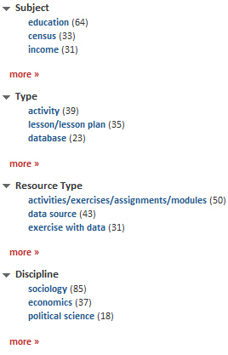 | 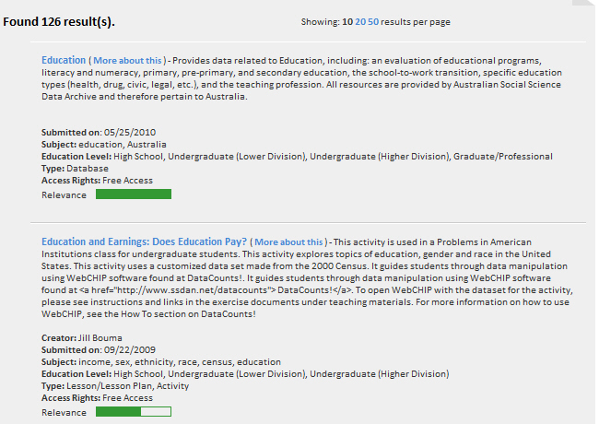
 | 

Searching by Resource | 
 | 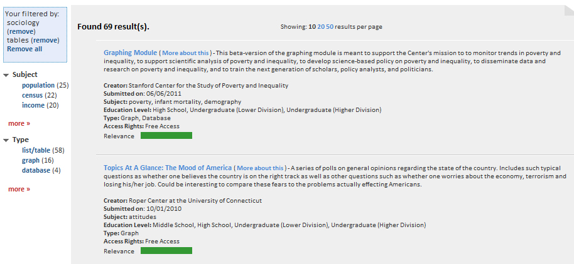  Above is an example of a search of tables for the discipline Sociology. Notice the left hand side provides links for more filtering and for browsing other resource types.

Using a Resource
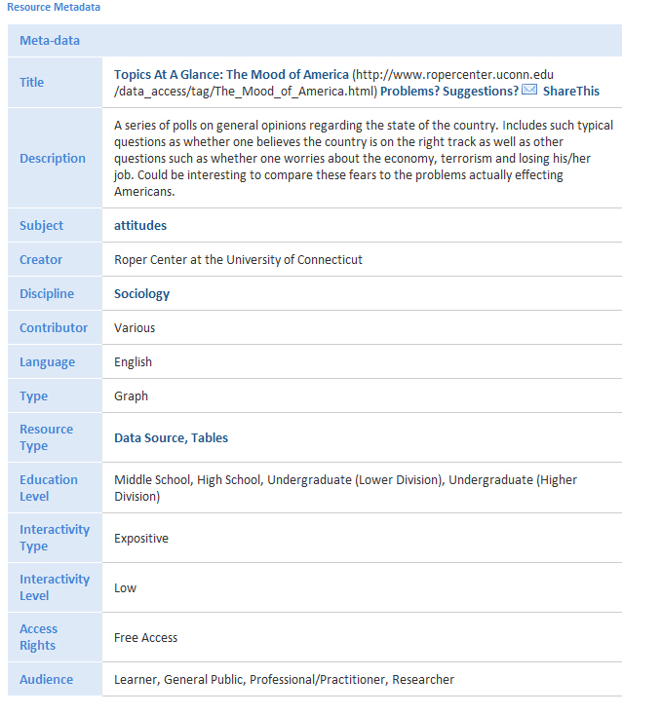 | 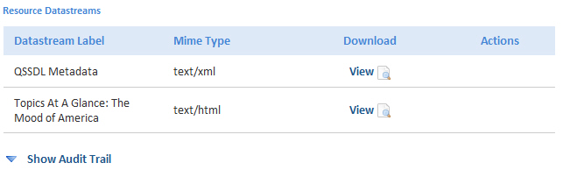  Click on the “More about this” link next to the title of the resource. This will result in a set of metadata elements you can use to evaluate whether or not the source is right for your course. Highlighted items will link you to more resources using the same term; for example, clicking on Tables will display all tables in TwD. Below the metadata description are links to the resources available for downloading or viewing.

 | Teaching with Data.Org was built to provide resources for incorporating quantitative literacy (QL) into social science disciplines and into coursework as a whole; not just in methods courses. Even if you are not a quantitatively focused instructor, you can still use these materials to build students’ skills in becoming numerate and able to use quantitative reasoning in understanding sociology.
What is Numeracy? | By the term “numeracy” we mean:  “ability to reason and solve sophisticated quantitative problems, … basic understanding of the scientific method, and … ability to communicate at a substantial level about quantitative issues in everyday life.”  National Numeracy Network (http://serc.carleton.edu/nnn/resources/index.html)
What is Quantitative Literacy? | By Quantitative Literacy we mean to build students’ abilities in:  “comfort, competency, and "habit of mind" in working with numerical data … as important in today's highly quantitative society as reading and writing were in previous generations.”  National Numeracy Network (http://serc.carleton.edu/nnn/resources/index.html)
What is Quantitative Reasoning? | Quantitative Reasoning is a competency that is part of QL:  “higher-order reasoning and critical thinking skills needed to understand and to create sophisticated arguments supported by quantitative data.”  National Numeracy Network (http://serc.carleton.edu/nnn/resources/index.html)
What are QL/QR competencies? | - Read and understand graphs, tables, etc.  - Interpret quantitative information and make appropriate inferences  - Solve problems using logic, math and statistics  - Communicate verbally, graphically and numerically  - Recognize limitations and bias  - Discriminate between association and causation; probability and chance

How will using TwD.Org build QL/QR competencies? | - Demonstrate how social science applies to everyday life  - Chance to “work like a social scientist”  - Underscore importance of research methods using statistics  - Strengthen quantitative literacy skills in all courses
 | 
Project Partners | Inter-university Consortium for Political and Social Research  Social Science Data Analysis Network  Social Science Research and Instructional Council  National Science Digital Library
Readings | ”Responding to the Quantitative Literacy Gap Among Students in Sociology Courses” Teaching Sociology April, 2009 37:151-170  ”Integrating Sociological Research into Large Introductory Courses: Learning Content and Increasing Quantitative Literacy” Teaching Sociology January, 2006 34: 54-64  “Using ICPSR Resources to Teach Sociology” Teaching Sociology January 1, 2008 36: 17-25  “Integrating Data Analysis (IDA): Working With Sociology Departments to Address the Quantitative Literacy Gap Teaching Sociology January 2006 vol. 34 no. 1 23-38
Quantitative Literacy | National Numeracy Network

