Executing a CRP Check

Executing a CRP Check Overview
The CRPS supports the Contractor Responsibility Program in that it allows for contractors to be checked for obligations, Commonwealth suspensions/debarments, Federal suspension/ debarments, and performance issues. The CRP Check functionality in the CRPS requires the user to enter a contractor name and taxpayer identification number (TIN). This information is then used to query the CRPS database for approved performance issues and outstanding obligations (with the Department of Revenue, the Department of Labor and Industry Unemployment Compensation, and the Department of Labor and Industry State Worker’s Insurance Fund). The information is also used to query the DGS Suspension/Debarment database for Commonwealth suspensions/debarments, and the Excluded Parties List System (EPLS) which lists the Federal suspensions/debarments.

The system uses the contractor TIN supplied by the user to query the data for obligations, approved performance issues, and Commonwealth suspensions/debarments. The CRPS requires that a contractor name be provided in addition to the contractor TIN because the EPLS uses the name to execute a search in the federal suspension/debarment data. If an exact match is found for that name, the EPLS verifies that the TIN supplied matches the TIN stored for that contractor in the federal suspension/debarment data. Therefore, it is required that the full contractor name as well as the TIN be supplied for all CRP Checks.

The results returned from the CRPS and the data that is available to be viewed depends on the type of issue, and the fields for each type of issue may differ. In addition, the data that displays is based on the data available to CRPS and some records are more complete than others. This is based on the data available in the data source that the CRPS is querying.

Depending on the results of the check, the user may have the ability to print the CRP Check Certification Form. This form indicates that the check has been done and the contractor was deemed responsible. If the contractor does not have any issues, the form may be printed and it indicates that no records were found. If the contractor has any obligations, this form is not available for print. If the contractor has any suspensions/debarments (Commonwealth or Federal) and/or any performance issues, this form is available to be printed, but the issues found are listed on the form. If the contractor has any obligations, the user can register to be notified via email when the contractor has been cleared of all obligations.

This chapter will review the following activities:

- Execute a CRP Check
- Review CRP Check results with no records found and print certification
- Review CRP Check results with obligations found and register for notification
- Review CRP Check results with Commonwealth suspensions/debarments and/or performance issues and print certification
- Review CRP Check results with Federal suspensions/debarments and print certification

Executing a CRP Check At-A-Glance
User | PI Creator | PI Approver | Administrator | Task/Demo
X | X | X | X | - Execute a CRP Check  - Enter the name and taxpayer identification number (TIN) for a contractor that must be checked as part of the procurement process  - The results may include obligations, Commonwealth suspensions/debarments, Federal suspensions/debarments, and performance issues. The functionality available in the CRPS depends on the results.
X | X | X | X | - Review CRP Check results with no records found and print certification  - If the contractor being checked has no outstanding obligations, approved performance issues, Commonwealth suspensions/debarments from the past 5 years, or Federal suspensions/debarments, then the CRP Check Certification Form is available.  - The CRP Check Certification Form can be printed or saved as a .pdf file to document that the check was executed and no records were found.
X | X | X | X | - Review CRP Check results with obligations found and register for notification  - If the contractor being checked has any obligations (DOR, L&I UC, or L&I SWIF), the CRP Check Certification Form is not available. The ability to register to receive a notification when the contractor is cleared of all obligations is available.
X | X | X | X | - Review CRP Check results with commonwealth suspensions/debarments and/or performance issues and print certification  - It is possible that a contractor being checked may have suspensions, debarments, or performance issues and not have any obligations. If this occurs, the CRP Check Certification Form is available to print, but the existence of the suspension, debarment, or performance issue is noted on the form.
X | X | X | X | - Review CRP Check results with federal suspensions/debarments and print certification  - It is possible that a contractor being checked may have Federal suspensions or debarments. If this occurs, the CRP Check Certification Form is available to print, but the existence of the suspension/debarment is noted on the form.
Demonstration 1: Execute a CRP Check
- Access the CRPS and select the CRP Check link on the left navigation pane.
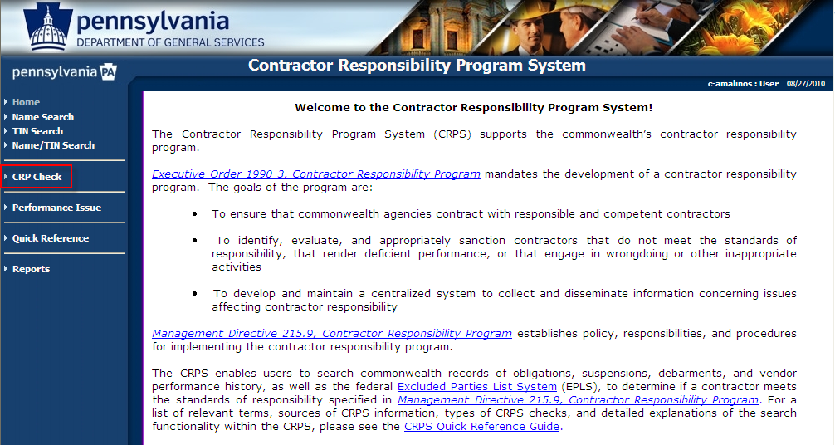

- Enter the contractor’s name in the Name field and the contractor’s taxpayer identification number in TIN. Both are required.
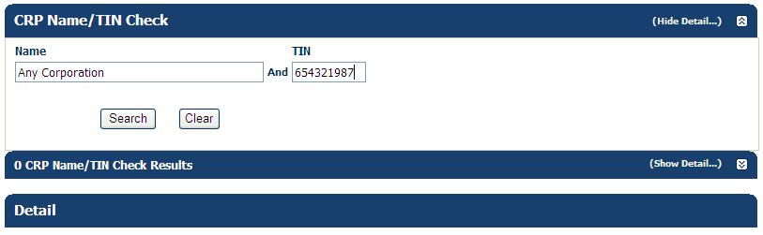

The contractor’s name must be a minimum of three characters, and the TIN must be 9 digits with no punctuation (i.e., no dashes). The Name entered should be the official name of the contractor. Because the Name is required for usage in the EPLS system to check for Federal suspensions/debarments, the Name must be the full name of the contractor. Wildcard characters cannot be used, and partial names will result in erroneous results from the EPLS. If the contractor is an individual, then the name should be entered in the following format: Last Name, First Name.

- Select Search.

If no results are found for the contractor, the following is displayed:
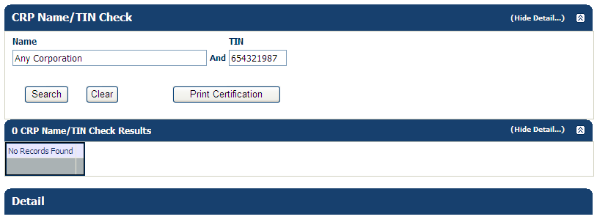
Proceed to Demonstration 2.

If obligations are found for the contractor, the following is displayed:
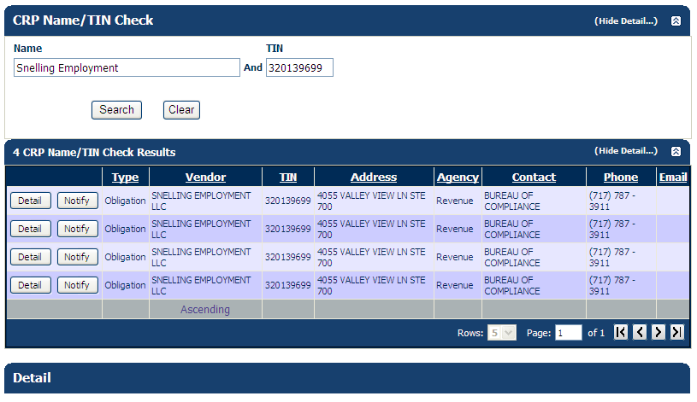
Proceed to Demonstration 3.

If suspensions/debarments or approved performance issues are found, the following is displayed:

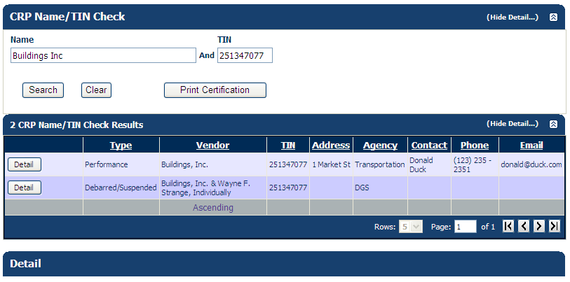

Proceed to Demonstration 4. Proceed to Demonstration 5 for information on Federal suspensions/debarments.

Demonstration 2: Review CRP Check results with no records found and print certification
- Execute Demo 1 for a contractor with no obligations, approved performance issues, Commonwealth suspensions/debarments, or Federal suspensions/debarments.

The following displays:

“No records found” indicates the contractor was not found in any of the CRP data sources.

- Select the Print Certification button.
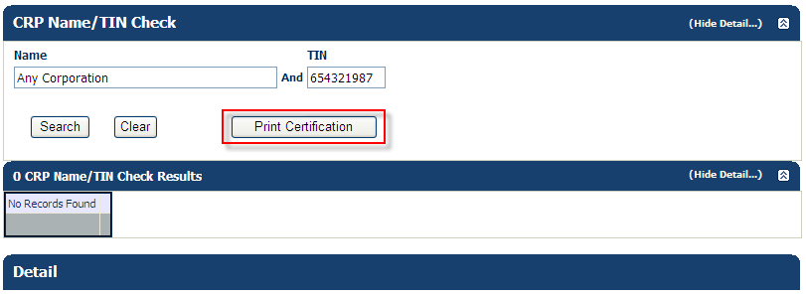

The CRP Check Certification Form displays.
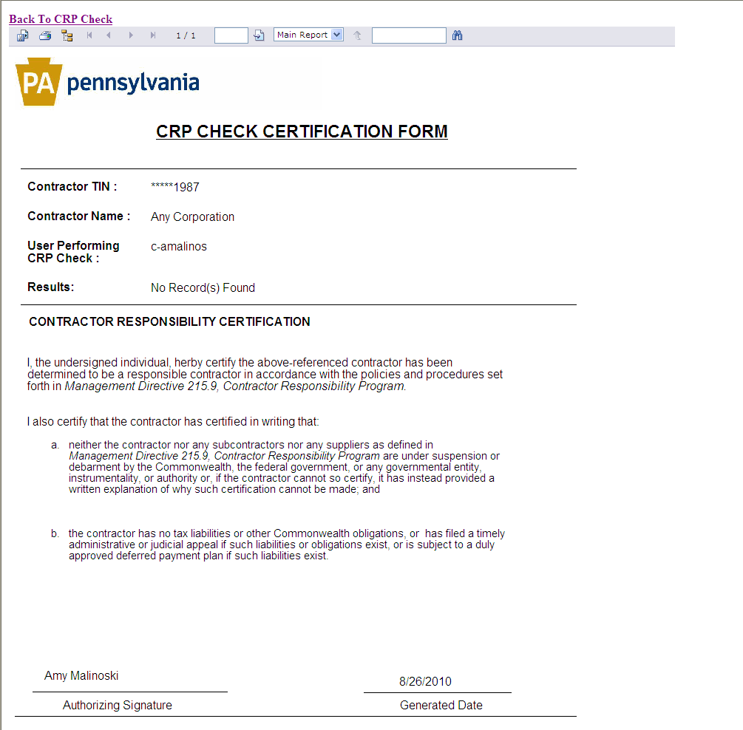

- The Contractor TIN is partially masked for privacy reasons.
- The User Performing CRP Check is the CWOPA or MUSER username of the person executing the check. The system populates this information based on who is logged in when executing the check.
- The Results indicate No Records Found which means that the contractor does not have any obligations, approved performance issues, Commonwealth suspensions/debarments (within the past 5 years), or Federal suspensions/debarments.
- The Authorizing Signature is automatically completed by the system using the username currently logged in and the First and Last Name stored for the user in the system. If a First and Last Name are not stored for the user in the system, your CWOPA or MUSER username will display.
- The Generated Date is the date when the CRP Check was executed in the system.

- Export and/or Print the CRP Check Certification Form.

- Select the Back to CRP Check link to return to the CRPS.

Demonstration 3: Review CRP Check results with obligations found and register for notification
- Execute Demo 1 for a contractor with obligations.

The following displays:


The Print Certification button is not available.

- Select the Detail button to view the information stored in the database for the obligation.
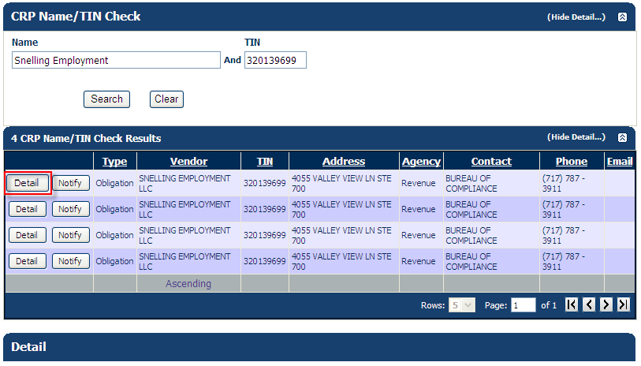

The information displays. The fields that display are the possible fields that could display for the obligation; however, depending on the information supplied to the CRPS, some fields may be blank.

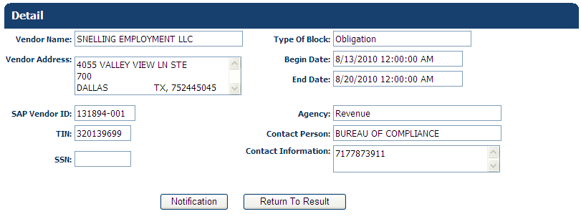

- Select the Return to Result button.

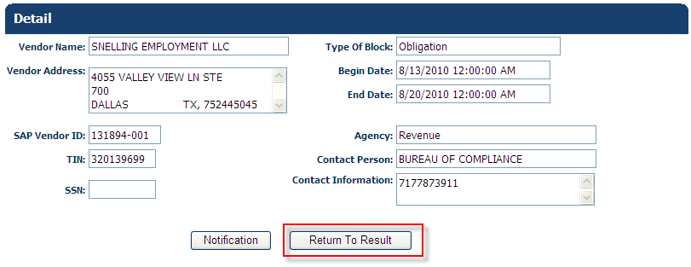

- Select the Notify button; this allows you to sign up for a notification that will be sent once all obligations for the contractor have been removed.

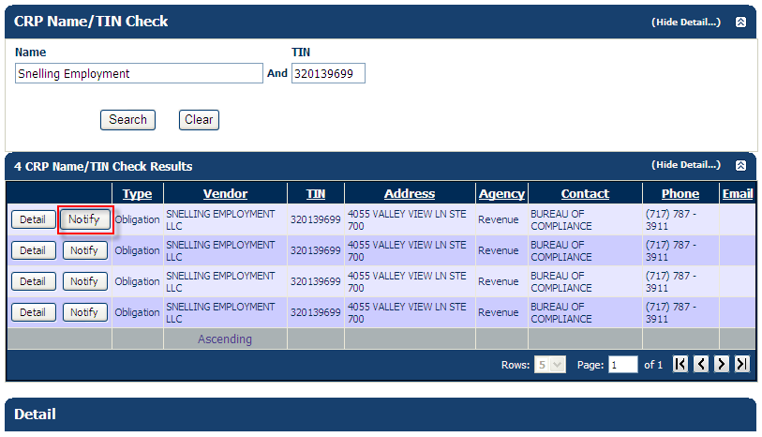

The Notification button is also available on the Results screen.

If a contractor has more than one obligation, it is only necessary to enter a notification one time. The email is sent by the system once all obligations for the contractor have been cleared.

The Email Notification window displays.

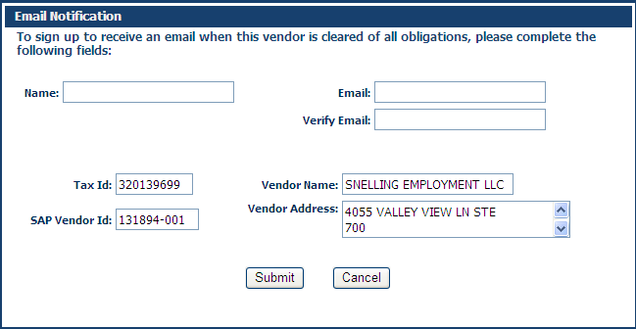

- Complete the Enter Name, Email, and Verify Email fields. (The contractor information auto-populates by the system and cannot be changed.)

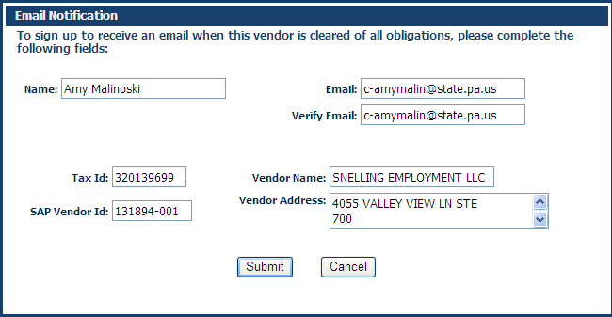

- Select the Submit button.

You will see a message that the notification information was received.

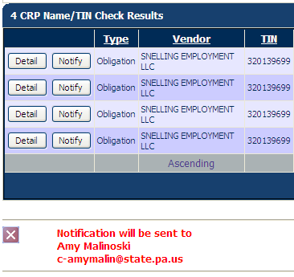
Demonstration 4: Review CRP Check results with Commonwealth suspensions/debarments and/or performance issues and print certification
- Execute Demo 1 for a contractor with no obligations, but with suspensions/debarments and/or approved performance issues.

The following displays:

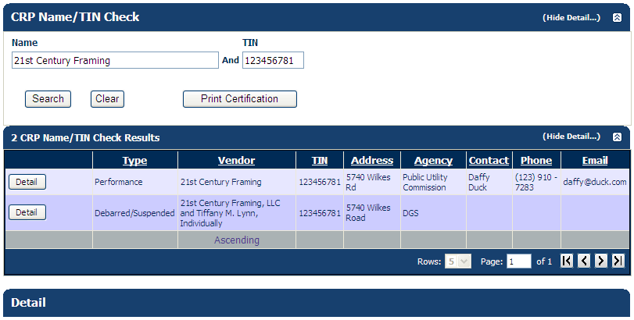

The Print Certification button is available.

- Select the Detail button to view the information stored for the suspension/debarment and/or performance issue.

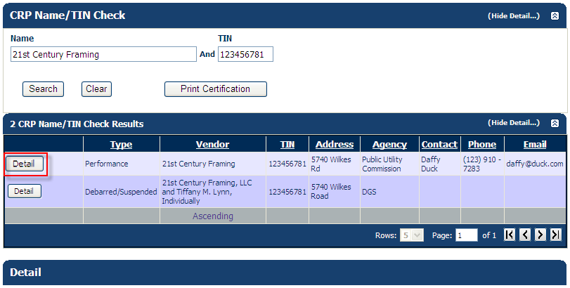

The information displays. The fields containing data vary depending on whether it is a performance issue or a Commonwealth suspension/debarment. The information that displays depends on the information available to the system.

Performance Issue example:
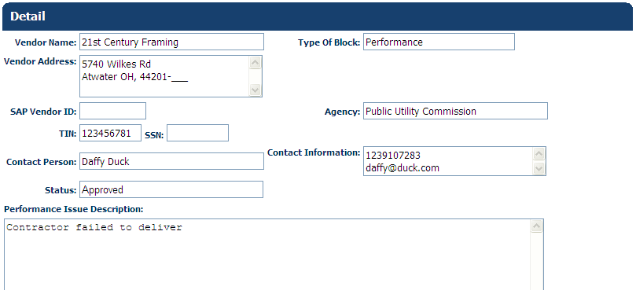

Commonwealth Suspensions/Debarment example:
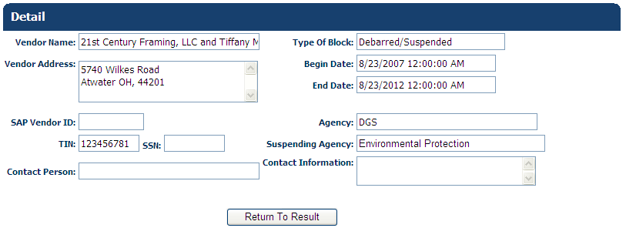

- Select the Return to Result button.

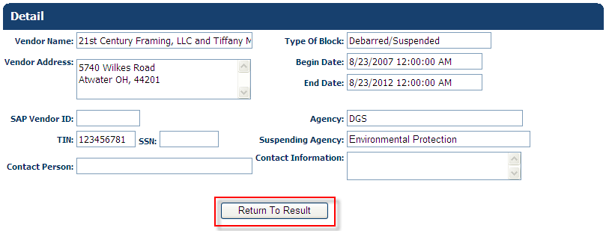

- Select the Print Certification button.

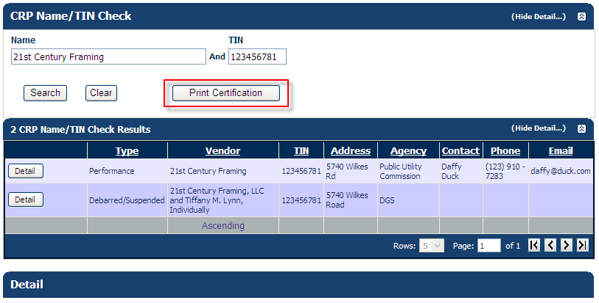

The CRP Check Certification Form displays.

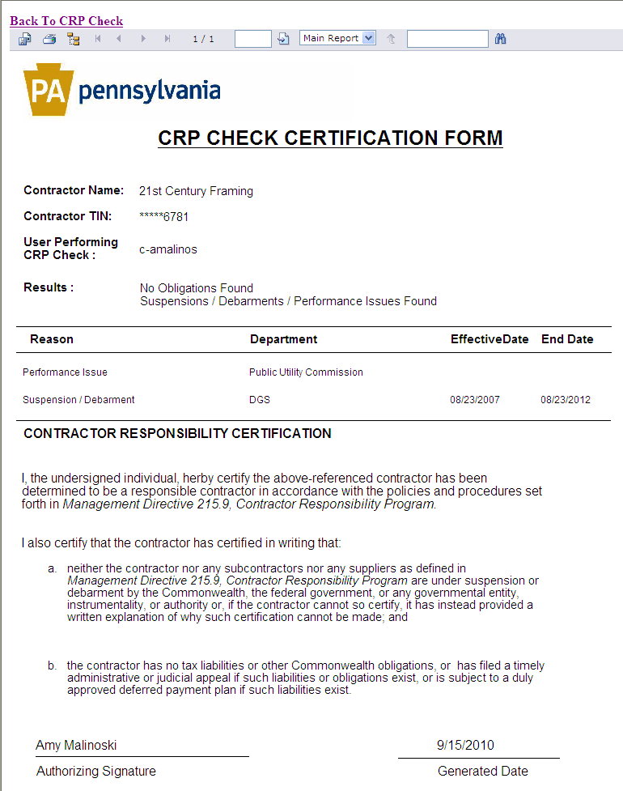

- Export and/or Print the CRP Check Certification Form.

- Select the Back to CRP Check link to return to the CRPS.

Demonstration 5: Review CRP Check results with federal suspensions/debarments and print certification
- Execute Demo 1 for a contractor with a Federal suspension/debarment.

The following displays:
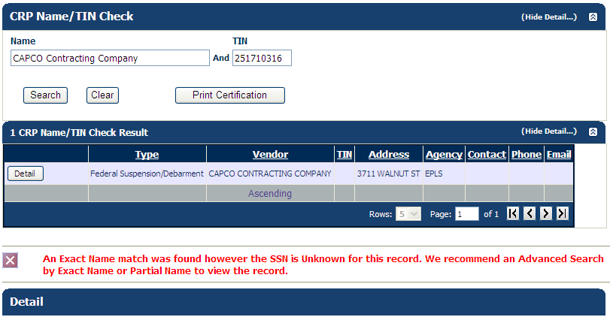

The EPLS uses the Name and TIN supplied in the CRPS when checking their system for matching records. The EPLS first checks the Name and if an exact match is found, it will check the TIN provided. Even if the TIN doesn’t match, the EPLS provides a matching result to the CRPS. If this occurs, an error message displays on the web page to indicate that a match was found on Name, but the TIN either wasn’t found or didn’t match. The error message that displays in the CRPS is the same error message returned from the EPLS.
An example of the error message when the TIN isn’t found:
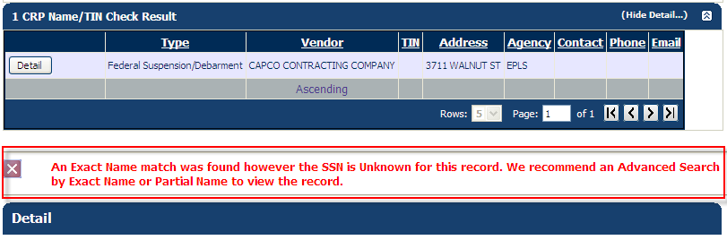
An example of the error message when the TIN doesn’t match:
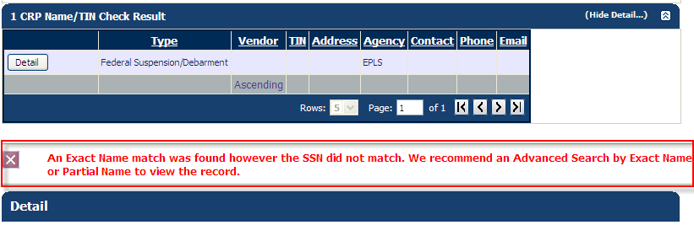
If the CRP Check returns an EPLS result and an error message is returned, you need to go to the EPLS website (www.epls.gov) and execute an Advanced Search to determine if in fact the contractor you are checking has a federal suspension/debarment listed on the EPLS.
The Print Certification button is available.

- Select the Detail button to view the data stored for the Federal suspension/debarment.
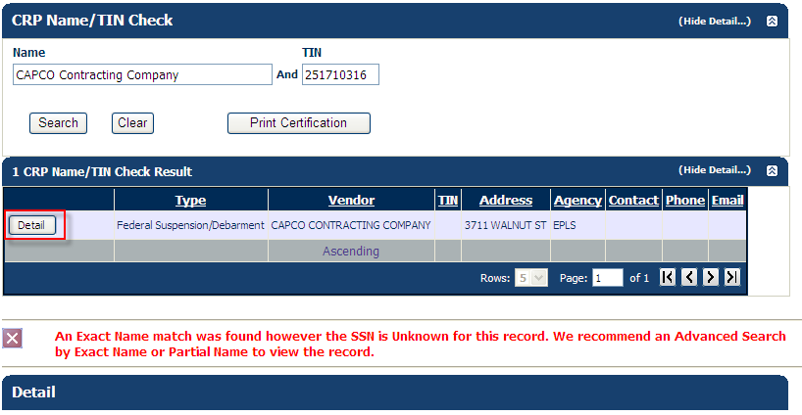

The data available from the EPLS regarding the Federal suspension/debarment displays on the page.
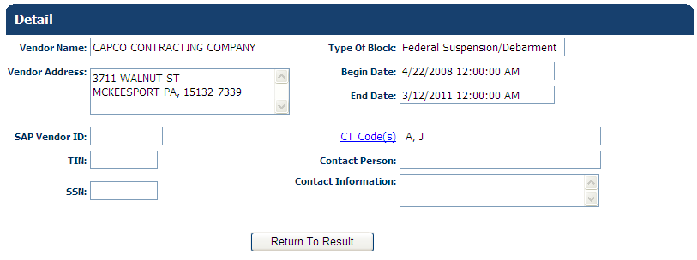

If a Federal suspension/debarment is found in the EPLS, the cause treatment code (CT code) is supplied to the CRPS and displays in the Detail. The field label CT Code is a hyperlink to the EPLS website where you can research the CT codes returned for the contractor.
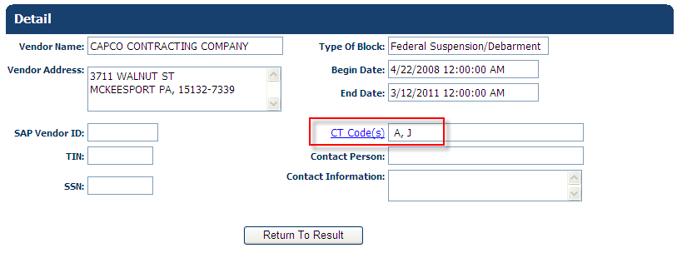

- Select the Return to Result button.

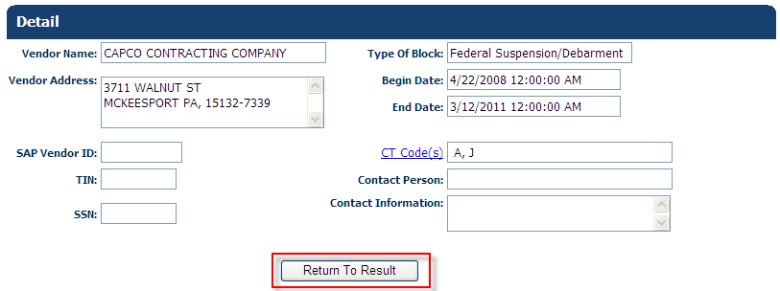

- Select the Print Certification button.

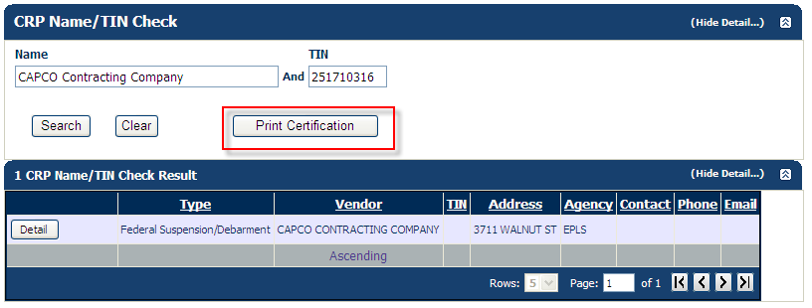

The CRP Check Certification Form displays.

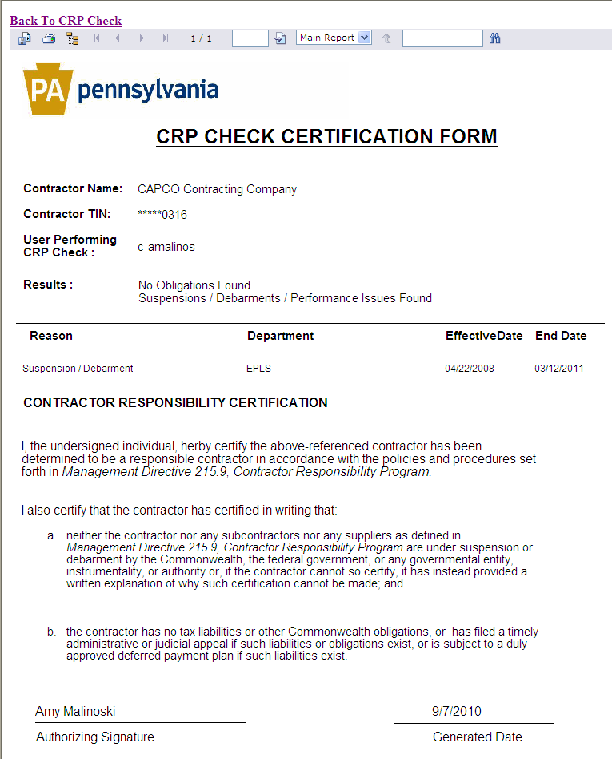

- Export and/or Print the CRP Check Certification Form.

- Select the Back to CRP Check link to return to the CRPS.

