

Activity 2.3.2 Tensile Testing – SIM

Introduction
 | Tensile testing provides engineers with the ability to verify and establish material properties related to a specific material. This verification process is critical in ensuring that the selected material will meet design specifications. In this activity you will interpret and make sample specific calculations related to the material properties of a dog bone test sample. | 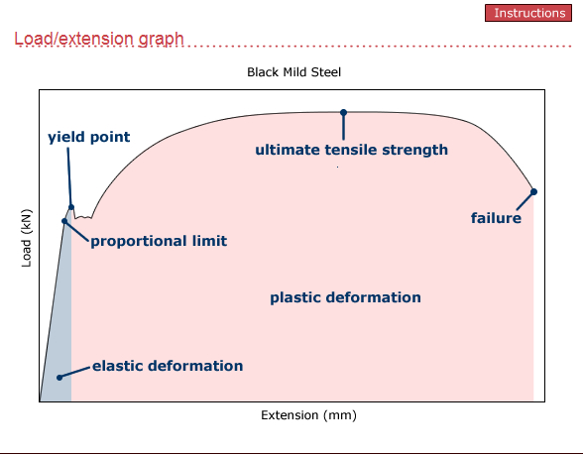
- Four materials are available to test. All but cast iron will create usable data for this activity. Check with your instructor to determine which material you will test. A sampling of each material should be tested among the class. |  |  | 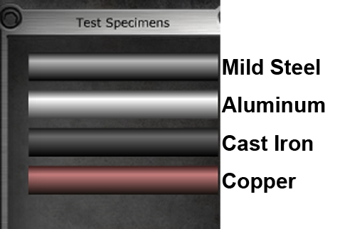

- Test the material by dragging it into the clamps and pressing Start.
- Upon completion of the test, enlarge your browser window by using Ctrl + so that the graph is large.
- Take a screen shot of the browser, paste it into the Proportional Limit table below, and then crop out all but the graph. Copy the cropped image and paste it into the remainder of the tables.
The original diameter of the specimen is 5mm or 0.20 in. and the original length is 75mm or 2.95 in.

Test Sample Calculations
Proportional Limit Stress
The greatest stress that a material is capable of withstanding without deviation from straight line proportionality between the stress and strain. If the force applied to a material is released, the material will return to its original size and shape.
Tensile test results graph (Insert test graph)
Locate the proportional limit on the test graph.
Solve for the proportional limit stress: σ = P/A

Yield Point Stress
The point at which a sudden elongation takes place while the load on the sample remains the same or actually drops. If the force applied to the material is released, the material will not return to its original shape.
Tensile test results graph (Insert test graph)
Locate the Yield Point on the test graph.
Solve for the Yield Point stress: σ = P/A

Ultimate/Tensile Stress
The point at which a maximum load for a sample is achieved. Beyond this point elongation of the sample continues, but the force exerted decreases.
Tensile test results graph (Insert test graph)
Locate the maximum load location on the test graph.
Solve for the Ultimate/Tensile stress: σ = P/A

Breaking/Rupture Point
The maximum amount of stress that can be applied before rupture occurs. The specimen fractures in the necking region where the material reduces in diameter as it elongates.
Tensile test results graph (Insert test graph)
Locate the Breaking/Rupture Point on the test graph.
Solve for the Breaking/Rupture Point stress: σ = P/A

Modulus of Elasticity
A measure of a material’s ability to regain its original dimensions after the removal of a load or force. The modulus is the slope of the straight line portion of the stress-strain diagram up to the proportional limit.
Tensile test results graph (Insert test graph)
Solve for the Modulus of Elasticity: E = (P₁-P₂)L₀/( δ ₁-δ₂)A

Modulus of Resilience
A measure of a material’s ability to absorb energy up to the elastic limit. This modulus is represented by the area under the stress vs. strain curve from 0-force to the elastic limit.
Tensile test results graph (Insert test graph)
Solve for the Modulus of Resilience: U_{r} = ½(σ_{yp})(ε _{yp})

Modulus of Toughness
A measure of a material’s ability to plastically deform without fracturing. Work is performed by the material absorbing energy from the blow or deformation. This measurement is equal to the area under the stress vs. strain curve from its origin through the rupture point.
Tensile test results graph (Insert test graph)
Solve for the Modulus of Toughness: U_{t} = 1/3 (ε _{br})( σ_{yp} + 2 σ_{ult})

