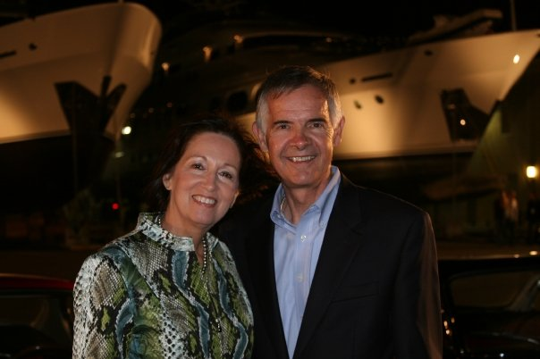
Captain Johnny “Turk” Green
-by Joyce White

John would state he was successful in the Navy because it gave him the opportunity for education. His passion was Naval Aviation and he would tell everyone he was “The Happiest Sailor in the Navy”. The John “Turk” Green Memorial Scholarship reinforces Turk’s legacy of bold leadership while enforcing his steadfast support of educational opportunities for our military families.
John was raised in Missouri with seven siblings, the son of a prison guard and grandson of a turkey farmer. Turk enlisted in the Navy becoming an electronics technician and eventually serving on the Presidential Yacht, USS Sequoia, during President Nixon’s administration.
John met Barbara Hawkins, the daughter of a retired Air Force Colonel, on a visit back home. They married and moved to Washington, DC, where Barbara completed her undergraduate degree. Subsequently, she supported John as he earned his degree in electrical engineering at the University of Missouri as part of the Navy’s commissioning program (NESEP). From there, John embarked upon a career which would see him blossom as a skilled aviator, mariner, motivational leader, and distinguished Naval Officer. First as a Light Attack pilot in the A-7, and then as part of the initial Strike Fighter cadre in the F-18, John was known for his superb work ethic and professionalism. His positive attitude and contagious enthusiasm, coupled with his wife’s never ending support of Navy life, earned both a large following of friends and fans. As Turk served his country and military families, Barb was active in every squadron and command spouse club, while working professionally and raising two lovely children, Shannon and Kyle. Barb served as President of the Cecil Field Officers’ Spouse Club where they raised money for annual scholarships benefiting children and spouses.
Following Strike Fighter Command in Atsugi Japan, John completed Naval Nuclear Power Training. As Executive Officer of USS HARRY TRUMAN , he arrived one month before the Nation’s newest aircraft carrier was commissioned in Norfolk, VA. Relocating his family to Bremerton, WA, John assumed command of the USS CAMDEN, the first American warship on site to provide assistance and support to the USS COLE after it was attacked off the coast of Yemen in 2000.
The Green family once again returned to Norfolk where John served as the Chief of Staff for Commander, Naval Air Force Atlantic. Barbara continued her many efforts in support of our Navy families while serving on the Wings Over Atlantic Scholarship Foundation Committee. She held the offices of Treasurer and Secretary, and was crucial in organizing accounting practices to protect its investments. She was relentless in locating investors for the scholarships as her mantra was “Military families serve, too”. Simultaneously, she was President of Wings Over Atlantic Spouse Club whose focus was fellowship and education for Aviation spouses. All the while she worked full time at USPA-IRA/First Command.
At the request of COMNAVAIRTLANT, Captain Green was sent to Mayport, Florida as Commanding Officer of the USS John F. Kennedy. Within weeks, he resurrected the morale and spirit of the sailors, resulting in 1,100 materials and engineering issues repaired or corrected before returning to his position at AIRLANT.
John then took Command of the USS Theodore Roosevelt becoming the only Naval Aviator to ever Command both a Nuclear Powered and Conventional Carrier. As Barbara continued to work, she served as advisor to the spouse groups, Ombudsmen and family members of the 2300 member crew. Whenever possible, she also accompanied John during his numerous speaking engagements to the Navy supporters near and far, often speaking herself on the concerns and lives of our Navy spouses and their children. She also worked courageously to raise funds to award scholarships for military families.
After commanding “TR” Captain Green was selected to be Chief of Staff, NORTHCOM in Colorado Springs, where he oversaw the planning, direction and execution of rescue and cleanup operations post Hurricane Katrina. Captain Green’s final tour as a Naval Officer was as Commanding Officer of the Cheyenne Mountain Complex. This mighty “Turk” lost his valiant battle with esophageal cancer in 2008.
Throughout their life of Naval Service, Captain John Green and his wife Barbara never shirked from responsibility or in seeking to improve themselves through continued growth and education as they enthusiastically encouraged all those around them to continue their professional training, personal growth and schooling. Years of inspirational leadership, dedication of personal time, tireless support, and sage guidance to our sailors and families became the impetus behind an effort to fund an ongoing scholarship in the Green’s honor.
The John “Turk” Green Memorial Scholarship has been endowed with $46,000 which will yield a $2500 yearly scholarship. The recipient will be awarded this amount for 4 years which will make this a $10,000 scholarship.

Is Johnny Green still the “Happiest Sailor in the Navy”…. YOU BET!!!!!!!!!!!!

