**Lego Robot to fight Coronavirus**

Name: Dineshkanna B R

Roll no: 19L113

Year: 2019-23

Dept: ECE

I'm Dineshkanna, a second year student studying ECE at PSG tech. I like to lead a team in most of the situations and love to organise and find solutions for various tasks.

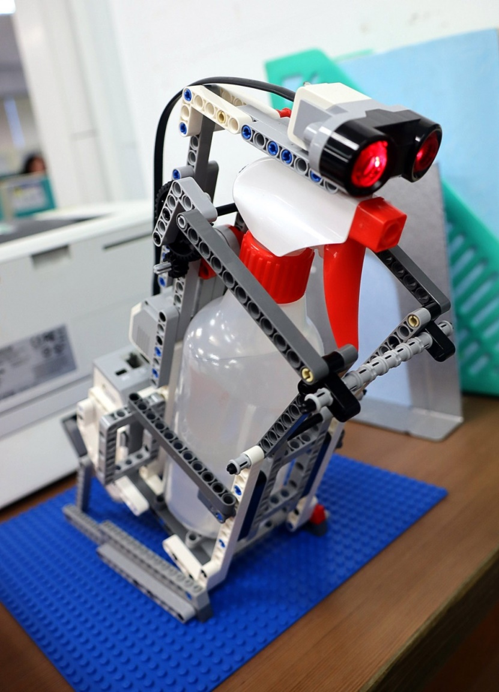

<https://www.taiwannews.com.tw/en/news/3894997>

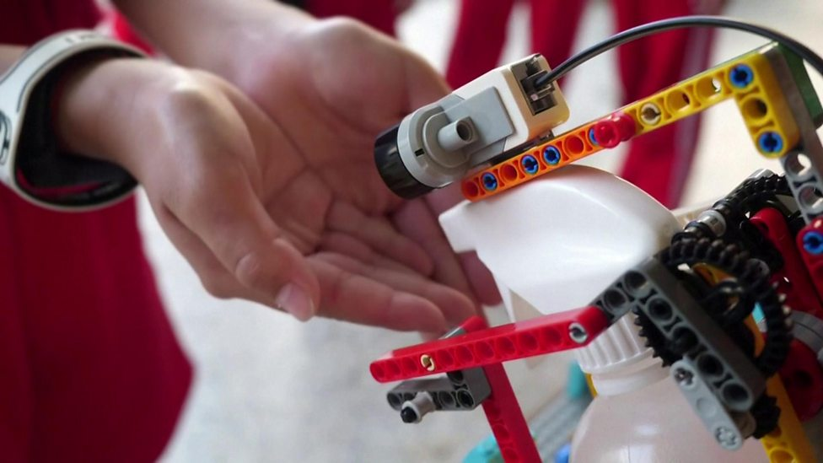

<https://www.bbc.co.uk/newsround/51824178>