**Telehealth and its role in Covid-19 pandemic**

-Kanisha R



<https://online.marymount.edu/blog/telehealth-for-family-nurse-practitioners>

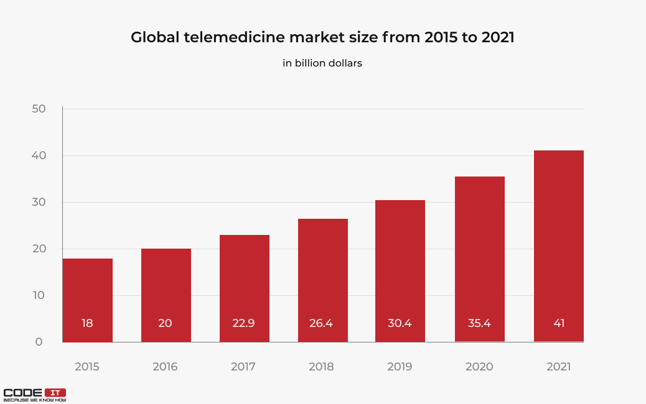<https://codeit.us/blog/telemedicine-apps-development>

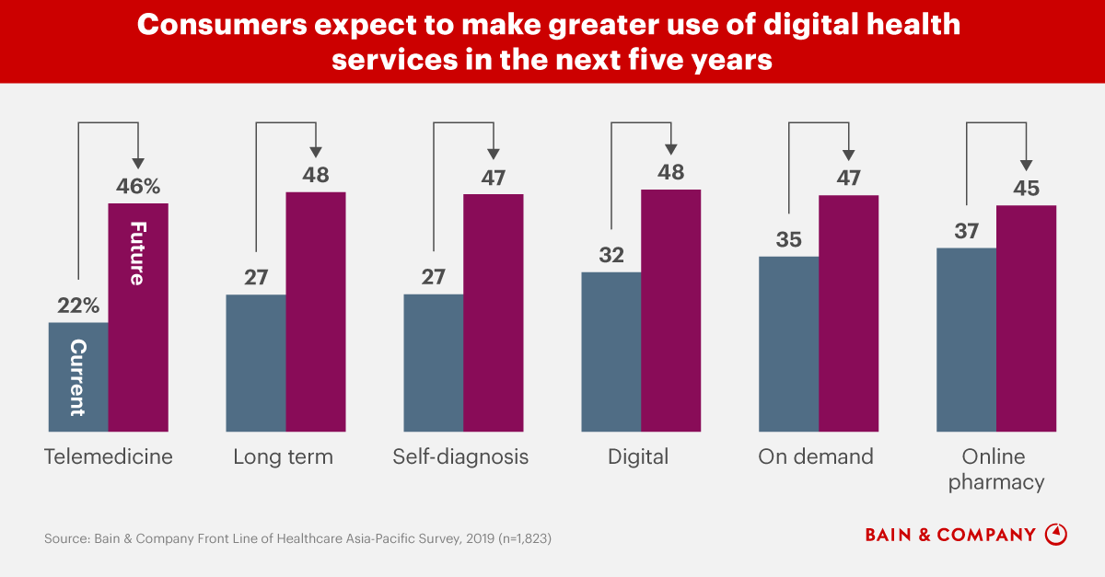

<https://www.bain.com/insights/covid-19-accelerates-the-adoption-of-telemedicine-in-asia-pacific-countries/>