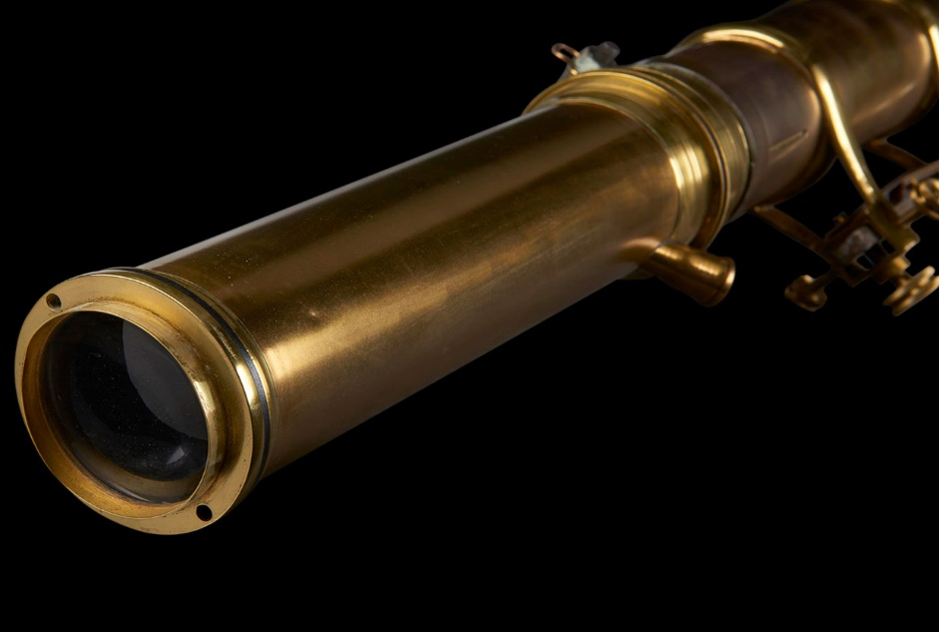

A quartz lens from a Finsen lamp, used to administer UV phototherapy to patients.

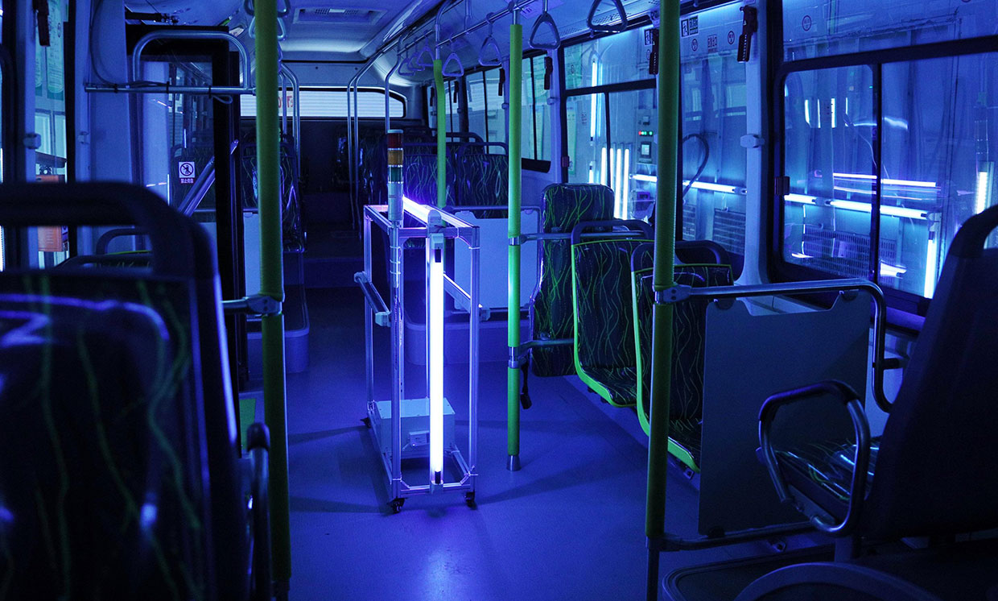

Bus disinfected using uv light

About the writer:

Name: S.Preethi

Roll no: 19D228

Year:2019-23

Dept: BME

I'm Preethi, a second-year student studying BME at PSG tech, who is a passionate leaner and enthusiastic explorer who loves travelling. I’m more of doer than thinker.