Grant Pathway — System Architecture Overview
Infrastructure and Data Flow Diagram
RapidGlobe Ltd (Reg. 05615649) · v1.0 · 29 June 2026 · CONFIDENTIAL
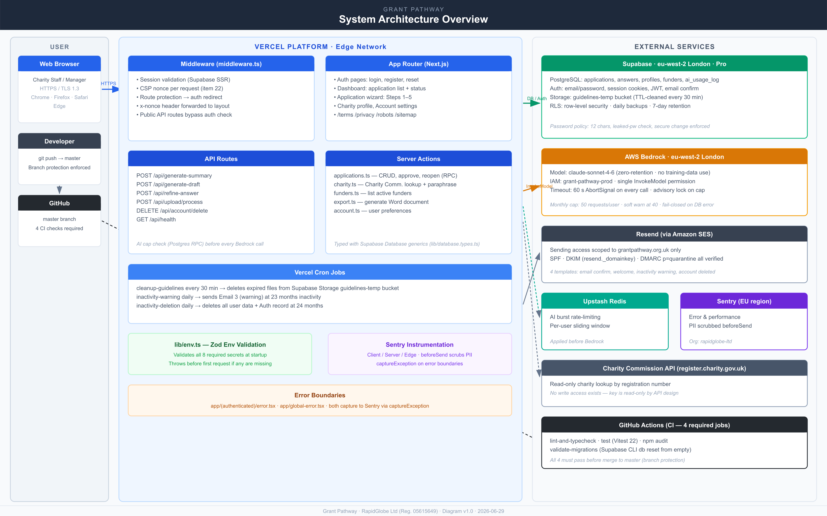

Architecture Summary
- User Layer: Charity staff access Grant Pathway via web browser over HTTPS/TLS 1.3. Developers push code via git; all pushes are gated by four mandatory CI checks before reaching master.
- Vercel Platform: Next.js App Router handles all page rendering. Middleware runs on every request to validate the Supabase session and generate a fresh CSP nonce. API routes handle AI generation, file processing, and account deletion. Three Vercel Cron jobs manage storage cleanup and inactivity deletion.
- Supabase (eu-west-2, London): PostgreSQL database stores all application data under row-level security. Supabase Auth manages email/password sessions. The guidelines-temp Storage bucket holds uploaded files temporarily; contents are cleaned every 30 minutes.
- AWS Bedrock (eu-west-2, London): Claude claude-sonnet-4-6 processes funder guidelines and generates draft answers. Zero-retention and no training-data use enforced. Access is scoped to a single IAM user with one InvokeModel permission.
- Resend: Transactional email delivery via Amazon SES. API key scoped to grantpathway.org.uk. SPF, DKIM, and DMARC all verified.
- Upstash Redis: Per-user burst rate-limiting applied before every Bedrock call.
- Sentry (EU region): Error and performance monitoring. PII is scrubbed in beforeSend hooks before any data leaves the application.
- GitHub Actions: Four CI jobs (lint-and-typecheck, test, audit, validate-migrations) run on every push. All four must pass before a merge to master is permitted.

