Grant Pathway — Application Workflow
User Journey — From Login to Export
RapidGlobe Ltd (Reg. 05615649) · v1.0 · 29 June 2026 · CONFIDENTIAL
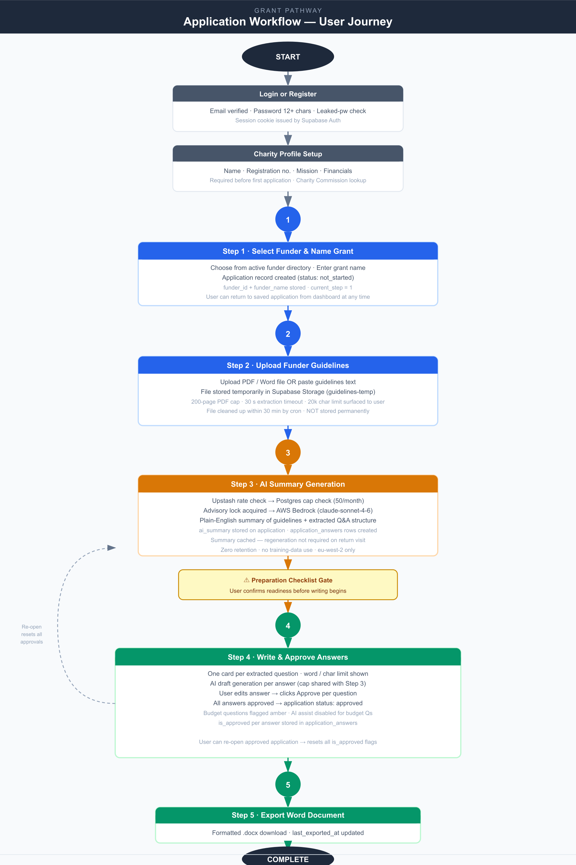

Workflow Summary
- Login / Register: Users create an account with a verified email address. Password must be at least 12 characters and is checked against known-leaked passwords via the HaveIBeenPwned API.
- Charity Profile: Before starting an application, users complete their charity profile including name, registration number, mission statement, and financial data. The Charity Commission API pre-fills data where available.
- Step 1 — Select Funder & Name Grant: User selects the target funder from the active directory and enters the name of the specific grant. The application record is created with status not_started.
- Step 2 — Upload Guidelines: User uploads a PDF or Word file, or pastes the funder guidelines as text. The file is stored temporarily and deleted within 30 minutes. Guidelines are never stored permanently.
- Step 3 — AI Summary: AWS Bedrock (Claude claude-sonnet-4-6) reads the guidelines and produces a plain-English summary plus an extracted question structure. A monthly cap of 50 AI requests per user applies. The summary is cached so users can return without regenerating.
- Step 4 — Write & Approve Answers: Users write answers to each extracted question, optionally using AI-generated drafts as a starting point. Every answer must be individually approved before the application can be exported. Budget questions are flagged and AI assistance is disabled for them. Users may re-open an approved application, which resets all approvals.
- Step 5 — Export Word Document: The completed application is exported as a formatted .docx file ready for submission. The export timestamp is recorded on the application record.

