Background | Off-white (#F8FAFC) with a teal bottom bar (add a teal rectangle shape at the bottom of the slide)
Visual | Grant Pathway logo centred, full size (approx 350px wide in Canva)
On-screen text | Line 1: grantpathway.org.uk  Line 2 (in teal bar): Free for UK charities. Always.
Text style | Line 1: Montserrat Bold 22pt teal | Line 2: Lato Italic 16pt amber, inside teal bar
Animation | Fade In, no exit animation (hold to end of video)
Duration | 2 seconds
Canva tip | Keep this slide clean. Logo, website URL, tagline. No clutter. The teal bottom bar gives a professional finish. Hold this frame for the full 2 seconds.

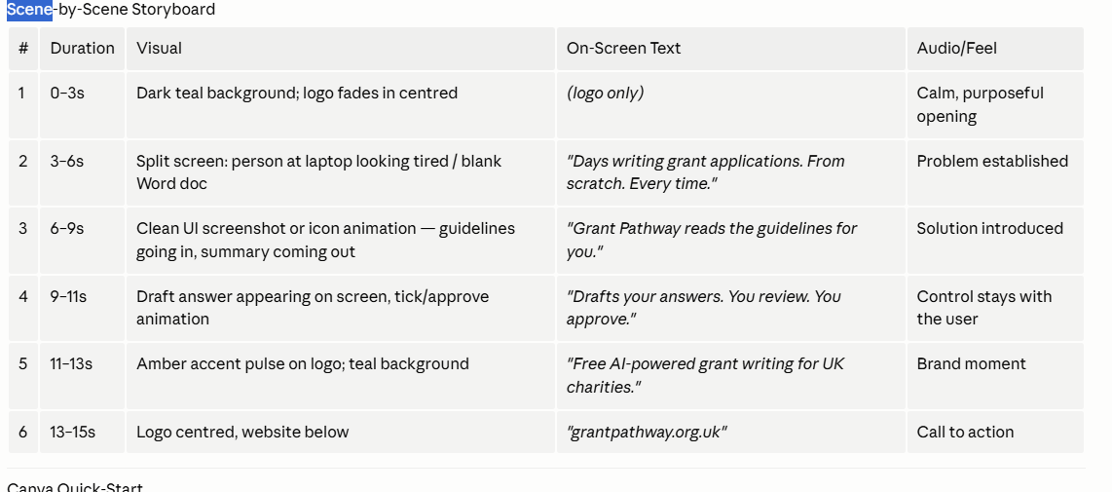
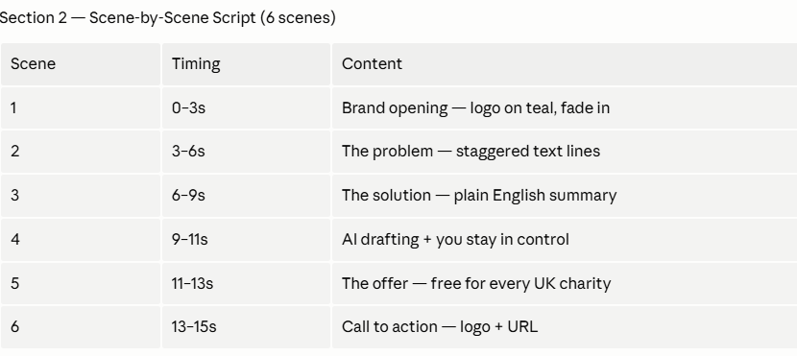

Hello, lets go back to the pathway_explainer video. What do you suggest as background for slides 2 - 5? Rather amend the original video, can you create a short video

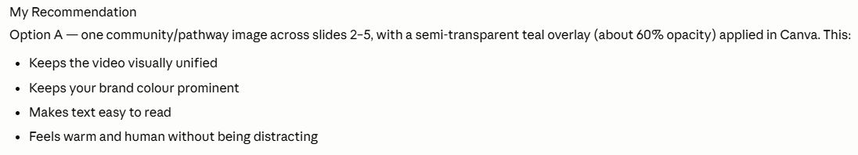

Teal od6e6e
Amber D977o6

