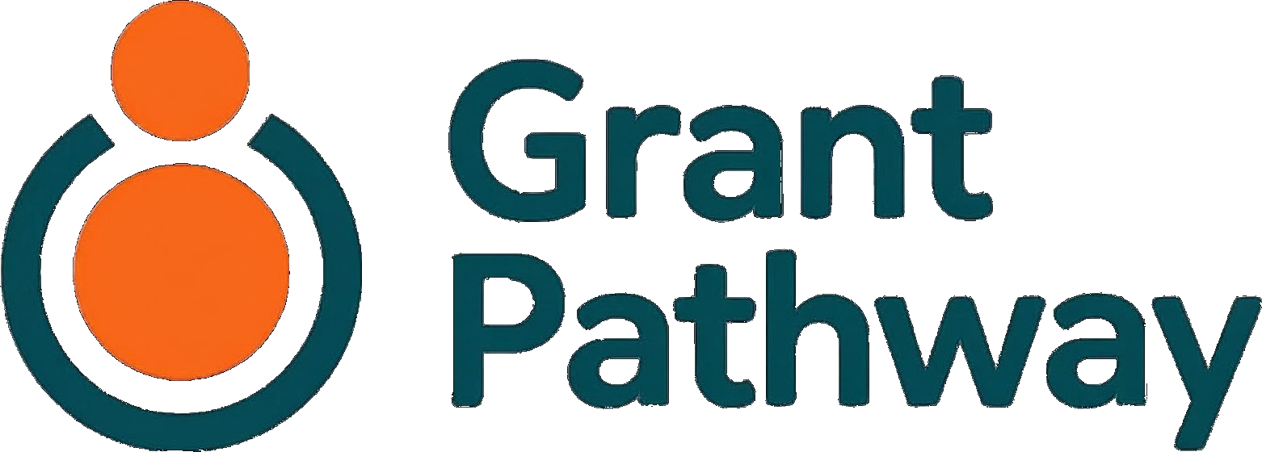
Privacy Policy

Service provided by:

June 2026
v1.0

Version: 1.1
Effective date: [TO BE CONFIRMED]
Last updated: 26 May 2026
Change from v1.0 (22 May 2026): Section 5 updated to reflect Amazon Bedrock (eu-west-2, London) as the AI processing provider, replacing the previous Anthropic direct API reference; Sentry data region corrected to European Union. Section 6 updated to reflect that AI processing no longer involves a US data transfer. Section 7 updated to accurately disclose the 7-day automated backup retention window that applies after account deletion (ADR-DATA-005).

1. Who We Are
Grant Pathway is a free online tool that helps UK charities write grant applications. It is provided by RapidGlobe Ltd, a company registered in England and Wales.
Company name | RapidGlobe Ltd
Company registration number | 05615649
Registered address | Ground Floor Suite, Crown House, 40 North Street, Hornchurch, Essex RM11 1EW
ICO registration number | [TO BE CONFIRMED — see note below]
Data protection contact | wjokhia@rapidglobe.com

⚠ ICO registration: Processing personal data of UK individuals requires registration with the Information Commissioner's Office in most cases. Please confirm your ICO registration number before this policy goes live. Register or check your status at ico.org.uk.
RapidGlobe Ltd is the data controller for the personal information you provide when using Grant Pathway. This means we decide how and why your data is used, and we are responsible for keeping it safe.

2. What Information We Collect

Information you give us
When you register and use Grant Pathway, you provide:
- Your email address — used to create and identify your account
- Your organisation's details — the name, description, who you help, and where you work, as entered in your organisation profile
- Grant application content — funder guidelines you upload or paste in, and the application questions and draft answers you work on within the tool
- Any edits or corrections you make to AI-generated content before saving it

Information we collect automatically
- Usage data — a count of AI-assisted requests made per account each month, used to manage the fair-use limit
- Session data — a secure token stored in your browser that keeps you signed in while you use the service
- Error reports — if something goes wrong, limited technical information about the error may be collected to help us diagnose and fix the problem
We do not collect payment information. We do not use advertising trackers. We do not build profiles for marketing purposes.

3. How We Use Your Information
We use your information to:
- Provide the service — create your account, save your organisation profile, generate AI-assisted summaries and draft answers tailored to your charity, and let you export completed applications
- Maintain the service — monitor for errors, manage the fair-use limit, and keep the system running reliably
- Communicate with you — send a welcome email when you register, and a warning email if your account is approaching the two-year inactivity threshold (see Section 7)
- Keep the service secure — detect and prevent fraudulent or abusive use of the platform
We do not use your information for marketing. We do not sell your data. We do not use your information to train artificial intelligence models.

4. Legal Basis for Processing
Under the UK General Data Protection Regulation (UK GDPR), we must have a legal basis for processing your personal data. We rely on the following:
Processing activity | Legal basis
Creating and managing your account | Contract — necessary to provide the service you have signed up for
Saving your organisation profile and application content | Contract — necessary to deliver the core features of the service
Sending service emails (welcome, inactivity warning) | Contract / Legitimate interests — necessary to operate the account lifecycle and keep you informed
Managing the fair-use limit | Legitimate interests — necessary to manage running costs and ensure fair access for all users
Error monitoring and security | Legitimate interests — necessary to keep the service reliable and protect against abuse

5. Who We Share Your Information With
We do not sell your data. We do not share it for advertising or marketing purposes. We work with a small number of trusted third-party service providers who process data on our behalf:
Provider | What they do | Where they are based
Supabase | Stores your account, organisation profile, and application data | United Kingdom (London)
Amazon Web Services (Bedrock) | Powers the AI features that summarise funder guidelines and generate draft answers | United Kingdom / European Union
Resend | Sends transactional emails (welcome email, inactivity warning) | United States
Vercel | Hosts the Grant Pathway web application | United States (with global edge network)
Sentry | Captures error reports to help us diagnose and fix technical problems | European Union

Each provider is bound by a data processing agreement and is only permitted to use your data to deliver the service to us — not for their own commercial purposes.
A note on AI processing: When you ask Grant Pathway to summarise funder guidelines or generate a draft answer, the relevant content (funder guidelines and your organisation profile) is processed by Amazon Web Services using the Anthropic Claude model via the Amazon Bedrock service. This processing takes place within the United Kingdom (AWS eu-west-2, London) under normal operating conditions, and never outside the European Economic Area under any circumstances. Your email address is never sent to the AI processing layer. Anthropic does not use this data to train its AI models — this commitment is upheld through the AWS and Anthropic terms governing the Bedrock service.

6. International Data Transfers
Two of our service providers are based outside the United Kingdom — Resend and Vercel (both United States). Where personal data is transferred to these providers, we ensure that appropriate safeguards are in place — typically the UK's International Data Transfer Agreement (IDTA) or equivalent standard contractual clauses — so that your data continues to be protected to the same standard as within the UK.
AI processing (Amazon Web Services Bedrock) takes place within the UK or EEA and does not constitute an international transfer.
Error reports processed by Sentry are stored in the European Union, which is covered by the UK's adequacy decision for EU/EEA countries — no additional transfer mechanism is required.

7. How Long We Keep Your Information
Data | Retention period
Account details and organisation profile | Until you delete your account, or until the inactivity deletion policy applies (see below)
Application content | Deleted when your account is deleted
AI usage log | Deleted when your account is deleted
Automated backup copies | Permanently removed within 7 days of account deletion, as part of standard backup rotation (see below)
Email delivery records | Held by Resend in accordance with their standard retention policy (up to 90 days)
Error reports | Retained for up to 12 months for diagnostic purposes, anonymised where possible

Inactivity deletion: If your account has not been used for two years, we will send a warning email to your registered address. If you do not log in within 30 days of that warning, your account and all associated data will be permanently deleted. You will receive no further warning before deletion occurs.
Account deletion on request: You can delete your account at any time from within the service. Your data is removed from our live systems immediately and permanently. As part of our operational backup infrastructure, automated backup copies are permanently removed within 7 days as part of the standard backup rotation cycle. These backup copies are not accessible to users and cannot be used to restore deleted content.

8. Your Rights
Under UK GDPR, you have the following rights in relation to your personal data:
- Right of access — you can request a copy of the personal data we hold about you
- Right to rectification — you can ask us to correct inaccurate or incomplete data
- Right to erasure — you can ask us to delete your personal data (you can also do this directly by deleting your account within the service)
- Right to restriction — you can ask us to limit how we process your data while a concern is being resolved
- Right to data portability — you can ask for your data in a structured, commonly used, machine-readable format
- Right to object — you can object to processing based on legitimate interests
- Rights related to automated decision-making — Grant Pathway does not make automated decisions that have a legal or similarly significant effect on you
To exercise any of these rights, please contact us at wjokhia@rapidglobe.com. We will respond within one month of receiving your request. We may need to verify your identity before we can process it.
There is no charge for exercising your rights in most cases.

9. Cookies
Grant Pathway uses a small number of cookies that are strictly necessary to operate the service:
- Authentication cookie — a secure, encrypted token that keeps you signed in during your session. This cookie is deleted when you sign out or when your session expires.
We do not use advertising cookies, analytics cookies, or any third-party tracking technology. Because we only use cookies that are strictly necessary for the service to function, we are not required to ask for your consent to set them — but we want to be transparent about their use.

10. Changes to This Policy
If we make significant changes to this policy — for example, if we add a new category of data or a new service provider — we will notify you by email before the changes take effect.
Minor or clarificatory changes may be made without advance notice. The updated policy will always be available at grantpathway.org.uk, and the "Last updated" date at the top of this page will reflect when it was last changed.

11. How to Contact Us
For any questions about this privacy policy, or to exercise your data rights, please contact us:
Email: wjokhia@rapidglobe.com
Post: RapidGlobe Ltd, Ground Floor Suite, Crown House, 40 North Street, Hornchurch, Essex RM11 1EW
We aim to respond to all enquiries within five working days.

12. How to Complain
If you are not satisfied with how we have handled your personal data, you have the right to lodge a complaint with the Information Commissioner's Office (ICO), the UK's data protection authority:
- Website: ico.org.uk
- Telephone: 0303 123 1113
- Post: Information Commissioner's Office, Wycliffe House, Water Lane, Wilmslow, Cheshire SK9 5AF
We would always prefer the opportunity to resolve any concern directly before a formal complaint is made. Please contact us first and we will do our best to address your concern promptly.

Grant Pathway is provided by RapidGlobe Ltd (company number 05615649), registered in England and Wales.
Version: 1.1
Effective date: [TO BE CONFIRMED]
Last updated: 26 May 2026

