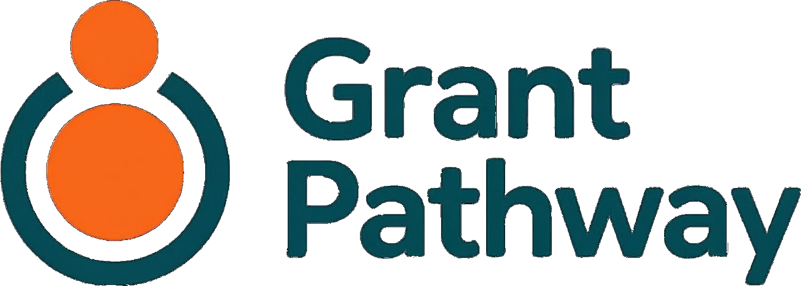
Terms of Service

Service provided by:
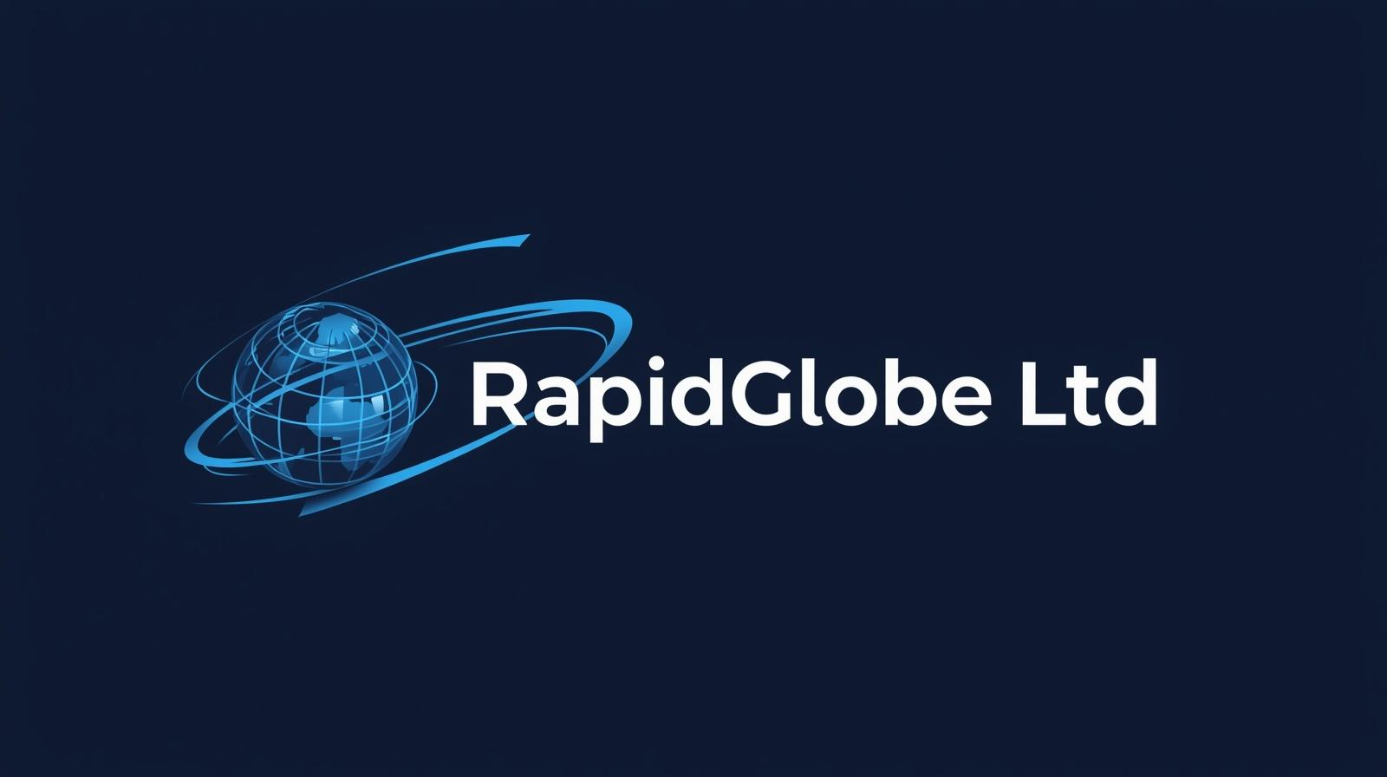
June 2026
v1.0

Version: 1.1
Effective date: [TO BE CONFIRMED]
Last updated: 26 May 2026
Change from v1.0 (22 May 2026): Section 5 updated to reference Amazon Bedrock as the AI processing layer, consistent with the privacy policy and DR-DP-002. Section 9 updated to acknowledge that operational backup infrastructure is maintained for disaster recovery purposes; this does not constitute a guarantee of data recovery and does not change the limitation of liability in Section 10.

1. Introduction
Grant Pathway is a free online tool that helps UK charities write grant applications. It is provided by RapidGlobe Ltd (company registration number 05615649), a company registered in England and Wales at Ground Floor Suite, Crown House, 40 North Street, Hornchurch, Essex RM11 1EW ("we", "us", "our").
By creating an account and using Grant Pathway, you agree to be bound by these Terms of Service. Please read them carefully before you register.
If you do not agree to these terms, you should not use the service.

2. Who Can Use Grant Pathway
Grant Pathway is intended for charitable organisations based in or operating in the United Kingdom. To register and use the service, you must:
- Represent a UK-based charitable organisation — this includes registered charities, charitable incorporated organisations (CIOs), community interest companies (CICs), charitable trusts, community benefit societies, and similar bodies whose purpose is charitable or for the public benefit
- Be authorised by that organisation to use the service on its behalf
- Be at least 18 years old
Grant Pathway is not for personal use. It is not intended for commercial fundraising. It is not for use by organisations that are not charitable in nature.
If you are unsure whether your organisation is eligible, please contact us at wjokhia@rapidglobe.com before registering.

3. Your Account
When you register, you create a personal account linked to your email address. You are responsible for:
- Keeping your login credentials secure and confidential
- All activity that takes place under your account
- Ensuring that the information in your organisation profile is accurate and kept up to date
If you believe your account has been accessed without your authorisation, contact us immediately at wjokhia@rapidglobe.com.
You may only hold one account per person. You may not share your account with other individuals. You may not create multiple accounts to circumvent the fair-use limit or any other restriction.

4. Using the Service
You agree to use Grant Pathway only for its intended purpose: supporting your charitable organisation in writing grant applications.
You must not:
- Use the service for any unlawful purpose or in breach of any applicable law or regulation
- Submit false or misleading information about your organisation or its work
- Attempt to gain unauthorised access to the service, its systems, or other users' accounts
- Use the service to generate or distribute content that is unlawful, defamatory, discriminatory, or harmful
- Interfere with the service or place an unreasonable burden on our infrastructure in a way that disrupts access for other users
- Attempt to reverse engineer, decompile, or extract the source code of any proprietary components of the service
We reserve the right to suspend or terminate accounts that violate these terms (see Section 11).

5. AI-Generated Content
Grant Pathway uses artificial intelligence to summarise funder guidelines and generate draft answers to application questions. This is designed to support your writing — not to replace your judgement.
Before any AI-generated content is saved to your application, you are asked to confirm that:
- It accurately describes your charity and project
- All figures, dates, and facts are correct
- It answers the question that was asked
You are responsible for all content you submit in a grant application. Grant Pathway generates a draft. You decide whether to use it, edit it, or discard it entirely. We do not review your applications. We do not submit applications on your behalf.
We make no representation that using Grant Pathway will result in a successful grant application. Funding decisions rest entirely with the relevant funder.
The AI features are powered by the Anthropic Claude model, accessed via Amazon Web Services' Bedrock service (eu-west-2, London). When you request a summary or draft answer, the relevant content from your funder guidelines and organisation profile is processed within UK and European Economic Area infrastructure. Please see our Privacy Policy for full details of how your data is handled in this process.

6. Fair Use
Grant Pathway is free to use. To manage the running costs of the AI features and ensure fair access for all users, each account is subject to a fair-use limit of 20 AI-assisted requests per calendar month.
This limit is intended to accommodate the realistic needs of a small charity writing grant applications throughout the year. The limit resets at the start of each calendar month.
If you believe the limit is preventing you from using the service reasonably, please contact us at wjokhia@rapidglobe.com.

7. Your Content and Data
You retain ownership of all content you create or upload through Grant Pathway — including your organisation profile, any funder guidelines you upload, and the application content you work on.
By using the service, you grant RapidGlobe Ltd a limited, non-exclusive licence to store, process, and use that content solely to provide the service to you. This licence ends when you delete the relevant content or close your account.
We do not use your content to train artificial intelligence models. We do not share it with third parties for commercial purposes.
For full details of how we handle your data, please read our Privacy Policy.

8. Intellectual Property
Grant Pathway's source code is open source and is publicly available. It may be used, modified, and distributed in accordance with the terms of its open-source licence.
The Grant Pathway name, logo, and brand materials are owned by RapidGlobe Ltd. You may not use them without our prior written permission.

9. Availability and Changes to the Service
We aim to keep Grant Pathway available at all times, but we do not guarantee uninterrupted access. The service may be temporarily unavailable due to planned maintenance, technical issues, or circumstances outside our control.
We maintain operational backup infrastructure (automated daily database backups) as a safeguard against technical failures, security incidents, and provider outages. This is an internal operational measure. It does not constitute a guarantee that data can or will be recovered in any particular circumstance, and it does not entitle users to request restoration of previously deleted or lost data.
We reserve the right to:
- Modify, update, or remove features of the service at any time
- Suspend the service temporarily for maintenance or technical reasons
- Discontinue the service entirely
If we decide to discontinue the service permanently, we will give reasonable advance notice and ensure that users have the opportunity to export their data before the service closes.

10. Limitation of Liability
Grant Pathway is provided free of charge and on an "as is" basis. To the fullest extent permitted by applicable law, RapidGlobe Ltd excludes all warranties, express or implied, including any warranty that the service will be uninterrupted, error-free, or that AI-generated content will be accurate or suitable for any particular purpose.
To the fullest extent permitted by law, RapidGlobe Ltd shall not be liable for:
- Loss of funding or missed grant opportunities arising from use of the service
- Errors, inaccuracies, or omissions in AI-generated content
- Loss or corruption of data (other than where caused by our negligence)
- Any indirect, special, consequential, or incidental loss arising from your use of, or inability to use, the service
Nothing in these terms excludes or limits our liability for:
- Death or personal injury caused by our negligence
- Fraud or fraudulent misrepresentation
- Any other liability that cannot lawfully be excluded or limited
Because the service is provided free of charge, these limitations reflect a fair allocation of risk between us.

11. Suspension and Termination
You may close your account at any time from within the service. Closure is immediate and all associated data will be permanently deleted from our live systems. Automated backup copies are permanently removed within 7 days as part of standard backup rotation.
We may suspend or terminate your account if:
- You breach any of these terms
- We reasonably believe your account is being used fraudulently, abusively, or in a way that may harm other users or the service
- We are required to do so by law
Where we suspend or terminate your account for a breach, we will inform you unless we are legally prevented from doing so. Where possible, we will give you the opportunity to export your data before termination takes effect.
Accounts that have not been used for two years are subject to our inactivity deletion policy. Please see our Privacy Policy for details.

12. Changes to These Terms
We may update these terms from time to time. If we make significant changes, we will notify you by email at least 14 days before the changes take effect. Continued use of the service after the effective date of any change constitutes your acceptance of the updated terms.
If you do not agree to the updated terms, you should stop using the service and delete your account before the changes take effect.
The "Last updated" date at the top of this page tells you when the terms were most recently changed.

13. Governing Law
These Terms of Service are governed by the laws of England and Wales. Any dispute arising from or in connection with your use of Grant Pathway will be subject to the exclusive jurisdiction of the courts of England and Wales.

14. Contact
For any questions about these terms, please contact us:
Email: wjokhia@rapidglobe.com
Post: RapidGlobe Ltd, Ground Floor Suite, Crown House, 40 North Street, Hornchurch, Essex RM11 1EW

Grant Pathway is provided by RapidGlobe Ltd (company number 05615649), registered in England and Wales.
Version: 1.1
Effective date: [TO BE CONFIRMED]
Last updated: 26 May 2026

