WIRESHARK NETWORK TRAFFIC ANALYSIS
Network Analysis Project

Student Name: Maketele Rapola
Institution: Central University of Technology (CUT)
Programme: Computer Networking
Tool: Wireshark
Date: November 2026

Wireshark Network Traffic Analysis
1. Introduction
This project focuses on analysing network traffic using Wireshark, a network protocol analyser. The purpose was to capture and examine network packets to understand how devices communicate over a network.
The analysis focused on DNS, TCP, UDP, ICMP and IP traffic, as well as the protocol hierarchy.
The project was conducted using my own computer and network connection for educational purposes.
2. Objectives
The main objectives of this project were to:
- Capture network traffic using Wireshark.
- Identify and analyse DNS packets.
- Examine TCP communication and its connection flags.
- Identify UDP packets and examine their ports.
- Capture and analyse ICMP Echo requests and replies.
- Examine IP source and destination information.
- Use the Protocol Hierarchy tool to identify protocols in captured network traffic.
- Understand how different protocols support network communication.
3. Tools and Technologies Used
The following tools and technologies were used:
- Wireshark: Used to capture and analyse network packets.
- Windows Command Prompt: Used to generate ICMP traffic using the ping command.
- Internet connection: Used to generate network traffic for analysis.
- Web browser: Used to generate DNS and other network traffic by visiting websites.
- Windows operating system: Used as the working environment.
4. Methodology
The project was completed using the following steps:
- Installed and opened Wireshark on the computer.
- Selected the active Wi-Fi network interface.
- Started capturing network traffic.
- Visited a website to generate network traffic.
- Saved the captured traffic in PCAPNG format.
- Used Wireshark display filters to identify DNS, TCP, UDP and IP packets.
- Generated ICMP traffic using the Windows Command Prompt with the command ping -n 5 8.8.8.8.
- Captured and saved the ICMP traffic separately.
- Used the Protocol Hierarchy feature under the Statistics menu to examine the protocols in the capture.
- Took screenshots of the analysis and saved them as project evidence.
5. DNS Traffic Analysis
DNS (Domain Name System) is used to translate domain names into IP addresses.
In this project, DNS traffic was examined using the Wireshark display filter dns.
The DNS packets were inspected to identify DNS queries and responses. The analysis focused on the requested domain name, DNS record type and returned answer.
Figure 1: DNS Traffic Analysis
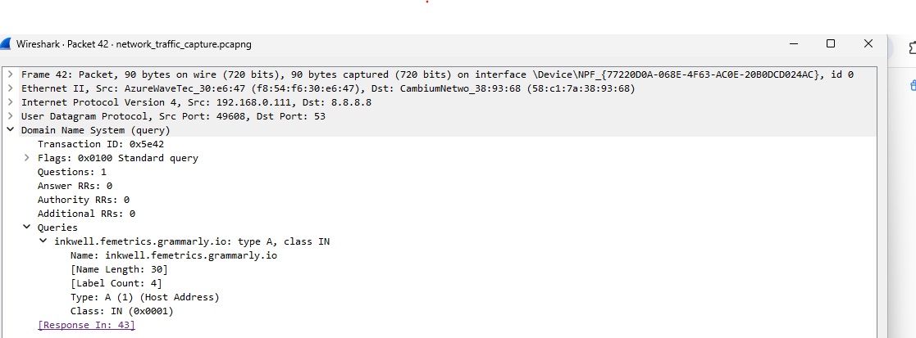
DNS Findings:
- Domain name: inkwell.femetrics.grammarly.io
- Record type: A
- DNS answer: 192.168.0.111
- Observation: The DNS response translated the domain name into an IP address.
Screenshot: dns_analysis.png
6. TCP Traffic Analysis
TCP (Transmission Control Protocol) provides reliable communication between devices. It establishes connections and ensures that data is delivered correctly.
The Wireshark display filter tcp was used to identify TCP packets.
The TCP packet details were examined, including source ports, destination ports, sequence numbers, acknowledgement numbers and TCP flags.
Important TCP flags include:
- SYN: Starts a connection.
- ACK: Acknowledges received data.
- FIN: Closes a connection normally.
- RST: Resets a connection.
Figure 2: TCP Traffic Analysis
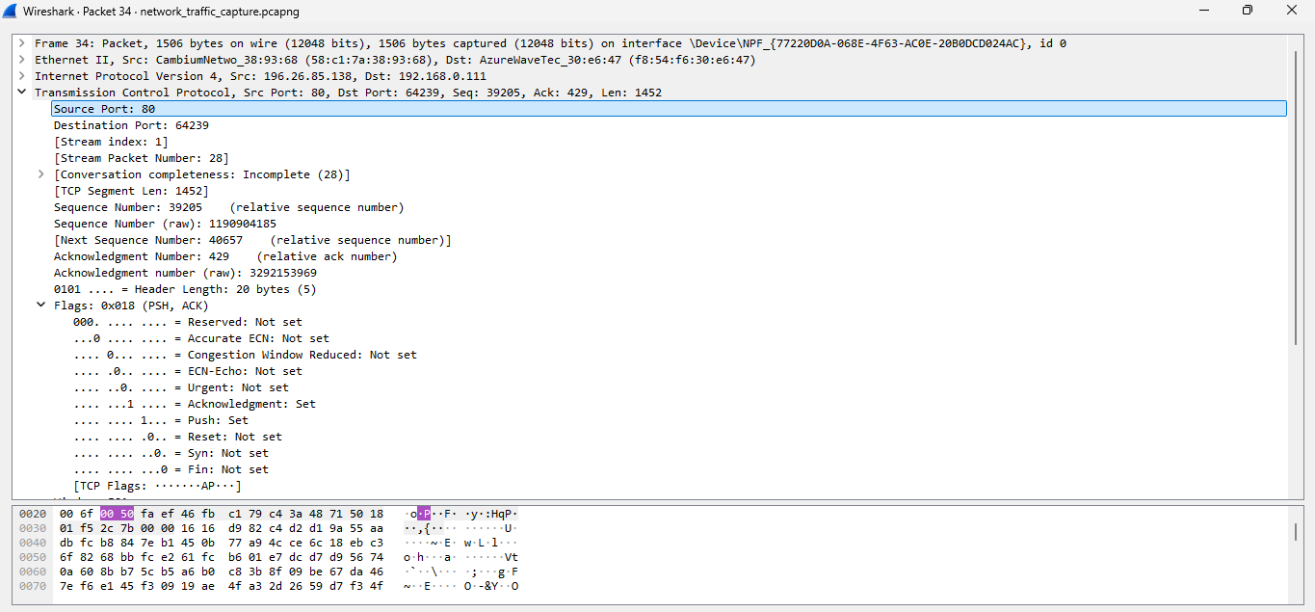
TCP Findings:
- Source port: 88
- Destination port: 64239
- TCP flags: 0x018
- Sequence number: 39205
- Observation: TCP uses flags to establish, manage and terminate connections.
Screenshot: tcp_analysis.png
7. UDP Traffic Analysis
UDP (User Datagram Protocol) is a connectionless transport protocol. Unlike TCP, it does not establish a connection before sending data.
The Wireshark display filter udp was used to identify UDP packets.
The analysis focused on source ports, destination ports, packet length and checksum information.
DNS commonly uses UDP port 53 for queries.
Figure 3: UDP Traffic Analysis
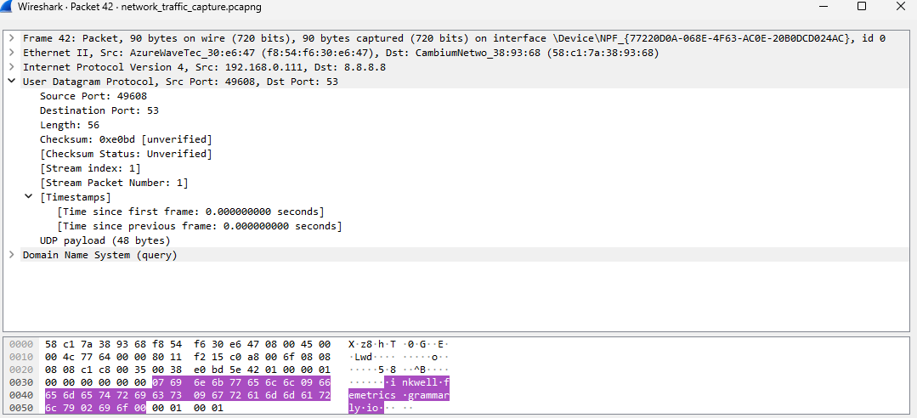
UDP Findings:
- Source port: 49608
- Destination port: 53
- UDP length: 56
- Checksum: 0xe0bd
- Observation: UDP allows data to be transmitted without establishing a connection first.
Screenshot: udp_analysis.png
8. ICMP Traffic Analysis
ICMP (Internet Control Message Protocol) is used for network diagnostics and reporting communication errors.
The Windows Command Prompt was used to generate ICMP traffic with the command:
ping -n 5 8.8.8.8
The ping test completed with 0% packet loss, indicating that all five ping requests received replies.
The Wireshark display filter icmp was used to examine the captured packets.
ICMP message types include:
- Type 8: Echo Request.
- Type 0: Echo Reply.
Figure 4: ICMP Traffic Analysis
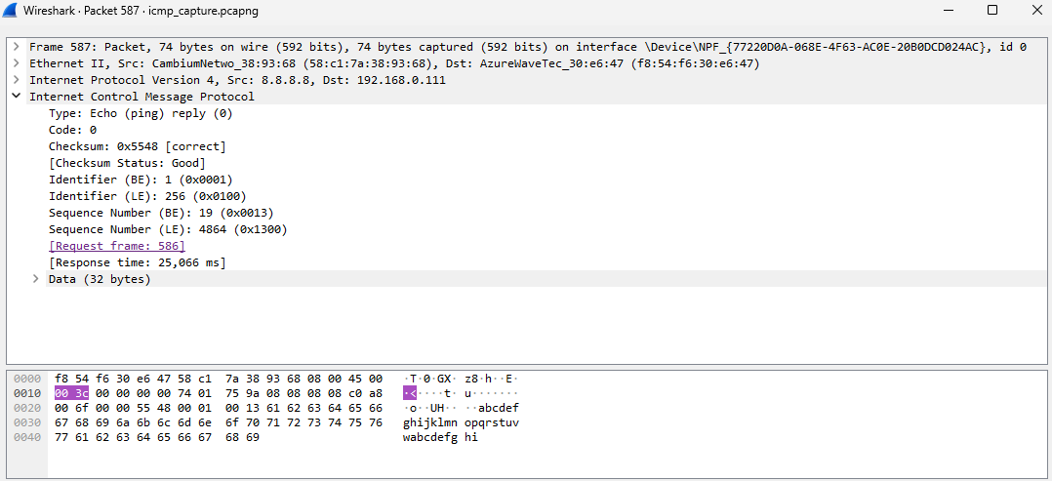
ICMP Findings:
- Destination: 8.8.8.8
- Ping result: 0% packet loss
- Echo Request type: 8
- Echo Reply type: 0
- Observation: The ping test demonstrated successful communication with the destination.
Figure 5: ICMP Protocol Hierarchy
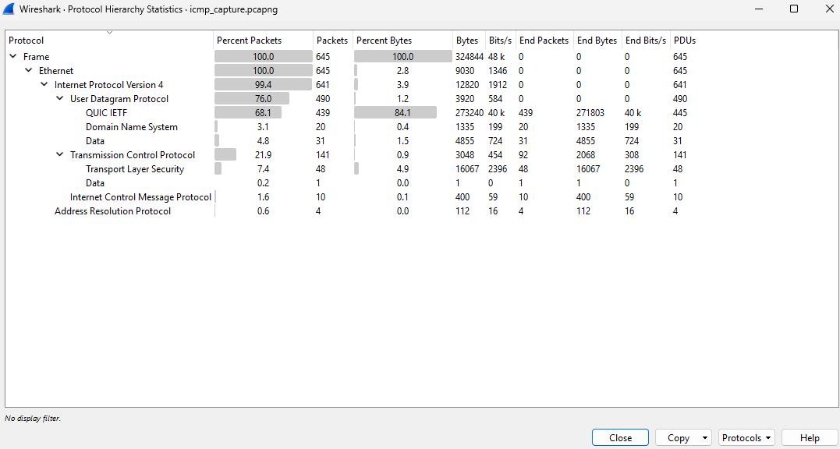
Screenshots: icmp_analysis.png and icmp_protocol_hierarchy.png
9. IP Traffic Analysis
IP (Internet Protocol) is responsible for addressing and routing packets between devices.
The Wireshark display filter ip was used to examine IPv4 traffic.
The following packet information was inspected:
- Source address.
- Destination address.
- Protocol.
- Packet length.
- Packet information.
Figure 6: IP Traffic Analysis
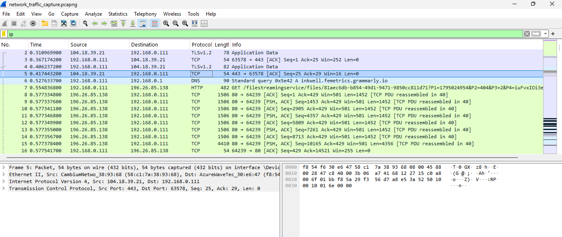
IP Findings:
- Protocols observed: TLSv1.2, TCP, DNS, HTTP
- Packet length: 78
- Observation: IP addresses identify the source and destination of network packets.
Screenshot: ip_traffic.png
10. Protocol Hierarchy Analysis
The Protocol Hierarchy feature in Wireshark was accessed through Statistics → Protocol Hierarchy.
This feature provides an overview of the protocols found in the captured network traffic.
The analysis examined the protocol names, number of packets, percentage of packets and bytes transferred.
Figure 7: Protocol Hierarchy Analysis
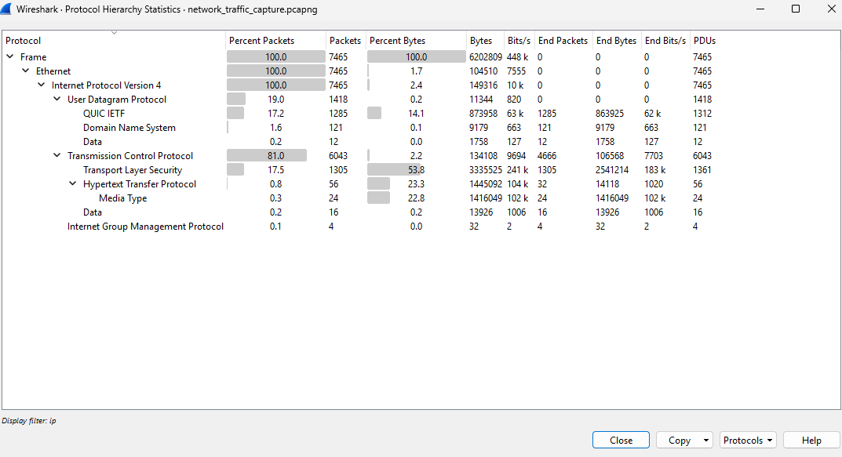
Protocol Hierarchy Findings:

Protocols observed:
1. IPv4
2. UDP
3. DNS
4. TCP

Total packets: 7465
Total bytes: 6202809

Observation: The Protocol Hierarchy feature provided an overview of the protocols identified in the captured network traffic.
Screenshots: protocol_hierarchy.png and icmp_protocol_hierarchy.png
11. Security and Privacy Considerations
During this project, the following security and privacy practices were followed:
- Network traffic was captured from my own computer and network connection.
- Sensitive information was hidden from screenshots before sharing.
- Personal IP addresses, MAC addresses and device information were protected.
- Private communications and account information were not intentionally collected.
- Capture files were treated as potentially sensitive because they may contain network information.
These practices help protect personal information when performing network traffic analysis.
12. Conclusion
This project provided practical experience in capturing and analysing network traffic using Wireshark.
The analysis covered DNS, TCP, UDP, ICMP and IP protocols. It also demonstrated how to use display filters and the Protocol Hierarchy feature to examine network communication.
The ICMP ping test successfully completed with 0% packet loss, demonstrating successful communication with the test destination.
Overall, this project improved my understanding of network protocols, packet analysis and basic network troubleshooting. It also provided practical experience that can be applied in networking and cybersecurity.

