WIRESHARK NETWORK TRAFFIC ANALYSIS
Network Analysis Project

Student Name: Maketele Rapola
Institution: Central University of Technology (CUT)
Programme: Computer Networking
Tool: Wireshark
Date: November 2026

Table of Contents
1. Introduction 3
2. Objectives 3
3. Tools and Technologies Used 3
4. Methodology 3
5. DNS Traffic Analysis 4
DNS Findings: 4
6. TCP Traffic Analysis 4
TCP Findings: 5
7. UDP Traffic Analysis 5
UDP Findings: 6
8. ICMP Traffic Analysis 6
ICMP Findings: 7
9. IP Traffic Analysis 8
IP Findings: 8
10. Protocol Hierarchy Analysis 8
Protocol Hierarchy Findings: 9
Protocols observed: 9
11. Security and Privacy Considerations 10
12. Conclusion 10

1. Introduction
This project focuses on analysing network traffic using Wireshark, a network protocol analyser. The purpose was to capture and examine network packets to understand how devices communicate over a network.
The analysis focused on DNS, TCP, UDP, ICMP and IP traffic, as well as the protocol hierarchy.
The project was conducted using my own computer and network connection for educational purposes.

2. Objectives
The main objectives of this project were to:
- Capture network traffic using Wireshark.
- Identify and analyse DNS packets.
- Examine TCP communication and its connection flags.
- Identify UDP packets and examine their ports.
- Capture and analyse ICMP Echo requests and replies.
- Examine IP source and destination information.
- Use the Protocol Hierarchy tool to identify protocols in captured network traffic.
- Understand how different protocols support network communication.

3. Tools and Technologies Used
The following tools and technologies were used:
- Wireshark: Used to capture and analyse network packets.
- Windows Command Prompt: Used to generate ICMP traffic using the ping command.
- Internet connection: Used to generate network traffic for analysis.
- Web browser: Used to generate DNS and other network traffic by visiting websites.
- Windows operating system: Used as the working environment.

4. Methodology
The project was completed using the following steps:
- Installed and opened Wireshark on the computer.
- Selected the active Wi-Fi network interface.
- Started capturing network traffic.
- Visited a website to generate network traffic.
- Saved the captured traffic in PCAPNG format.
- Used Wireshark display filters to identify DNS, TCP, UDP and IP packets.
- Generated ICMP traffic using the Windows Command Prompt with the command ping -n 5 8.8.8.8.
- Captured and saved the ICMP traffic separately.
- Used the Protocol Hierarchy feature under the Statistics menu to examine the protocols in the capture.
- Took screenshots of the analysis and saved them as project evidence.

5. DNS Traffic Analysis
DNS (Domain Name System) is used to translate domain names into IP addresses.
In this project, DNS traffic was examined using the Wireshark display filter dns.
The DNS packets were inspected to identify DNS queries and responses. The analysis focused on the requested domain name, DNS record type and returned answer.
Figure 1: DNS Traffic Analysis
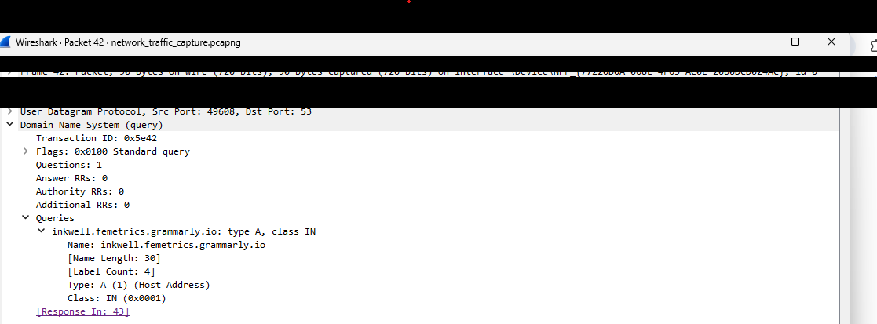

DNS Findings:
- Domain name: inkwell.femetrics.grammarly.io
- Record type: A
- DNS answer: Not visible in the submitted screenshot. The displayed query packet has Answer RRs: 0; Wireshark links it to response frame 43, which must be checked before recording an answer.
- Observation: The screenshot shows an A-record DNS query for inkwell.femetrics.grammarly.io. The query packet itself contains no answer records.
Screenshot: dns_analysis.png

6. TCP Traffic Analysis
TCP (Transmission Control Protocol) provides reliable communication between devices. It establishes connections and ensures that data is delivered correctly.
The Wireshark display filter tcp was used to identify TCP packets.
The TCP packet details were examined, including source ports, destination ports, sequence numbers, acknowledgement numbers and TCP flags.
Important TCP flags include:
- SYN: Starts a connection.
- ACK: Acknowledges received data.
- FIN: Closes a connection normally.
- RST: Resets a connection.
Figure 2: TCP Traffic Analysis
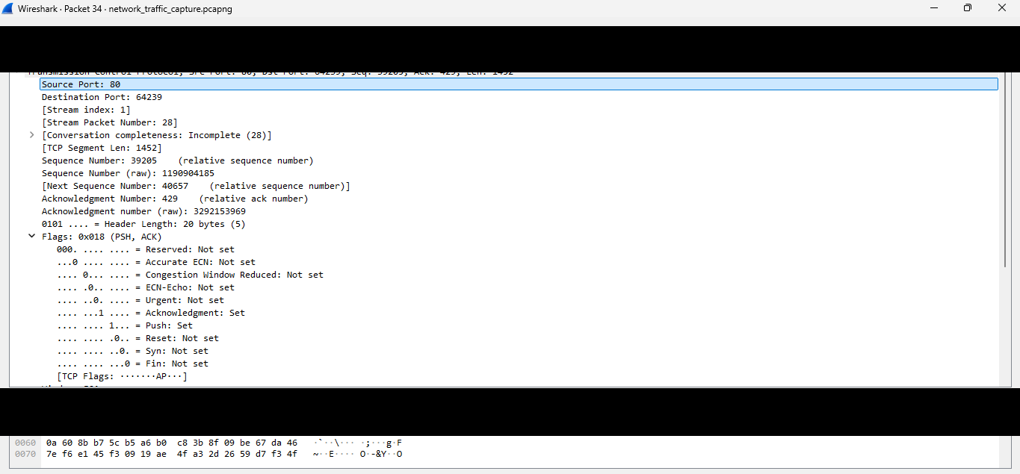

TCP Findings:
- Source port: 80
- Destination port: 64239
- TCP flags: 0x018 (PSH and ACK set)
- Sequence number: 39205
- Observation: The selected TCP segment has the PSH and ACK flags set. This indicates acknowledged data is being pushed to the receiving application; it is not a connection-start packet.
Screenshot: tcp_analysis.png

7. UDP Traffic Analysis
UDP (User Datagram Protocol) is a connectionless transport protocol. Unlike TCP, it does not establish a connection before sending data.
The Wireshark display filter udp was used to identify UDP packets.
The analysis focused on source ports, destination ports, packet length and checksum information.
DNS commonly uses UDP port 53 for queries.
Figure 3: UDP Traffic Analysis
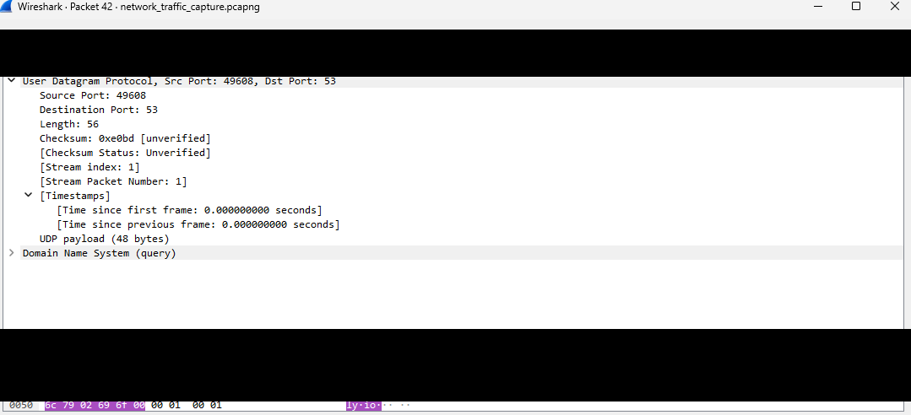

UDP Findings:
- Source port: 49608
- Destination port: 53
- UDP length: 56
- Checksum: 0xe0bd (Wireshark marks it unverified)
- Observation: UDP allows data to be transmitted without establishing a connection first.
Screenshot: udp_analysis.png

8. ICMP Traffic Analysis
ICMP (Internet Control Message Protocol) is used for network diagnostics and reporting communication errors.
The Windows Command Prompt was used to generate ICMP traffic with the command:
ping -n 5 8.8.8.8
The ping test completed with 0% packet loss, indicating that all five ping requests received replies.
The Wireshark display filter icmp was used to examine the captured packets.
ICMP message types include:
- Type 8: Echo Request.
- Type 0: Echo Reply.
Figure 4: ICMP Traffic Analysis
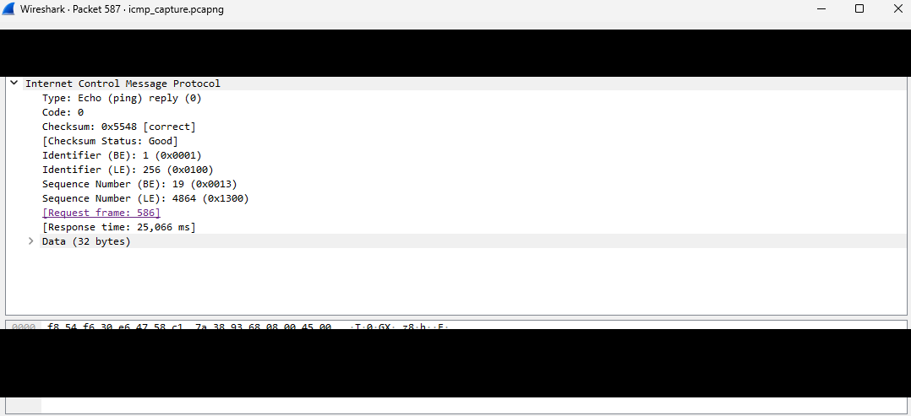

ICMP Findings:
- Ping destination: 8.8.8.8
- Ping test result: 0% packet loss (all five ping attempts received replies)
- Captured packet: Echo Reply (Type 0, Code 0)
- Sequence number: 19; response time: 25.066 ms
- Observation: The selected packet is an ICMP Echo Reply. Wireshark links it to request frame 586.
Figure 5: ICMP Protocol Hierarchy
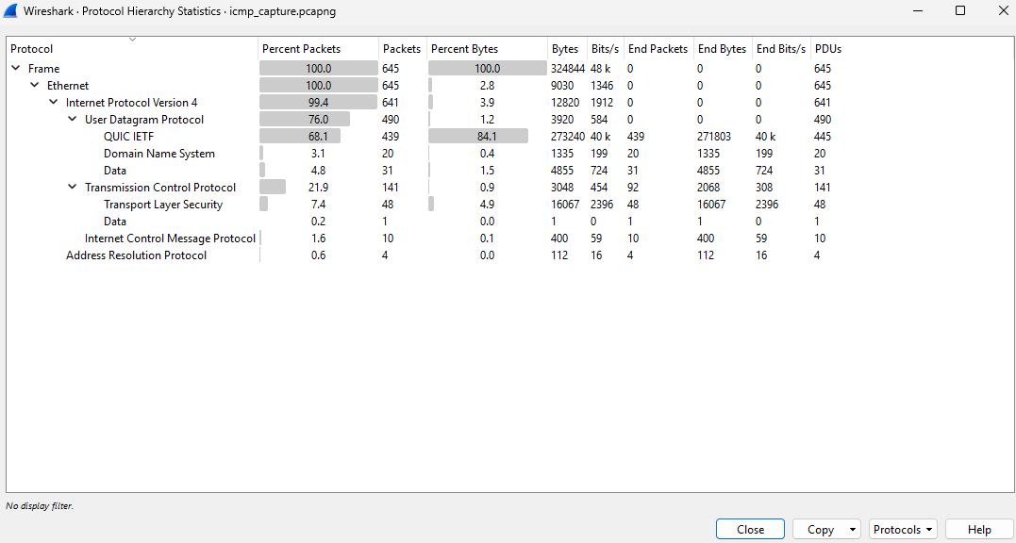
The separate ICMP capture contained 645 total packets and 324,844 bytes. ICMP accounted for 10 packets (1.6% of packets) and 400 bytes. Screenshots: icmp_analysis.png and icmp_protocol_hierarchy.png.

9. IP Traffic Analysis
IP (Internet Protocol) is responsible for addressing and routing packets between devices.
The Wireshark display filter ip was used to examine IPv4 traffic.
The following packet information was inspected:
- Source address.
- Destination address.
- Protocol.
- Packet length.
- Packet information.
Figure 6: IP Traffic Analysis
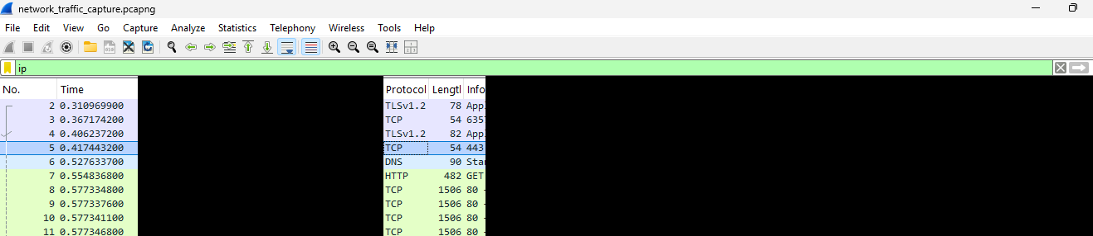

IP Findings:
- Protocols observed in the packet list: TLSv1.2, TCP, DNS and HTTP
- Example packet length: 78 bytes (Frame 2)
- Observation: IP addresses identify the source and destination of network packets.
Screenshot: ip_traffic.png

10. Protocol Hierarchy Analysis
The Protocol Hierarchy feature in Wireshark was accessed through Statistics → Protocol Hierarchy.
This feature provides an overview of the protocols found in the captured network traffic.
The analysis examined the protocol names, number of packets, percentage of packets and bytes transferred.
Figure 7: Protocol Hierarchy Analysis
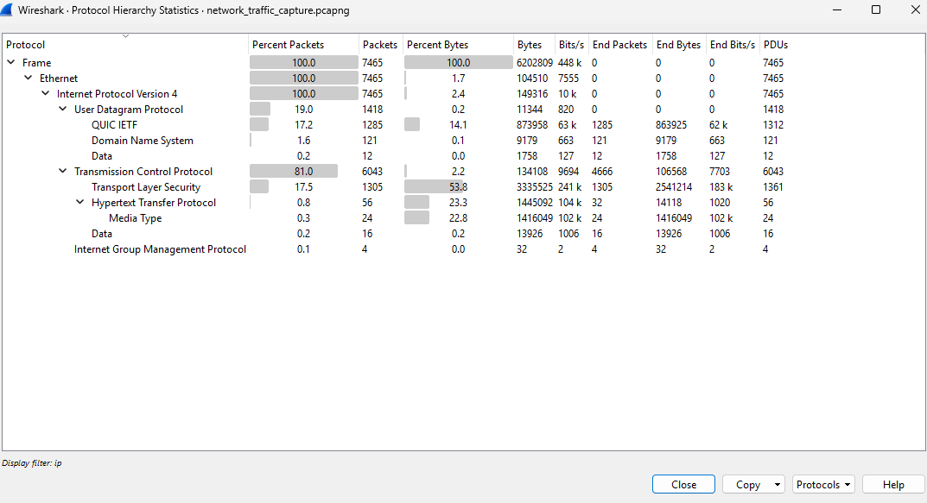

Protocol Hierarchy Findings:

Protocols observed:
The main capture's Frame row reported 7,465 packets and 6,202,809 bytes. The protocol breakdown below is taken from the submitted Protocol Hierarchy screenshot.
Protocol | Packets | Bytes | % Bytes
Frame (total) | 7,465 | 6,202,809 | 100.0%
Ethernet | 7,465 | 104,510 | 1.7%
IPv4 | 7,465 | 149,316 | 2.4%
UDP | 1,418 | 11,344 | 0.2%
QUIC IETF | 1,285 | 873,958 | 14.1%
DNS | 121 | 9,179 | 0.1%
Data (under UDP) | 12 | 1,758 | 0.0%
TCP | 6,043 | 134,108 | 2.2%
TLS | 1,305 | 3,335,525 | 53.8%
HTTP | 56 | 1,445,092 | 23.3%
Media Type | 24 | 1,416,049 | 22.8%
Data (under TCP) | 16 | 13,926 | 0.2%
IGMP | 4 | 32 | 0.0%
Note: Protocol hierarchy rows are nested; child protocol totals overlap with parent totals and should not be added together.

Observation: The Protocol Hierarchy feature provided an overview of the protocols identified in the captured network traffic.
Screenshots: protocol_hierarchy.png and icmp_protocol_hierarchy.png

11. Security and Privacy Considerations
During this project, the following security and privacy practices were followed:
- Network traffic was captured from my own computer and network connection.
- Sensitive information has been redacted in the screenshots included in this edited report. The original unredacted screenshots and raw capture files should not be published.
- Private and public IP addresses, MAC addresses and interface identifiers were exposed in the original screenshots and have been covered in the report copy. Review any separate image files before uploading them.
- Private communications and account information were not intentionally collected.
- Capture files were treated as potentially sensitive because they may contain network information.
These practices help protect personal information when performing network traffic analysis.

12. Conclusion
This project provided practical experience in capturing and analysing network traffic using Wireshark. The analysis covered DNS, TCP, UDP, ICMP and IPv4 traffic and used display filters and the Protocol Hierarchy feature.
The submitted DNS screenshot records an A-record query for inkwell.femetrics.grammarly.io; the answer value is not visible in that screenshot. The selected TCP segment used source port 80 and destination port 64239, with PSH and ACK flags set. The UDP example used destination port 53. The ICMP ping test completed with 0% packet loss, and the selected reply had Type 0, Code 0.
The main capture contained 7,465 packets and 6,202,809 bytes. Its hierarchy showed TCP, TLS, UDP, QUIC, DNS, HTTP and IGMP traffic.
Overall, this project improved my understanding of network protocols, packet analysis and basic network troubleshooting. The findings represent the traffic captured during this exercise and may differ in another capture or network environment.

