Electronic Circuits Lab

Simulation Results and Calculations

Group P11

Govind Sajeev – B200938EC

Calculation:

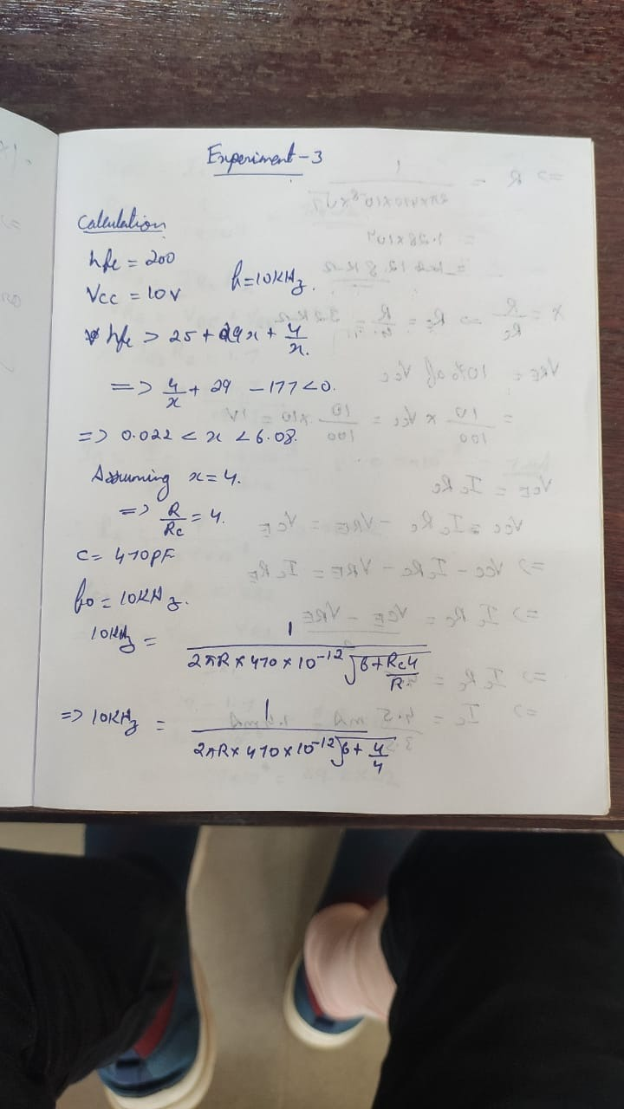

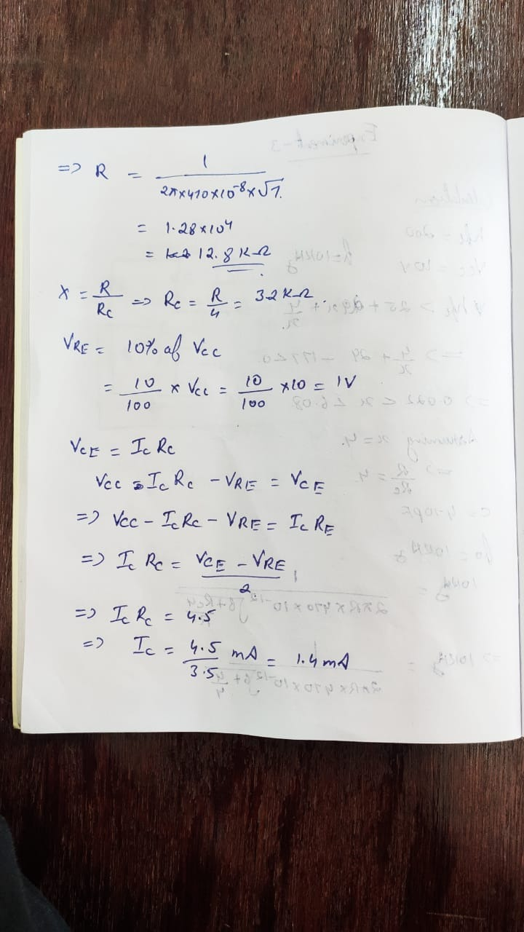

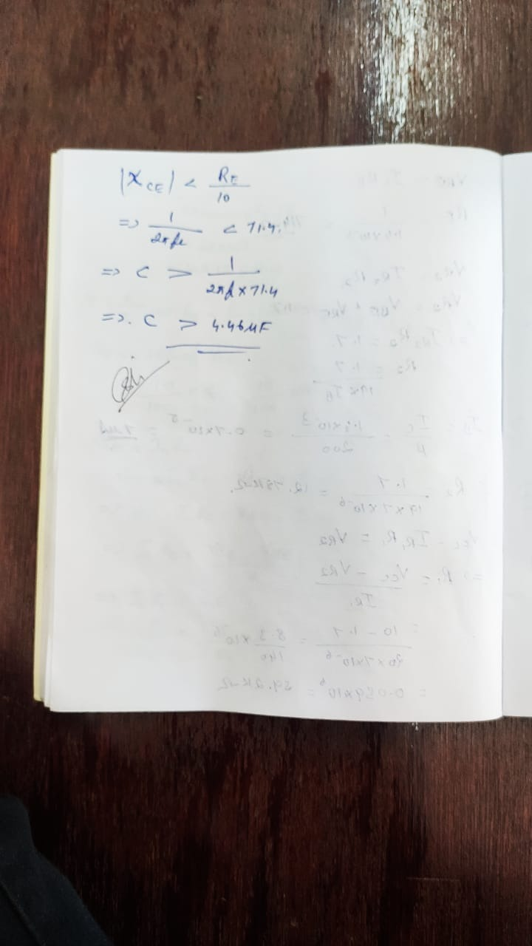

Circuit Diagram

**RC Cascade:**

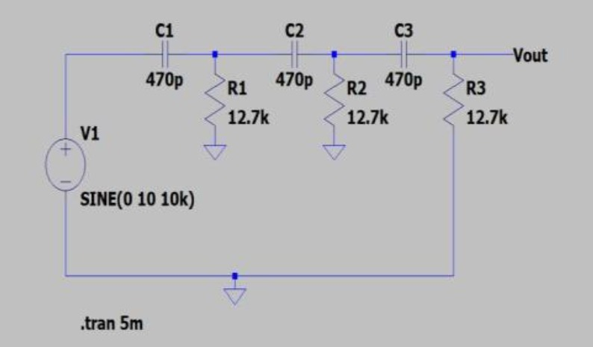

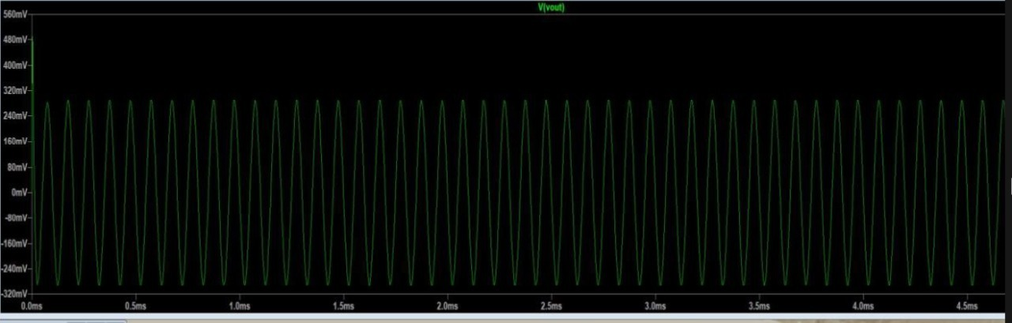

**CE Configuration:**

**CE Configuration with input:**

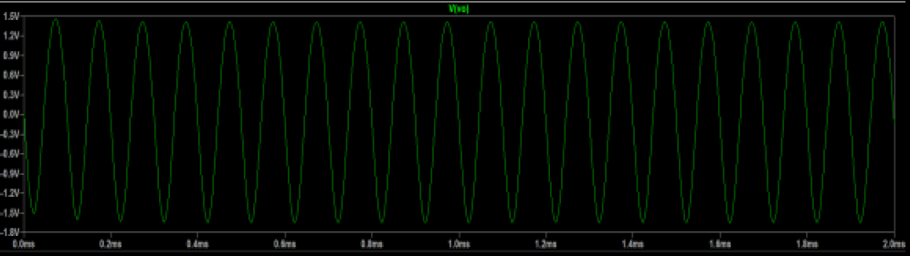

**Frequency Response:**

**Phase Shift Oscillators:**

