Gergely Daróczi
Unified plots
This document demonstrates the features of unifying plots in pander. First, if you do not want to deal with styling each of your images, just activate it: evalsOptions('graph.unify', TRUE).
Note: please install lattice and ggplot2 on your computer prior to trying to run all examples of this document.

Options
There are a bunch of options you might want to check out, these are:
- graph.nomargin
- graph.fontfamily
- graph.fontcolor
- graph.fontsize
- graph.grid
- graph.grid.minor
- graph.grid.color
- graph.grid.lty
- graph.boxes
- graph.legend.position
- graph.background
- graph.panel.background
- graph.colors
- graph.color.rnd
- graph.axis.angle
- graph.symbol
Find more details on pander's homepage.

Default options
Not touching the above ones, let us check out how different plots look like by calling base R graphing function, lattice or ggplot2!

Histogram

Base R plot
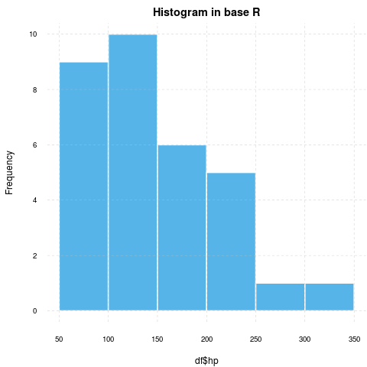 WARNING

lattice
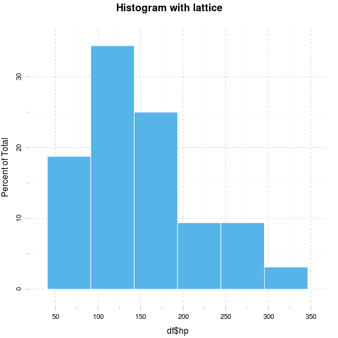

ggplot2
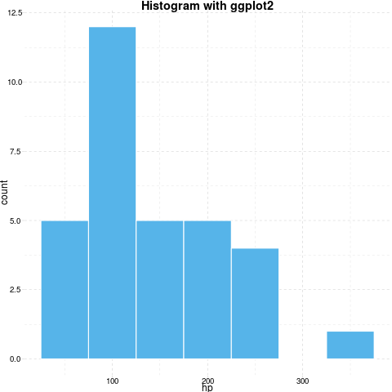

Barplot

Base R plot
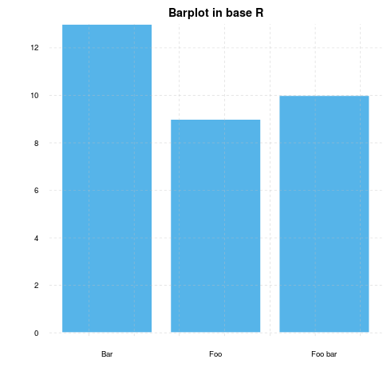 WARNING

lattice
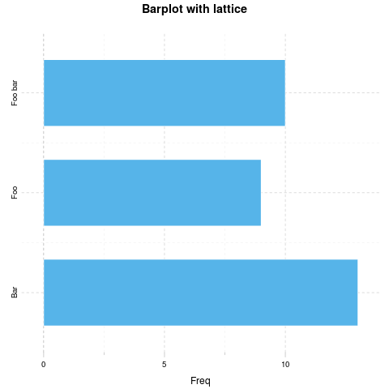

ggplot2
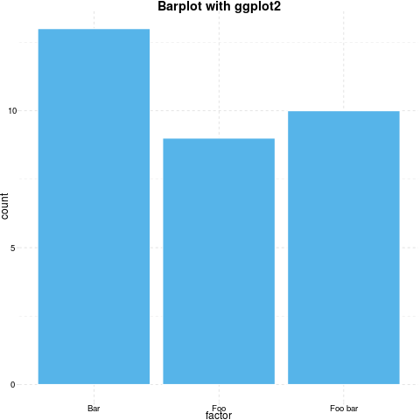

Points

Base R plot
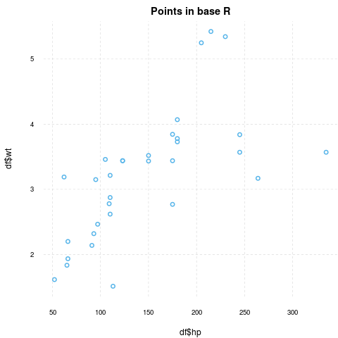 WARNING

lattice
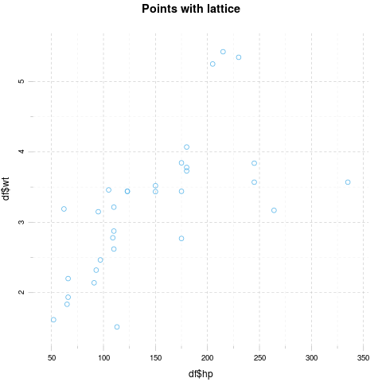

ggplot2
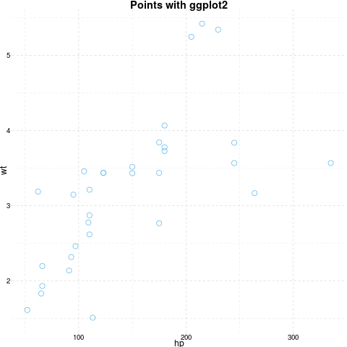

Grouped plot

Base R plot
I have no idea how to do that besides manually adding points.

lattice
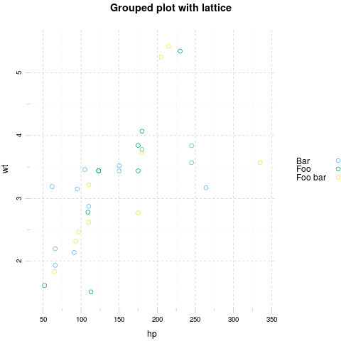

ggplot2
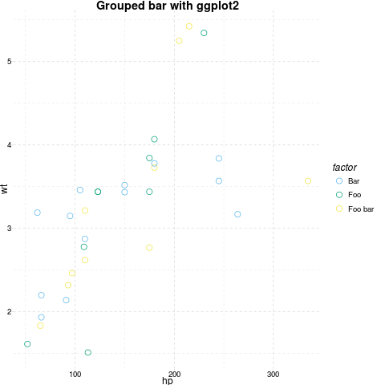

Facets

Base R plot
I have no idea how to do that besides par(mfrow=c(foo, bar)).

lattice
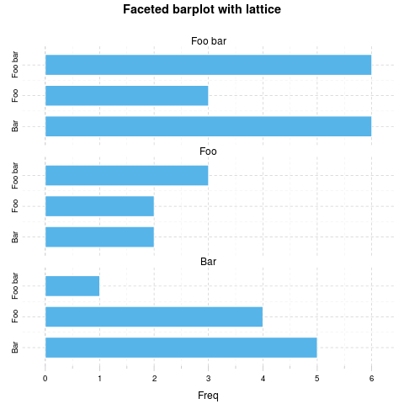

ggplot2
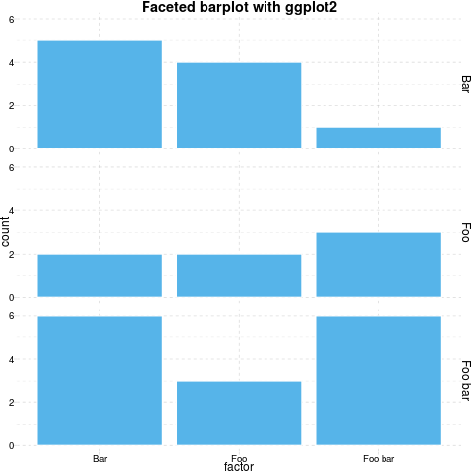

Boxplot

Base R plot
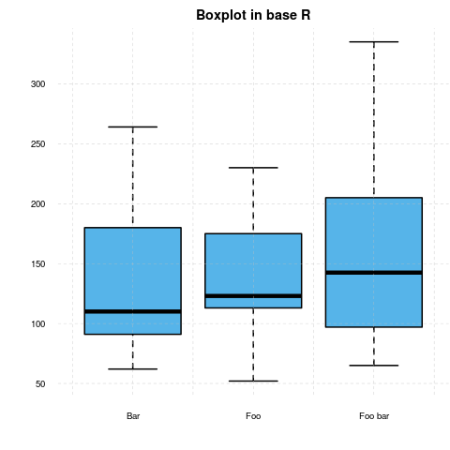 WARNING

lattice
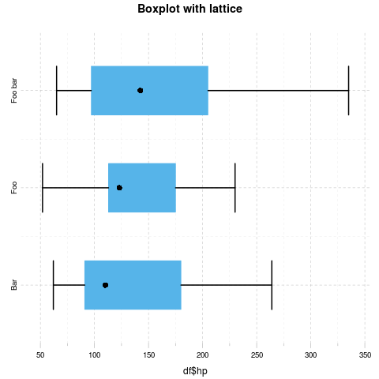

ggplot2
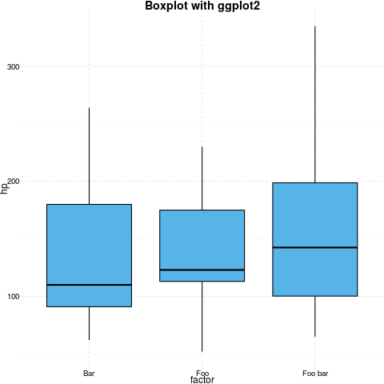

Lines

Base R plot
ERROR

lattice
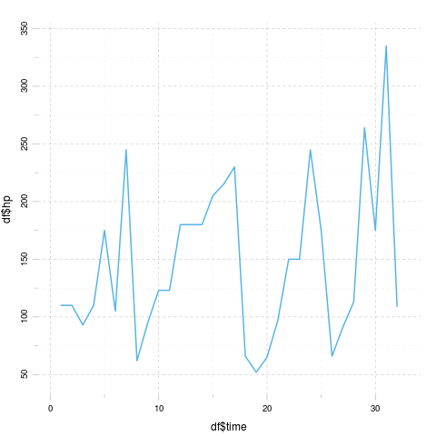

ggplot2
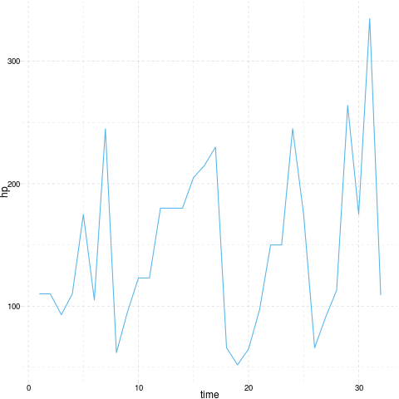

Custom options
Below you can find some images generated by the exact same commands but with some modified panderOptions:
panderOptions('graph.fontfamily', "Comic Sans MS")
panderOptions('graph.fontsize', 18)
panderOptions('graph.fontcolor', 'blue')
panderOptions('graph.grid.color', 'blue')
panderOptions('graph.axis.angle', 3)
panderOptions('graph.boxes', T)
panderOptions('graph.legend.position', 'top')
panderOptions('graph.colors', rainbow(5))
panderOptions('graph.grid', FALSE)
panderOptions('graph.symbol', 22)

Histogram

Base R plot
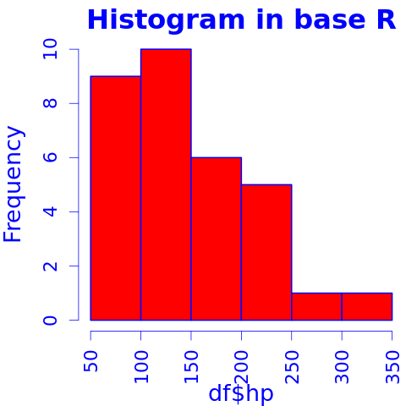

lattice
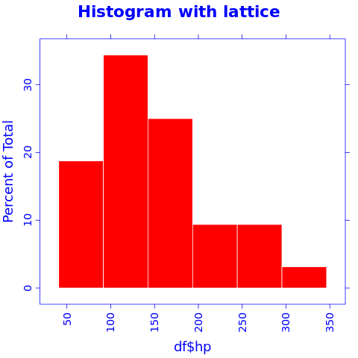

ggplot2
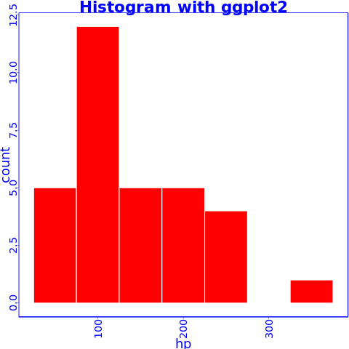

Barplot

Base R plot
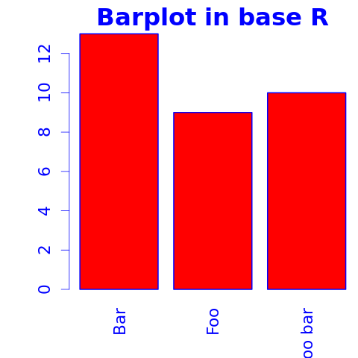
Yeah, the "Foo bar" label is cropped. We need a custom mar option here:
But wait, we lost the color! Right: unfortunately coloring base R plots is really hackish, pander is adding the col attribute to the calls. If you start to tweak par in a chunk, you should prepare to some unwanted side-effects. Solution:

lattice
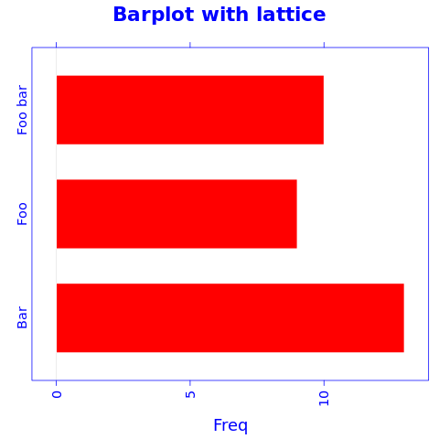

ggplot2
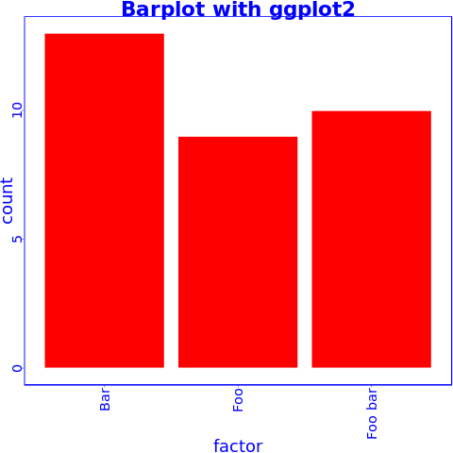

Points

Base R plot
ERROR

lattice
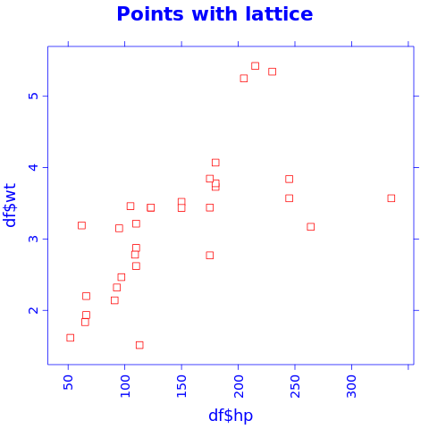

ggplot2
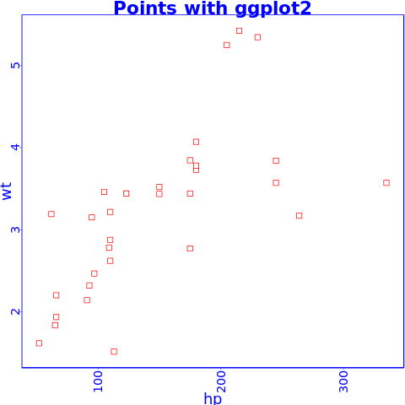

Grouped plot

Base R plot
I have no idea how to do that besides manually adding points.

lattice
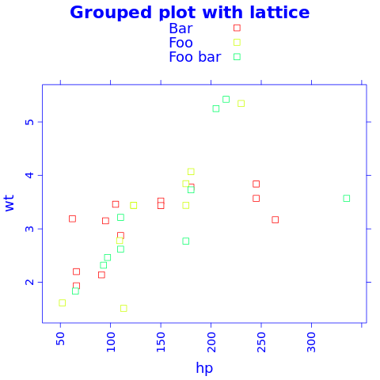

ggplot2
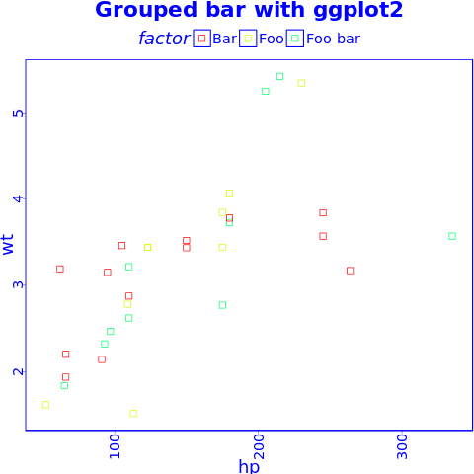

Facets

Base R plot
I have no idea how to do that besides par(mfrow=c(foo, bar)).

lattice
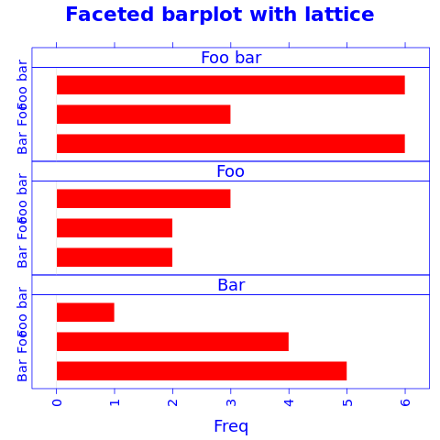

ggplot2
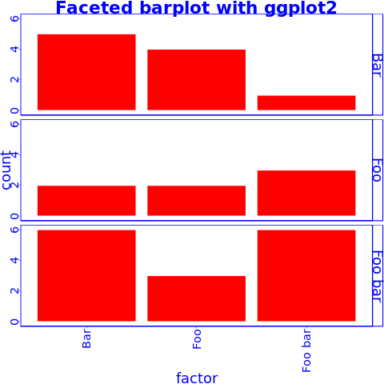

Boxplot

Base R plot
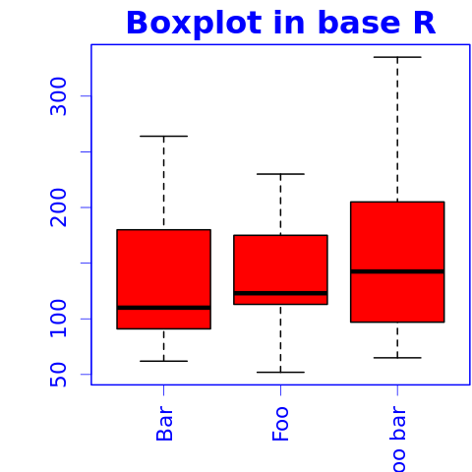

lattice
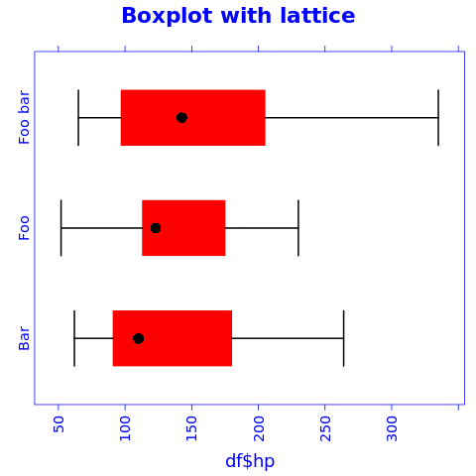

ggplot2
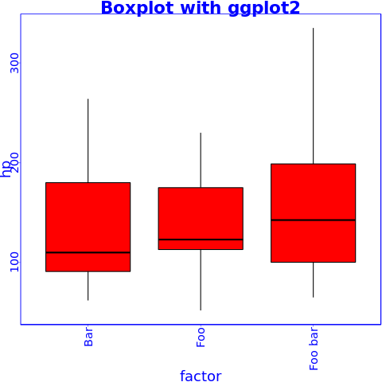

Lines

Base R plot
ERROR

lattice
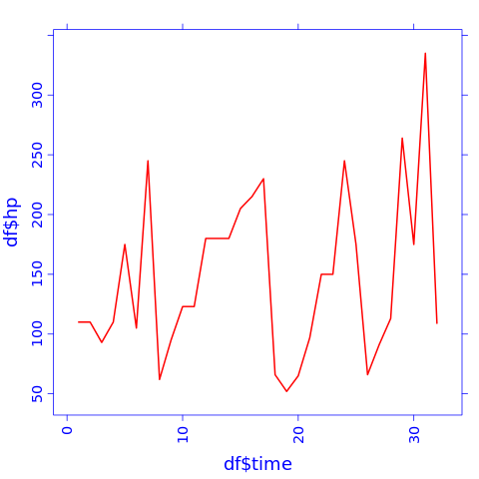

ggplot2
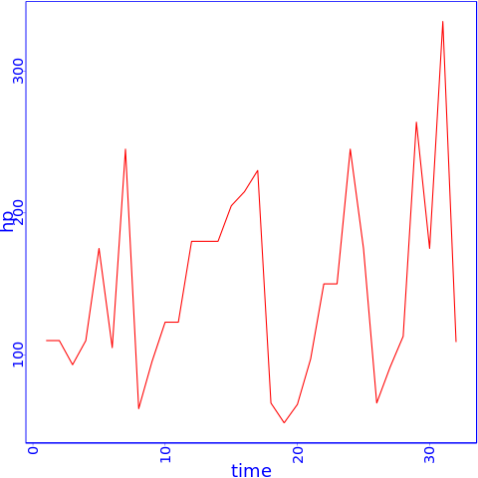

Applying default formatting to image is somehow compromised (the result could differ from what you specified in panderOptions). Hints: printing lattice/ggplot2 is not needed and tweaking base plots with par might have some side-effects!
Applying default formatting to image is somehow compromised (the result could differ from what you specified in panderOptions). Hints: printing lattice/ggplot2 is not needed and tweaking base plots with par might have some side-effects!
Applying default formatting to image is somehow compromised (the result could differ from what you specified in panderOptions). Hints: printing lattice/ggplot2 is not needed and tweaking base plots with par might have some side-effects!
Applying default formatting to image is somehow compromised (the result could differ from what you specified in panderOptions). Hints: printing lattice/ggplot2 is not needed and tweaking base plots with par might have some side-effects!
:1:1: unexpected '/' 1: / ^
:1:1: unexpected '/' 1: / ^
:1:1: unexpected '/' 1: / ^

