Gergely Daróczi
Minimal example for Pandoc.brew

Introduction
We have two meta-information above:
- author
- title
A third field could be there too: date. For details, please check out Pandoc's homepage or just use pandoc.title function of this package.
As you can see writing and formatting paragraphs cannot be easier :)
But what about R? Let us return pi: 3.14159265358979

R objects
Pander.brew would transform any returned R object to Pandoc's markdown in each code block.
For example mtcars's first 5 cases look like:
 | mpg | cyl | disp | hp | drat | wt
Mazda RX4 | 21 | 6 | 160 | 110 | 3.9 | 2.6
Mazda RX4 Wag | 21 | 6 | 160 | 110 | 3.9 | 2.9
Datsun 710 | 23 | 4 | 108 | 93 | 3.9 | 2.3
Hornet 4 Drive | 21 | 6 | 258 | 110 | 3.1 | 3.2
Hornet Sportabout | 19 | 8 | 360 | 175 | 3.1 | 3.4
 | qsec | vs | am | gear | carb
Mazda RX4 | 16 | 0 | 1 | 4 | 4
Mazda RX4 Wag | 17 | 0 | 1 | 4 | 4
Datsun 710 | 19 | 1 | 1 | 4 | 1
Hornet 4 Drive | 19 | 1 | 0 | 3 | 1
Hornet Sportabout | 17 | 0 | 0 | 3 | 2
As you can see some formatting was added to the returned table and was also split up as the original table would have been too wide.
We could try other R objects too, for example prcomp on iris:
 | PC1 | PC2 | PC3 | PC4
Sepal.Length | 0.361 | -0.657 | 0.582 | 0.315
Sepal.Width | -0.085 | -0.730 | -0.598 | -0.320
Petal.Length | 0.857 | 0.173 | -0.076 | -0.480
Petal.Width | 0.358 | 0.075 | -0.546 | 0.754
Principal Components Analysis
 | PC1 | PC2 | PC3 | PC4
Standard deviation | 2.0563 | 0.4926 | 0.2797 | 0.1544
Proportion of Variance | 0.9246 | 0.0531 | 0.0171 | 0.0052
Cumulative Proportion | 0.9246 | 0.9777 | 0.9948 | 1.0000

Returning plot
Plots are automatically grabbed between brew tags:
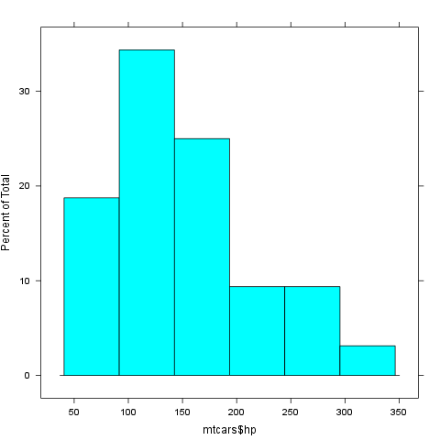

This report was generated with R (2.15.0) and pander (0.1) in 0.548 sec on x86_64-unknown-linux-gnu platform.

