Rapport package team
Descriptive statistics
2011-04-26 20:25 CET

Description
This template will return descriptive statistics of a numerical or frequency table of a categorical variable.
gender ("Gender")
The dataset has 709 observations with 673 valid values (missing: 36).
gender | N | % | Cumul. N | Cumul. %
male | 410 | 60.92 | 410 | 60.92
female | 263 | 39.08 | 673 | 100.00
Total | 673 | 100.00 | 673 | 100.00
Frequency table: Gender
The most frequent value is male.
Charts
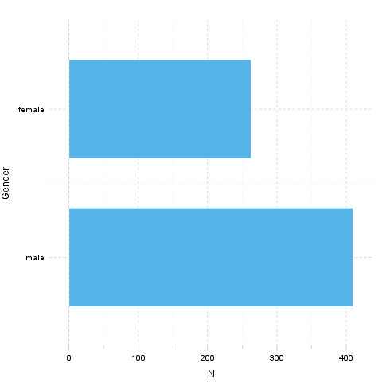
It seems that the highest value is 2 which is exactly 2 times higher than the smallest value (1).
Description
This template will return descriptive statistics of a numerical or frequency table of a categorical variable.
age ("Age")
The dataset has 709 observations with 677 valid values (missing: 32).
Base statistics
Variable | mean | sd | var
Age | 24.57 | 6.849 | 46.91
Descriptives: Age
The standard deviation is 6.849 (variance: 46.91). The expected value is around 24.57, somewhere between 24.06 and 25.09 with the standard error of 0.2632.
Charts
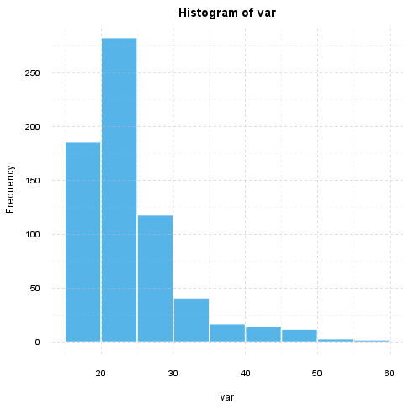
It seems that the highest value is 58 which is exactly 3.625 times higher than the smallest value (16).
If we suppose that Age is not near to a normal distribution (skewness: 1.925, kurtosis: 4.463), checking the median (23) might be a better option instead of the mean. The interquartile range (6) measures the statistics dispersion of the variable (similar to standard deviation) based on median.
Description
This template will return descriptive statistics of a numerical or frequency table of a categorical variable.
hp
The dataset has 32 observations with 32 valid values (missing: 0).
Base statistics
Variable | mean | sd | var
hp | 146.7 | 68.56 | 4701
Descriptives: hp
The standard deviation is 68.56 (variance: 4701). The expected value is around 146.7, somewhere between 122.9 and 170.4 with the standard error of 12.12.
Charts
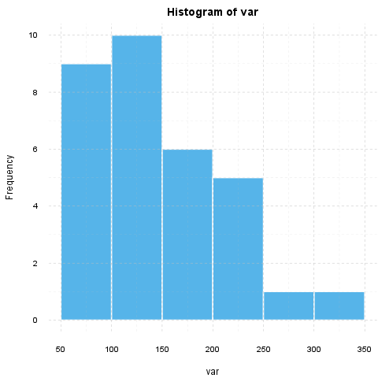
It seems that the highest value is 335 which is exactly 6.442 times higher than the smallest value (52).
If we suppose that hp is not near to a normal distribution (skewness: 0.726, kurtosis: -0.1356), checking the median (123) might be a better option instead of the mean. The interquartile range (83.5) measures the statistics dispersion of the variable (similar to standard deviation) based on median.
—————
This report was generated with R (2.15.1) and rapport (0.4) in 1.258 sec on x86_64-unknown-linux-gnu platform.


