Example template
Rapport package team @ https://github.com/aL3xa/rapport
2011-04-26 20:25 CET

Description
This template demonstrates the basic features of rapport. We all hope you will like it!
Début
Hello, world!
I have just specified a Variable in this template named to leisure. The label of this variable is "Internet usage in leisure time (hours per day)".
And wow, the mean of leisure is 3.1994!
Descriptive statistics
 | Min. | 1st Qu. | Median | Mean | 3rd Qu. | Max. | NA's
1 | 0.0 | 2.0 | 3.0 | 3.2 | 4.0 | 12.0 | 37.0

The 5 highest values are: 12, 12, 10, 10 and 10.
Description
This template demonstrates the basic features of rapport. We all hope you will like it!
Début
Hello, world!
I have just specified a Variable in this template named to leisure. The label of this variable is "Internet usage in leisure time (hours per day)".
And wow, the mean of leisure is 3.1994!
For more detailed statistics, you should have set desc=TRUE!
Description
This template demonstrates the basic features of rapport. We all hope you will like it!
Début
Hello, world!
I have just specified a Variable in this template named to leisure. The label of this variable is "Internet usage in leisure time (hours per day)".
And wow, the mean of leisure is 3.1994!
For more detailed statistics, you should have set desc=TRUE!
Histogram
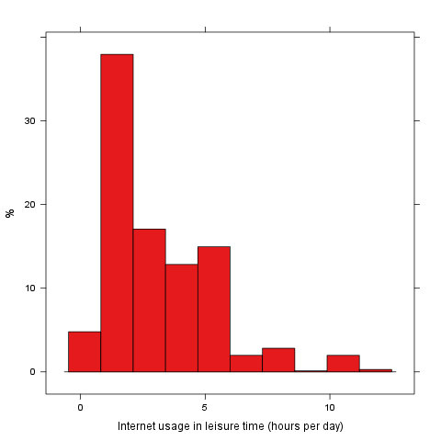
Description
This template demonstrates the basic features of rapport. We all hope you will like it!
Début
Hello, world!
I have just specified a Variable in this template named to leisure. The label of this variable is "Internet usage in leisure time (hours per day)".
And wow, the mean of leisure is 3.1994!
For more detailed statistics, you should have set desc=TRUE!
Histogram
