Descriptive statistics
Rapport package team @ https://github.com/aL3xa/rapport
2011-04-26 20:25 CET

Description
This template will return descriptive statistics of numerical or frequency tables of categorical variables.
gender ("Gender")
The dataset has 709 observations with 673 valid values (missing: 36) in gender ("Gender"), which seems to be a qualitative variable.
Base statistics
gender | N | % | Cumul. N | Cumul. %
male | 410 | 60.9212 | 410 | 60.9212
female | 263 | 39.0788 | 673 | 100
Total | 673 | 100 | 673 | 100

Barplot
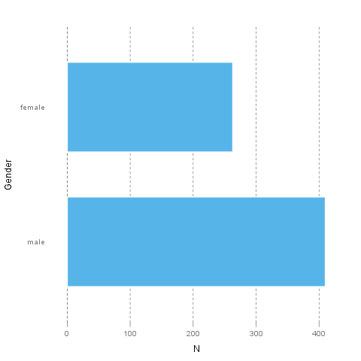
It seems that the highest value is 2 which is exactly 2 times higher than the smallest value (1).
The most frequent value is male.
age ("Age")
The dataset has 709 observations with 677 valid values (missing: 32) in age ("Age"), which seems to be a quantitative variable.
Base statistics
Variable | mean | sd | var
Age | 24.5731 | 6.8491 | 46.9107

Histogram
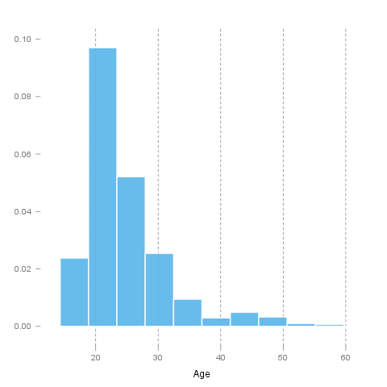
It seems that the highest value is 58 which is exactly 3.625 times higher than the smallest value (16).
The standard deviation is 6.8491 (variance: 46.9107). The expected value is around 24.5731, somewhere between 24.0572 and 25.0891 with the standard error of 0.2632.
If we suppose that Age is not near to a normal distribution (test: see below, skewness: 1.9254, kurtosis: 4.463), checking the median (23) might be a better option instead of the mean. The interquartile range (6) measures the statistics dispersion of the variable (similar to standard deviation) based on median.
Normality tests
Introduction
In statistics, normality refers to an assumption that the distribution of a random variable follows normal (Gaussian) distribution. Because of its bell-like shape, it's also known as the "bell curve". The formula for normal distribution is:
$f(x) = \frac{1}{\sqrt{2\pi{}\sigma{}^2}} e^{-\frac{(x-\mu{})^2}{2\sigma{}^2}}$
Normal distribution belongs to a location-scale family of distributions, as it's defined two parameters:
• μ - mean or expectation (location parameter)
• σ² - variance (scale parameter)
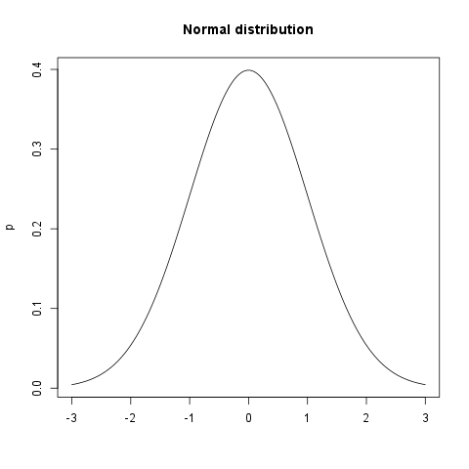
Normality Tests
Overview
Various hypothesis tests can be applied in order to test if the distribution of given random variable violates normality assumption. These procedures test the H₀ that provided variable's distribution is normal. At this point only few such tests will be covered: the ones that are available in stats package (which comes bundled with default R installation) and nortest package that is available on CRAN.
• Shapiro-Wilk test is a powerful normality test appropriate for small samples. In R, it's implemented in shapiro.test function available in stats package.
• Lilliefors test is a modification of Kolmogorov-Smirnov test appropriate for testing normality when parameters or normal distribution (μ, σ²) are not known. lillie.test function is located in nortest package.
• Anderson-Darling test is one of the most powerful normality tests as it will detect the most of departures from normality. You can find ad.test function in nortest package.
• Pearson Χ² test is another normality test which takes more "traditional" approach in normality testing. pearson.test is located in nortest package.
Results
Here you can see the results of applied normality tests (p-values less than 0.05 indicate significant discrepancies):
 | Statistic | p-value
Shapiro-Wilk normality test | 0.8216 | 0
Lilliefors (Kolmogorov-Smirnov) normality test | 0.17 | 0
Anderson-Darling normality test | 32.1645 | 0
Pearson chi-square normality test | 625.8479 | 0

So, let's draw some conclusions based on applied normality test:
• according to Shapiro-Wilk test, the distribution of Age is not normal.
• based on Lilliefors test, distribution of Age is not normal
• Anderson-Darling test confirms violation of normality assumption
• Pearson's Χ² test classifies the underlying distribution as non-normal
Diagnostic Plots
There are various plots that can help you decide about the normality of the distribution. Only a few most commonly used plots will be shown: histogram, Q-Q plot and kernel density plot.
Histogram
Histogram was first introduced by Karl Pearson and it's probably the most popular plot for depicting the probability distribution of a random variable. However, the decision depends on number of bins, so it can sometimes be misleading. If the variable distribution is normal, bins should resemble the "bell-like" shape.
Q-Q Plot
"Q" in Q-Q plot stands for quantile, as this plot compares empirical and theoretical distribution (in this case, normal distribution) by plotting their quantiles against each other. For normal distribution, plotted dots should approximate a "straight", x = y line.
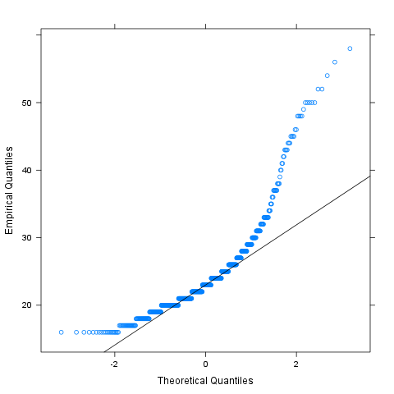
Kernel Density Plot
Kernel density plot is a plot of smoothed empirical distribution function. As such, it provides good insight about the shape of the distribution. For normal distributions, it should resemble the well known "bell shape".
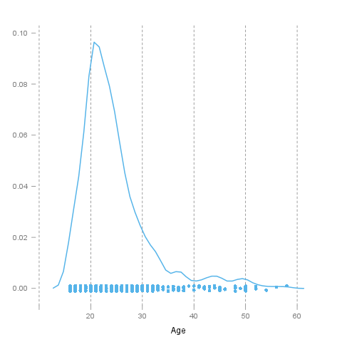
Description
This template will return descriptive statistics of numerical or frequency tables of categorical variables.
chatim ("Chat & IM usage")
The dataset has 709 observations with 669 valid values (missing: 40) in chatim ("Chat & IM usage"), which seems to be a qualitative variable.
Base statistics
chatim | N | % | Cumul. N | Cumul. %
never | 60 | 8.9686 | 60 | 8.9686
very rarely | 73 | 10.9118 | 133 | 19.8804
rarely | 58 | 8.6697 | 191 | 28.5501
sometimes | 113 | 16.8909 | 304 | 45.441
often | 136 | 20.3288 | 440 | 65.7698
very often | 88 | 13.154 | 528 | 78.9238
always | 141 | 21.0762 | 669 | 100
Total | 669 | 100 | 669 | 100

Barplot
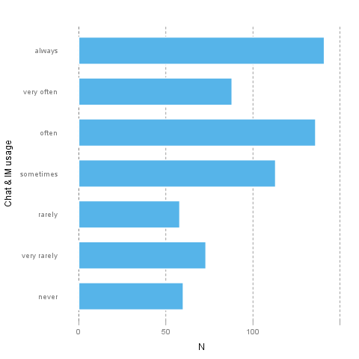
It seems that the highest value is 7 which is exactly 7 times higher than the smallest value (1).
The most frequent value is always.
game ("On-line games usage")
The dataset has 709 observations with 677 valid values (missing: 32) in game ("On-line games usage"), which seems to be a qualitative variable.
Base statistics
game | N | % | Cumul. N | Cumul. %
never | 352 | 51.9941 | 352 | 51.9941
very rarely | 128 | 18.9069 | 480 | 70.901
rarely | 32 | 4.7267 | 512 | 75.6278
sometimes | 60 | 8.8626 | 572 | 84.4904
often | 37 | 5.4653 | 609 | 89.9557
very often | 35 | 5.1699 | 644 | 95.1256
always | 33 | 4.8744 | 677 | 100
Total | 677 | 100 | 677 | 100

Barplot
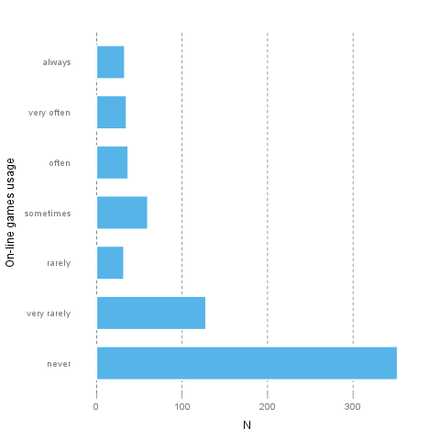
It seems that the highest value is 7 which is exactly 7 times higher than the smallest value (1).
The most frequent value is never.
surf ("Web surfing usage")
The dataset has 709 observations with 678 valid values (missing: 31) in surf ("Web surfing usage"), which seems to be a qualitative variable.
Base statistics
surf | N | % | Cumul. N | Cumul. %
never | 17 | 2.5074 | 17 | 2.5074
very rarely | 26 | 3.8348 | 43 | 6.3422
rarely | 33 | 4.8673 | 76 | 11.2094
sometimes | 107 | 15.7817 | 183 | 26.9912
often | 158 | 23.3038 | 341 | 50.295
very often | 142 | 20.944 | 483 | 71.2389
always | 195 | 28.7611 | 678 | 100
Total | 678 | 100 | 678 | 100

Barplot
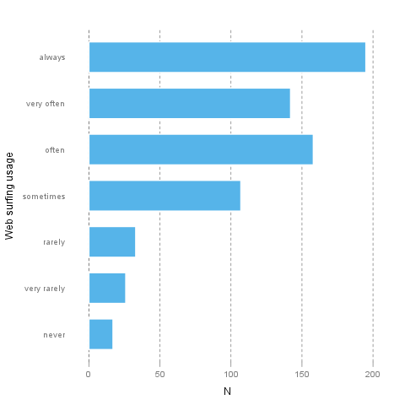
It seems that the highest value is 7 which is exactly 7 times higher than the smallest value (1).
The most frequent value is always.
email ("Email usage")
The dataset has 709 observations with 672 valid values (missing: 37) in email ("Email usage"), which seems to be a qualitative variable.
Base statistics
email | N | % | Cumul. N | Cumul. %
never | 13 | 1.9345 | 13 | 1.9345
very rarely | 36 | 5.3571 | 49 | 7.2917
rarely | 46 | 6.8452 | 95 | 14.1369
sometimes | 87 | 12.9464 | 182 | 27.0833
often | 123 | 18.3036 | 305 | 45.3869
very often | 108 | 16.0714 | 413 | 61.4583
always | 259 | 38.5417 | 672 | 100
Total | 672 | 100 | 672 | 100

Barplot
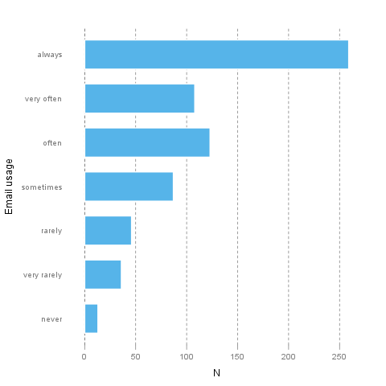
It seems that the highest value is 7 which is exactly 7 times higher than the smallest value (1).
The most frequent value is always.
download ("Download usage")
The dataset has 709 observations with 677 valid values (missing: 32) in download ("Download usage"), which seems to be a qualitative variable.
Base statistics
download | N | % | Cumul. N | Cumul. %
never | 11 | 1.6248 | 11 | 1.6248
very rarely | 28 | 4.1359 | 39 | 5.7607
rarely | 29 | 4.2836 | 68 | 10.0443
sometimes | 80 | 11.8168 | 148 | 21.8612
often | 124 | 18.3161 | 272 | 40.1773
very often | 160 | 23.6337 | 432 | 63.8109
always | 245 | 36.1891 | 677 | 100
Total | 677 | 100 | 677 | 100

Barplot
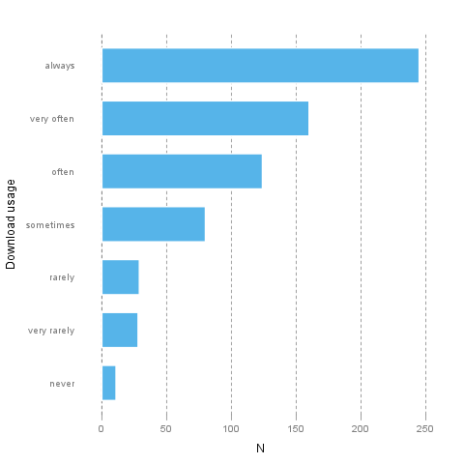
It seems that the highest value is 7 which is exactly 7 times higher than the smallest value (1).
The most frequent value is always.
forum ("Web forums usage")
The dataset has 709 observations with 673 valid values (missing: 36) in forum ("Web forums usage"), which seems to be a qualitative variable.
Base statistics
forum | N | % | Cumul. N | Cumul. %
never | 76 | 11.2927 | 76 | 11.2927
very rarely | 80 | 11.8871 | 156 | 23.1798
rarely | 72 | 10.6984 | 228 | 33.8782
sometimes | 111 | 16.4933 | 339 | 50.3715
often | 109 | 16.1961 | 448 | 66.5676
very often | 119 | 17.682 | 567 | 84.2496
always | 106 | 15.7504 | 673 | 100
Total | 673 | 100 | 673 | 100

Barplot
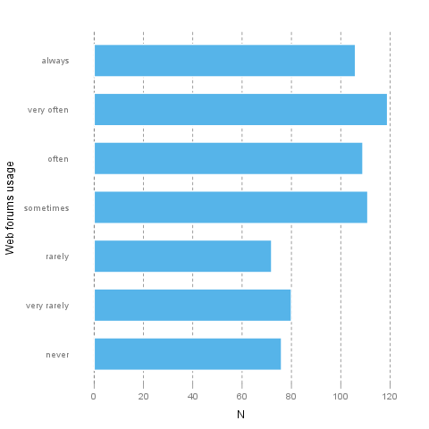
It seems that the highest value is 7 which is exactly 7 times higher than the smallest value (1).
The most frequent value is very often.
socnet ("Social networks usage")
The dataset has 709 observations with 678 valid values (missing: 31) in socnet ("Social networks usage"), which seems to be a qualitative variable.
Base statistics
socnet | N | % | Cumul. N | Cumul. %
never | 208 | 30.6785 | 208 | 30.6785
very rarely | 102 | 15.0442 | 310 | 45.7227
rarely | 57 | 8.4071 | 367 | 54.1298
sometimes | 87 | 12.8319 | 454 | 66.9617
often | 79 | 11.6519 | 533 | 78.6136
very often | 80 | 11.7994 | 613 | 90.413
always | 65 | 9.587 | 678 | 100
Total | 678 | 100 | 678 | 100

Barplot
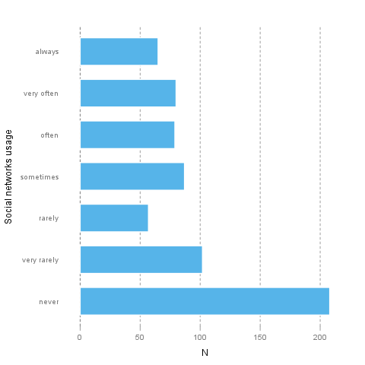
It seems that the highest value is 7 which is exactly 7 times higher than the smallest value (1).
The most frequent value is never.
xxx ("Adult sites usage")
The dataset has 709 observations with 674 valid values (missing: 35) in xxx ("Adult sites usage"), which seems to be a qualitative variable.
Base statistics
xxx | N | % | Cumul. N | Cumul. %
never | 274 | 40.6528 | 274 | 40.6528
very rarely | 124 | 18.3976 | 398 | 59.0504
rarely | 52 | 7.7151 | 450 | 66.7656
sometimes | 131 | 19.4362 | 581 | 86.2018
often | 46 | 6.8249 | 627 | 93.0267
very often | 28 | 4.1543 | 655 | 97.181
always | 19 | 2.819 | 674 | 100
Total | 674 | 100 | 674 | 100

Barplot
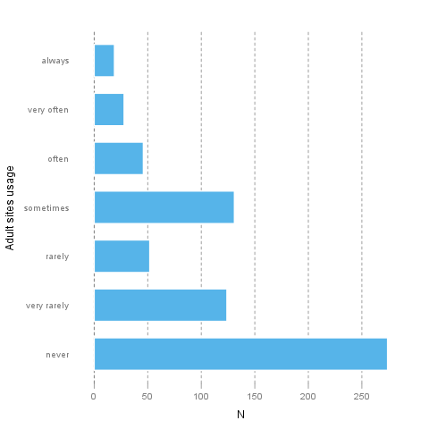
It seems that the highest value is 7 which is exactly 7 times higher than the smallest value (1).
The most frequent value is never.
Description
This template will return descriptive statistics of numerical or frequency tables of categorical variables.
hp
The dataset has 32 observations with 32 valid values (missing: 0) in hp, which seems to be a quantitative variable.
Base statistics
Variable | mean | sd | var
hp | 146.6875 | 68.5629 | 4700.8669

Histogram
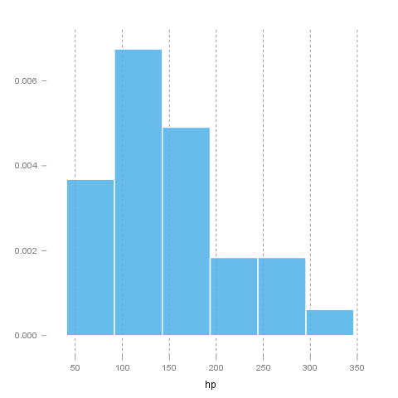
It seems that the highest value is 335 which is exactly 6.4423 times higher than the smallest value (52).
The standard deviation is 68.5629 (variance: 4700.8669). The expected value is around 146.6875, somewhere between 122.9317 and 170.4433 with the standard error of 12.1203.
If we suppose that hp is not near to a normal distribution (test: see below, skewness: 0.726, kurtosis: -0.1356), checking the median (123) might be a better option instead of the mean. The interquartile range (83.5) measures the statistics dispersion of the variable (similar to standard deviation) based on median.
Normality tests
Introduction
In statistics, normality refers to an assumption that the distribution of a random variable follows normal (Gaussian) distribution. Because of its bell-like shape, it's also known as the "bell curve". The formula for normal distribution is:
$f(x) = \frac{1}{\sqrt{2\pi{}\sigma{}^2}} e^{-\frac{(x-\mu{})^2}{2\sigma{}^2}}$
Normal distribution belongs to a location-scale family of distributions, as it's defined two parameters:
• μ - mean or expectation (location parameter)
• σ² - variance (scale parameter)
Normality Tests
Overview
Various hypothesis tests can be applied in order to test if the distribution of given random variable violates normality assumption. These procedures test the H₀ that provided variable's distribution is normal. At this point only few such tests will be covered: the ones that are available in stats package (which comes bundled with default R installation) and nortest package that is available on CRAN.
• Shapiro-Wilk test is a powerful normality test appropriate for small samples. In R, it's implemented in shapiro.test function available in stats package.
• Lilliefors test is a modification of Kolmogorov-Smirnov test appropriate for testing normality when parameters or normal distribution (μ, σ²) are not known. lillie.test function is located in nortest package.
• Anderson-Darling test is one of the most powerful normality tests as it will detect the most of departures from normality. You can find ad.test function in nortest package.
• Pearson Χ² test is another normality test which takes more "traditional" approach in normality testing. pearson.test is located in nortest package.
Results
Here you can see the results of applied normality tests (p-values less than 0.05 indicate significant discrepancies):
 | Statistic | p-value
Shapiro-Wilk normality test | 0.9334 | 0.0488
Lilliefors (Kolmogorov-Smirnov) normality test | 0.1664 | 0.0245
Anderson-Darling normality test | 0.7077 | 0.0584
Pearson chi-square normality test | 11.5 | 0.0423

So, let's draw some conclusions based on applied normality test:
• according to Shapiro-Wilk test, the distribution of hp is not normal.
• based on Lilliefors test, distribution of hp is not normal
• Anderson-Darling test confirms normality assumption
• Pearson's Χ² test classifies the underlying distribution as non-normal
Diagnostic Plots
There are various plots that can help you decide about the normality of the distribution. Only a few most commonly used plots will be shown: histogram, Q-Q plot and kernel density plot.
Histogram
Histogram was first introduced by Karl Pearson and it's probably the most popular plot for depicting the probability distribution of a random variable. However, the decision depends on number of bins, so it can sometimes be misleading. If the variable distribution is normal, bins should resemble the "bell-like" shape.
Q-Q Plot
"Q" in Q-Q plot stands for quantile, as this plot compares empirical and theoretical distribution (in this case, normal distribution) by plotting their quantiles against each other. For normal distribution, plotted dots should approximate a "straight", x = y line.
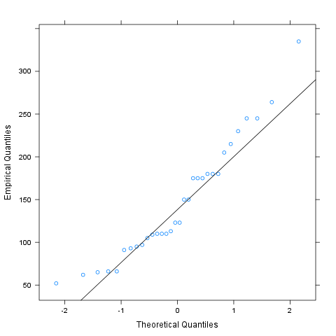
Kernel Density Plot
Kernel density plot is a plot of smoothed empirical distribution function. As such, it provides good insight about the shape of the distribution. For normal distributions, it should resemble the well known "bell shape".
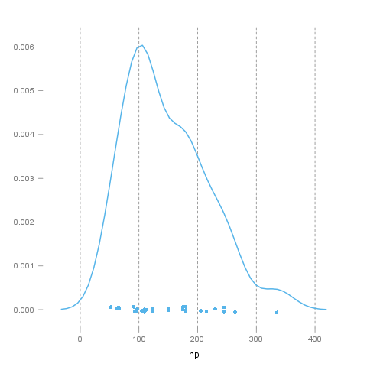
wt
The dataset has 32 observations with 32 valid values (missing: 0) in wt, which seems to be a quantitative variable.
Base statistics
Variable | mean | sd | var
wt | 3.2172 | 0.9785 | 0.9574

Histogram
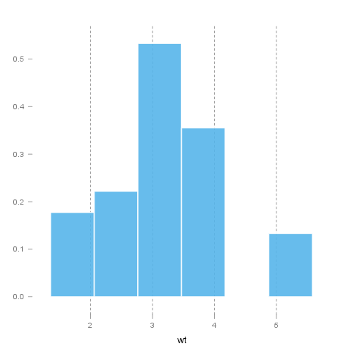
It seems that the highest value is 5.424 which is exactly 3.5849 times higher than the smallest value (1.513).
The standard deviation is 0.9785 (variance: 0.9574). The expected value is around 3.2172, somewhere between 2.8782 and 3.5563 with the standard error of 0.173.
If we suppose that wt is not near to a normal distribution (test: see below, skewness: 0.4231, kurtosis: -0.0227), checking the median (3.325) might be a better option instead of the mean. The interquartile range (1.0288) measures the statistics dispersion of the variable (similar to standard deviation) based on median.
Normality tests
Introduction
In statistics, normality refers to an assumption that the distribution of a random variable follows normal (Gaussian) distribution. Because of its bell-like shape, it's also known as the "bell curve". The formula for normal distribution is:
$f(x) = \frac{1}{\sqrt{2\pi{}\sigma{}^2}} e^{-\frac{(x-\mu{})^2}{2\sigma{}^2}}$
Normal distribution belongs to a location-scale family of distributions, as it's defined two parameters:
• μ - mean or expectation (location parameter)
• σ² - variance (scale parameter)
Normality Tests
Overview
Various hypothesis tests can be applied in order to test if the distribution of given random variable violates normality assumption. These procedures test the H₀ that provided variable's distribution is normal. At this point only few such tests will be covered: the ones that are available in stats package (which comes bundled with default R installation) and nortest package that is available on CRAN.
• Shapiro-Wilk test is a powerful normality test appropriate for small samples. In R, it's implemented in shapiro.test function available in stats package.
• Lilliefors test is a modification of Kolmogorov-Smirnov test appropriate for testing normality when parameters or normal distribution (μ, σ²) are not known. lillie.test function is located in nortest package.
• Anderson-Darling test is one of the most powerful normality tests as it will detect the most of departures from normality. You can find ad.test function in nortest package.
• Pearson Χ² test is another normality test which takes more "traditional" approach in normality testing. pearson.test is located in nortest package.
Results
Here you can see the results of applied normality tests (p-values less than 0.05 indicate significant discrepancies):
 | Statistic | p-value
Shapiro-Wilk normality test | 0.9433 | 0.0927
Lilliefors (Kolmogorov-Smirnov) normality test | 0.1356 | 0.1412
Anderson-Darling normality test | 0.6091 | 0.1038
Pearson chi-square normality test | 4.5 | 0.4799

So, let's draw some conclusions based on applied normality test:
• according to Shapiro-Wilk test, the distribution of wt is normal.
• based on Lilliefors test, distribution of wt is not normal
• Anderson-Darling test confirms normality assumption
• Pearson's Χ² test classifies the underlying distribution as non-normal
Diagnostic Plots
There are various plots that can help you decide about the normality of the distribution. Only a few most commonly used plots will be shown: histogram, Q-Q plot and kernel density plot.
Histogram
Histogram was first introduced by Karl Pearson and it's probably the most popular plot for depicting the probability distribution of a random variable. However, the decision depends on number of bins, so it can sometimes be misleading. If the variable distribution is normal, bins should resemble the "bell-like" shape.
Q-Q Plot
"Q" in Q-Q plot stands for quantile, as this plot compares empirical and theoretical distribution (in this case, normal distribution) by plotting their quantiles against each other. For normal distribution, plotted dots should approximate a "straight", x = y line.
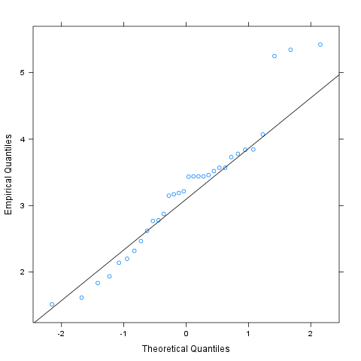
Kernel Density Plot
Kernel density plot is a plot of smoothed empirical distribution function. As such, it provides good insight about the shape of the distribution. For normal distributions, it should resemble the well known "bell shape".
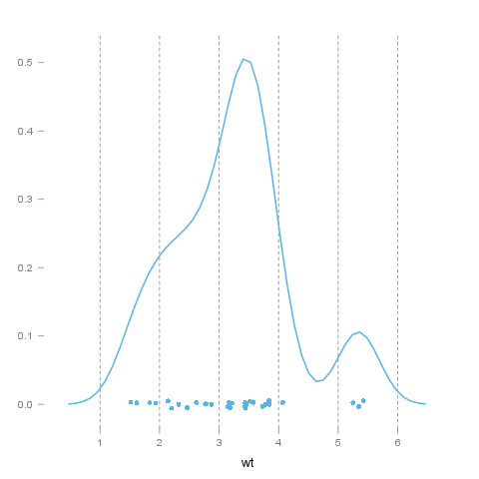
—————
This report was generated with R (2.14.0) and rapport (0.2) in 6.843 sec on x86_64-unknown-linux-gnu platform.


