Descriptive statistics
Rapport package team @ https://github.com/aL3xa/rapport
2011-04-26 20:25 CET

Description
This template will return descriptive statistics and frequency table of a categorical variable.
gender ("Gender")
The dataset has 709 observations with 673 valid values (missing: 36) in gender ("Gender"), which seems to be a qualitative variable.
Base statistics
gender | N | % | Cumul. N | Cumul. %
male | 410 | 60.9212 | 410 | 60.9212
female | 263 | 39.0788 | 673 | 100
Total | 673 | 100 | 673 | 100

Barplot
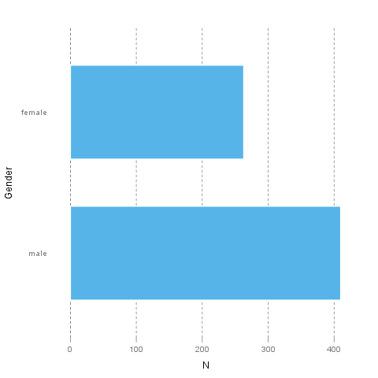
It seems that the highest value is 2 which is exactly 2 times higher than the smallest value (1).
The most frequent value is male.
Description
This template will return descriptive statistics and frequency table of a categorical variable.
dwell ("Dwelling")
The dataset has 709 observations with 662 valid values (missing: 47) in dwell ("Dwelling"), which seems to be a qualitative variable.
Base statistics
dwell | N | % | Cumul. N | Cumul. %
city | 599 | 90.4834 | 599 | 90.4834
small town | 33 | 4.9849 | 632 | 95.4683
village | 30 | 4.5317 | 662 | 100
Total | 662 | 100 | 662 | 100

Barplot
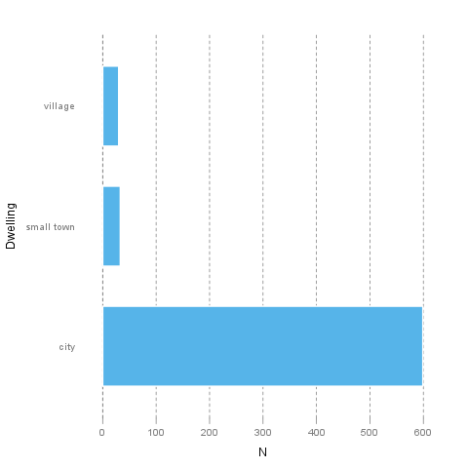
It seems that the highest value is 3 which is exactly 3 times higher than the smallest value (1).
The most frequent value is city.
—————
This report was generated with R (2.14.0) and rapport (0.2) in 0.704 sec on x86_64-unknown-linux-gnu platform.


