Descriptives
Rapport package team @ https://github.com/aL3xa/rapport
2011-04-26 20:25 CET

Description
This template will return descriptive statistics of a numerical, or a frequency table of a categorical variable.
gender ("Gender")
The dataset has 709 observations with 709 valid values (missing: 0) in gender ("Gender"). This variable seems to be a factor.
Base statistics
gender | N | pct | cum.n | cum.pct
male | 7344.00 | 60.93 | 7344.00 | 60.93
female | 4709.00 | 39.07 | 12053.00 | 100.00

Barplot
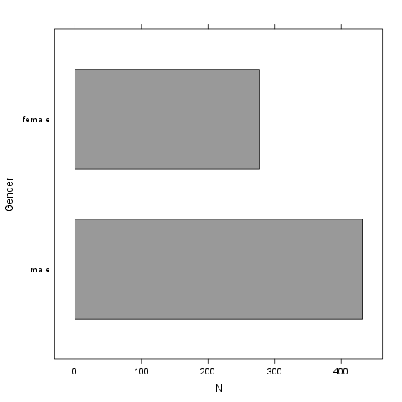
It seems that the highest value is 2 which is exactly 2 times higher than the smallest value (1).
Description
This template will return descriptive statistics of a numerical, or a frequency table of a categorical variable.
age
The dataset has 709 observations with 709 valid values (missing: 0) in age. This variable seems to be numeric.
Base statistics
value | mean | sd | var
(all) | 24.56 | 6.84 | 46.78

Histogram
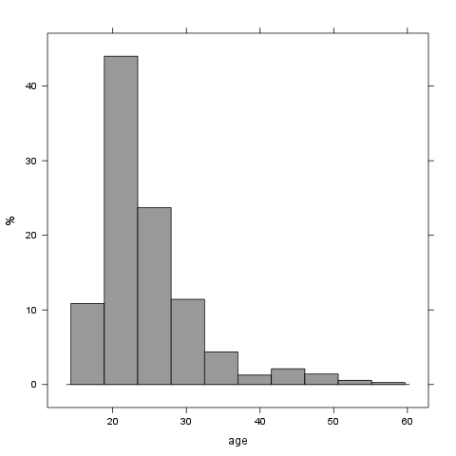
It seems that the highest value is 58 which is exactly 3.625 times higher than the smallest value (16).

