Outlier tests
Rapport package team @ https://github.com/aL3xa/rapport
2011-04-26 20:25 CET

Description
This template will check if provided variable has any outliers.
Boxplot
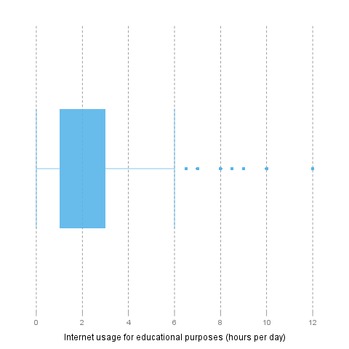
Lund test
It seems that 4 extreme values can be found in "Internet usage for educational purposes (hours per day)". These are: 10, 0.5, 1.5, 0.5.
Explanation
The above test for outliers was based on lm(1 ~ edu):
 | Estimate | Std. Error | t value | Pr(>|t|)
(Intercept) | 2.0481 | 0.078 | 26.2677 | 0

References
• Lund, R. E. 1975, "Tables for An Approximate Test for Outliers in Linear Models", Technometrics, vol. 17, no. 4, pp. 473-476.
• Prescott, P. 1975, "An Approximate Test for Outliers in Linear Models", Technometrics, vol. 17, no. 1, pp. 129-132.
Grubb's test
Grubbs test for one outlier shows that highest value 12 is an outlier (p=0.0002).
References
• Grubbs, F.E. (1950). Sample Criteria for testing outlying observations. Ann. Math. Stat. 21, 1, 27-58.
Dixon's test
chi-squared test for outlier shows that highest value 12 is an outlier (p=0).
References
• Dixon, W.J. (1950). Analysis of extreme values. Ann. Math. Stat. 21, 4, 488-506.
Description
This template will check if provided variable has any outliers.
Boxplot
Lund test
It seems that 4 extreme values can be found in "Internet usage for educational purposes (hours per day)". These are: 10, 0.5, 1.5, 0.5.
Explanation
The above test for outliers was based on lm(1 ~ edu):
 | Estimate | Std. Error | t value | Pr(>|t|)
(Intercept) | 2.0481 | 0.078 | 26.2677 | 0

References
• Lund, R. E. 1975, "Tables for An Approximate Test for Outliers in Linear Models", Technometrics, vol. 17, no. 4, pp. 473-476.
• Prescott, P. 1975, "An Approximate Test for Outliers in Linear Models", Technometrics, vol. 17, no. 1, pp. 129-132.
Grubb's test
Grubbs test for one outlier shows that highest value 12 is an outlier (p=0.0002).
References
• Grubbs, F.E. (1950). Sample Criteria for testing outlying observations. Ann. Math. Stat. 21, 1, 27-58.
Dixon's test
chi-squared test for outlier shows that highest value 12 is an outlier (p=0).
References
• Dixon, W.J. (1950). Analysis of extreme values. Ann. Math. Stat. 21, 4, 488-506.
Description
This template will check if provided variable has any outliers.
Boxplot
Lund test
It seems that 4 extreme values can be found in "Internet usage for educational purposes (hours per day)". These are: 10, 0.5, 1.5, 0.5.
Explanation
The above test for outliers was based on lm(1 ~ edu):
 | Estimate | Std. Error | t value | Pr(>|t|)
(Intercept) | 2.0481 | 0.078 | 26.2677 | 0

—————
This report was generated with R (2.14.0) and rapport (0.1) in 1.157 sec on x86_64-unknown-linux-gnu platform.


