Normality Tests
Rapport package team @ https://github.com/aL3xa/rapport
2011-04-26 20:25 CET

Description
Overview of several normality tests and diagnostic plots that can screen departures from normality.

Introduction
In statistics, normality refers to an assumption that the distribution of a random variable follows normal (Gaussian) distribution. Because of its bell-like shape, it's also known as the "bell curve". The formula for normal distribution is:
$f(x) = \frac{1}{\sqrt{2\pi{}\sigma{}^2}} e^{-\frac{(x-\mu{})^2}{2\sigma{}^2}}$
Normal distribution belongs to a location-scale family of distributions, as it's defined two parameters:
- μ - mean or expectation (location parameter)
- σ² - variance (scale parameter)
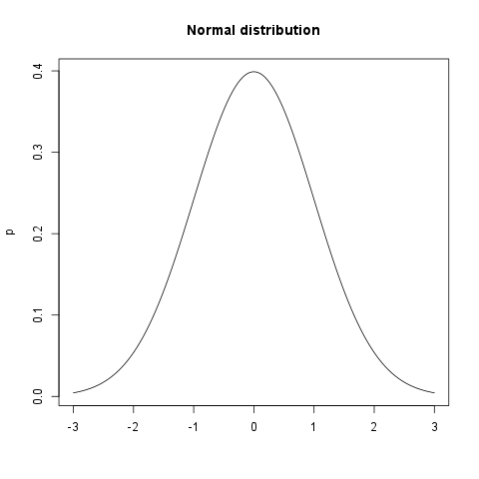

Normality Tests

Overview
Various hypothesis tests can be applied in order to test if the distribution of given random variable violates normality assumption. These procedures test the H₀ that provided variable's distribution is normal. At this point only few such tests will be covered: the ones that are available in stats package (which comes bundled with default R installation) and nortest package that is available on CRAN.
- Shapiro-Wilk test is a powerful normality test appropriate for small samples. In R, it's implemented in shapiro.test function available in stats package.
- Lilliefors test is a modification of Kolmogorov-Smirnov test appropriate for testing normality when parameters or normal distribution (μ, σ²) are not known. lillie.test function is located in nortest package.
- Anderson-Darling test is one of the most powerful normality tests as it will detect the most of departures from normality. You can find ad.test function in nortest package.
- Pearson Χ² test is another normality test which takes more "traditional" approach in normality testing. pearson.test is located in nortest package.

Results
Here you can see the results of applied normality tests (p-values less than 0.05 indicate significant discrepancies):
 | Statistic | p-value
Shapiro-Wilk normality test | 0.9001 | 0
Lilliefors (Kolmogorov-Smirnov) normality test | 0.168 | 0
Anderson-Darling normality test | 18.753 | 0
Pearson chi-square normality test | 1791.25 | 0
So, let's draw some conclusions based on applied normality test:
- according to Shapiro-Wilk test, the distribution of Internet usage in leisure time (hours per day) is not normal.
- based on Lilliefors test, distribution of Internet usage in leisure time (hours per day) is not normal
- Anderson-Darling test confirms violation of normality assumption
- Pearson's Χ² test classifies the underlying distribution as normal

Diagnostic Plots
There are various plots that can help you decide about the normality of the distribution. Only a few most commonly used plots will be shown: histogram, Q-Q plot and kernel density plot.

Histogram
Histogram was first introduced by Karl Pearson and it's probably the most popular plot for depicting the probability distribution of a random variable. However, the decision depends on number of bins, so it can sometimes be misleading. If the variable distribution is normal, bins should resemble the "bell-like" shape.
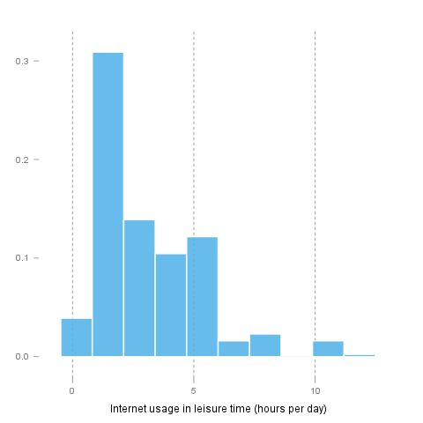

Q-Q Plot
"Q" in Q-Q plot stands for quantile, as this plot compares empirical and theoretical distribution (in this case, normal distribution) by plotting their quantiles against each other. For normal distribution, plotted dots should approximate a "straight", x = y line.
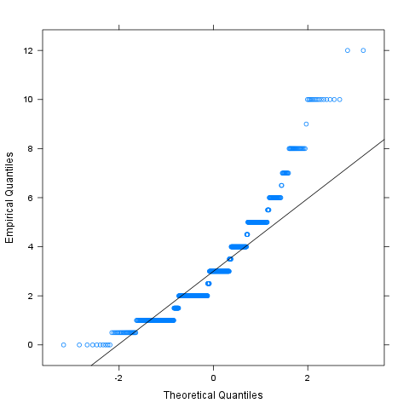

Kernel Density Plot
Kernel density plot is a plot of smoothed empirical distribution function. As such, it provides good insight about the shape of the distribution. For normal distributions, it should resemble the well known "bell shape".
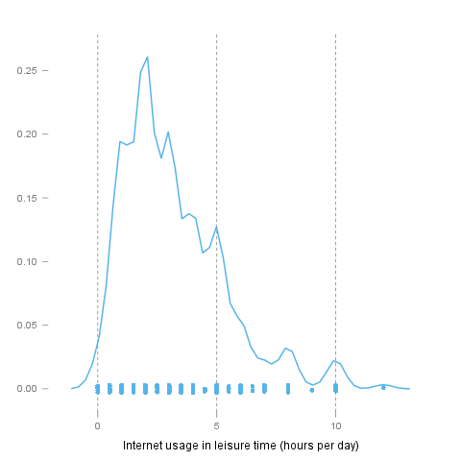

Description
Overview of several normality tests and diagnostic plots that can screen departures from normality.

Introduction
In statistics, normality refers to an assumption that the distribution of a random variable follows normal (Gaussian) distribution. Because of its bell-like shape, it's also known as the "bell curve". The formula for normal distribution is:
$f(x) = \frac{1}{\sqrt{2\pi{}\sigma{}^2}} e^{-\frac{(x-\mu{})^2}{2\sigma{}^2}}$
Normal distribution belongs to a location-scale family of distributions, as it's defined two parameters:
- μ - mean or expectation (location parameter)
- σ² - variance (scale parameter)

Normality Tests

Overview
Various hypothesis tests can be applied in order to test if the distribution of given random variable violates normality assumption. These procedures test the H₀ that provided variable's distribution is normal. At this point only few such tests will be covered: the ones that are available in stats package (which comes bundled with default R installation) and nortest package that is available on CRAN.
- Shapiro-Wilk test is a powerful normality test appropriate for small samples. In R, it's implemented in shapiro.test function available in stats package.
- Lilliefors test is a modification of Kolmogorov-Smirnov test appropriate for testing normality when parameters or normal distribution (μ, σ²) are not known. lillie.test function is located in nortest package.
- Anderson-Darling test is one of the most powerful normality tests as it will detect the most of departures from normality. You can find ad.test function in nortest package.
- Pearson Χ² test is another normality test which takes more "traditional" approach in normality testing. pearson.test is located in nortest package.

Results
Here you can see the results of applied normality tests (p-values less than 0.05 indicate significant discrepancies):
 | Statistic | p-value
Shapiro-Wilk normality test | 0.9001 | 0
Lilliefors (Kolmogorov-Smirnov) normality test | 0.168 | 0
Anderson-Darling normality test | 18.753 | 0
Pearson chi-square normality test | 1791.25 | 0
So, let's draw some conclusions based on applied normality test:
- according to Shapiro-Wilk test, the distribution of Internet usage in leisure time (hours per day) is not normal.
- based on Lilliefors test, distribution of Internet usage in leisure time (hours per day) is not normal
- Anderson-Darling test confirms violation of normality assumption
- Pearson's Χ² test classifies the underlying distribution as normal

Diagnostic Plots
There are various plots that can help you decide about the normality of the distribution. Only a few most commonly used plots will be shown: histogram, Q-Q plot and kernel density plot.

Histogram
Histogram was first introduced by Karl Pearson and it's probably the most popular plot for depicting the probability distribution of a random variable. However, the decision depends on number of bins, so it can sometimes be misleading. If the variable distribution is normal, bins should resemble the "bell-like" shape.

Q-Q Plot
"Q" in Q-Q plot stands for quantile, as this plot compares empirical and theoretical distribution (in this case, normal distribution) by plotting their quantiles against each other. For normal distribution, plotted dots should approximate a "straight", x = y line.

Kernel Density Plot
Kernel density plot is a plot of smoothed empirical distribution function. As such, it provides good insight about the shape of the distribution. For normal distributions, it should resemble the well known "bell shape".
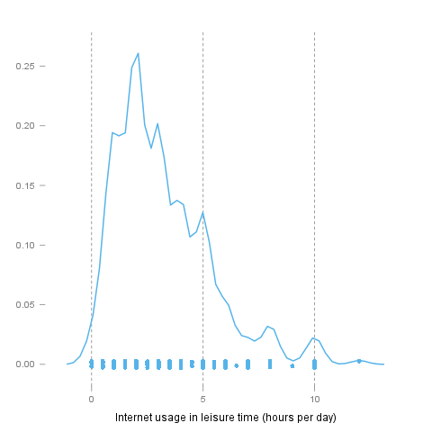

Description
Overview of several normality tests and diagnostic plots that can screen departures from normality.

Introduction
In statistics, normality refers to an assumption that the distribution of a random variable follows normal (Gaussian) distribution. Because of its bell-like shape, it's also known as the "bell curve". The formula for normal distribution is:
$f(x) = \frac{1}{\sqrt{2\pi{}\sigma{}^2}} e^{-\frac{(x-\mu{})^2}{2\sigma{}^2}}$
Normal distribution belongs to a location-scale family of distributions, as it's defined two parameters:
- μ - mean or expectation (location parameter)
- σ² - variance (scale parameter)

Normality Tests

Overview
Various hypothesis tests can be applied in order to test if the distribution of given random variable violates normality assumption. These procedures test the H₀ that provided variable's distribution is normal. At this point only few such tests will be covered: the ones that are available in stats package (which comes bundled with default R installation) and nortest package that is available on CRAN.
- Shapiro-Wilk test is a powerful normality test appropriate for small samples. In R, it's implemented in shapiro.test function available in stats package.
- Lilliefors test is a modification of Kolmogorov-Smirnov test appropriate for testing normality when parameters or normal distribution (μ, σ²) are not known. lillie.test function is located in nortest package.
- Anderson-Darling test is one of the most powerful normality tests as it will detect the most of departures from normality. You can find ad.test function in nortest package.
- Pearson Χ² test is another normality test which takes more "traditional" approach in normality testing. pearson.test is located in nortest package.

Results
Here you can see the results of applied normality tests (p-values less than 0.05 indicate significant discrepancies):
 | Statistic | p-value
Shapiro-Wilk normality test | 0.9001 | 0
Lilliefors (Kolmogorov-Smirnov) normality test | 0.168 | 0
Anderson-Darling normality test | 18.753 | 0
Pearson chi-square normality test | 1791.25 | 0
So, let's draw some conclusions based on applied normality test:
- according to Shapiro-Wilk test, the distribution of Internet usage in leisure time (hours per day) is not normal.
- based on Lilliefors test, distribution of Internet usage in leisure time (hours per day) is not normal
- Anderson-Darling test confirms violation of normality assumption
- Pearson's Χ² test classifies the underlying distribution as normal

Diagnostic Plots
There are various plots that can help you decide about the normality of the distribution. Only a few most commonly used plots will be shown: histogram, Q-Q plot and kernel density plot.

Histogram
Histogram was first introduced by Karl Pearson and it's probably the most popular plot for depicting the probability distribution of a random variable. However, the decision depends on number of bins, so it can sometimes be misleading. If the variable distribution is normal, bins should resemble the "bell-like" shape.

Q-Q Plot
"Q" in Q-Q plot stands for quantile, as this plot compares empirical and theoretical distribution (in this case, normal distribution) by plotting their quantiles against each other. For normal distribution, plotted dots should approximate a "straight", x = y line.
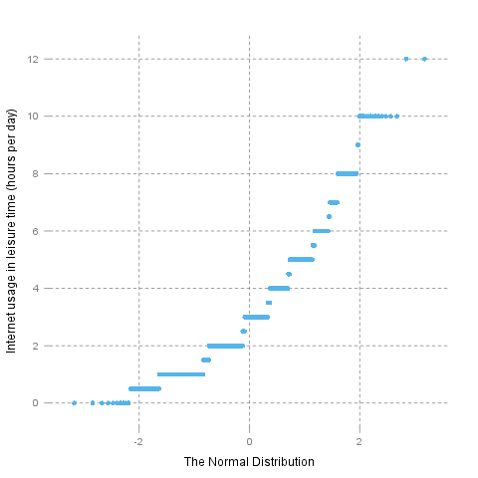

Kernel Density Plot
Kernel density plot is a plot of smoothed empirical distribution function. As such, it provides good insight about the shape of the distribution. For normal distributions, it should resemble the well known "bell shape".
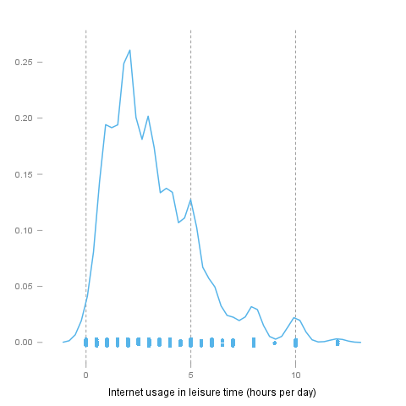

This report was generated with R (2.14.0) and rapport (0.2) in 3.197 sec on x86_64-unknown-linux-gnu platform.


