Rapport package team
Crosstable
2011-04-26 20:25 CET

Description
Returning the Chi-squared test of two given variables with count, percentages and Pearson's residuals table.

Variable description
Two variables specified:
- "gender" ("Gender") with 673 and
- "dwell" ("Dwelling") with 662 valid values.

Counts
 | city | small town | village | Missing | Sum
male | 338 | 28 | 19 | 25 | 410
female | 234 | 3 | 9 | 17 | 263
Missing | 27 | 2 | 2 | 5 | 36
Sum | 599 | 33 | 30 | 47 | 709
Counted values
Most of the cases (338) can be found in "male-city" categories. Row-wise "male" holds the highest number of cases (410) while column-wise "city" has the utmost cases (599).

Percentages
 | city | small town | village | Missing | Sum
male | 47.67 | 3.95 | 2.68 | 3.53 | 57.83
female | 33.00 | 0.42 | 1.27 | 2.40 | 37.09
Missing | 3.81 | 0.28 | 0.28 | 0.71 | 5.08
Sum | 84.49 | 4.65 | 4.23 | 6.63 | 100.00
Total percentages
 | city | small town | village | Missing
male | 82.44 | 6.83 | 4.63 | 6.10
female | 88.97 | 1.14 | 3.42 | 6.46
Missing | 75.00 | 5.56 | 5.56 | 13.89
Sum | 84.49 | 4.65 | 4.23 | 6.63
Row percentages
 | city | small town | village | Missing | Sum
male | 56.43 | 84.85 | 63.33 | 53.19 | 57.83
female | 39.07 | 9.09 | 30.00 | 36.17 | 37.09
Missing | 4.51 | 6.06 | 6.67 | 10.64 | 5.08
Column percentages

Chi-squared test
Test statistic | df | P value
16.18 | 6 | 0.01282
Pearson's Chi-squared test: table
It seems that a real association can be pointed out between gender and dwell by the Pearson's Chi-squared test (χ=16.18 at the degree of freedom being 6) at the significance level of 0.01282. Based on Goodman and Kruskal's lambda it seems that dwell (λ=0.6321) has an effect on gender (λ=0) if we assume both variables to be nominal. The association between the two variables seems to be weak based on Cramer's V (0.08722).
 | city | small town | village
male | -3.08 | 3.43 | 0.76
female | 3.08 | -3.43 | -0.76
Pearson's residuals
Based on Pearson's resuals the following cells seems interesting (with values higher then 2 or lower then -2):
- "male - city"
- "female - city"
- "male - small town"
- "female - small town"

Charts
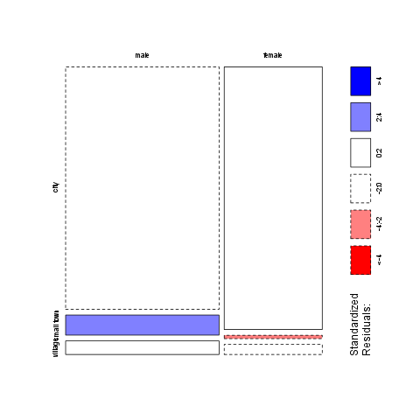

Description
Returning the Chi-squared test of two given variables with count, percentages and Pearson's residuals table.

Variable description
Two variables specified:
- "email" ("Email usage") with 672 and
- "dwell" ("Dwelling") with 662 valid values.

Counts
 | city | small town | village
never | 12 | 0 | 0
very rarely | 30 | 1 | 3
rarely | 41 | 3 | 1
sometimes | 67 | 4 | 8
often | 101 | 10 | 5
very often | 88 | 5 | 5
always | 226 | 9 | 7
Missing | 34 | 1 | 1
Sum | 599 | 33 | 30
Counted values (continued below)
 | Missing | Sum
never | 1 | 13
very rarely | 2 | 36
rarely | 1 | 46
sometimes | 8 | 87
often | 7 | 123
very often | 10 | 108
always | 17 | 259
Missing | 1 | 37
Sum | 47 | 709
Most of the cases (226) can be found in "always-city" categories. Row-wise "always" holds the highest number of cases (259) while column-wise "city" has the utmost cases (599).

Percentages
 | city | small town | village
never | 1.69 | 0.00 | 0.00
very rarely | 4.23 | 0.14 | 0.42
rarely | 5.78 | 0.42 | 0.14
sometimes | 9.45 | 0.56 | 1.13
often | 14.25 | 1.41 | 0.71
very often | 12.41 | 0.71 | 0.71
always | 31.88 | 1.27 | 0.99
Missing | 4.80 | 0.14 | 0.14
Sum | 84.49 | 4.65 | 4.23
Total percentages (continued below)
 | Missing | Sum
never | 0.14 | 1.83
very rarely | 0.28 | 5.08
rarely | 0.14 | 6.49
sometimes | 1.13 | 12.27
often | 0.99 | 17.35
very often | 1.41 | 15.23
always | 2.40 | 36.53
Missing | 0.14 | 5.22
Sum | 6.63 | 100.00
 | city | small town | village | Missing
never | 92.31 | 0.00 | 0.00 | 7.69
very rarely | 83.33 | 2.78 | 8.33 | 5.56
rarely | 89.13 | 6.52 | 2.17 | 2.17
sometimes | 77.01 | 4.60 | 9.20 | 9.20
often | 82.11 | 8.13 | 4.07 | 5.69
very often | 81.48 | 4.63 | 4.63 | 9.26
always | 87.26 | 3.47 | 2.70 | 6.56
Missing | 91.89 | 2.70 | 2.70 | 2.70
Sum | 84.49 | 4.65 | 4.23 | 6.63
Row percentages
 | city | small town | village
never | 2.00 | 0.00 | 0.00
very rarely | 5.01 | 3.03 | 10.00
rarely | 6.84 | 9.09 | 3.33
sometimes | 11.19 | 12.12 | 26.67
often | 16.86 | 30.30 | 16.67
very often | 14.69 | 15.15 | 16.67
always | 37.73 | 27.27 | 23.33
Missing | 5.68 | 3.03 | 3.33
Column percentages (continued below)
 | Missing | Sum
never | 2.13 | 1.83
very rarely | 4.26 | 5.08
rarely | 2.13 | 6.49
sometimes | 17.02 | 12.27
often | 14.89 | 17.35
very often | 21.28 | 15.23
always | 36.17 | 36.53
Missing | 2.13 | 5.22

Chi-squared test
Test statistic | df | P value
20.63 | 21 | 0.4818
Pearson's Chi-squared test: table
It seems that no real association can be pointed out between email and dwell by the Pearson's Chi-squared test (χ=20.63 at the degree of freedom being 21) at the significance level of 0.4818. For this end no other statistical tests were performed.
 | city | small town | village
never | 1.15 | -0.81 | -0.77
very rarely | -0.41 | -0.59 | 1.20
rarely | 0.20 | 0.49 | -0.80
sometimes | -1.75 | -0.02 | 2.49
often | -1.28 | 1.90 | -0.18
very often | -0.17 | 0.00 | 0.24
always | 2.10 | -1.26 | -1.64
Pearson's residuals
Based on Pearson's resuals the following cells seems interesting (with values higher then 2 or lower then -2):
- "always - city"
- "sometimes - village"

Charts
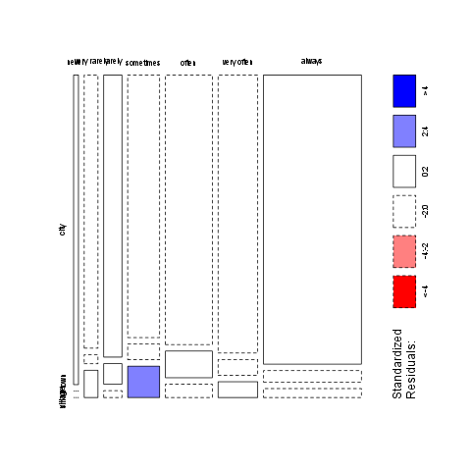

This report was generated with R (2.15.1) and rapport (0.4) in 1.608 sec on x86_64-unknown-linux-gnu platform.


