Descriptives
Rapport package team @ https://github.com/aL3xa/rapport
2011-04-26 20:25 CET

Description
This template will return descriptive statistics of numerical, or frequency tables of categorical variables.

gender ("Gender")
The dataset has 709 observations with 709 valid values (missing: 0) in gender ("Gender"). This variable seems to be a factor.

Base statistics
gender | N | pct | cum.n | cum.pct
male | 7344.00 | 60.93 | 7344.00 | 60.93
female | 4709.00 | 39.07 | 12053.00 | 100.00

Barplot
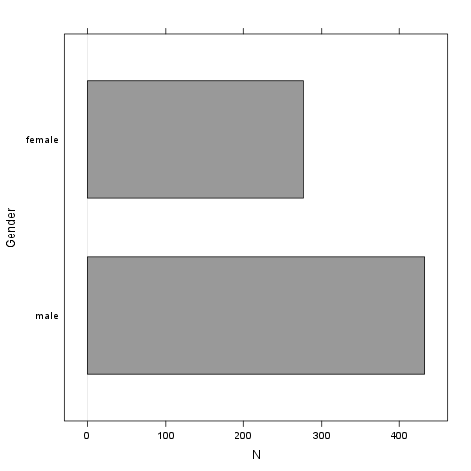
It seems that the highest value is 2 which is exactly 2 times higher than the smallest value (1).

age
The dataset has 709 observations with 709 valid values (missing: 0) in age. This variable seems to be numeric.

Base statistics
value | mean | sd | var
(all) | 24.56 | 6.84 | 46.78

Histogram
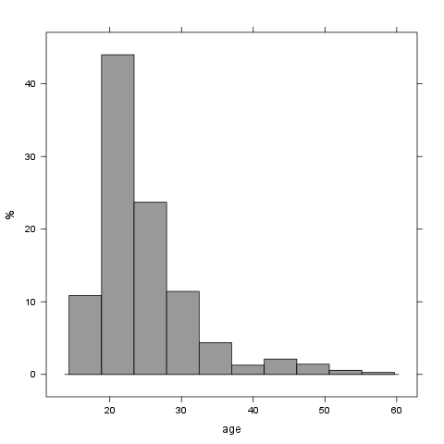
It seems that the highest value is 58 which is exactly 3.625 times higher than the smallest value (16).

Description
This template will return descriptive statistics of numerical, or frequency tables of categorical variables.

chatim ("Chat & IM usage")
The dataset has 709 observations with 709 valid values (missing: 0) in chatim ("Chat & IM usage"). This variable seems to be a factor.

Base statistics
chatim | N | pct | cum.n | cum.pct
never | 896.00 | 9.03 | 896.00 | 9.03
very rarely | 1092.00 | 11.00 | 1988.00 | 20.03
rarely | 910.00 | 9.17 | 2898.00 | 29.20
sometimes | 1736.00 | 17.49 | 4634.00 | 46.69
often | 1988.00 | 20.03 | 6622.00 | 66.71
very often | 1316.00 | 13.26 | 7938.00 | 79.97
always | 1988.00 | 20.03 | 9926.00 | 100.00
Warning in "if (is.numeric(var)) { ; rp.desc(NULL, rp.name(var), c('mean', 'sd', 'var'), rp.data) ; } else { ; rp.freq(rp.name(var), rp.data) ; }": "invalid factor level, NAs generated + invalid factor level, NAs generated + invalid factor level, NAs generated"

Barplot
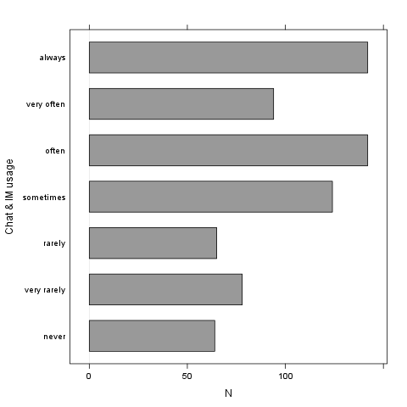
It seems that the highest value is 7 which is exactly 7 times higher than the smallest value (1).

game ("On-line games usage")
The dataset has 709 observations with 709 valid values (missing: 0) in game ("On-line games usage"). This variable seems to be a factor.

Base statistics
game | N | pct | cum.n | cum.pct
never | 5152.00 | 51.90 | 5152.00 | 51.90
very rarely | 1848.00 | 18.62 | 7000.00 | 70.52
rarely | 490.00 | 4.94 | 7490.00 | 75.46
sometimes | 910.00 | 9.17 | 8400.00 | 84.63
often | 532.00 | 5.36 | 8932.00 | 89.99
very often | 518.00 | 5.22 | 9450.00 | 95.20
always | 476.00 | 4.80 | 9926.00 | 100.00
Warning in "if (is.numeric(var)) { ; rp.desc(NULL, rp.name(var), c('mean', 'sd', 'var'), rp.data) ; } else { ; rp.freq(rp.name(var), rp.data) ; }": "invalid factor level, NAs generated + invalid factor level, NAs generated + invalid factor level, NAs generated"

Barplot
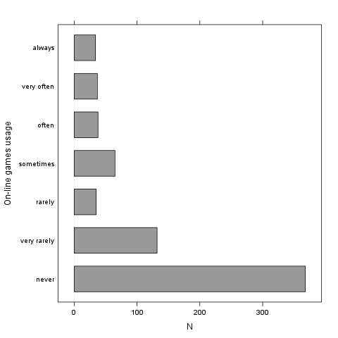
It seems that the highest value is 7 which is exactly 7 times higher than the smallest value (1).

surf ("Web surfing usage")
The dataset has 709 observations with 709 valid values (missing: 0) in surf ("Web surfing usage"). This variable seems to be a factor.

Base statistics
surf | N | pct | cum.n | cum.pct
never | 238.00 | 2.40 | 238.00 | 2.40
very rarely | 364.00 | 3.67 | 602.00 | 6.06
rarely | 476.00 | 4.80 | 1078.00 | 10.86
sometimes | 1624.00 | 16.36 | 2702.00 | 27.22
often | 2296.00 | 23.13 | 4998.00 | 50.35
very often | 2114.00 | 21.30 | 7112.00 | 71.65
always | 2814.00 | 28.35 | 9926.00 | 100.00
Warning in "if (is.numeric(var)) { ; rp.desc(NULL, rp.name(var), c('mean', 'sd', 'var'), rp.data) ; } else { ; rp.freq(rp.name(var), rp.data) ; }": "invalid factor level, NAs generated + invalid factor level, NAs generated + invalid factor level, NAs generated"

Barplot
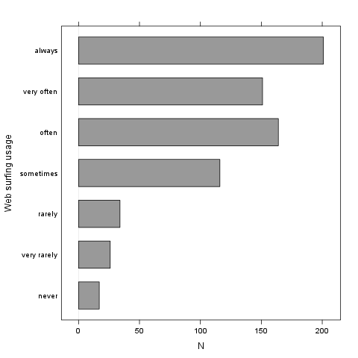
It seems that the highest value is 7 which is exactly 7 times higher than the smallest value (1).

email ("Email usage")
The dataset has 709 observations with 709 valid values (missing: 0) in email ("Email usage"). This variable seems to be a factor.

Base statistics
email | N | pct | cum.n | cum.pct
never | 182.00 | 1.83 | 182.00 | 1.83
very rarely | 532.00 | 5.36 | 714.00 | 7.19
rarely | 714.00 | 7.19 | 1428.00 | 14.39
sometimes | 1260.00 | 12.69 | 2688.00 | 27.08
often | 1806.00 | 18.19 | 4494.00 | 45.28
very often | 1624.00 | 16.36 | 6118.00 | 61.64
always | 3808.00 | 38.36 | 9926.00 | 100.00
Warning in "if (is.numeric(var)) { ; rp.desc(NULL, rp.name(var), c('mean', 'sd', 'var'), rp.data) ; } else { ; rp.freq(rp.name(var), rp.data) ; }": "invalid factor level, NAs generated + invalid factor level, NAs generated + invalid factor level, NAs generated"

Barplot
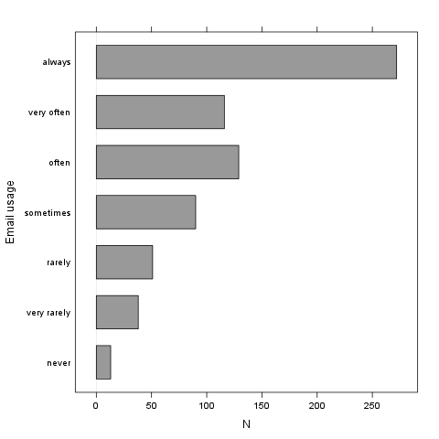
It seems that the highest value is 7 which is exactly 7 times higher than the smallest value (1).

download ("Download usage")
The dataset has 709 observations with 709 valid values (missing: 0) in download ("Download usage"). This variable seems to be a factor.

Base statistics
download | N | pct | cum.n | cum.pct
never | 154.00 | 1.55 | 154.00 | 1.55
very rarely | 406.00 | 4.09 | 560.00 | 5.64
rarely | 420.00 | 4.23 | 980.00 | 9.87
sometimes | 1190.00 | 11.99 | 2170.00 | 21.86
often | 1820.00 | 18.34 | 3990.00 | 40.20
very often | 2394.00 | 24.12 | 6384.00 | 64.32
always | 3542.00 | 35.68 | 9926.00 | 100.00
Warning in "if (is.numeric(var)) { ; rp.desc(NULL, rp.name(var), c('mean', 'sd', 'var'), rp.data) ; } else { ; rp.freq(rp.name(var), rp.data) ; }": "invalid factor level, NAs generated + invalid factor level, NAs generated + invalid factor level, NAs generated"

Barplot
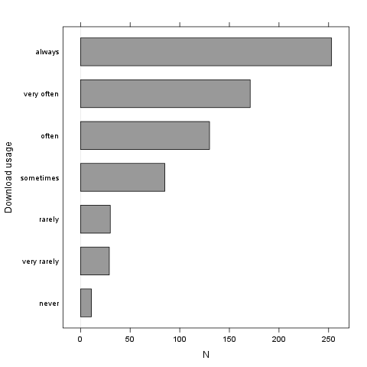
It seems that the highest value is 7 which is exactly 7 times higher than the smallest value (1).

forum ("Web forums usage")
The dataset has 709 observations with 709 valid values (missing: 0) in forum ("Web forums usage"). This variable seems to be a factor.

Base statistics
forum | N | pct | cum.n | cum.pct
never | 1120.00 | 11.28 | 1120.00 | 11.28
very rarely | 1176.00 | 11.85 | 2296.00 | 23.13
rarely | 1036.00 | 10.44 | 3332.00 | 33.57
sometimes | 1736.00 | 17.49 | 5068.00 | 51.06
often | 1568.00 | 15.80 | 6636.00 | 66.85
very often | 1750.00 | 17.63 | 8386.00 | 84.49
always | 1540.00 | 15.51 | 9926.00 | 100.00
Warning in "if (is.numeric(var)) { ; rp.desc(NULL, rp.name(var), c('mean', 'sd', 'var'), rp.data) ; } else { ; rp.freq(rp.name(var), rp.data) ; }": "invalid factor level, NAs generated + invalid factor level, NAs generated + invalid factor level, NAs generated"

Barplot
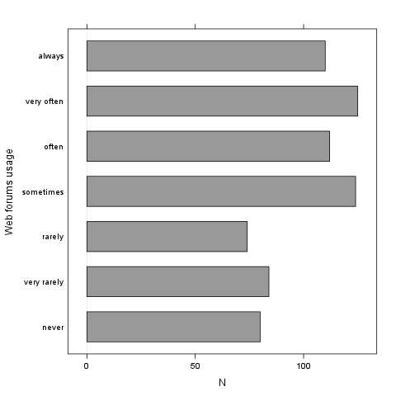
It seems that the highest value is 7 which is exactly 7 times higher than the smallest value (1).

socnet ("Social networks usage")
The dataset has 709 observations with 709 valid values (missing: 0) in socnet ("Social networks usage"). This variable seems to be a factor.

Base statistics
socnet | N | pct | cum.n | cum.pct
never | 2940.00 | 29.62 | 2940.00 | 29.62
very rarely | 1554.00 | 15.66 | 4494.00 | 45.28
rarely | 826.00 | 8.32 | 5320.00 | 53.60
sometimes | 1316.00 | 13.26 | 6636.00 | 66.85
often | 1148.00 | 11.57 | 7784.00 | 78.42
very often | 1190.00 | 11.99 | 8974.00 | 90.41
always | 952.00 | 9.59 | 9926.00 | 100.00
Warning in "if (is.numeric(var)) { ; rp.desc(NULL, rp.name(var), c('mean', 'sd', 'var'), rp.data) ; } else { ; rp.freq(rp.name(var), rp.data) ; }": "invalid factor level, NAs generated + invalid factor level, NAs generated + invalid factor level, NAs generated"

Barplot
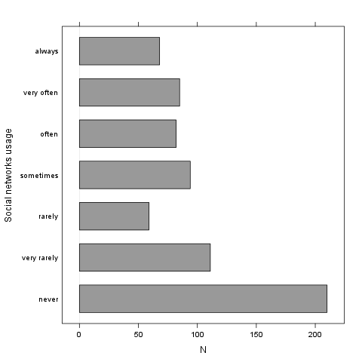
It seems that the highest value is 7 which is exactly 7 times higher than the smallest value (1).

xxx ("Adult sites usage")
The dataset has 709 observations with 709 valid values (missing: 0) in xxx ("Adult sites usage"). This variable seems to be a factor.

Base statistics
xxx | N | pct | cum.n | cum.pct
never | 4102.00 | 41.33 | 4102.00 | 41.33
very rarely | 1792.00 | 18.05 | 5894.00 | 59.38
rarely | 770.00 | 7.76 | 6664.00 | 67.14
sometimes | 1918.00 | 19.32 | 8582.00 | 86.46
often | 672.00 | 6.77 | 9254.00 | 93.23
very often | 406.00 | 4.09 | 9660.00 | 97.32
always | 266.00 | 2.68 | 9926.00 | 100.00
Warning in "if (is.numeric(var)) { ; rp.desc(NULL, rp.name(var), c('mean', 'sd', 'var'), rp.data) ; } else { ; rp.freq(rp.name(var), rp.data) ; }": "invalid factor level, NAs generated + invalid factor level, NAs generated + invalid factor level, NAs generated"

Barplot
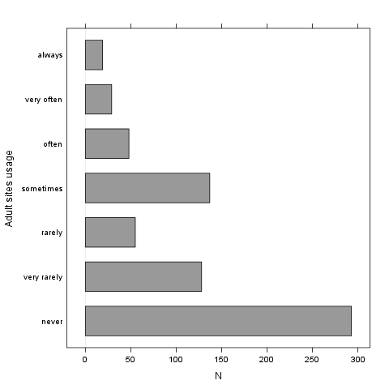
It seems that the highest value is 7 which is exactly 7 times higher than the smallest value (1).

long.use ("How long you've been on the Internet?")
The dataset has 709 observations with 709 valid values (missing: 0) in long.use ("How long you've been on the Internet?"). This variable seems to be a factor.

Base statistics
long.use | N | pct | cum.n | cum.pct
less than 6 months | 294.00 | 2.96 | 294.00 | 2.96
1 years | 728.00 | 7.33 | 1022.00 | 10.30
2 years | 966.00 | 9.73 | 1988.00 | 20.03
3 years | 1092.00 | 11.00 | 3080.00 | 31.03
4 years | 1064.00 | 10.72 | 4144.00 | 41.75
5 years | 1036.00 | 10.44 | 5180.00 | 52.19
5 years and more | 4746.00 | 47.81 | 9926.00 | 100.00
Warning in "if (is.numeric(var)) { ; rp.desc(NULL, rp.name(var), c('mean', 'sd', 'var'), rp.data) ; } else { ; rp.freq(rp.name(var), rp.data) ; }": "invalid factor level, NAs generated + invalid factor level, NAs generated + invalid factor level, NAs generated"

Barplot
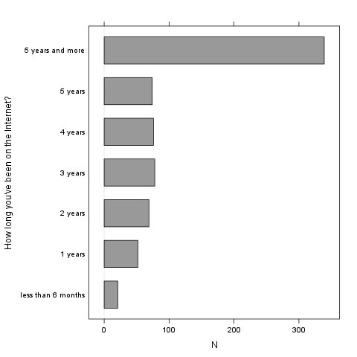
It seems that the highest value is 7 which is exactly 7 times higher than the smallest value (1).

