Descriptives
Rapport package team @ https://github.com/aL3xa/rapport
2011-04-26 20:25 CET

Description
This template will return descriptive statistics of a numerical, or a frequency table of a categorical variable.

Variable description
The dataset has 709 observations with 709 valid values (missing: 0) in "it.edu" ("Internet usage for educational purposes (hours per day)"). This variable seems to be numeric.

Base statistics
 | 0 | 0.5 | 1 | 1.5 | 2 | 2.5 | 3 | 3.5 | 4 | 4.5 | 5 | 5.5 | 6 | 6.5 | 7 | 8 | 8.5 | 9 | 10 | 12
1 | 61.00000 | 102.00000 | 204.00000 | 27.00000 | 109.00000 | 17.00000 | 66.00000 | 2.00000 | 37.00000 | 2.00000 | 33.00000 | 1.00000 | 13.00000 | 1.00000 | 1.00000 | 25.00000 | 1.00000 | 2.00000 | 2.00000 | 3.00000

Histogram
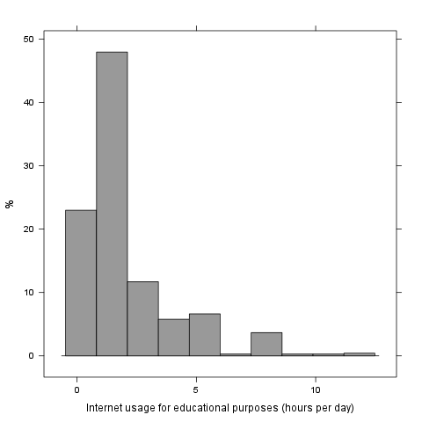
It seems that the highest value is 12 which is exactly Inf times higher than the smalles values (0).
If we suppose that "Internet usage for educational purposes (hours per day) is not near to a normal distribution (test: , skewness: 1.8593, kurtosis: 6.8501), checking the median (1) might be a better option instead of the mean. The interquartile range (2) measures the statistics dispersion of the variable (similar to standard deviation) based on median.

