ANOVA Template
Rapport package team @ https://github.com/aL3xa/rapport
2011-04-26 20:25 CET

Description
An ANOVA report with table of descriptives, diagnostic tests and ANOVA-specific statistics.
Introduction
Analysis of Variance or ANOVA is a statistical procedure that tests equality of means for several samples. It was first introduced in 1921. by famous English statistician Sir Ronald Aylmer Fisher.
Model Overview
One-Way ANOVA was carried out, with Gender as independent variable, and Internet usage in leisure time (hours per day) as a response variable. Factor interaction was taken into account.
Descriptives
In order to get more insight on the model data, a table of frequencies for ANOVA factors is displayed, as well as a table of descriptives.
Frequency Table
Below lies a frequency table for factors in ANOVA model. Note that the missing values are removed from the summary.
gender | N | % | Cumul. N | Cumul. %
male | 410 | 60.9212 | 410 | 60.9212
female | 263 | 39.0788 | 673 | 100
Total | 673 | 100 | 673 | 100

Descriptive Statistics
The following table displays the descriptive statistics of ANOVA model. Factor levels and/or their combinations lie on the left hand side, while the corresponding statistics for response variable are given on the right-hand side.
fac | min(resp) | max(resp) | mean(resp) | SD(resp) | median(resp) | IQR(resp) | skewness(resp) | kurtosis(resp)
male | 0 | 12 | 3.2699 | 1.9535 | 3 | 3 | 0.9479 | 4.0064
female | 0 | 12 | 3.0643 | 2.3546 | 2 | 3 | 1.4064 | 4.9089
 | 0 | 10 | 3.3824 | 2.5822 | 3 | 2 | 1.2197 | 3.8058

Diagnostics
Before we carry out ANOVA, we'd like to check some basic assumptions. For those purposes, normality and homoscedascity tests are carried out alongside several graphs that may help you with your decision on model's main assumptions.
Diagnostics
Univariate Normality
We will use Shapiro-Wilk, Lilliefors and Anderson-Darling tests to screen departures from normality in the response variable (Internet usage in leisure time (hours per day)).
 | W | p
shapiro.test | 0.9001 | 0
lillie.test | 0.168 | 0
ad.test | 18.753 | 0

As you can see, applied tests confirm departures from normality.
Homoscedascity
In order to test homoscedascity, Bartlett and Fligner-Kileen tests are applied.
 | H | p
fligner.test | 0.4629 | 0.4963
bartlett.test | 10.7698 | 0.001

When it comes to equality of variances, applied tests yield inconsistent results. While Fligner-Kileen test confirmed the hypotheses of homoscedascity, Bartlett's test rejected it.
Diagnostic Plots
Here you can see several diagnostic plots for ANOVA model:
• residuals against fitted values
• scale-location plot of square root of residuals against fitted values
• normal Q-Q plot
• residuals against leverages
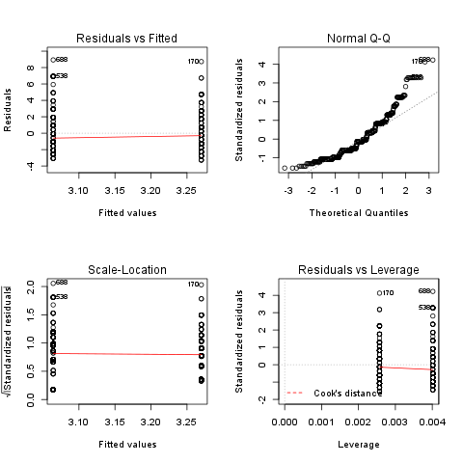
ANOVA Summary
ANOVA Table
 | Df | Sum.Sq | Mean.Sq | F.value | Pr..F.
gender | 1 | 6.4217 | 6.4217 | 1.4302 | 0.2322
Residuals | 636 | 2855.63 | 4.49

F-test for Gender is not statistically significant, which implies that there is no Gender effect on response variable.
Description
An ANOVA report with table of descriptives, diagnostic tests and ANOVA-specific statistics.
s
Introduction
Analysis of Variance or ANOVA is a statistical procedure that tests equality of means for several samples. It was first introduced in 1921. by famous English statistician Sir Ronald Aylmer Fisher.
Model Overview
Two-Way ANOVA was carried out, with Gender and Relationship status as independent variables, and Internet usage in leisure time (hours per day) as a response variable. Factor interaction was taken into account.
Descriptives
In order to get more insight on the model data, a table of frequencies for ANOVA factors is displayed, as well as a table of descriptives.
Frequency Table
Below lies a frequency table for factors in ANOVA model. Note that the missing values are removed from the summary.
gender | partner | N | % | Cumul. N | Cumul. %
male | in a relationship | 150 | 23.6967 | 150 | 23.6967
female | in a relationship | 120 | 18.9573 | 270 | 42.654
male | married | 33 | 5.2133 | 303 | 47.8673
female | married | 29 | 4.5814 | 332 | 52.4487
male | single | 204 | 32.2275 | 536 | 84.6761
female | single | 97 | 15.3239 | 633 | 100
Total | Total | 633 | 100 | 633 | 100

Descriptive Statistics
The following table displays the descriptive statistics of ANOVA model. Factor levels and/or their combinations lie on the left hand side, while the corresponding statistics for response variable are given on the right-hand side.
gender | partner | min(resp) | max(resp) | mean(resp) | SD(resp) | median(resp) | IQR(resp) | skewness(resp) | kurtosis(resp)
male | in a relationship | 0.5 | 12 | 3.0582 | 1.9692 | 2.5 | 2 | 1.3376 | 5.727
male | married | 0 | 8 | 2.9848 | 2.029 | 3 | 2 | 0.9027 | 3.351
male | single | 0 | 10 | 3.5027 | 1.9361 | 3 | 3 | 0.7636 | 3.1208
male |  | 0.5 | 6.5 | 3.1304 | 1.7788 | 3 | 2.75 | 0.0719 | 1.9965
female | in a relationship | 0.5 | 10 | 3.0439 | 2.2158 | 3 | 3 | 1.4017 | 4.9165
female | married | 0 | 10 | 2.4808 | 1.9671 | 2 | 1.75 | 2.1875 | 9.2864
female | single | 0 | 12 | 3.3226 | 2.6791 | 3 | 3.5 | 1.2045 | 4.0139
female |  | 0.5 | 6 | 2.6562 | 1.739 | 2 | 3 | 0.6914 | 2.4285
 | in a relationship | 0 | 8 | 3.3333 | 2.4398 | 3 | 2.5 | 0.7897 | 2.5973
 | married | 2 | 7 | 3.8 | 1.9235 | 3 | 1 | 1.018 | 2.6519
 | single | 0 | 10 | 3.5833 | 3.2039 | 3 | 1.5 | 1.279 | 3.4365
 |  | 1 | 2 | 1.5 | 0.7071 | 1.5 | 0.5 | 0 | 1

Diagnostics
Before we carry out ANOVA, we'd like to check some basic assumptions. For those purposes, normality and homoscedascity tests are carried out alongside several graphs that may help you with your decision on model's main assumptions.
Diagnostics
Univariate Normality
We will use Shapiro-Wilk, Lilliefors and Anderson-Darling tests to screen departures from normality in the response variable (Internet usage in leisure time (hours per day)).
 | W | p
shapiro.test | 0.9001 | 0
lillie.test | 0.168 | 0
ad.test | 18.753 | 0

As you can see, applied tests confirm departures from normality.
Homoscedascity
In order to test homoscedascity, Bartlett and Fligner-Kileen tests are applied.
 | H | p
fligner.test | 1.1234 | 0.2892
bartlett.test | 11.1267 | 0.0009

When it comes to equality of variances, applied tests yield inconsistent results. While Fligner-Kileen test confirmed the hypotheses of homoscedascity, Bartlett's test rejected it.
Diagnostic Plots
Here you can see several diagnostic plots for ANOVA model:
• residuals against fitted values
• scale-location plot of square root of residuals against fitted values
• normal Q-Q plot
• residuals against leverages
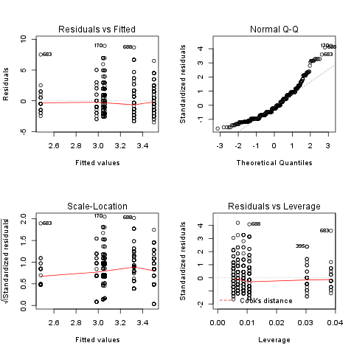
ANOVA Summary
ANOVA Table
 | Df | Sum.Sq | Mean.Sq | F.value | Pr..F.
gender | 1 | 4.9473 | 4.9473 | 1.0853 | 0.2979
partner | 2 | 31.2124 | 15.6062 | 3.4237 | 0.0332
gender:partner | 2 | 3.0375 | 1.5188 | 0.3332 | 0.7168
Residuals | 593 | 2703.0899 | 4.5583

F-test for Gender is not statistically significant, which implies that there is no Gender effect on response variable. Effect of Relationship status on response variable is significant. Interaction between levels of Gender and Relationship status wasn't found significant (p = 0.717).
—————
This report was generated in R with Rapport in 0.617 sec. Feel free to create your own reporting templates!


