Example template
(Username not set) (E-mail address not set)
2011-04-26 20:25 CET

Description
This template demonstrates the basic features of rapport. We all hope you will like it!

Début
Hello, world!
I have just specified a Variable in this template named to leisure. The label of this variable is "Internet usage in leisure time (hours per day)".
And wow, the mean of leisure is 3.1994!

Descriptive statistics
Min. | 1st Qu. | Median | Mean | 3rd Qu. | Max. | NA's
0.000 | 2.000 | 3.000 | 3.199 | 4.000 | 12.000 | 37.000
The 5 highest values are: 12, 12, 10, 10 and 10.

Description
This template demonstrates the basic features of rapport. We all hope you will like it!

Début
Hello, world!
I have just specified a Variable in this template named to leisure. The label of this variable is "Internet usage in leisure time (hours per day)".
And wow, the mean of leisure is 3.1994!
For more detailed statistics, you should have set desc=TRUE!

Description
This template demonstrates the basic features of rapport. We all hope you will like it!

Début
Hello, world!
I have just specified a Variable in this template named to leisure. The label of this variable is "Internet usage in leisure time (hours per day)".
And wow, the mean of leisure is 3.1994!
For more detailed statistics, you should have set desc=TRUE!

Histogram
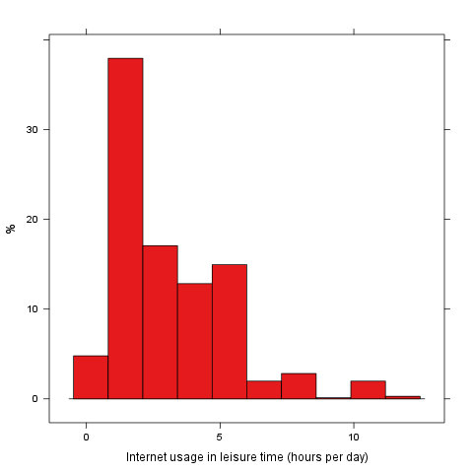

Description
This template demonstrates the basic features of rapport. We all hope you will like it!

Début
Hello, world!
I have just specified a Variable in this template named to leisure. The label of this variable is "Internet usage in leisure time (hours per day)".
And wow, the mean of leisure is 3.1994!
For more detailed statistics, you should have set desc=TRUE!

Histogram
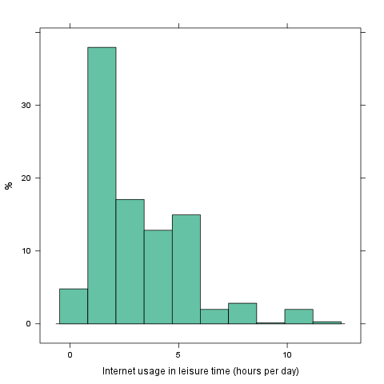

This report was generated with rapport.


