**Udacity First Project – Explore Weather Trends**

My goal is to create a visualization and prepare a write up describing the similarities and differences between global temperature trends and temperature trends in the closest big city to where you live. To do this, I follow the steps below:

* **Extract the data** from the database. There's a workspace in the next section that is connected to a database. I export the temperature data for the world as well as for the closest big city to where you live. You can find a list of cities and countries in the city_list table. To interact with the database, I write a SQL queries as shown below.







* **Download csv file for each query**. All these files are listed below.
  + city_data_ankara.csv
  + city_list_ankara_turkey.csv
  + global_data.csv
* **Open Jupyter Notebook** to handle with this process.
* **Create** P1_Explore_Weather_Trends.ipynb as **Python 3**.
* **Import** all relevant and essential libraries used in this process.

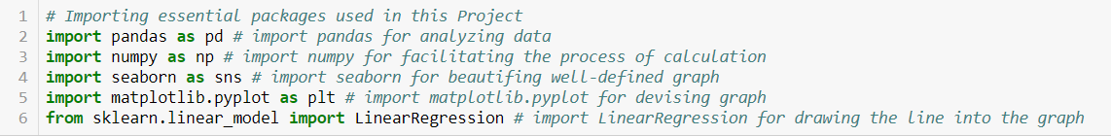

* **Load all these csv files** and **assign** them to each relevant **dataframe**.

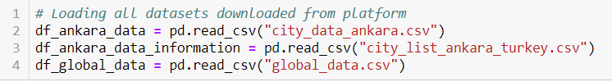

* **Determine** whether **each data frame** has value or not.

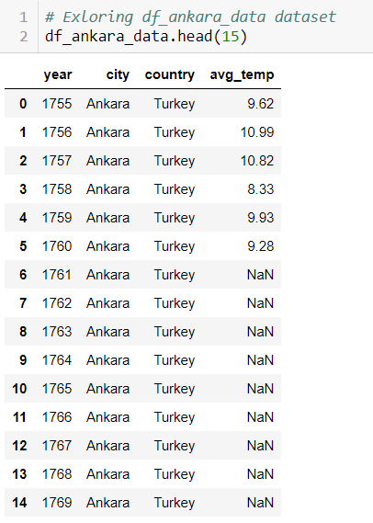

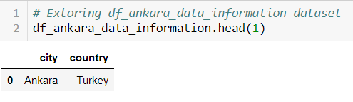

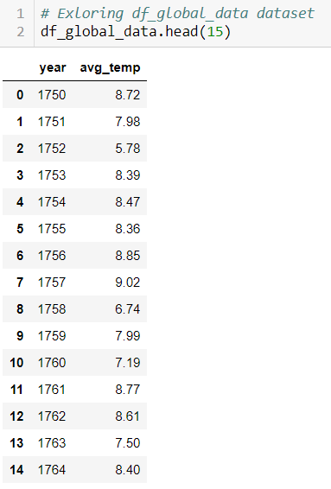

* **Eliminate** null values from **df_ankara_data** and check if null value is appeared or not.

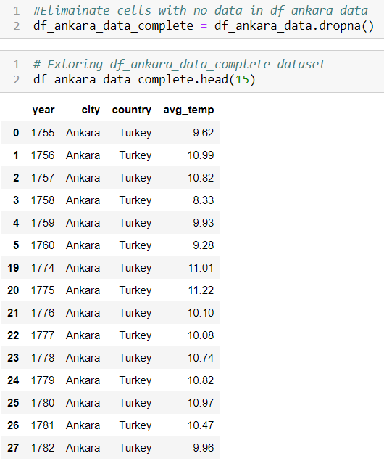

* Because both global and Ankara data **csv files** have **avg_temp** column, I changed it as a **relevant name with respect to its relevant file** for calcualting **moving averange** having 10 window size. Moreover, as **all values** are the same as **avg_temp**, I defined **None** for assignment process.

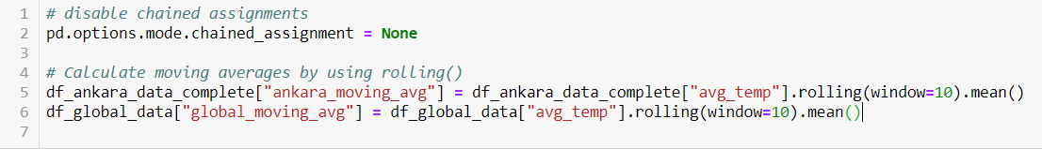

* **Create a new data frame** having year, ankara_moving_avg and lastly global_moving_avg. **Eliminate null values** in this new data frame. **Show** it.

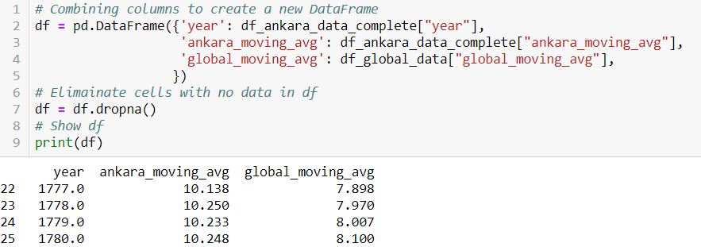

* **Reshape this data frame** by using **melt function** and **Determine** year **as id, ankara_moving_avg and global_moving_avg** as **variable** and lastly **their values** as shown **observation**.

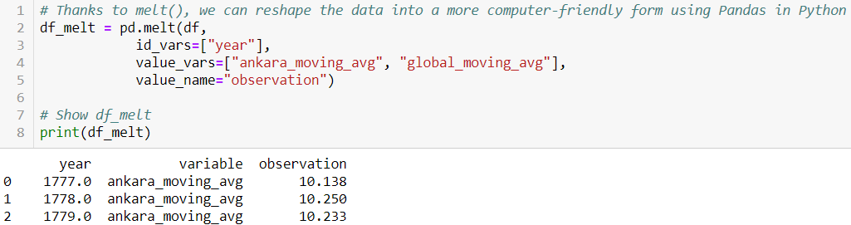

* **Show the graph** by using **this reshaped data frame**

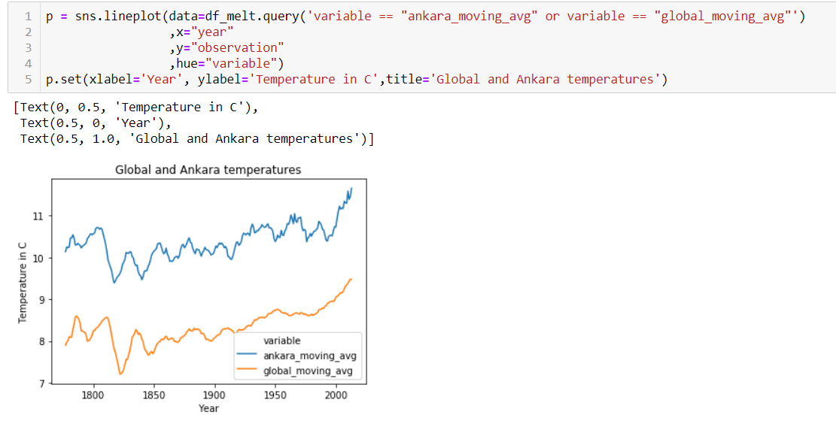

* **Determine the observation** based on a graph shown above.
  + **First Observation** is determined whether Ankara hotter or colder than the global average and show how it has changed over time?
    - **Calculate the temperature difference** between the average temperature of both Ankara and Global. Then, Calculating moving averange for temperature difference which has been done before. Add all two values into the data frame.

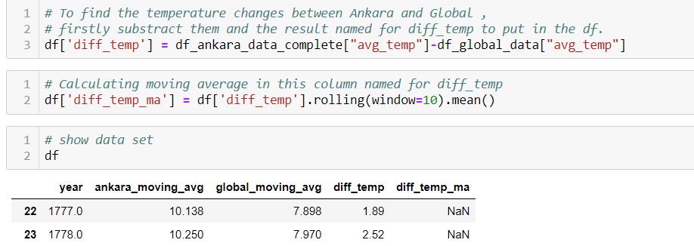

* **Use describe()** function to get more detail information of this data frame.

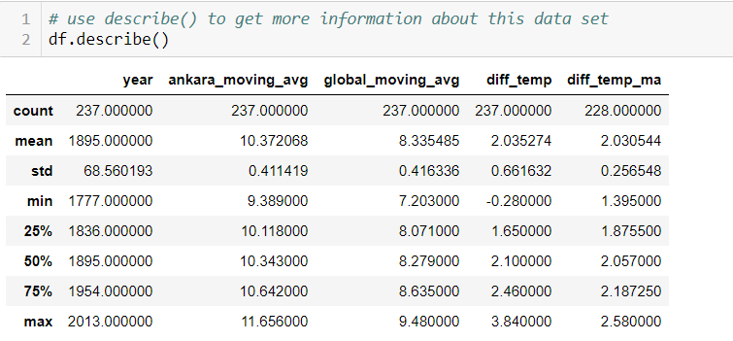

* **Draw Graph**

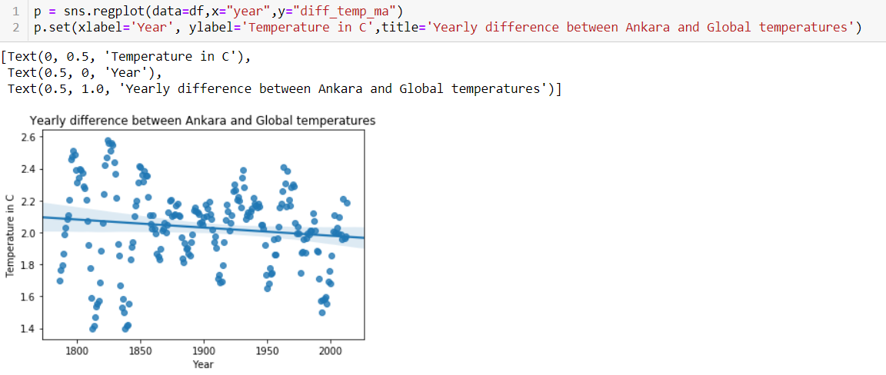

**The result of Observation 1 :** During 300 years, Ankara was hotter than the global averange approximately 2.03 coming from diff_temp column based on mean row. Moreover, its temperature ratio comparing to global averange was slightly getting lower year by year from starting point(nearly 2,1) to end point(nearly 1,9)

* + **Second Observation and Third Observation** are shown what the general trend looks like and determine both the temperature of Ankara and Global are getting hotter or not?
    - In order to look through Ankara Graph firstly, first add **averange temperature of Ankara** into the dataframe and **draw the graph** be using year and this temperature.

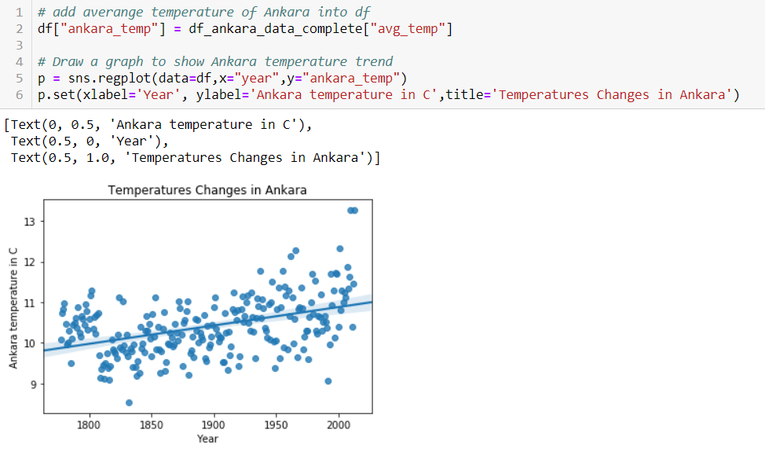

* + - In order to find slope of the line, first **reshape of year** part of this graph.

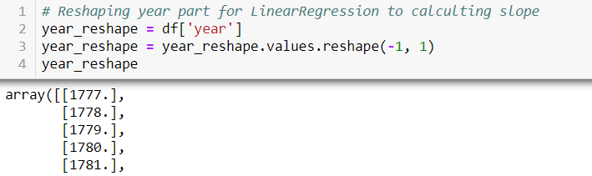

Determine y-axis as averange temperature of Ankara and determine a Linear Regression by using year as x-axis and y-axis for averange temperature of Ankara.

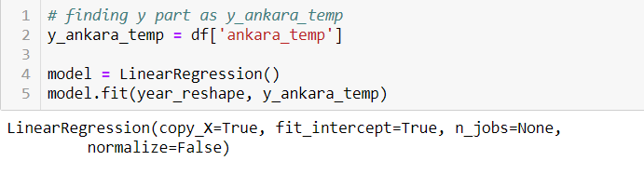

* + - **Show slope**

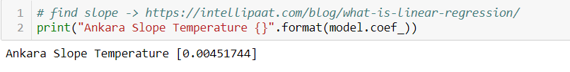

**The result of Observation 2 :** During 300 years, Ankara has been getting hotter by approximately 0.0045 ratio per pear. Its trend is going up.

* + - In order to look through Global Temperature lastly, The same process has been done for it by using the averange temperature of Global.

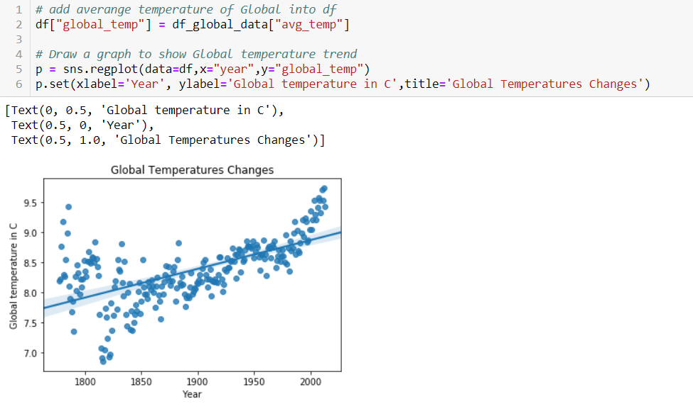

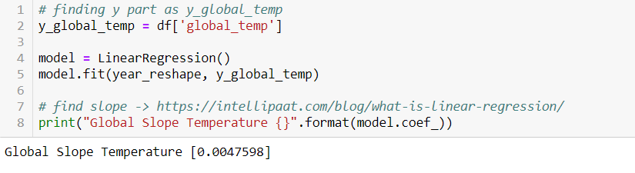

**The result of Observation 3 :** During 300 years, Global Temperature has been getting hotter by approximately 0.0047 ratio per pear. Its trend is going up.

* + **Fourth Observation and Fifth Observation** are shownhow the trend has changed in the last 10 years?
    - **Using Filter** to shown only the last 10 years for year’s column and then show new data frame.

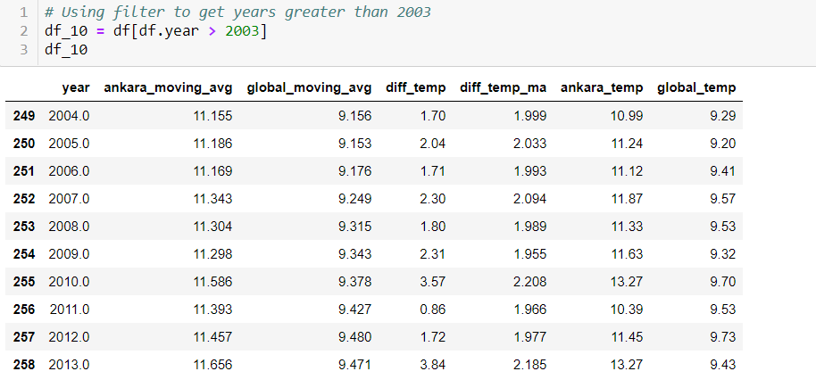

* + - Draw a graph for his data frame as shown above for Ankara.

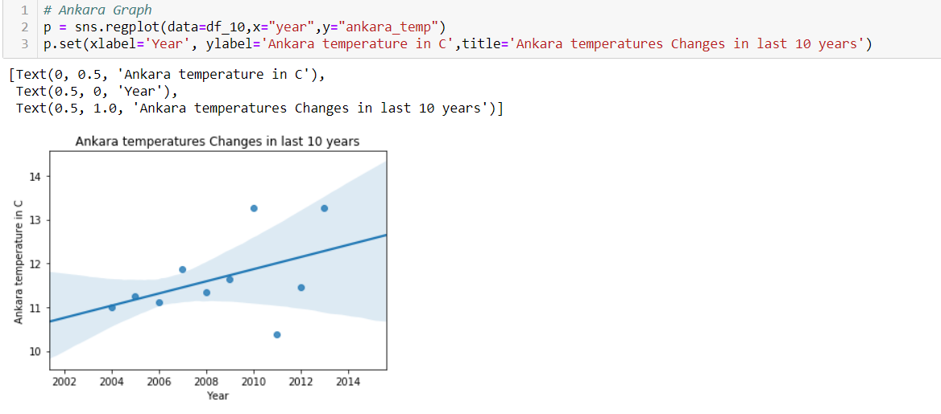

* + - Find Slope fort his graph

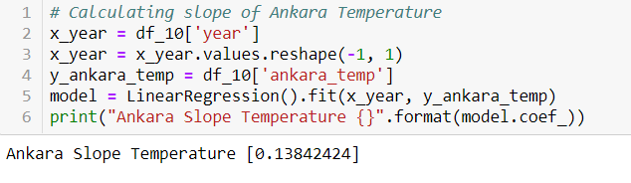

**The result of Observation 4** : During 10 years, Ankara has been getting hotter by approximately 0.13 ratio per pear. Its trend is going up.

* + - The same process has done for Global Temperature

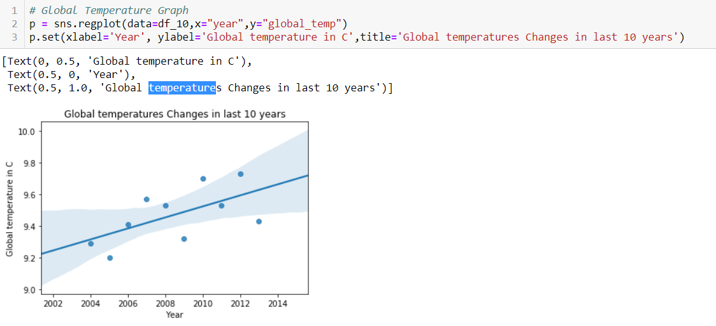

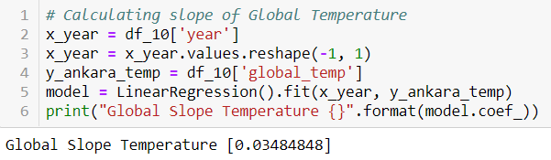

**The result of Observation 4** : During 10 years, Ankara has been getting hotter by approximately 0.034 ratio per pear. Its trend is going up.

The resource Link : [Project Link](https://github.com/Rapter1990/Udacity-Data-Analyst-Nanodegree/blob/master/P1_Explore_Weather_Trends/P1_Explore_Weather_Trends.ipynb)