Open Call 1

D2.1
System Architecture Specification

DOCUMENT CONTROL SHEET
HEDGE IoT PROJECT INFORMATION
Project Number | 101136216
Project Acronym | HEDGE-IoT
Project Full title | Holistic Approach towards Empowerment of the Digitalization of the Energy Ecosystem through adoption of IoT solutions
Project Start Date | 01 October 2024
Project Duration | 48 months
Funding Instrument | HORIZON | Type of action | HORIZON Innovation Actions
Call | HORIZON-CL5-2023-D3-01
Topic | HORIZON-CL5-2023-D3-01-15
Coordinator | EUROPEAN DYNAMICS LUXEMBOURG SA (ED)
OPEN CALL 1 PROJECT INFORMATION
Third Party Name
Project Acronym | HEDGE-ExpertAI
Project Full title | Context-Aware AI Discovery and Recommendation Assistant for the HEDGE-IoT App Store
Project Start Date
Project Duration | 6 months
Topic | Topic 15 — AI-Enhanced Data App Discovery & Recommendation Engine
Pilot | HEDGE-IoT App Store
Mentor

DELIVERABLE INFORMATION
Deliverable No. | D2.1
Deliverable Title | System Architecture Specification
Author
Reviewed by
Due date
Submission Date
Deliverable Type | ☒ Document, Report (R) ☐ DMP ☐ DEC ☐ Other
Dissemination Level | ☐ Public (PU) ☐ Sensitive (SEN) ☐ Classified
PU: Public, fully open
SEN: Sensitive, limited under the conditions of the Grant Agreement
Classified R-UE/EU-R – EU RESTRICTED under the Commission Decision No2015/444
Classified C-UE/EU-C – EU CONFIDENTIAL under the Commission Decision No2015/444
Classified S-UE/EU-S – EU SECRET under the Commission Decision No2015/444

Document Revision History
Version | Date | Description of change | List of contributor(s)

Disclaimer
This deliverable defines the HEDGE-ExpertAI system architecture and the integration interfaces required for the HEDGE-IoT App Store.

Copyright notice
© HEDGE-IoT, 2024

EXECUTIVE SUMMARY
HEDGE-ExpertAI is a six-month Open Call 1 project under HEDGE-IoT Topic 15. Its purpose is to make applications in the HEDGE-IoT App Store easier to discover and understand through natural-language interaction, hybrid retrieval, and concise explanations grounded in authoritative catalogue metadata.
This deliverable defines the target architecture for the App Store plug-in, backend integration boundary, conversational and recommendation capabilities, catalogue synchronization, metadata and semantic handling, security and deployment principles, and KPI measurement points.
The architecture separates platform integration concerns from the assistant capabilities and identifies the information exchanges required between HEDGE-IoT and HEDGE-ExpertAI. It provides the technical basis for implementation, integration, validation, and deployment planning.

TABLE OF CONTENTS
EXECUTIVE SUMMARY | 6
LIST OF FIGURES | 8
LIST OF TABLES | 8
ABBREVIATIONS | 9
1 INTRODUCTION | 10
2 ARCHITECTURE DRIVERS | 10
3 SYSTEM CONTEXT AND BOUNDARIES | 12
4 FUNCTIONAL ARCHITECTURE | 13
5 PRINCIPAL FLOWS | 15
6 INFORMATION AND SEMANTIC DESIGN | 17
7 EXTERNAL INTERFACES | 18
8 DEPLOYMENT, SECURITY AND OPERATIONS | 18
9 KPI AND VALIDATION DESIGN | 19
10 INTEGRATION COORDINATION | 20
11 RISKS AND MITIGATIONS | 20
12 TRACEABILITY | 21
13 CONCLUSION AND NEXT STEPS | 21
REFERENCES | 22

LIST OF FIGURES
Figure 1. Target system context and integration boundaries | 12
Figure 2. Functional architecture and information flows | 13
Figure 3. Proposed conversational request, retrieval, grounding, and response sequence | 15
Figure 4. Proposed catalogue acquisition, validation, lifecycle, indexing, and freshness-evidence sequence | 16

LIST OF TABLES
Table 1. Abbreviations used in this deliverable | 9
Table 2. Project functional requirements | 10
Table 3. Quality and validation requirements | 11
Table 4. Primary actors and responsibilities | 13
Table 5. Target components and responsibilities | 13
Table 6. Project technology baseline | 14
Table 7. Canonical App metadata model | 17
Table 8. KPI measurement approach | 19
Table 9. Integration inputs and project follow-up | 20
Table 10. Architecture and integration risks | 20
Table 11. Traceability from project objectives to this architecture | 21

ABBREVIATIONS
Table 1. Abbreviations used in this deliverable
Term | Meaning
API | Application Programming Interface
CORS | Cross-Origin Resource Sharing
CSP | Content Security Policy
DPIA | Data Protection Impact Assessment
GDPR | General Data Protection Regulation
HEDGE-IoT | Holistic Approach towards Empowerment of the Digitalization of the Energy Ecosystem through adoption of IoT solutions
KPI | Key Performance Indicator
LLM | Large Language Model
M1–M6 | Project months 1 through 6
OpenAPI | Machine-readable specification for HTTP APIs
RASA | Open-source conversational AI framework used in the project architecture
SAREF | Smart Applications REFerence ontology
SEN | Sensitive dissemination level under the Grant Agreement
TLS | Transport Layer Security

1 INTRODUCTION

1.1 Purpose
The purpose of D2.1 is to establish a reviewable architecture baseline for HEDGE-ExpertAI and provide a common reference for technical alignment between the HEDGE-ExpertAI project team and the relevant HEDGE-IoT contacts.

1.2 Scope
The specification covers the target system context, functional capabilities, principal request and synchronization flows, information model, external interfaces, security and privacy principles, deployment portability, and validation design.

1.3 Design basis
This architecture follows the scope, objectives, tasks, deliverables, technologies, and targets defined in the HEDGE-ExpertAI project proposal. HEDGE-IoT platform details are represented through explicit integration interfaces so that the design can be completed against the official App Store environment and technical guidance.

2 ARCHITECTURE DRIVERS

2.1 Functional requirements
Table 2. Project functional requirements
ID | Requirement
FR-01 | Accept a natural-language request and return relevant App suggestions with concise, source-grounded explanations.
FR-02 | Support conversational intent and entity handling, including the multi-turn behavior agreed for the pilot.
FR-03 | Combine keyword and semantic retrieval; use SAREF-aligned information only as an optional signal where authoritative metadata supports it.
FR-04 | Acquire and index catalogue metadata from the official HEDGE-IoT App Store interface.
FR-05 | Detect additions and changes; handle withdrawals or deletions if the agreed catalogue interface exposes those lifecycle signals.
FR-06 | Provide a lightweight plug-in compatible with the HEDGE-IoT App Store front end.
FR-07 | Expose backend integration interfaces through an OpenAPI-documented contract.
FR-08 | Collect only the interaction evidence required by the project validation plan.

2.2 Quality and validation requirements
Table 3. Quality and validation requirements
ID | Requirement or target | Architecture and verification response
QR-01 | At least 70% top-2 relevance on pilot queries. | Evaluate against a representative labelled query set and retain ranked outputs and relevance labels.
QR-02 | Architecture objective: average response time below 5 seconds; final validation target: median response time below 5 seconds. | Capture end-to-end request timings and report both average and median with the test conditions.
QR-03 | Operational indexing objective: new or updated Apps searchable within 2 hours; final validation ceiling: 24 hours. | Measure from the authoritative publication or update time to searchable availability and report both thresholds.
QR-04 | At least 50 labelled sample queries defined with the HEDGE-IoT team. | Jointly prepare representative queries and relevance labels, with a held-out evaluation set.
QR-05 | Explanations contextually accurate in at least 80% of reviewed cases. | Apply a source-grounding and contextual-accuracy review rubric to the evaluation sample.
QR-06 | At least one accepted recommendation in at least 70% of pilot sessions. | Record the defined acceptance action and calculate the result over complete pilot sessions.
QR-07 | At least 10 complete user-interaction sessions. | Record complete session evidence for the final validation report.
QR-08 | Containerized, documented, reusable delivery with Apache-2.0 licensing for the core integration toolkit. | Maintain container, API, deployment, licence, and dependency documentation.
QR-09 | At least 80% unit and integration test coverage of core functionality. | Measure the defined core code scope and publish the coverage report with test evidence.
QR-10 | Multilingual text input and multi-turn dialogue. | Include the selected pilot languages and representative dialogue scenarios in the test plan.

2.3 Architecture principles
• Authoritative-source first: recommendations and explanations are grounded in App Store records obtained through the agreed interface.
• Contract before coupling: external schemas, identity behavior, and lifecycle rules are versioned and tested at the integration boundary.
• Functional portability: capabilities are defined independently of a single database, vector engine, cache, queue, or model runtime.
• Least privilege and data minimization: only the minimum agreed metadata, query context, and validation evidence cross each boundary.
• Observable outcomes: request, retrieval, synchronization, and validation timestamps are measurable without exposing sensitive content.
• Graceful degradation: failure of optional semantic or generation capabilities does not create unsupported recommendations.

3 SYSTEM CONTEXT AND BOUNDARIES

3.1 External context
The solution spans two environments: the HEDGE-IoT App Store environment, which hosts the front end and catalogue interface, and the HEDGE-ExpertAI deployment environment, which hosts the assistant capabilities. Their integration covers the user-facing plug-in, catalogue metadata exchange, platform-supported access controls, and validation evidence.
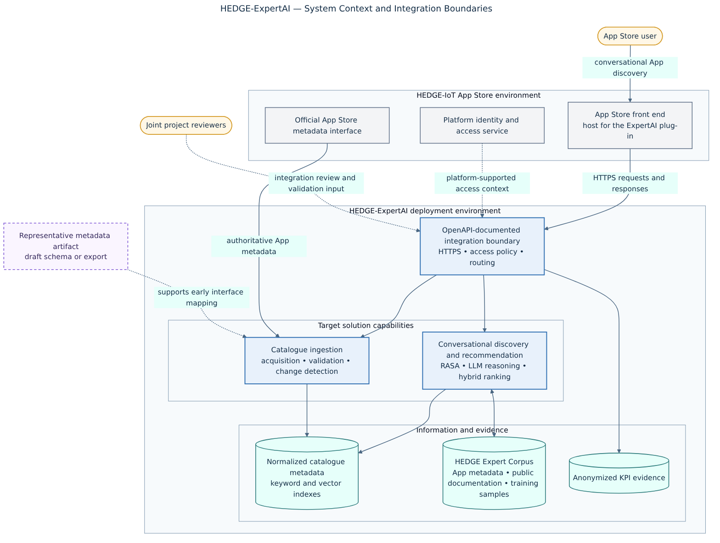
Figure 1. Target system context and integration boundaries.

3.2 Trust boundaries
• The App Store-facing backend boundary provides the integration entry point for assistant requests.
• The official App Store interface provides the catalogue records used for discovery; its contract defines identifiers, fields, timestamps, and available lifecycle signals.
• Identity and access behavior follows the mechanism and policy supported by the App Store environment.
• The LLM receives only the query context and source records needed to create the response.
• Validation evidence is separated from catalogue data and handled according to the project retention and access policy.

3.3 Actors and responsibilities
Table 4. Primary actors and responsibilities
Actor | Responsibility
App Store user | Express a need, review returned Apps and rationales, and provide feedback where consented.
HEDGE-IoT App Store technical contact | Provide the integration surface, catalogue contract, sandbox access process, and lifecycle semantics.
HEDGE-IoT identity and security contact | Provide the supported access context, browser policy, service-authentication approach, and security requirements.
Deployment operations contact | Provide hosting and network requirements where HEDGE infrastructure is used and coordinate operational handover.
Project validation reviewers | Collaborate on representative queries, relevance labels, review criteria, and validation evidence.
HEDGE-ExpertAI project team | Maintain the architecture; implement and test the integration contracts; provide documentation and validation artifacts.

4 FUNCTIONAL ARCHITECTURE

4.1 Capability view
The target design separates the online conversational path from catalogue synchronization. Both paths depend on normalized, provenance-aware metadata and meet at the discovery and ranking capability. This separation allows catalogue updates and user requests to be scaled, tested, and governed independently.
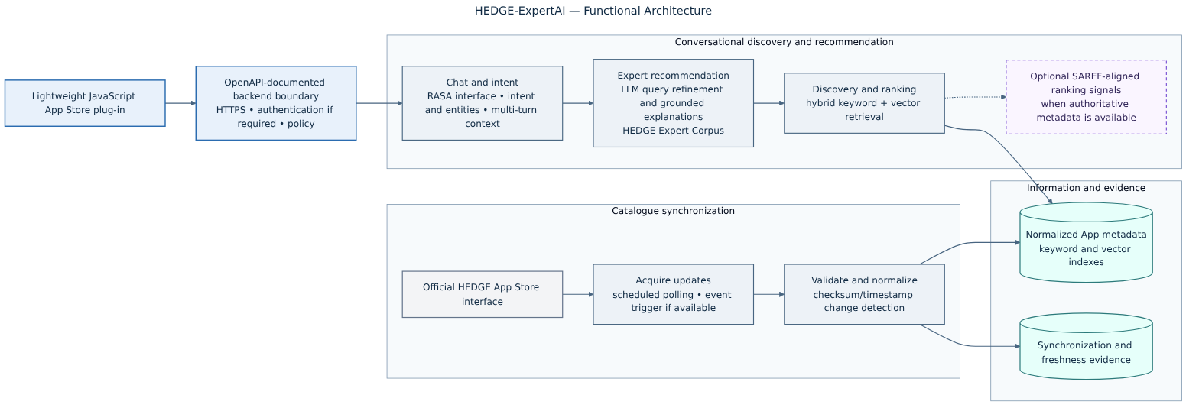
Figure 2. Functional architecture and information flows.

4.2 Component responsibilities
Table 5. Target components and responsibilities
Component | Responsibility | Principal interface or state
App Store plug-in | Capture natural-language requests; render recommendations, rationales, source links, and pilot feedback controls. | HEDGE front end; HTTPS request/response or the selected streaming pattern.
Backend boundary | Apply access policy, request validation, routing, rate control, correlation identifiers, and API versioning. | OpenAPI-documented external contract.
Chat and intent | Interpret intent and entities; manage the agreed conversational context; coordinate response assembly. | RASA interface and application session context.
Expert recommendation | Refine the search intent; request ranked candidates; create concise grounded rationales; apply output checks and fallback rules. | Discovery/ranking interface and selected LLM runtime.
Discovery and ranking | Retrieve lexical and semantic candidates, combine rankings, apply filters and optional authoritative SAREF signals. | Keyword and vector representations.
Catalogue ingestion | Acquire, validate, normalize, compare, and apply catalogue lifecycle changes with provenance and retry controls. | Official metadata contract and synchronization evidence.
Metadata repository | Maintain canonical normalized records, source identifiers, versions, timestamps, lifecycle status, and provenance. | Authoritative internal representation derived from HEDGE records.
Retrieval indexes | Provide replaceable lexical and semantic search representations derived from normalized metadata. | Keyword and vector indexes; rebuildable from canonical records.
HEDGE Expert Corpus | Provide curated contextual material for domain adaptation, query interpretation, and source-grounded explanations. | Corpus manifest, provenance, versions, and access policy.
Validation evidence | Support the future recording of metric inputs and validation results without unnecessary query-content retention. | Controlled evidence structure and export format.

4.3 Technology alignment
The project technology baseline uses open-source frameworks and portable interfaces across the conversational, retrieval, ingestion, and delivery layers.
Table 6. Project technology baseline
Area | Technology baseline
Conversation and integration | RASA/Python; FastAPI endpoints; lightweight JavaScript plug-in; HTTPS; OAuth-compatible authentication if required.
Recommendation and retrieval | LangChain or equivalent orchestration; Elasticsearch or Whoosh for keyword retrieval; FAISS for vector indexing and search; SentenceTransformers with open embedding models such as MiniLM or all-MPNet-base-v2.
Ingestion and scheduling | Node.js and Python; checksums or timestamps for change detection; Celery and Redis workers; webhooks/event updates if the official interface provides them.
Packaging and delivery | Docker and local Docker Compose; portability toward Kubernetes; GitHub Actions for linting, tests and container builds; OpenAPI documentation.

SAREF-aligned information is used as an optional ranking signal where corresponding metadata and provenance are available. Publisher-supplied terms, project mappings, and inferred labels remain distinguishable in the data model.

5 PRINCIPAL FLOWS

5.1 Conversational recommendation flow
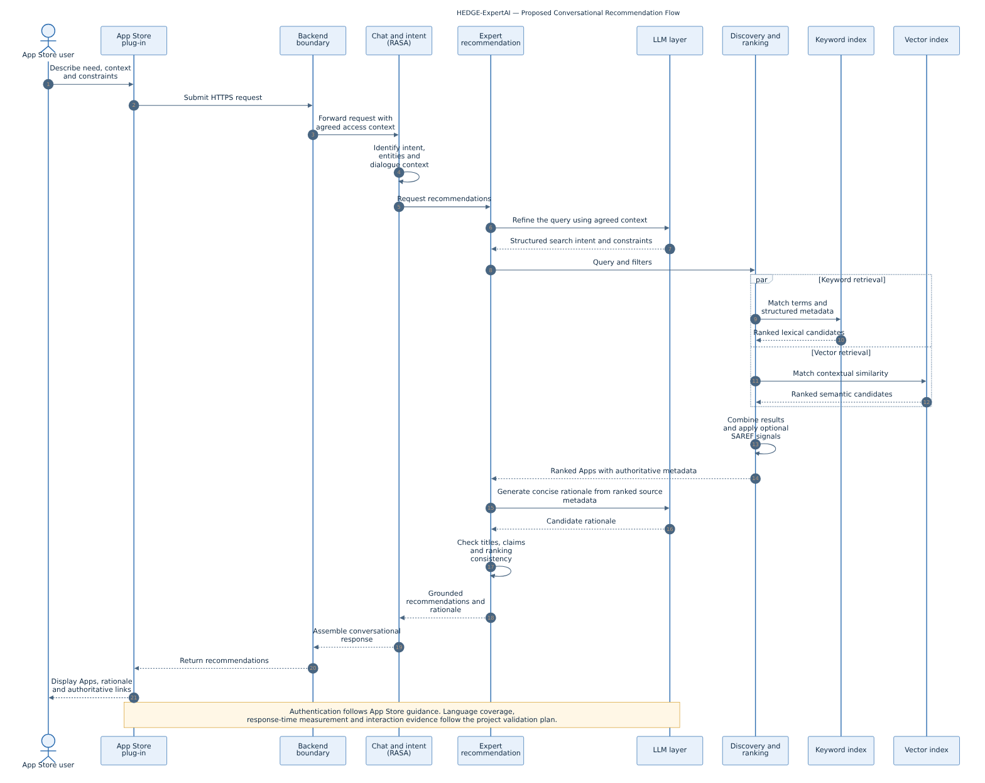
Figure 3. Proposed conversational request, retrieval, grounding, and response sequence.
1. The user expresses a need, operating context, or constraint through the App Store plug-in.
2. The backend boundary validates the request and passes only the agreed access and session context.
3. The conversational layer identifies intent, entities, and the context permitted by the agreed interaction model.
4. The recommendation capability refines the structured search intent and requests keyword and semantic candidates.
5. The ranking capability combines candidates, applies structured filters, and uses SAREF-aligned signals only where authoritative information exists.
6. The recommendation capability creates a concise rationale from the returned source records and checks names, claims, links, and ranking consistency.
7. The plug-in presents recommendations and source links; agreed interaction evidence is recorded separately from catalogue data.

5.2 Catalogue synchronization flow
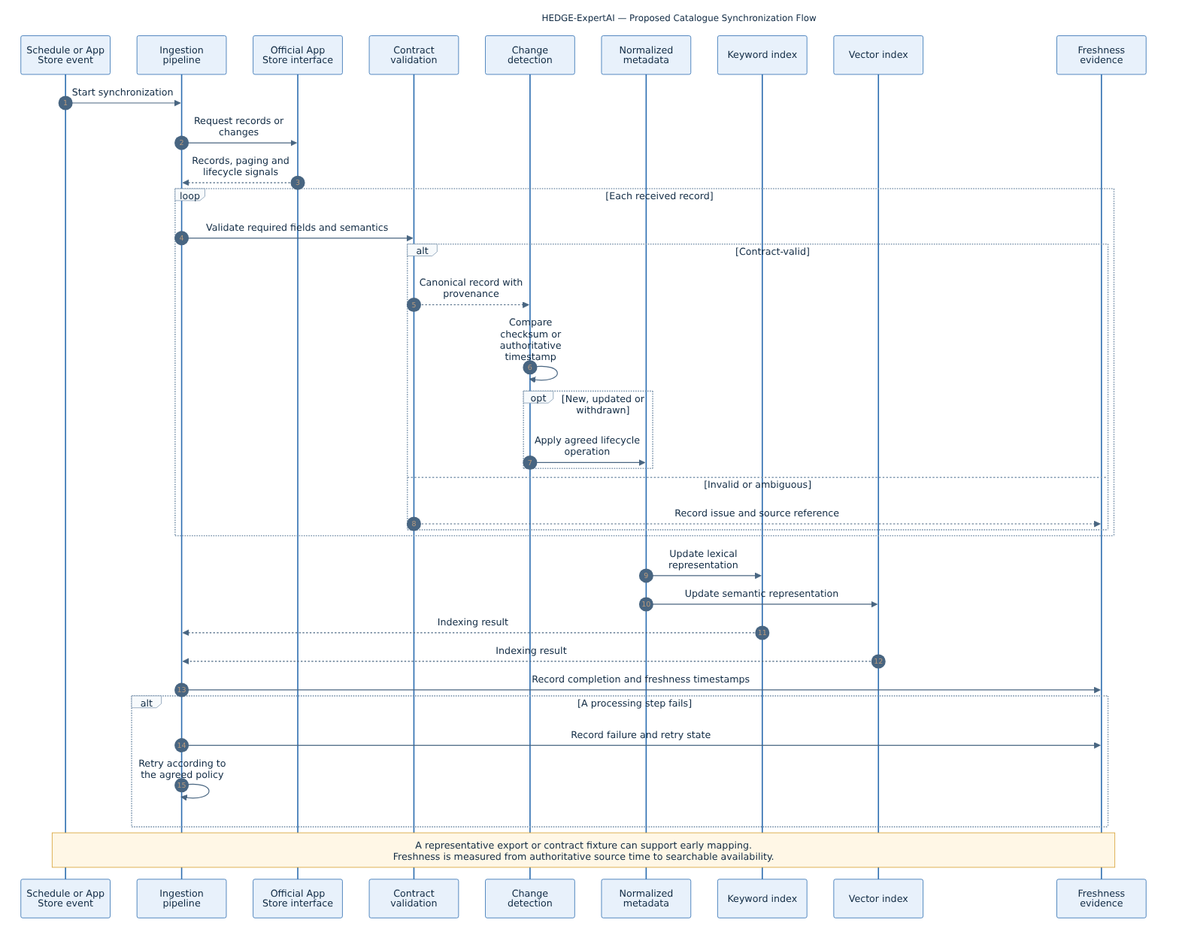
Figure 4. Proposed catalogue acquisition, validation, lifecycle, indexing, and freshness-evidence sequence.
1. A schedule or App Store event initiates synchronization according to the agreed interface capability.
2. The ingestion capability requests records or changes and observes pagination, rate limits, and retry guidance.
3. Records are validated against the versioned contract and normalized with source provenance.
4. Stable identifiers, authoritative timestamps or checksums, and lifecycle signals determine whether to add, update, withdraw, delete, or leave a record unchanged.
5. Canonical metadata is applied before derived keyword and vector representations are updated.
6. Completion, source time, searchable time, failures, and retries are recorded to support the agreed freshness metric.

6 INFORMATION AND SEMANTIC DESIGN

6.1 Canonical App record
Table 7. Canonical App metadata model
Field group | Required design intent
Identity | Stable App identifier; canonical detail/navigation link; publisher or responsible party where supplied.
Discovery content | Title, concise and detailed descriptions, keywords/tags, categories, and supported language.
Technical context | Inputs, outputs, protocols, deployment or device constraints, dependencies, and version where supplied.
Lifecycle | Publication status, version, created/updated timestamps, withdrawal/deletion signal, and source schema version.
Semantics | Authoritative SAREF or extension URIs/labels and provenance when the source contract supplies them.
Provenance | Source endpoint or export, acquisition time, source revision, normalization version, and validation outcome.

6.2 Derived search representations
Keyword and vector indexes are derived, rebuildable representations. They do not replace the normalized catalogue record as the authoritative catalogue representation. A ranking result must retain the source App identifier and enough provenance to construct an authoritative link and explain the matched evidence.

6.3 HEDGE Expert Corpus
The HEDGE Expert Corpus comprises App metadata, public HEDGE-IoT documentation, and training samples. It supports domain adaptation, intent understanding, and concise, source-grounded explanations within the expert recommendation layer.
Corpus preparation and model adaptation shall preserve source provenance, applicable licences, data-protection requirements, reproducibility, and evaluation evidence. The detailed procedure will be documented as part of the AI processing and validation design.

6.4 Data minimization and retention
The use case relies on public App metadata and user-initiated queries and does not require personal data. Logs used for KPI measurement are anonymized and retained only for the project period. Query-content storage is minimized, and access tokens and unnecessary prompt content are excluded from logs. If the data-processing scope changes, the project will assess and apply the required data-protection measures, including a DPIA where applicable.

6.5 Public telemetry statement
Anonymized telemetry intended for public reporting is limited to aggregate, non-identifying project metrics. The reporting plan will define the publication destination, included fields, schedule, retention period, and responsible owner before export.

7 EXTERNAL INTERFACES

7.1 App Store metadata interface
The App Store metadata interface covers the base environment, authentication, list and detail operations, field schema, pagination, rate limits, error model, schema versioning, lifecycle behavior, localization, and event or polling support. A representative export or draft contract can support early mapping, while final compatibility and freshness evidence uses the official interface contract.

7.2 App Store plug-in
Plug-in integration covers the embedding mechanism, asset hosting, navigation links, visual and accessibility guidance, browser support, CSP/CORS behavior, localization, release process, analytics, and feedback handling. Authentication and browser-security behavior follow the approach supported by the App Store environment.

7.3 Backend contract
Externally consumed operations are versioned and described through OpenAPI. The contract covers request and response schemas, error codes, correlation identifiers, authentication and authorization requirements, timeouts, rate limits, the selected response-delivery pattern, and compatibility policy. Example payloads use synthetic or authorized records.

7.4 Identity and access
The project design supports OAuth-compatible authentication where required by the App Store environment. The interface specification will document the platform-supported user and service access model, including credential or token validation, authorization scope, session lifecycle, and service-to-service rules where applicable.

8 DEPLOYMENT, SECURITY AND OPERATIONS

8.1 Deployment boundary
The pilot architecture supports deployment on an owned server hosted in an EU ISO/IEC 27001-certified data centre and remains portable to a HEDGE-IoT data centre or cloud node. Deployment planning will assign responsibilities for infrastructure, network access, secrets, monitoring, backup, incident handling, and handover for the selected environment.

8.2 Network and secrets
• Expose only the agreed backend boundary; keep data services and model runtimes on non-public service networks.
• Use TLS for external traffic and for internal traffic where the hosting threat model requires it.
• Store secrets outside images and source control; define issuance, rotation, revocation, and emergency access responsibilities.
• Apply allow-lists or egress policy for the official catalogue source and any agreed model or observability service.
• Record security-relevant events without tokens, full prompts, or unnecessary catalogue payloads.

8.3 Availability and graceful degradation
Timeouts, bounded retries, backoff, circuit-breaking, health checks, and rollback are defined per environment. If the LLM is unavailable or cannot produce a grounded rationale, the service should return deterministic ranked results with source links or abstain; it must not manufacture catalogue facts. If optional semantic metadata is absent, retrieval continues without the semantic boost.

8.4 Operational evidence
Operational monitoring should cover service availability, request latency, retrieval latency, error rates, synchronization outcomes, source-to-searchable freshness, queue or schedule health, and index consistency. Exact tooling and retention are environment decisions, not architecture claims.

9 KPI AND VALIDATION DESIGN

9.1 Measurement principles
• Freeze the representative catalogue snapshot, query set, labels, configuration, and software version for each formal run.
• Separate development/tuning queries from the held-out acceptance set.
• Define every numerator, denominator, exclusion, warm-up condition, and clock boundary before collecting evidence.
• Retain reproducible aggregate results and only the minimum necessary underlying evidence.
• Report confidence intervals or sample-size limitations where they materially affect interpretation.

9.2 Measurement points
Table 8. KPI measurement approach
KPI | Measurement | Planned evidence
Top-2 relevance | Share of held-out queries for which at least one of the first two Apps is labelled relevant under the defined rubric. | Frozen catalogue/query set, labels, ranking output, configuration, adjudication record.
Response time | Elapsed time between the defined request-start and response-complete events; report the required statistics and distribution. | Timestamped run log, environment/load profile, failures and exclusions.
Catalogue freshness | Elapsed time from the authoritative source event or timestamp to successful searchable availability. | Source time, acquisition time, index-complete time, lifecycle result, retries.
Explanation accuracy | Share of reviewed rationales meeting the agreed source-grounding and contextual-accuracy rubric. | Sample, source records, rationale, reviewer ratings, disagreements.
Accepted sessions | Share of complete consented sessions containing the defined acceptance action. | Pseudonymous session events, action definition, denominator and exclusions.
Session count | Number of complete interaction sessions meeting the defined completeness rule. | Session lifecycle evidence and consent/retention record.
Retrieval diagnostics | Precision, recall and mean reciprocal rank using the evaluation set. | Metric definitions, ranked output, labels, configuration and reproducible calculation.

9.3 Additional project indicators
Additional project-end indicators are TRL 8; at least 50 reproducible test cases; a 25% reduction in manual catalogue-maintenance actions; at least 30% faster App identification; and at least 60% of sandbox Apps receiving a qualified visit generated by the assistant. The validation plan will document the baseline, attribution rule, evidence source, and calculation method used for each indicator. Continuous adaptation to new Apps and interaction evidence will follow the same controlled evaluation process.

10 INTEGRATION COORDINATION
The following coordination points support App Store integration and the joint validation activities defined in the project plan. For each input, the HEDGE-ExpertAI team will provide a corresponding technical artifact for review.
Table 9. Integration inputs and project follow-up
Priority / area | HEDGE-IoT input | HEDGE-ExpertAI follow-up
Priority 1 — Technical coordination | Contacts for the App Store interface, front end, identity/security, infrastructure, and validation activities. | Maintain a concise contact and action register and route technical questions to the relevant role.
Priority 1 — Metadata interface | Sandbox access process, API and authentication guidance, representative records, and interface behavior. | Prepare the field and lifecycle mapping, adapter contract, and interface-test specification.
Priority 1 — Plug-in integration | Embedding and asset-hosting guidance, navigation behavior, browser/accessibility constraints, and supported access model. | Prepare the plug-in integration specification and compatibility checklist.
Priority 1 — Deployment interface | Applicable ingress, egress, DNS/TLS, secrets, infrastructure, and operational requirements for the selected environment. | Provide the deployment plan, resource estimate, connectivity checks, and rollback procedure.
Priority 2 — Catalogue semantics | Examples covering identifiers, required fields, timestamps, localization, lifecycle behavior, and available SAREF-aligned metadata. | Prepare the canonical mapping, synchronization rules, and semantic-validation specification.
Priority 2 — Joint validation | Participation in preparing the labelled query set and reviewing relevance and explanation criteria. | Prepare the reproducible test protocol and planned evidence format.

11 RISKS AND MITIGATIONS
Table 10. Architecture and integration risks
Risk | Effect | Mitigation / decision
Official interface availability or change | Can delay mapping or invalidate synchronization behavior. | Use a versioned adapter and an agreed contract fixture; freeze the schema used for formal validation.
Measurement protocol incomplete | Results may not be comparable across test runs. | Baseline the metric definitions, dataset, environment, and calculation method before formal evidence collection.
Ungrounded generated explanations | Can reduce trust or misrepresent Apps. | Ground on source records, validate claims and links, constrain output, and use deterministic fallback or abstention.
Catalogue lifecycle incomplete | Withdrawn or changed Apps can remain discoverable. | Agree stable IDs, timestamps, tombstones/deletion behavior, reconciliation, and freshness measurement.
Frontend integration incompatibility | Plug-in may fail CSP, identity, accessibility, or release requirements. | Apply the App Store integration guidance and test against the staging environment.
Deployment responsibilities incomplete | Can create gaps in DNS/TLS, secrets, monitoring, incident response, and rollback. | Document the responsibility matrix and environment checklist before deployment.
Personal data enters free text | Creates unplanned privacy and retention obligations. | Minimize logging, filter sensitive fields, apply the retention and access policy, and reassess data-protection requirements if scope changes.

12 TRACEABILITY
Table 11. Traceability from project objectives to this architecture
Project objective | Architecture response | Verification path
Objective 1 — conversational discovery | Sections 4 and 5 define the plug-in, conversational path, retrieval, and grounded response. | Agreed interface tests and user scenarios.
Objective 2 — metadata ingestion | Sections 5.2, 6, and 7.1 define acquisition, normalization, lifecycle, indexing, and provenance. | Contract tests and agreed freshness evidence.
Objective 3 — hybrid retrieval | Sections 4.2 and 6.2 separate keyword/vector representations and optional semantic signals. | Held-out relevance evaluation.
Objective 4 — expert LLM layer | Sections 4.2, 5.1, and 6.3 define corpus governance and source-grounded rationales. | Explanation rubric and reviewer evidence.
Objective 5 — App Store plug-in | Sections 3 and 7.2 define the frontend and security integration boundary. | Agreed staging compatibility and end-to-end sessions.
Objective 6 — open documentation | Section 7.3 requires versioned OpenAPI; Section 10 identifies integration artifacts. | Repository, licence, release, API and deployment documentation review.
M1 — architecture approval | This D2.1 provides the system architecture and integration baseline. | Recorded review comments and architecture approval.

13 CONCLUSION AND NEXT STEPS
This deliverable defines the HEDGE-ExpertAI target architecture, integration boundaries, information flows, technology baseline, security principles, and validation approach. The modular design supports conversational App discovery, source-grounded recommendations, catalogue synchronization, and portable deployment.
The next integration activities are to establish the official App Store interface mapping, complete the plug-in compatibility checklist, prepare the selected deployment environment, and baseline the joint validation dataset and measurement protocol. The resulting technical artifacts will support implementation, integration testing, and architecture review.

REFERENCES
[1] HEDGE-ExpertAI, Open Call 1 project proposal: Context-Aware AI Discovery and Recommendation Assistant for the HEDGE-IoT App Store.
[2] HEDGE-IoT, Open Call 1 Deliverable Template, supplied project template.
[3] ETSI, SAREF portal and ontology documentation, https://saref.etsi.org/.
[4] OpenAPI Initiative, OpenAPI Specification, https://spec.openapis.org/oas/latest.html.
[5] European Union, Regulation (EU) 2016/679 (General Data Protection Regulation).

Footnote
http://www.interneturl.com

