1: The two SSIDs of SSIDs of the two access points that are issuing most of the beacon frames are **00:06:25:67:22:94** and **00:16:b6:f7:1d:51** in this trace.

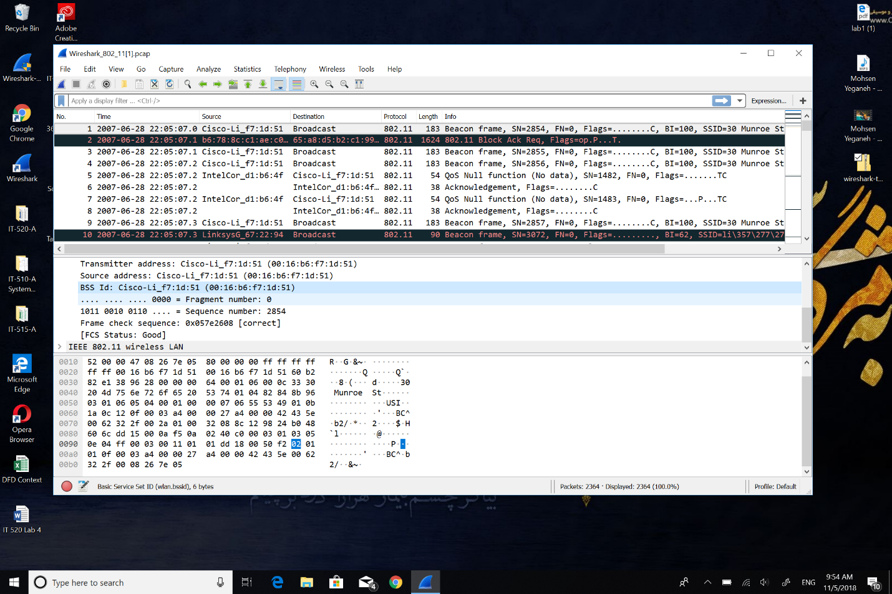



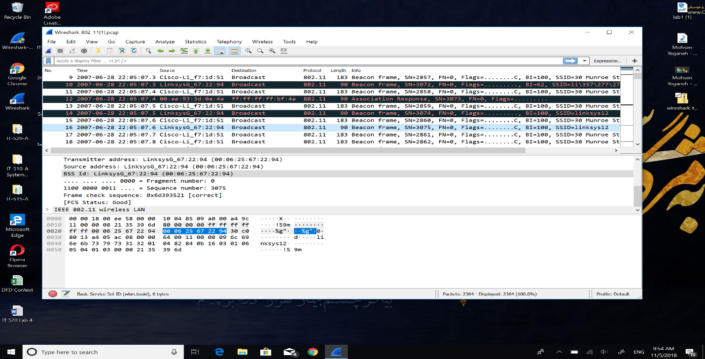



2: Time intervals are as bellow.

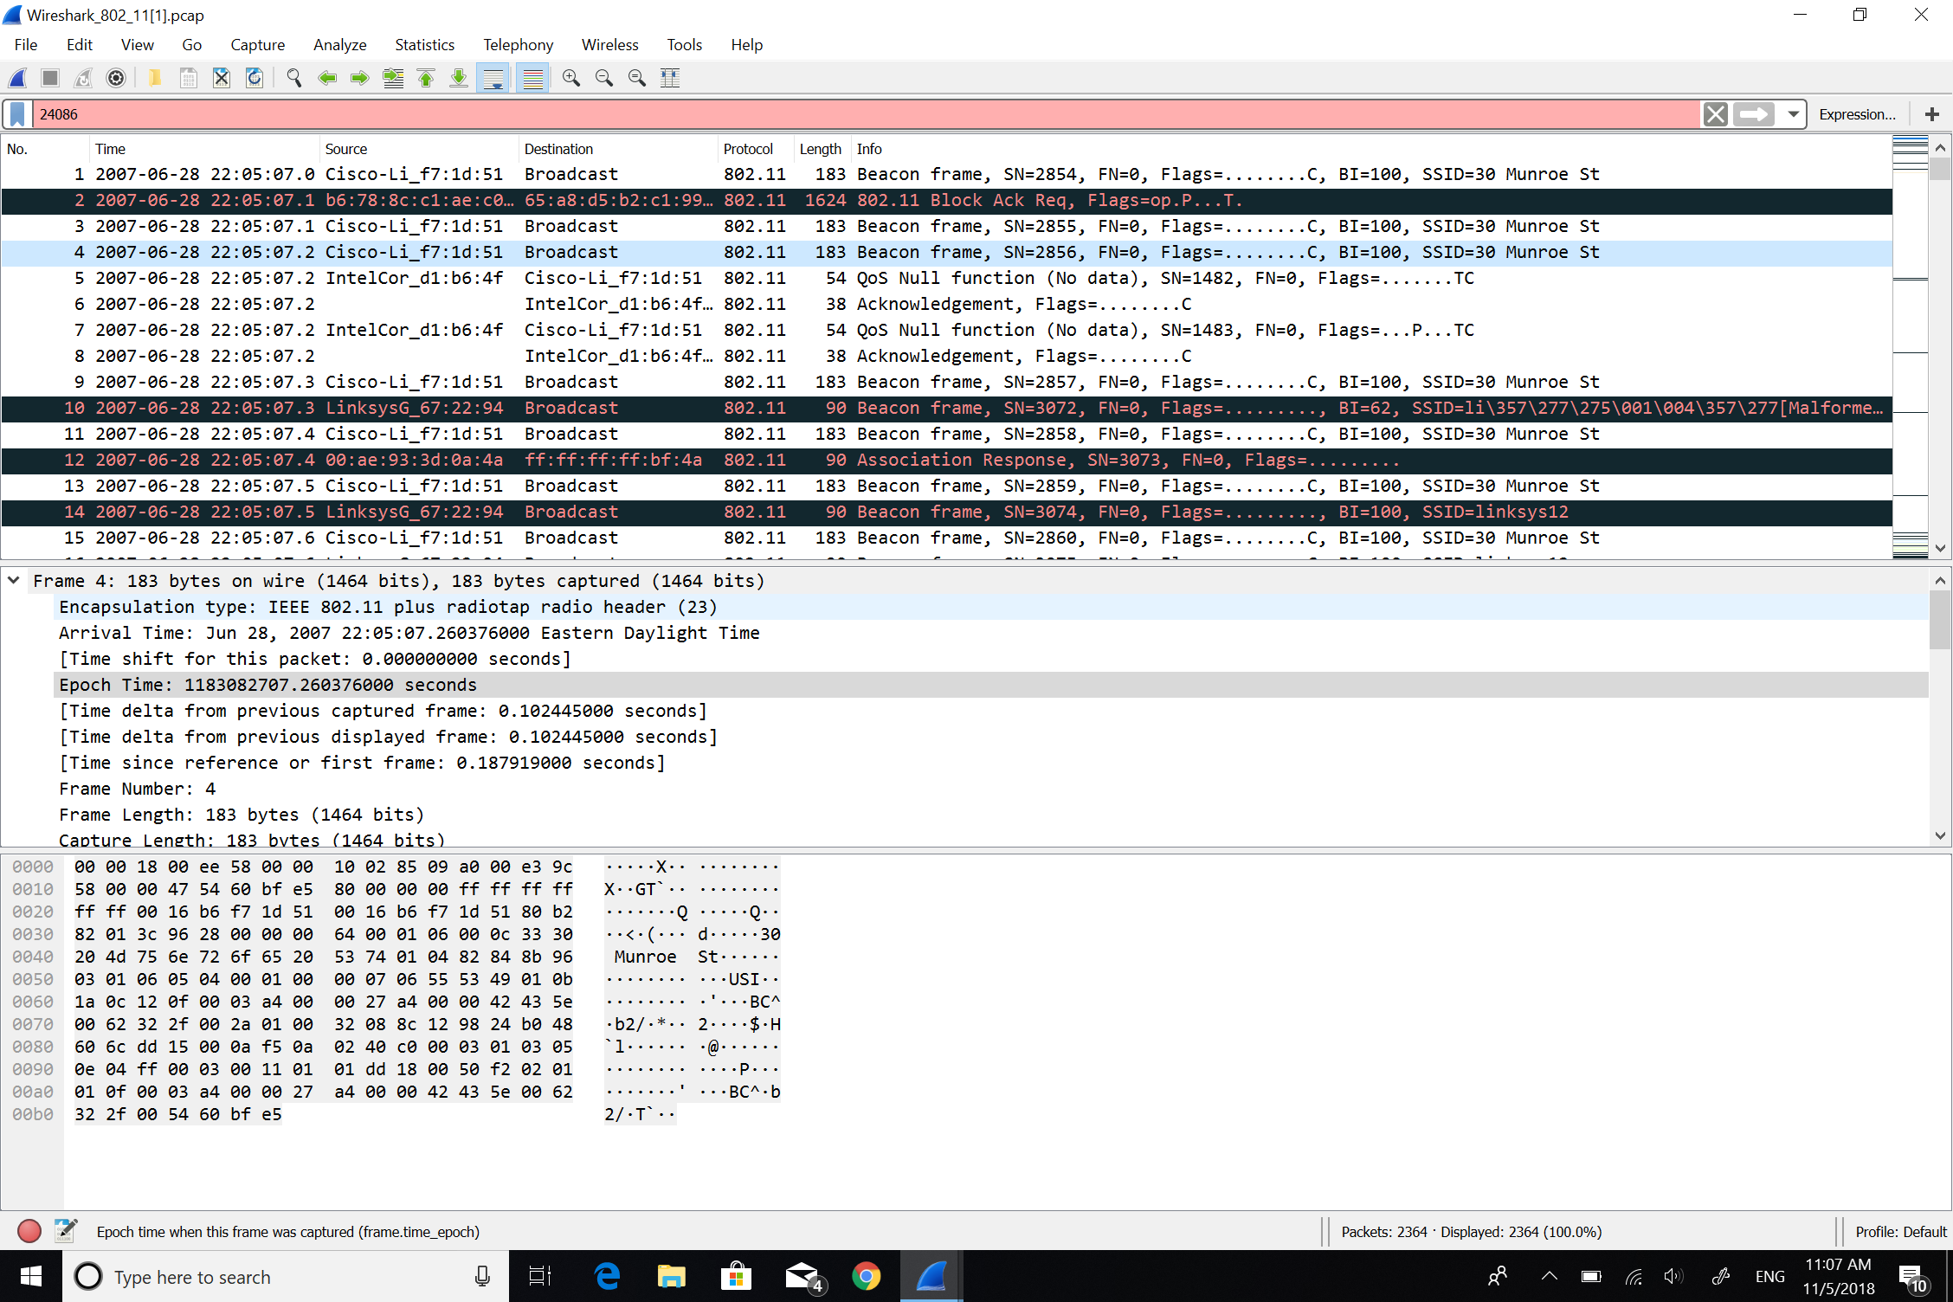



3: The source MAC address is:

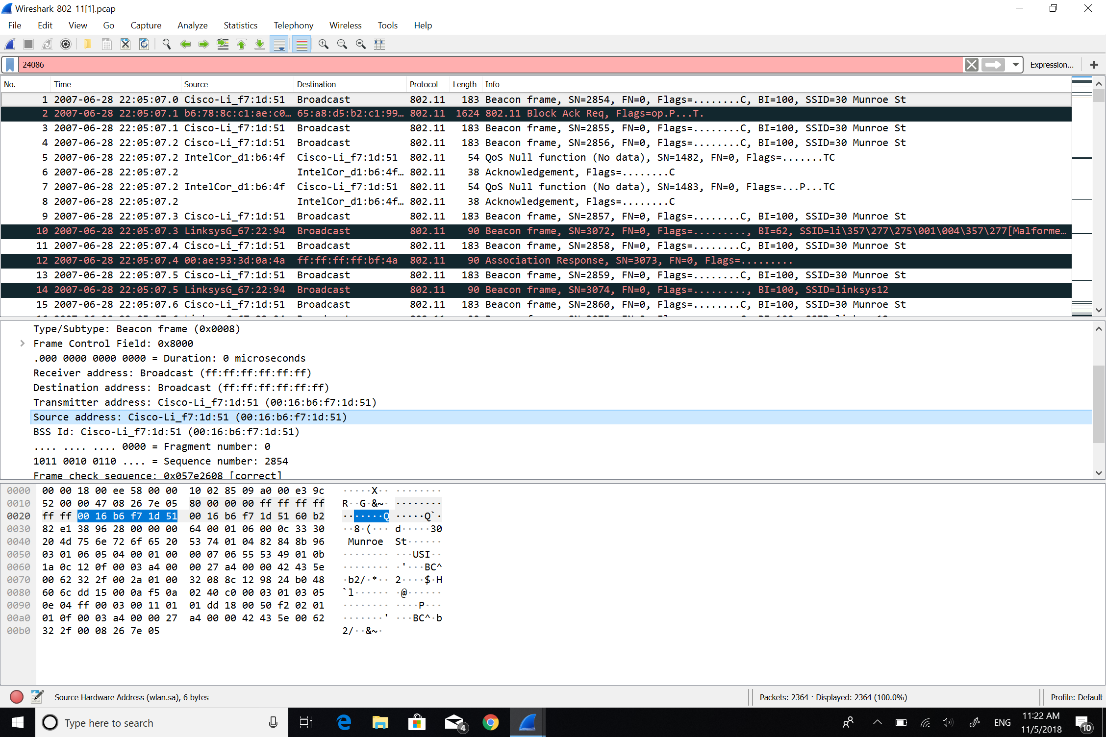



4: The destination MAC address:

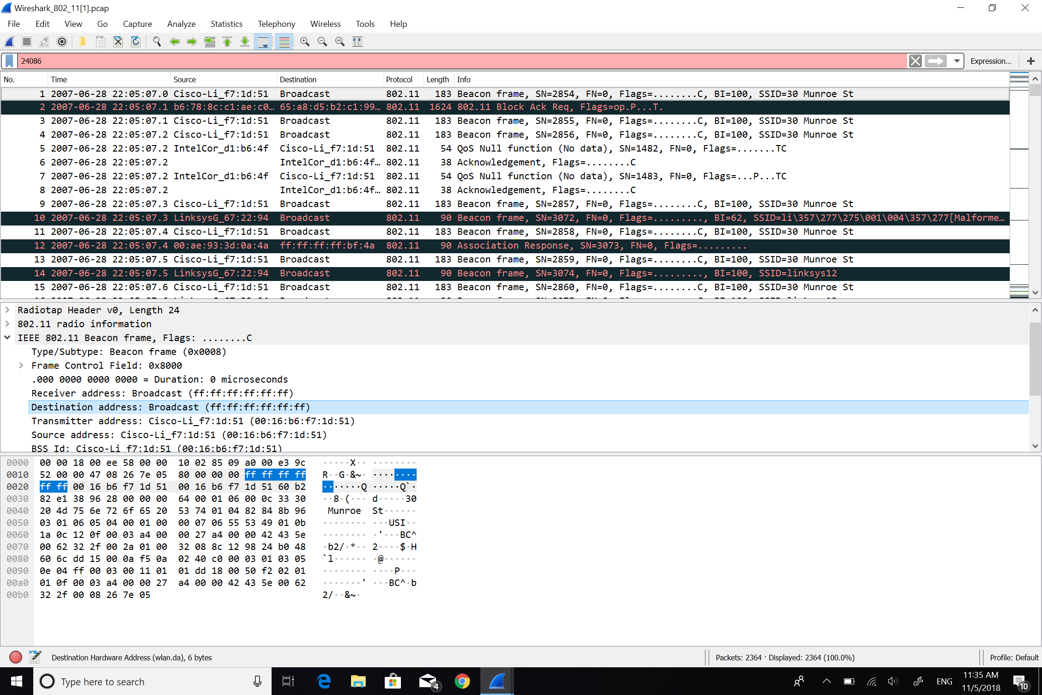



5: MAC BSS id:

