Codecov Test Evidence

Project: Campus Food Ordering Platform
Evidence Type: Automated testing / code coverage evidence
Tool Used: Codecov
Branch Tested: main

1. Codecov Overview

This screenshot shows the overall automated test coverage for the main branch.
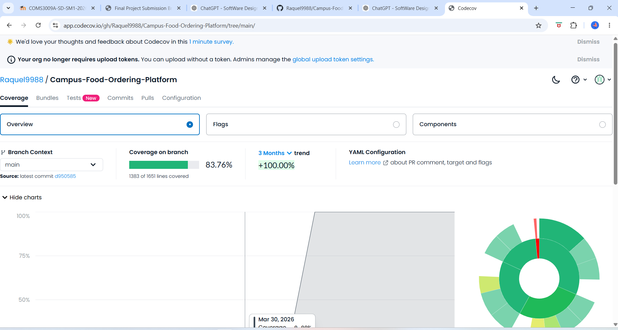

Important results shown:
- Overall coverage: 83.76%
- Covered lines: 1383 of 1651
- Missed lines: 268
- Coverage trend: +100.00%

2. Codecov File / Folder Coverage Breakdown

This screenshot shows the coverage breakdown by folder.
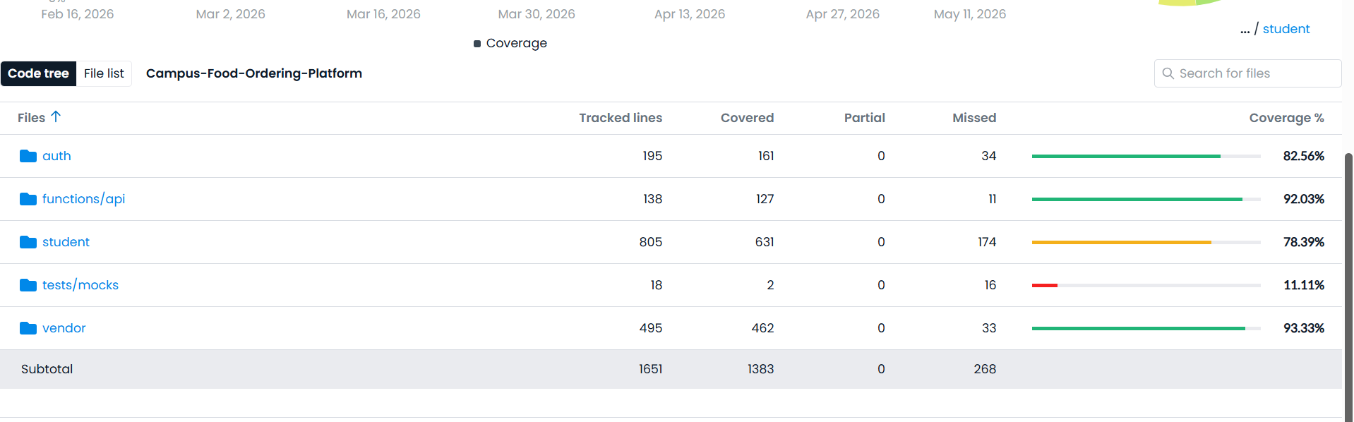
Important results shown:
- auth: 82.56%
- functions/api: 92.03%
- student: 78.39%
- tests/mocks: 11.11%
- vendor: 93.33%

3. Testing Evidence Summary

The Codecov evidence shows that automated testing was connected to the project and that the main branch has measurable test coverage.

The strongest covered areas are:
- vendor
- functions/api
- auth

The student folder also has acceptable coverage, while tests/mocks has lower coverage because mock files are mainly support files for testing rather than core production code.
