Sprint 1 Meeting Evidence

Project: Campus Food Ordering Platform
Sprint: Sprint 1
Evidence Type: Meeting screenshots and Scrum communication evidence

Meeting Screenshots Included

1. Sprint 1 Planning Meeting
Date: 30 March 2026
Duration: 1 hour 30 minutes
Type: In person
Purpose: Sprint 1 planning, task breakdown, user story discussion, and initial project structure.
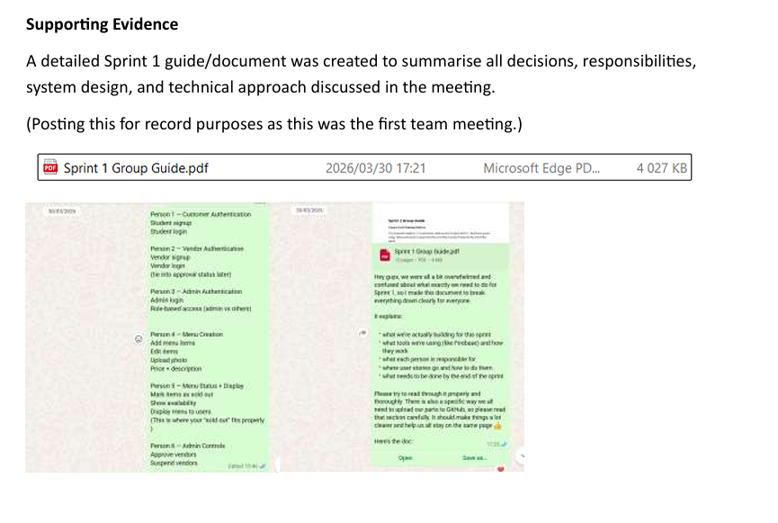

2. Sprint 1 Scrum / Planning Meeting
Date: 7 April 2026
Duration: 16 minutes
Purpose: CI/CD discussion, GitHub Issues, acceptance tests, vendor approval, and branching strategy.

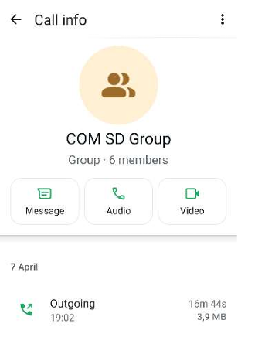

3. Sprint 1 Progress Meeting
Date: 10 April 2026
Duration: 30 minutes
Purpose: Progress check, completed login/registration functionality, admin access decision, and vendor dashboard planning.
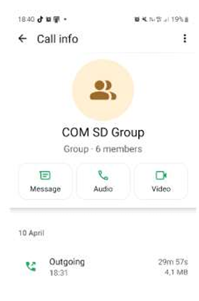

4. Sprint 1 Review Preparation Meeting
Date: 13 April 2026
Duration: 19 minutes
Purpose: Final Sprint 1 progress check, presentation preparation, and third-party identity provider discussion.

