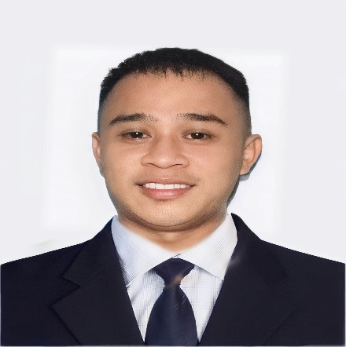

**ALLEN VOY MACARAEG**

# Purok Kaligayahan Brgy. Liminangcong Taytay Palawan 09061471083

# [macaraegallenvoy14@gmail.com](mailto:macaraegallenvoy14@gmail.com)

|  |  |  |  |  |  |  |  |  |  |  |  |
| --- | --- | --- | --- | --- | --- | --- | --- | --- | --- | --- | --- |
| **Personal Profile**  Gender : Male | | | | | | Course | | | : Bachelor of Science in Criminology | | |
| Home Address | :Brgy.Liminangcong Taytay Palawan | | | | | Specialization | | | : | | |
| Date of Birth | : November 22, 1998 | | | | | Ethnic Affiliation | | | : Bicolano | | |
| Place of Birth | : Pedragoza Maternity Clinic Antipolo City | | | | | Dialect Spoken | | | : Bicolano/Tagalog/English | | |
| Civil Status | : Single | | | | | PO Box | | | : | |  |
| Mailing Address | :Liminangcong Taytay Palawan | | | | |  | | |  | |  |
| Name of Spouse  No. Of Children  **Parents** | :  :0 | | | | |  | | |  | |  |
| **Father** |  | | | | | **Mother** | | |  | |  |
| Name | : Henry B. Macaraeg | | | | | Name | | |  | | : Alona B. Macaraeg |
| Date of Birth | : October 25 1967 | | | | | Date of Birth | | |  | | : November 16 1969 |
| Place of Birth | : Caloocan City | | | | | Place of Birth | | |  | | : Liminangcong Taytay Palawan |
| Educational Attainment :College Level | | | | | | | EducationalAttainment | | | | : College Level |
| Occupation : Driver | | | | | | | Occupation | | | | : Housewife |
| Place of Work : Antipolo City | | | | | | | Place of Work | | | | : Antipolo City |
| Annual Salary : Below 100, 000 | | | | | | | Annual Salary | | | | : below 100, 000 |
| **Educational Background**  College | | | Western Philippines University  Bachelor of Science in Criminology | | | | | | Year  2024 | |  |
| Senior High School | | | St. Ezekiel Moreno School  Senior High School/ General Academic Strand | | | | | | 2019 | |  |
| Junior High School | | | St. Ezekiel Moreno School  Grade 10- Completers | | | | |  | 2017 | |  |
| Elementary | | | Liminangcong Central School  Elementary Graduate | | | | |  | 2012 | |  |
|  | | |  | | | | |  |  | |  |
|  | |  | | **Seminar and Trainings Attended**  **Title**  **Venue**  **Date**  Reserve Officer Training Corps Western Philippines University August 22, 2019  Puerto Princesa City  Anti-Sexual Harrasment Western Philippines University February 16,2024  (RA.11313) Puerto Princesa City  Philippine Coast Guard Human Western Philippines University April 5, 2024  Resource Management Puerto Princesa City  Command |  | | | | |

**Technical/Skilss**

**Skills**

Flexibilty

Willing to Learn

Communication skills

Honest and Hardworking

Can work Under pressure

## Volunteer

|  |  |
| --- | --- |
| **Duration Nature of Work** | **Agency** |
| February 26, 2024 to May 3, 2024 On-the-Job Training | Puerto Princesa City Police Office |
| July 13, 2023 to November 24, 2023 Service Crew  **References** | Staff Search Service Asia |
| **Name Position Agency** | **Mobile/Email** |
| Jayson A. Garcia Operation supervisor JNT Express Palawan | 09079471329 / garciajayson890@gmail.com |
| Salvacion B. Rafols Teacher II San Jose National School | 09067443096/ salvacionrafols@gmail.com |
| Marie I. Camacho Manager FoodBucks catering | 09666639168/ mariecamacho@gmail.com |