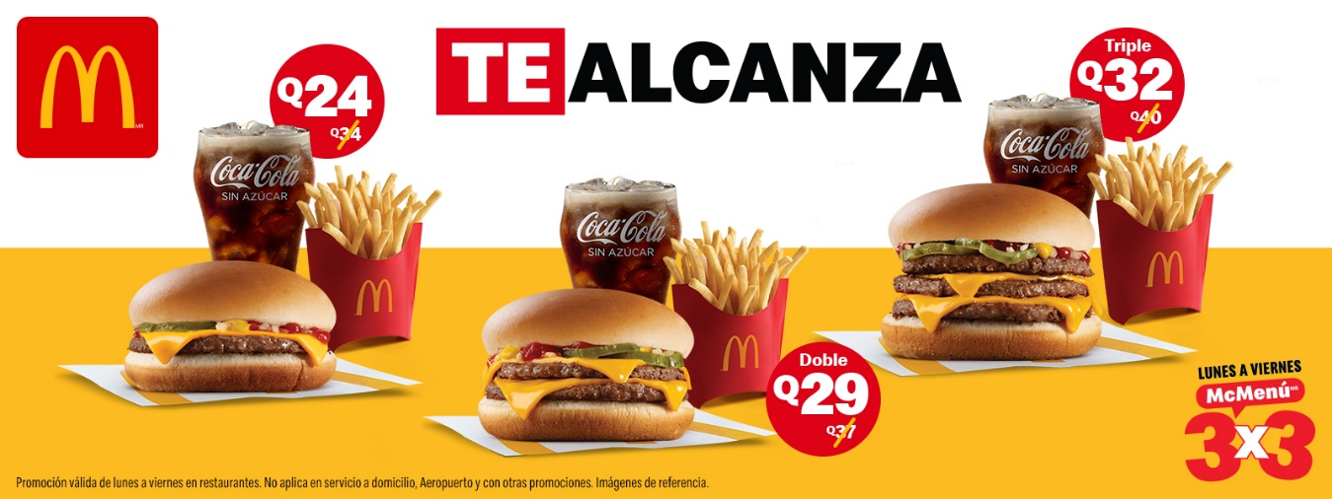

https://www.google.com/search?q=ver+la+tienda+de+McDonald%27s+en+Guatemala&gs_ivs=1#tts=0