🏠
House Price Prediction
using Machine Learning Regression Models
Project Report
AICTE | IBM SkillsBuild Data Analytics with AI Internship 2026 | BharatCares
Submitted by
Raquif Bashar
Program: Data Analytics with AI
Project: House Price Prediction

1. Introduction

1.1 Problem Statement
Real estate prices are influenced by a wide range of factors, including location, house size, number of rooms, neighbourhood income levels, and proximity to key geographical features such as the ocean. Manually estimating a fair house price is time-consuming and prone to human bias. The goal of this project is to design and evaluate a machine learning regression system that can accurately predict the median house value of a Californian district based on its socio-economic and geographical characteristics.

1.2 Objectives
- Perform Exploratory Data Analysis (EDA) on the California Housing dataset to understand feature distributions and relationships.
- Clean and preprocess the data, handling missing values and encoding categorical features.
- Engineer new, more informative features from the raw columns.
- Train and compare multiple machine learning regression algorithms.
- Tune the best-performing model using hyperparameter optimisation.
- Evaluate models using standard regression metrics: MAE, RMSE and R².
- Identify the features that most strongly influence house prices.
- Save the final trained model so it can be reused for future predictions.

1.3 Scope
This project covers the complete data analytics and machine learning pipeline — from raw data ingestion to a deployable, serialized prediction model — using Python's data science ecosystem (Pandas, Scikit-learn, Matplotlib, Seaborn).

2. Dataset Description
Name: California Housing Prices
Source: Derived from the 1990 U.S. Census; popularised by Aurélien Géron's book "Hands-On Machine Learning with Scikit-Learn, Keras & TensorFlow."
Dataset Link: https://raw.githubusercontent.com/ageron/handson-ml2/master/datasets/housing/housing.csv
Size: 20,640 rows × 10 columns

Column | Description
longitude, latitude | Geographic coordinates of the district
housing_median_age | Median age of houses in the district
total_rooms, total_bedrooms | Total number of rooms / bedrooms in the district
population, households | Total population and number of households in the district
median_income | Median household income (in tens of thousands of USD)
ocean_proximity | Categorical distance category from the ocean
median_house_value (Target) | Median house value in USD — the value to be predicted

3. Methodology

3.1 Data Cleaning
The dataset contained missing values only in the total_bedrooms column. Numeric missing values were imputed using the column median, and the single categorical column (ocean_proximity) had no missing values but was configured to use most-frequent imputation for robustness on new data.

3.2 Feature Engineering
Three derived ratio features were engineered to capture relationships that raw counts alone do not express well:
- rooms_per_household = total_rooms / households
- bedrooms_per_room = total_bedrooms / total_rooms
- population_per_household = population / households

3.3 Preprocessing Pipeline
A Scikit-learn ColumnTransformer was used to apply different preprocessing to numeric and categorical columns consistently across training, testing, and future inference:
- Numeric features: median imputation → StandardScaler (zero mean, unit variance).
- Categorical feature (ocean_proximity): most-frequent imputation → One-Hot Encoding.
Wrapping the ColumnTransformer inside a single Pipeline object with the regressor ensures there is no data leakage between the training and test sets.

3.4 Train-Test Split
The dataset was split into 80% training data (16,512 rows) and 20% testing data (4,128 rows) using a fixed random seed (random_state = 42) for reproducibility.

3.5 Models Trained
- Linear Regression — a simple linear baseline model.
- Decision Tree Regressor — a single non-linear tree-based model.
- Random Forest Regressor — an ensemble of 200 decision trees (bagging).
- Gradient Boosting Regressor — a sequential boosting ensemble.

3.6 Hyperparameter Tuning
The best-performing model (Random Forest) was further tuned using GridSearchCV with 3-fold cross-validation, searching over the number of estimators and maximum tree depth, optimising for the negative root-mean-squared-error.

4. Exploratory Data Analysis
Before modelling, the dataset was visually explored to understand feature distributions, spot outliers, and identify relationships with the target variable.

4.1 Target Variable Distribution
The median house value is right-skewed, with a large concentration of districts valued below $250,000 and a visible cap at $500,001, indicating the original dataset truncated very high values.
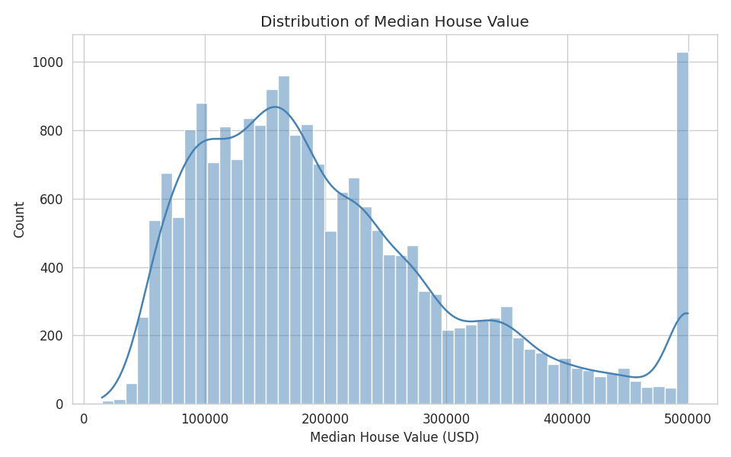
Figure 1: Distribution of Median House Value

4.2 Geographical Price Distribution
Plotting each district by its longitude and latitude, coloured by house value, clearly reveals that coastal districts near the San Francisco Bay Area and Los Angeles command the highest prices.
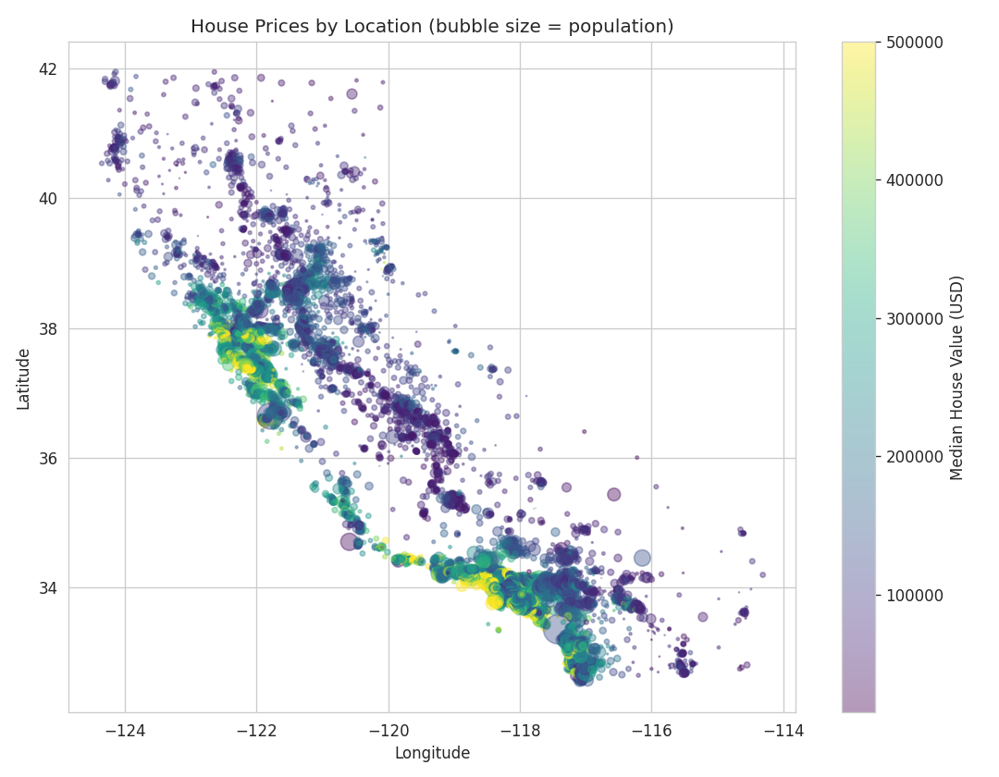
Figure 2: House Prices by Geographic Location

4.3 Ocean Proximity vs. House Value
Districts labelled "ISLAND" and "NEAR BAY"/"NEAR OCEAN" tend to have higher median house values than "INLAND" districts, confirming the intuitive importance of proximity to water.
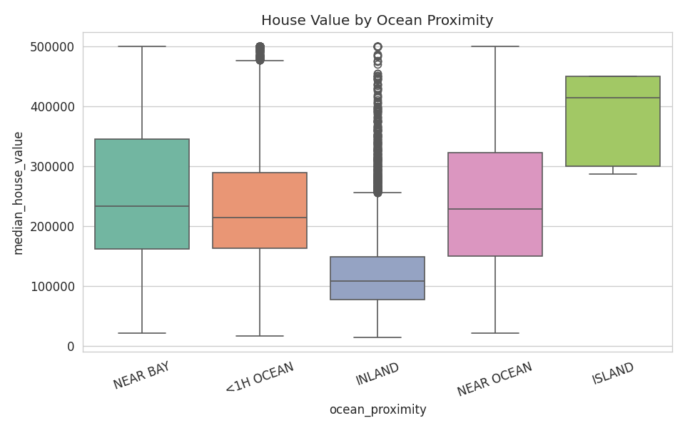
Figure 3: House Value by Ocean Proximity Category

4.4 Correlation Analysis
A correlation heatmap of the numeric features shows that median_income has by far the strongest positive correlation with median_house_value, while features like total_rooms and households correlate more strongly with each other than with price.
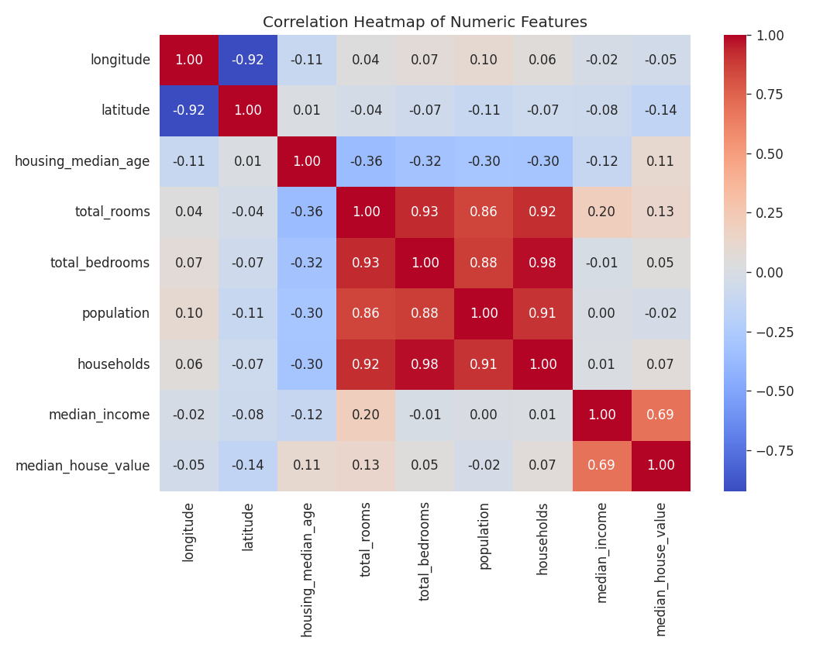
Figure 4: Correlation Heatmap of Numeric Features

4.5 Median Income vs. House Value
A scatter plot confirms a strong, roughly linear-looking positive relationship between median income and house value, with a visible price ceiling effect at the top of the income range.
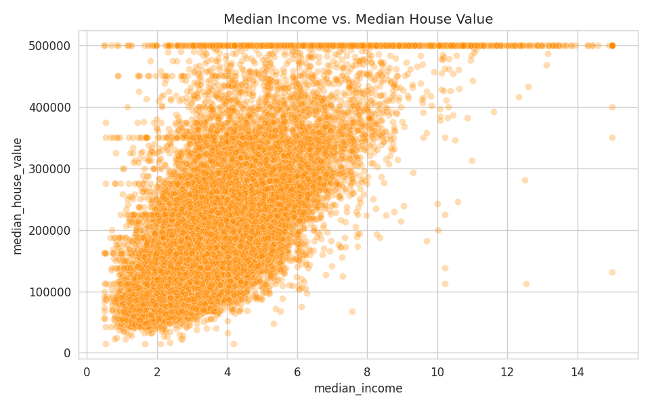
Figure 5: Median Income vs. Median House Value

5. Results & Evaluation

5.1 Model Comparison
All four models were trained on the same preprocessed training data and evaluated on the held-out 20% test set. The table below summarises the results, sorted by R² score (higher is better).
Model | MAE ($) | RMSE ($) | R² Score
Random Forest | 31,926 | 49,834 | 0.810
Gradient Boosting | 36,404 | 53,505 | 0.782
Linear Regression | 49,645 | 69,127 | 0.635
Decision Tree | 43,093 | 69,861 | 0.628

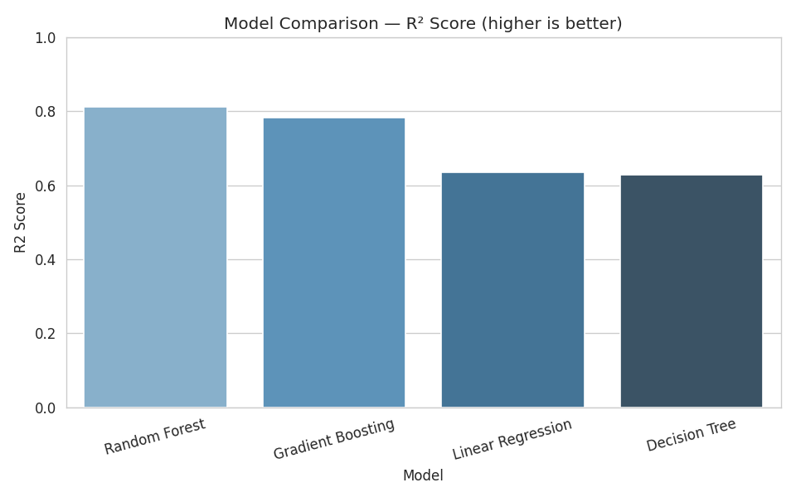
Figure 6: Model Comparison by R² Score

5.2 Hyperparameter-Tuned Model
The Random Forest model — the strongest baseline performer — was tuned with GridSearchCV over the number of trees and maximum depth. The tuned model achieved:
- MAE: $31,866.29
- RMSE: $49,666.70
- R² Score: 0.8118
This represents a small but meaningful improvement over the default Random Forest configuration, confirming the model was already close to its optimal settings for this feature set.
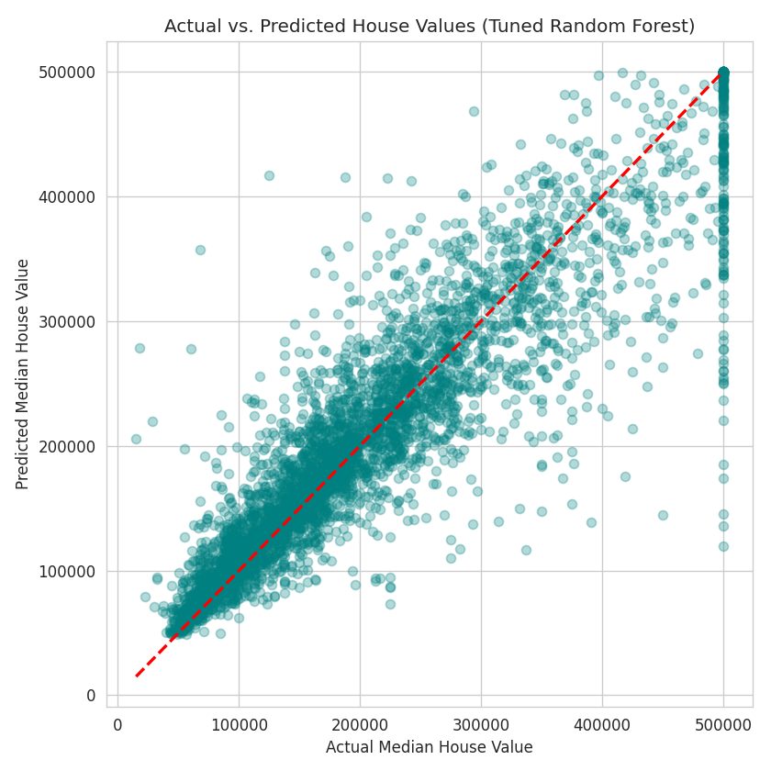
Figure 7: Actual vs. Predicted House Values (Tuned Random Forest)

5.3 Feature Importance
The tuned Random Forest model's built-in feature importance scores reveal which inputs most strongly drive its predictions:
Feature | Importance
median_income | 0.481
ocean_proximity_INLAND | 0.138
population_per_household | 0.121
longitude | 0.058
latitude | 0.056
housing_median_age | 0.044
rooms_per_household | 0.026
bedrooms_per_room | 0.024

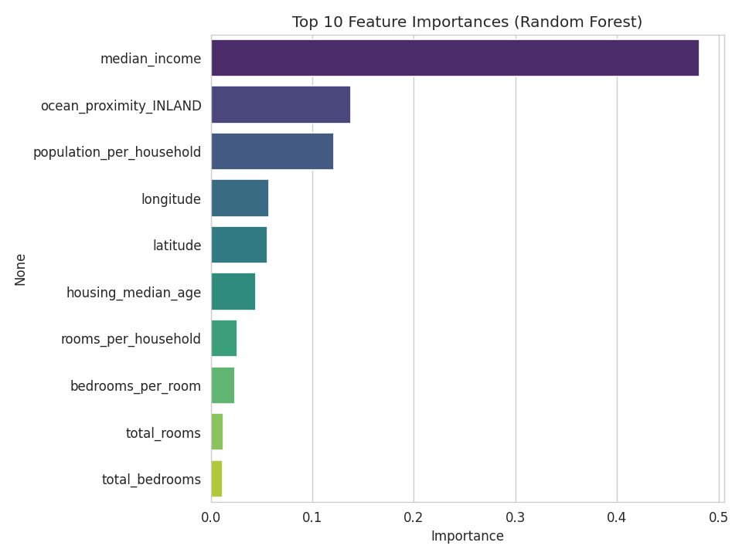
Figure 8: Top 10 Feature Importances
Median income alone accounts for nearly half of the model's predictive power, followed by whether a district is inland and its average population density per household — reinforcing well-known real-estate pricing intuition.

6. Conclusion
This project successfully developed an end-to-end machine learning pipeline to predict median house values in California districts. Key findings include:
- Ensemble tree-based models (Random Forest, Gradient Boosting) substantially outperformed the linear baseline, indicating the true relationship between features and house price is non-linear.
- The tuned Random Forest Regressor was selected as the final model, achieving an R² score of 0.812 on unseen test data — meaning it explains over 81% of the variance in house prices.
- Median income, ocean proximity, and population density per household were the most influential predictors of house price.
- Engineered ratio features (rooms_per_household, bedrooms_per_room, population_per_household) contributed meaningfully to model performance.
The final trained pipeline (preprocessing + model) was serialized using joblib as house_price_model.pkl, making it ready for reuse in a prediction script, web application, or API.

7. Future Scope
- Incorporate additional real-world features such as crime rate, school ratings, and distance to the nearest city centre.
- Experiment with advanced gradient boosting frameworks such as XGBoost or LightGBM.
- Explore neural network-based regression architectures for potential accuracy gains.
- Deploy the trained model as an interactive web application using Flask or Streamlit for real-time predictions.

8. References
- California Housing Prices Dataset — https://raw.githubusercontent.com/ageron/handson-ml2/master/datasets/housing/housing.csv
- Scikit-learn Documentation — https://scikit-learn.org/
- Géron, A. — Hands-On Machine Learning with Scikit-Learn, Keras & TensorFlow

