Let’s Taco About It

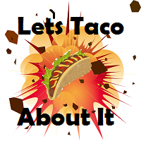

Normal Menu

* Taco (Comes with: Beef or Chicken, Lettuce and Cheese) $4.99
* Burrito (Comes with: Beef or Chicken, Lettuce and Cheese) $4.99
* Quesadilla (Comes with: Cheese, Chicken or Beef)

$3.00

* Nachos (Comes with: Cheese, Beef, Chips Lettuce)

$5.50

* Enchilada (Comes with: Beef or Chicken, Lettuce)

$4.00

* Pizza (Comes with: Pepperoni or Sausage)

$5.00

* Chimichanga (Comes with: Lettuce, Rice and beef)

$4.99

Specials

* Fish Taco-(A taco that has fish in it)

$4.99 \*Monday Only

* Avocado Chalupa-(A Chalupa that has avocado’s in it)

$4.99 \*Tuesday Only

* Taco Madness-(5 taco’s for the price of 2)

$10.99 \*Wednesday Only

* El Lucho Queso-(A plate full of cheese)

$5.99 \*Thursday Only

* Dorito Burrito-(A burrito with a Dorito’s on the inside)

$5.99 \*Friday Only

* The Macho Man Killer Keemstar-(One huge mess of mexican food comes with one of everything)
* $30.99 \*Saturday Only