CURRICULAM VITAE
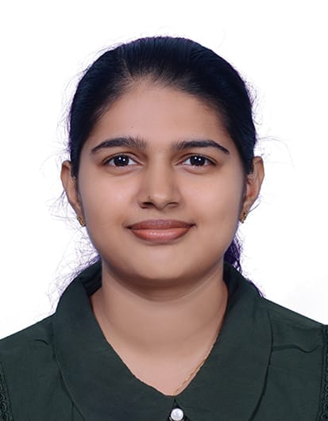

Ashna Puthenpurackal Kuriakose
Address:Puthenpurackal House
Mammalassery,Ramamangalam,
Ernakulam,Kerala,India
686663
Nationally: Indian
Gender: Female
DOB: 06/07/2001
Total months of experience: 29/07/2024- still working
OET validity:18/05/2026
PassportNo.: T5561051
Passport validity: 16/05/2029
Mobile Number: +919061332866/+916282589556

Academic Qualifications
Qualification | Name of  institution | Board of  Examination | Year of study
SSLC | M K M H S S Piravom | Board of  Public  Examinations,  Kerala | 2017
Plus two(Science) | M K M HSS Piravom | Board of  Higher  Secondary  Examination,  Kerala | 2017-2019

Professional Qualifications

Degree | Name of  institution | University | Year of study
Bachelor of  Science Nursing  (BSC Nursing) | Govt. College of nursing, Kottayam | Kerala  University of  Health and  Science | 2019-2024

Career Record
Hospital Name | Period | Area | Designation
Govt. Medical  College Hospital,  Kottayam | 29/07/2024- still working | Medical ward | Staff Nurse  (Compulsory  Nursing Service)

DETAILED EMPLOYMENT HISTORY

HOSPITAL NAME & ACCREDATION IF ANY : GOVT.MEDICAL COLLEGE
HOSPITAL KOTTAYAM ,Accredited
by Kerala University of health
sciences with A Plus

TOTAL NO. OF BEDS IN HOSPITAL : 2207
Type Of hospital : Tertiary hospital
DATE : From 29/07/2024 to still working
JOB TITLE : Staff nurse as part of compulsory
nursing service
Unit (Ward) : Medical ward
NO. OF BEDS IN THE UNIT : 60
Nurse patient Ratio : 3.60

Duties and Responsibilities
- Assessment, planning, implementation and evaluation of clients with various medical conditions.
- Monitor vital signs.
- Prepare and administers medications including controlled drugs and emergency drugs in a timely and safe manner.
- Administer medication as per doctor’s prescription like
anti-platelets, lipid lowering agents and anti hypertensive in accordance with hospital policies.
- Respond promptly to medical emergencies
- Perform all basic and acute life saving measures including CPR.
- Be an active member in handling emergency situations (CPR).
- Assist doctors in endotracheal intubation and central line insertion
- Care of peripheral access lines, central lines and tracheotomy
- Care of acutely ill patients requiring BIPAP, CPAP and vasoactive agents.
- Perform suction (oropharyngeal, tracheotomy).
- Follow infection control practices according to hospital policies.
- Ensure a clean and safe environment for patients
- Demonstrates effective communication skills with the multidisciplinary team, patients and their relatives.
- Participate in hand over reports and team meetings
- Practice in a way that acknowledges the dignity, culture, values, beliefs and rights of clients in medical ward.
- Able to perform ryles tube insertion, urinary catheterisation, peripheral IV line insertion, ABG and VBG.
- Able to perform IVF therapy, phlebotomy, wound care and blood transfusion.
- Able to perform admission and discharge procedures as per hospital policy.
- Equipped in handling mechanical defibrillators, cardiac monitors, syringe pumps and infusion pumps.
- Assist in daily living activities

Cases Handled
- Coronary Artery Disease
- Myocardial Infarction
- Pneumonia
- Chronic obstructive pulmonary diseases
- Tuberculosis
- Hypertension
- Arrhythmias
- Liver cirrhosis
- Gastroenteritis
- Diabates mellitus(type 1&2)
- Diabetic ketoacidosis
- Urinary tract infection
- Cerebrovascular Accident
- Seizures
- Meningitis
- Chronic kidney disease
- Electrolyte imbalances

Equipments Used
- Mechanical ventilators
- Portable ventilator
- Syringe pump
- Infusion pump
- Defibrillators
- Ambu bag
- Cardiac monitors
- Pulse oximeter
- Nebuliser
- BIPAP
- CPAP machine
- O2 flow meter
- Glucometer
- Suction machine

Training Courses • BLS and ACLS course

Professional References
Name and Address | Designation | Contact Information
Dr. Liny Joseph (Principal, Govt.  College of Nursing,  Kottayam, Kerala,  India) | Principal | Email:  principalcnk@gmail.com
Mrs. Bindhu TP  (Senior Nursing  Officer,Medical Ward,  Govt. Medical  College Hospital,  Kottayam, Kerala,  India) | Senior Nursing  Officer | Email:  bindhutp1@gmail.com  Phone Number:  +919447078516
Dr. Rakhi  Manjooran  (Assistant  Professor, Govt.  College of Nursing,  Kottayam, Kerala,  India) | Assistant Professor | Email:  rakhimoncy@gmail.com Phone Number:  +919495239516
Declaration
I hereby declare that the above-mentioned information is correct to the best of my knowledge and I bear the responsibility for the correctness of the above-mentioned.
Place:Ernakulam, Kerala
Date:

