Locomotives

- UML diagram
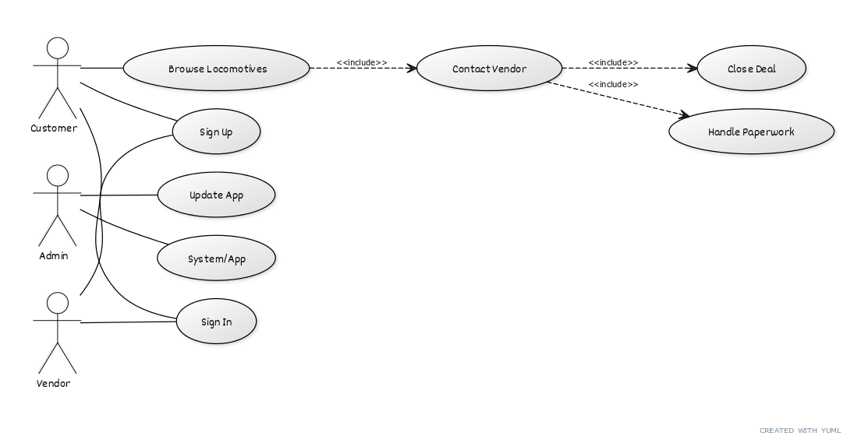
- Requirements:
  - web app using python, flask, html, css, js, supabase
  - Team members:
    - VASIU Rares-Andrei
    - CRISTINA Ovidiu-Lucian
  - Database, login, storage (etc.) is handled by open source model Supabase
  - Hosted online
  - Github link of open source project:

