**Campionat Mondial de Fotbal 2014**

**Cerinta 1**

Baza de date a Campionatului Mondial de Fotbal din 2014 contine toate cele 32 de echipe calificate in faza grupelor si sposnorii acestora. Pentru fiecare echipa calificata mai departe din faza grupelor(primele 2 echipe) avem datele despre antrenorii acestora. Meciurile din fazele eliminatorii dispun de bilete caracteristice fazei competitiei. Acestea sunt de tipul standard si VIP. Fazele eliminatorii ale Campionatului Mondial se vor disputa pe parcursul lunii iulie . Un meci este televizat de mai multe canalte tv, in functie de importanta acestuia. Meciurile terminate la egalitate se vor decide la lovituri de departajare.

De asemena baza de date prezinta date despre cei mai buni 10 jucatori de la campionatul Mondial.

Cerinta 2

Cerinta 3

Cerinta 4

create table tari(

id_tara varchar2(5) not null primary KEY,

nume_tara varchar2(50),

grupa char(1),

numar_puncte int

);

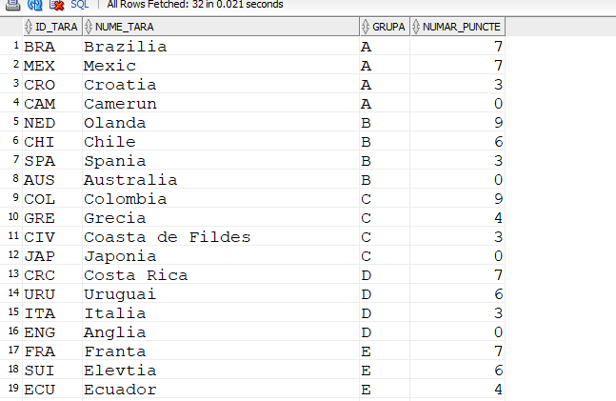

create table sponsorizeaza(

id_tara varchar2(5) not null,

id_sponsor int not null,

constraint pk_sponsorizeaza primary key(id_tara,id_sponsor)

);

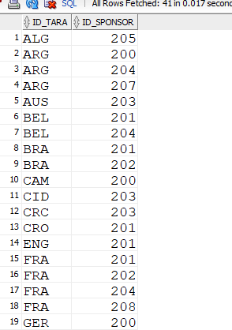

create table sponsori(

id_sponsor int not null primary KEY,

nume_sponsor varchar(30)

);

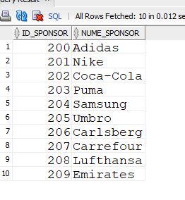

create table meci(

id_meci int not null primary key,

etapa varchar2(20),

data_meciului date not null,

id_stadion int not null,

id_echipa1 varchar2(50),

id_echipa2 varchar2(50),

goluri1 int,

goluri2 int,

penaltiuri1 int,

penaltiuri2 int

);

alter table meci add foreign key(id_echipa1) references tari(id_tara);

alter table meci add foreign key(id_echipa2) references tari(id_tara);

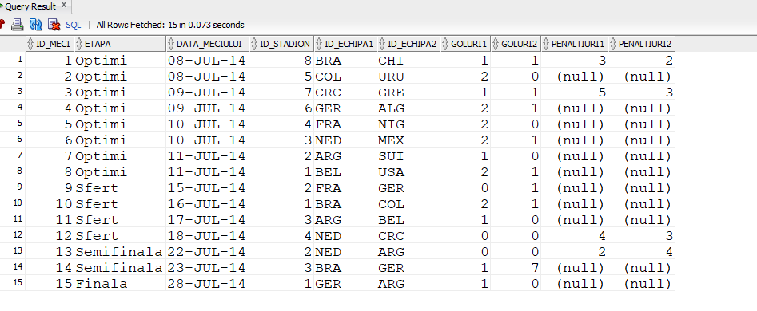

create table stadion(

id_stadion int not null primary key,

id_oras int,

stadion varchar2(50),

numar_locuri int

);

alter table stadion add foreign key(id_oras) REFERENCES orase(id_oras);

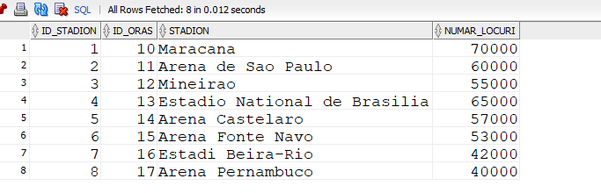

create table Orase(

id_oras int not null primary key,

nume varchar2(50),

populatie int,

suprafata float

);

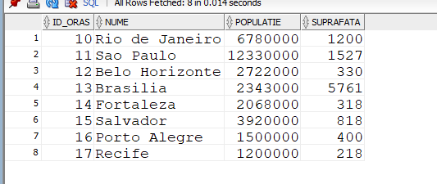

create table canale_tv(

id_canal int not null primary key,

nume_canal varchar2(30)

);

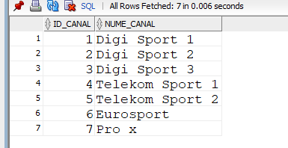

create table transmite(

id_canal int not null,

id_meci int not null,

constraint pk_transmite primary key(id_canal,id_meci)

);

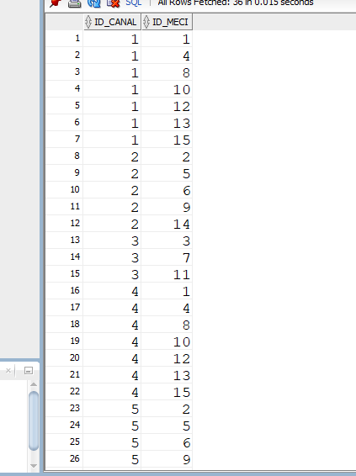

create table jucatori(

id_jucator int not null primary key,

nume varchar2(20),

prenume varchar2(20),

goluri int,

asisturi int,

rating float,

id_tara varchar2(50),

foreign key(id_tara) references tari(id_tara)

);

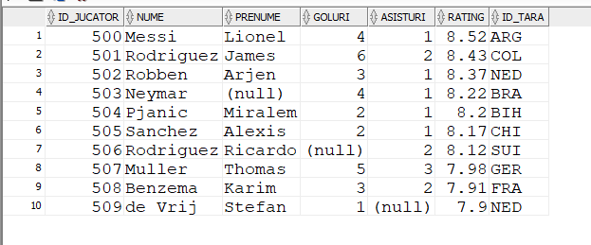

create table antrenori(

id_antrenor int not null primary key,

nume varchar2(20),

prenume varchar2(20),

id_tara varchar2(50),

foreign key(id_tara) references tari(id_tara)

);

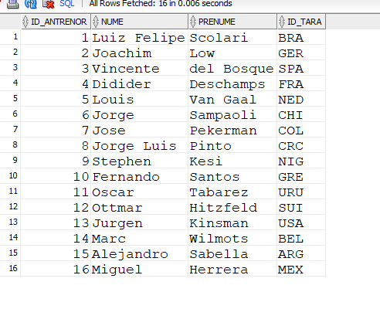

create table bilete(

id_bilet int not null primary key,

tip_bilet varchar2(50));

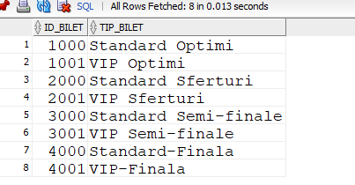

create table dispune(

id_bilet int,

id_meci int,

constraint pk_dispune primary key(id_bilet,id_meci));

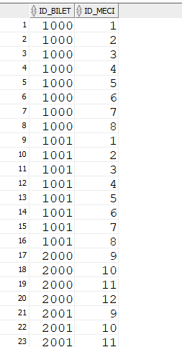

Cerinta 5

--tari

insert into tari

values('BRA','Brazilia','A',7);

insert into tari

values('MEX','Mexic','A',7);

insert into tari

values('CRO','Croatia','A',3);

insert into tari

values('CAM','Camerun','A',0);

insert into tari

values('NED','Olanda','B',9);

insert into tari

values('CHI','Chile','B',6);

insert into tari

values('SPA','Spania','B',3);

insert into tari

values('AUS','Australia','B',0);

insert into tari

values('COL','Colombia','C',9);

insert into tari

values('GRE','Grecia','C',4);

insert into tari

values('CIV','Coasta de Fildes','C',3);

insert into tari

values('JAP','Japonia','C',0);

insert into tari

values('CRC','Costa Rica','D',7);

insert into tari

values('URU','Uruguai','D',6);

insert into tari

values('ITA','Italia','D',3);

insert into tari

values('ENG','Anglia','D',0);

insert into tari

values('FRA','Franta','E',7);

insert into tari

values('SUI','Elevtia','E',6);

insert into tari

values('ECU','Ecuador','E',4);

insert into tari

values('HON','Honduras','E',0);

insert into tari

values('ARG','Argentina','F',9);

insert into tari

values('NIG','Nigeria','F',4);

insert into tari

values('BIH','Bosnia si Hertegovina','F',3);

insert into tari

values('IRA','Iran','F',1);

insert into tari

values('GER','Germania','G',7);

insert into tari

values('USA','Statele Unite ale Americii','G',5);

insert into tari

values('POR','Portugal','G',4);

insert into tari

values('GHA','Ghana','G',1);

insert into tari

values('BEL','Belgium','H',9);

insert into tari

values('ALG','Algeria','H',4);

insert into tari

values('RUS','Rusia','H',2);

insert into tari

values('KOR','Coreea de Sud','H',1);

--sponsori

insert into sponsori

values(200,'Adidas');

insert into sponsori

values(201,'Nike');

insert into sponsori

values(202,'Coca-Cola');

insert into sponsori

values(203,'Puma');

insert into sponsori

values(204,'Samsung');

insert into sponsori

values(205,'Umbro');

insert into sponsori

values(206,'Carlsberg');

insert into sponsori

values(207,'Carrefour');

insert into sponsori

values(208,'Lufthansa');

insert into sponsori

values(209,'Emirates');

--sponsorizeaza

--jucatori

insert into jucatori

values(500,'Messi','Lionel',4,1,8.52,'ARG');

insert into jucatori

values(501,'Rodriguez','James',6,2,8.43,'COL');

insert into jucatori

values(502,'Robben','Arjen',3,1,8.37,'NED');

insert into jucatori

values(503,'Neymar',null,4,1,8.22,'BRA');

insert into jucatori

values(504,'Pjanic','Miralem',2,1,8.2,'BIH');

insert into jucatori

values(505,'Sanchez','Alexis',2,1,8.17,'CHI');

insert into jucatori

values(506,'Rodriguez','Ricardo',null,2,8.12,'SUI');

insert into jucatori

values(507,'Muller','Thomas',5,3,7.98,'GER');

insert into jucatori

values(508,'Benzema','Karim',3,2,7.91,'FRA');

insert into jucatori

values(509,'de Vrij','Stefan',1,null,7.9,'NED');

--stadioane

create SEQUENCE nr

start with 1

increment by 1;

insert into stadion

values(nr.nextval,10,'Maracana',70000);

insert into stadion

values(nr.nextval,11,'Arena de Sao Paulo',60000);

insert into stadion

values(nr.nextval,12,'Mineirao',55000);

insert into stadion

values(nr.nextval,13,'Estadio National de Brasilia',65000);

insert into stadion

values(nr.nextval,14,'Arena Castelaro',57000);

insert into stadion

values(nr.nextval,15,'Arena Fonte Navo',53000);

insert into stadion

values(nr.nextval,16,'Estadi Beira-Rio',42000);

insert into stadion

values(nr.nextval,17,'Arena Pernambuco',40000);

rollback;

--orase

insert into orase

values(10,'Rio de Janeiro',6780000,1200);

insert into orase

values (11,'Sao Paulo',12330000,1527);

insert into orase

values(12,'Belo Horizonte',2722000,330);

insert into orase

values(13,'Brasilia',2343000,5761);

insert into orase

values(14,'Fortaleza',2068000,318);

insert into orase

values(15,'Salvador',3920000,818);

insert into orase

values(16,'Porto Alegre',1500000,400);

insert into orase

values(17,'Recife',1200000,218);

--canale tv

insert into canale_tv

values(1,'Digi Sport 1');

insert into canale_tv

values(2,'Digi Sport 2');

insert into canale_tv

values(3,'Digi Sport 3');

insert into canale_tv

values(4,'Telekom Sport 1');

insert into canale_tv

values(5,'Telekom Sport 2');

insert into canale_tv

values(6,'Eurosport');

insert into canale_tv

values(7,'Pro x');

--transmite AM RAMAS AIC

insert into transmite

values(1,1);

insert into transmite

values(1,4);

insert into transmite

values(1,8);

insert into transmite

values(1,10);

insert into transmite

values(1,12);

insert into transmite

values(1,13);

insert into transmite

values(1,15);

insert into transmite

values(2,2);

insert into transmite

values(2,5);

insert into transmite

values(2,6);

insert into transmite

values(2,9);

insert into transmite

values(2,14);

insert into transmite

values(3,3);

insert into transmite

values(3,7);

insert into transmite

values(3,11);

insert into transmite

values(4,1);

insert into transmite

values(4,4);

insert into transmite

values(4,8);

insert into transmite

values(4,10);

insert into transmite

values(4,12);

insert into transmite

values(4,13);

insert into transmite

values(4,15);

insert into transmite

values(5,2);

insert into transmite

values(5,5);

insert into transmite

values(5,6);

insert into transmite

values(5,9);

insert into transmite

values(5,14);

insert into transmite

values(6,3);

insert into transmite

values(6,7);

insert into transmite

values(6,11);

insert into transmite

values(7,13);

insert into transmite

values(8,13);

insert into transmite

values(7,14);

insert into transmite

values(8,14);

insert into transmite

values(7,15);

insert into transmite

values(8,15);

--antrenori

insert into antrenori

values(1,'Luiz Felipe','Scolari','BRA');

insert into antrenori

values(2,'Joachim','Low','GER');

insert into antrenori

values(3,'Vincente','del Bosque','SPA');

insert into antrenori

values(4,'Didider','Deschamps','FRA');

insert into antrenori

values(5,'Louis','Van Gaal','NED');

insert into antrenori

values(6,'Jorge','Sampaoli','CHI');

insert into antrenori

values(7,'Jose','Pekerman','COL');

insert into antrenori

values(8,'Jorge Luis','Pinto','CRC');

insert into antrenori

values(9,'Stephen','Kesi','NIG');

insert into antrenori

values(10,'Fernando','Santos','GRE');

insert into antrenori

values(11,'Oscar','Tabarez','URU');

insert into antrenori

values(12,'Ottmar','Hitzfeld','SUI');

insert into antrenori

values(13,'Jurgen','Kinsman','USA');

insert into antrenori

values(14,'Marc','Wilmots','BEL');

insert into antrenori

values(15,'Alejandro','Sabella','ARG');

insert into antrenori

values(16,'Miguel','Herrera','MEX');

--sponsorizata

insert into sponsorizeaza

values('ARG',200);

insert into sponsorizeaza

values('ARG',207);

insert into sponsorizeaza

values('ARG',204);

insert into sponsorizeaza

values('BRA',201);

insert into sponsorizeaza

values('BRA',202);

insert into sposnorizeaz

values('CHI',203);

insert into sponsorizeaza

values('NED',201);

insert into sponsorizeaza

values('NED',206);

insert into sponsorizeaza

values('FRA',201);

insert into sponsorizeaza

values('FRA',202);

insert into sponsorizeaza

values('FRA',208);

insert into sponsorizeaza

values('FRA',204);

insert into sponsorizeaza

values('SUI',201);

insert into sponsorizeaza

values('SUI',206);

insert into sponsorizeaza

values('CRC',203);

insert into sponsorizeaza

values('MEX',205);

insert into sponsorizeaza

values('GRE',203);

insert into sponsorizeaza

values('GER',200);

insert into sponsorizeaza

values('GER',206);

insert into sponsorizeaza

values('GER',209);

insert into sponsorizeaza

values('SPA',200);

insert into sponsorizeaza

values('SPA',207);

insert into sponsorizeaza

values('NIG',205);

insert into sponsorizeaza

values('ALG',205);

insert into sponsorizeaza

values('USA',200);

insert into sponsorizeaza

values('USA',203);

insert into sponsorizeaza

values('USA',209);

insert into sponsorizeaza

values('BEL',201);

insert into sponsorizeaza

values('BEL',204);

insert into sponsorizeaza

values('ENG',201);

insert into sponsorizeaza

values('ITA',200);

insert into sponsorizeaza

values('POR',201);

insert into sponsorizeaza

values('GHA',205);

insert into sponsorizeaza

values('CID',203);

insert into sponsorizeaza

values('RUS',203);

insert into sponsorizeaza

values('HON',205);

insert into sponsorizeaza

values('IRA',203);

insert into sponsorizeaza

values('URU',201);

insert into sponsorizeaza

values('JAP',200);

insert into sponsorizeaza

values('CRO',201);

insert into sponsorizeaza

values('CAM',200);

insert into sponsorizeaza

values('AUS',203);

create SEQUENCE nr

start with 1

increment by 1;

insert into meci

values(nr.nextval,'Optimi',Date'2014-7-8',8,'BRA','CHI',1,1,3,2);

insert into meci

values(nr.nextval,'Optimi',Date'2014-7-8',5,'COL','URU',2,0,null,null);

insert into meci

values(nr.nextval,'Optimi',Date'2014-7-9',7,'CRC','GRE',1,1,5,3);

insert into meci

values(nr.nextval,'Optimi',Date'2014-7-9',6,'GER','ALG',2,1,null,null);

insert into meci

values(nr.nextval,'Optimi',Date'2014-7-10',4,'FRA','NIG',2,0,null,null);

insert into meci

values(nr.nextval,'Optimi',Date'2014-7-10',3,'NED','MEX',2,1,null,null);

insert into meci

values(nr.nextval,'Optimi',Date'2014-7-11',2,'ARG','SUI',1,0,null,null);

insert into meci

values(nr.nextval,'Optimi',Date'2014-7-11',1,'BEL','USA',2,1,null,null);

insert into meci

values(nr.nextval,'Sfert',Date'2014-7-15',2,'FRA','GER',0,1,null,null);

insert into meci

values(nr.nextval,'Sfert',Date'2014-7-16',1,'BRA','COL',2,1,null,null);

insert into meci

values(nr.nextval,'Sfert',Date'2014-7-17',3,'ARG','BEL',1,0,NULL,NULL);

insert into meci

values(nr.nextval,'Sfert',Date'2014-7-18',4,'NED','CRC',0,0,4,3);

insert into meci

values(nr.nextval,'Semifinala',Date'2014-7-22',2,'NED','ARG',0,0,2,4);

insert into meci

values(nr.nextval,'Semifinala',Date'2014-7-23',3,'BRA','GER',1,7,NULL,NULL);

insert into meci

values(nr.nextval,'Finala',Date'2014-7-28',1,'GER','ARG',1,0,NULL,NULL);

rollback;

commit;

--bilete

insert into bilete

values(1000,'Standard_Optimi');

insert into bilete

values(1001,'VIP_Optimi');

insert into bilete

values(2000,'Standard_Sferturi');

insert into bilete

values(2001,'VIP_Sferturi');

insert into bilete

values(3000,'Standard_Semi-finale');

insert into bilete

values(3001,'VIP_Semi-finale');

insert into bilete

values(4000,'Standard-Finala');

insert into bilete

values(4001,'VIP-Finala');

--dispune

insert into dispune

values(1000,nr.nextval);

insert into dispune

values(1000,nr.nextval);

insert into dispune

values(1000,nr.nextval);

insert into dispune

values(1000,nr.nextval);

insert into dispune

values(1000,nr.nextval);

insert into dispune

values(1000,nr.nextval);

insert into dispune

values(1000,nr.nextval);

insert into dispune

values(1000,nr.nextval);

insert into dispune

values(2000,nr.nextval);

insert into dispune

values(2000,nr.nextval);

insert into dispune

values(2000,nr.nextval);

insert into dispune

values(2000,nr.nextval);

insert into dispune

values(3000,nr.nextval);

insert into dispune

values(3000,nr.nextval);

insert into dispune

values(4000,nr.nextval);

-------

drop sequence nr;

insert into dispune

values(1001,nr.nextval);

insert into dispune

values(1001,nr.nextval);

insert into dispune

values(1001,nr.nextval);

insert into dispune

values(1001,nr.nextval);

insert into dispune

values(1001,nr.nextval);

insert into dispune

values(1001,nr.nextval);

insert into dispune

values(1001,nr.nextval);

insert into dispune

values(1001,nr.nextval);

insert into dispune

values(2001,nr.nextval);

insert into dispune

values(2001,nr.nextval);

insert into dispune

values(2001,nr.nextval);

insert into dispune

values(2001,nr.nextval);

insert into dispune

values(3001,nr.nextval);

insert into dispune

values(3001,nr.nextval);

insert into dispune

values(4001,nr.nextval);

Cerinta 6

Pentru o etapa a meciurilor data selectati jucatorii din top 10 care joaca pe fiecare stadion

create or replace procedure p6(runda Meci.etapa%TYPE)

is

type t_i is table of stadion%Rowtype index by pls_integer;

stadioane t_i;

type t is table of meci%rowtype;

meciuri t:=t();

type t_i2 is table of jucatori%rowtype index by pls_integer;

jucatori_tab t_i2;

numar number;

Begin

select count(*)

into numar

from meci

where etapa=runda;

meciuri.extend(numar+1);

select*

bulk collect into meciuri

from meci

where meci.etapa=runda;

select*

bulk collect into stadioane

from stadion;

for i in meciuri.first..meciuri.last loop

for j in stadioane.first..stadioane.last loop

if (meciuri(i).id_stadion=stadioane(j).id_stadion)

then

DBMS_OUTPUT.PUT_LINE('In meciul '||i||' pe stadionul '||stadioane(j).stadion||'au jucat:');

select*

bulk collect into jucatori_tab

from jucatori

where id_tara=meciuri(i).id_echipa1 or id_tara=meciuri(i).id_echipa2;

if(jucatori_tab.count!=0)

then

for z in jucatori_tab.first..jucatori_tab.last loop

DBMS_OUTPUT.PUT_LINE(jucatori_tab(z).prenume||' '||jucatori_tab(z).nume);

end loop;

else

dbms_output.put_line('niciunul');

end if;

end if;

end loop;

end loop;

End;

/

Begin

p6('Optimi');

End;

/

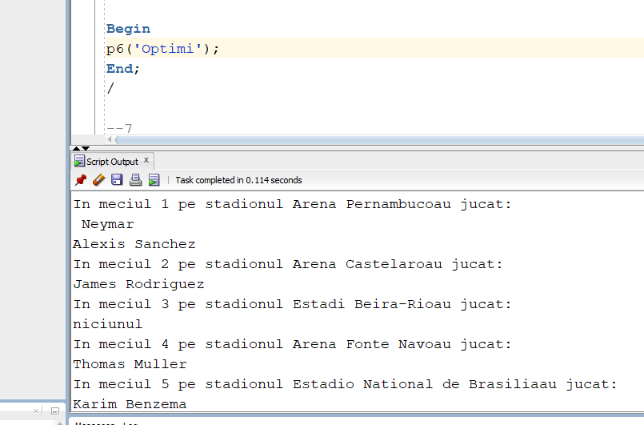

Cerinta 7

Afisati numarul de puncte al fiecarei echipe care a jucat in fazele eliminatorii impotriva unei echipe date ca parametru

create or replace procedure p7(echipa tari.id_tara%TYPE)

is

cursor c (echipa tari.id_tara%TYPE) is

select *

from meci

where meci.id_echipa1=echipa or echipa=meci.id_echipa2;

cursor c1 (echipa Meci.id_echipa1%TYPE) is

select numar_puncte

from tari

where id_tara=echipa;

cursor c2 (team Meci.id_echipa2%TYPE) is

select nume_tara

from tari

where tari.id_tara=team;

puncte number;

team tari.id_tara%TYPE;

nume tari.nume_tara%TYPE;

Begin

for meci in c(echipa) LOOp

if meci.id_echipa1=echipa

then

team:=meci.id_echipa2;

else

team:=meci.id_echipa1;

end if;

open c1(team);

fetch c1 into puncte;

open c2(team);

fetch c2 into nume;

DBMS_OUTPUT.PUT_LINE('Echipa '|| nume ||' a obtinut '|| puncte||' in faza grupelor');

close c1;

close c2;

end loop;

End;

/

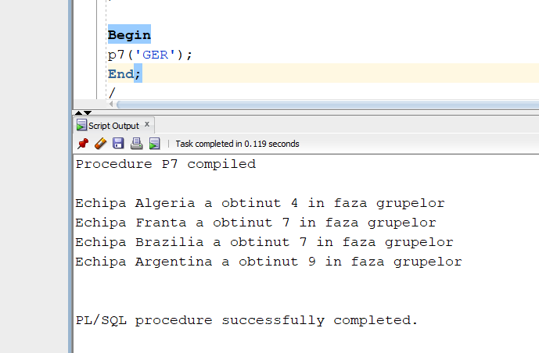

Cerinta 8

Afisati echipa cu cele mai multe puncte in faza grupelor care au un sponsor dat ca parametru si un numar minim de puncte acumulate.

create or replace function f8(sponsor sponsori.nume_sponsor%TYPE,nr_min number) return varchar2 is

tara_max tari.nume_tara%TYPE;

nr number;

max1 number:=nr_min-1;

max2 number:=-1;

v number;

nume tari.nume_tara%TYPE;

no_country exception;

too_many exception;

no_data_found exception;

Begin

select count(*)

into v

from sponsori

where nume_sponsor=sponsor;

if(v=0)

then

raise no_data_found;

end if;

for i in(select nume_tara,numar_puncte

from sponsorizeaza s1, sponsori s2, tari t

where sponsor=s2.nume_sponsor and s2.id_sponsor=s1.id_sponsor and s1.id_tara=t.id_tara)

loop

nr:=i.numar_puncte;

nume:=i.nume_tara;

if(nr>max1)

then

max1:=nr;

tara_max:=nume;

else

if(nr=max1)

then

max2:=nr;

end if;

end if;

end loop;

if(max1=nr_min-1)

then

raise no_country;

end if;

if(max1=max2)

then

raise too_many;

end if;

return tara_max;

Exception

when no_country then

return('No such country!');

when too_many then

return('More teams with same amount of points!');

when no_data_found then

return('No sponsor found');

End;

/

Begin

DBMS_OUTPUT.PUT_LINE(f8('Adidas',5));

End;

/

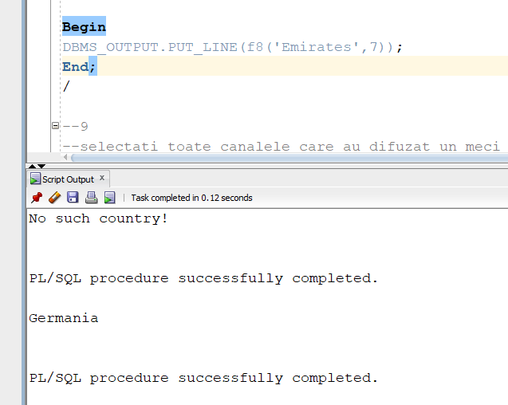

Exceptia no_data_found

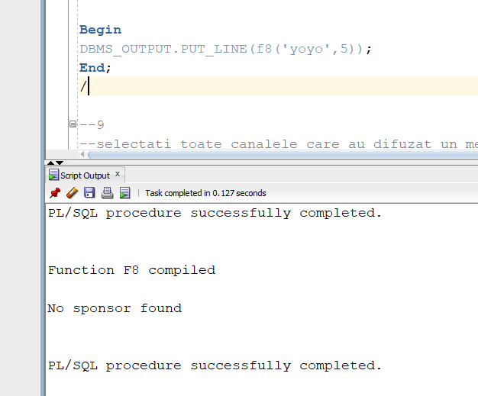

Exception too_many

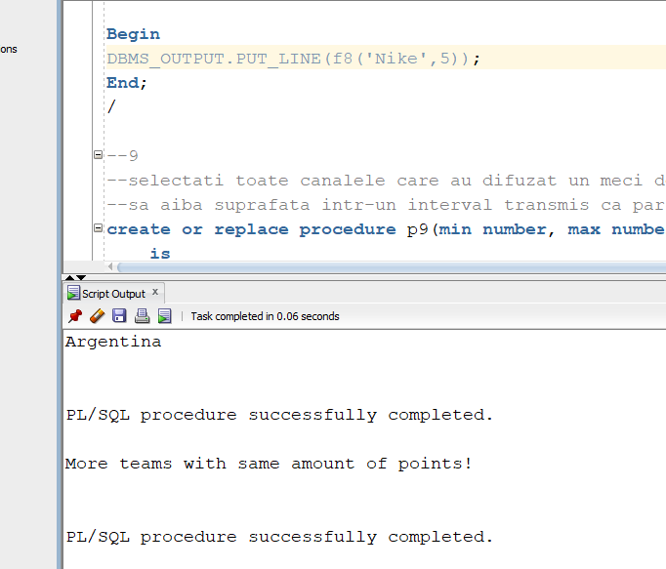

Exception no_country

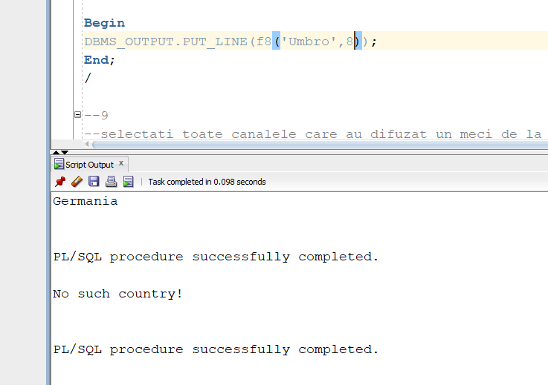

Cerinta 9

Selectati toate canalele care au difuzat un meci de la sferturi in sus intr-un oras care sa aiba suprafata intr-un interval transmis ca parametru.

create or replace procedure p9(min number, max number)

is

nume_oras orase.nume%TYPE;

Begin

select nume

into nume_oras

from orase

where suprafata>=min and suprafata<=max;

DBMS_OUTPUT.PUT_LINE('Canale:');

for canal in(select nume_canal

from canale_tv c, transmite t,meci m,stadion s,orase o

where c.id_canal=t.id_canal and t.id_meci=m.id_meci and m.id_meci>=9

and m.id_stadion=s.id_stadion and s.id_oras=o.id_oras and o.nume=nume_oras)

loop

DBMS_OUTPUT.PUT_LINE(canal.nume_canal);

end loop;

Exception

when No_data_found then

DBMS_OUTPUT.PUT_LINE('Nu exista oras cu suprafata ceruta');

when too_many_rows then

DBMS_OUTPUT.PUT_LINE('Prea multe orase cu suprafata ceruta');

End;

/

Begin

p9(1200,1300);

End;

/

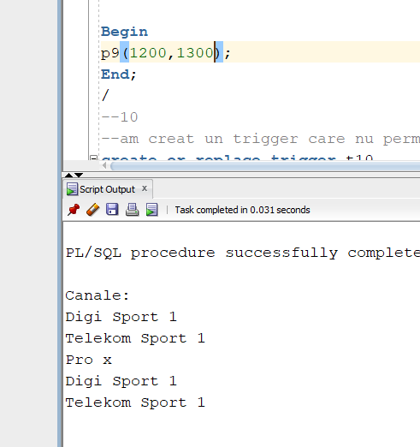

Exception no_data_found

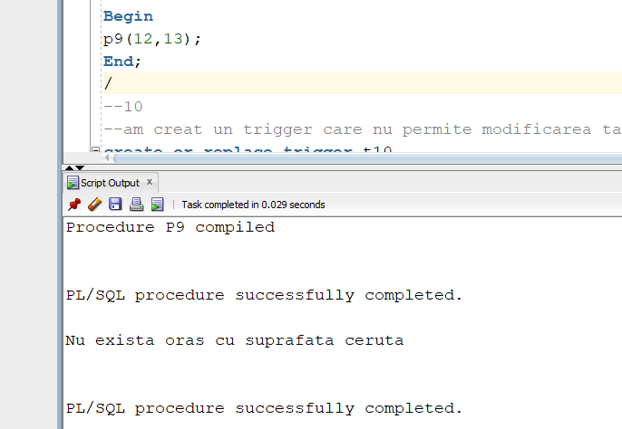

Exception too_many_rows

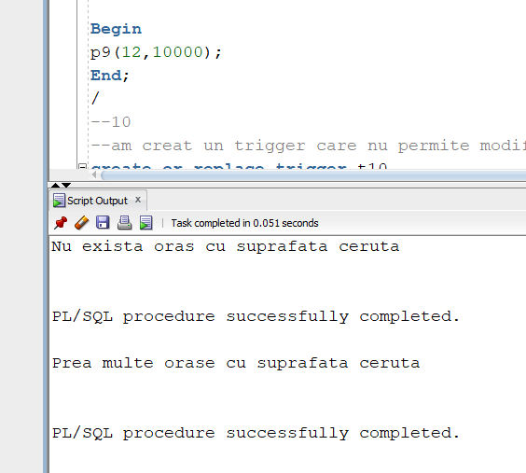

Cerinta 10

Am creat un trigger care nu permite modificarea tabele meci in afara campionatului mondial

create or replace trigger t10

before insert or update or delete on meci

Begin

if(sysdate>'01/AUG/2014' or sysdate<'01/JUL/2014')

then

raise_application_error(-20001,'Nu poti modifica tabela in afara perioadei Campionatului Mondial');

end if;

End;

/

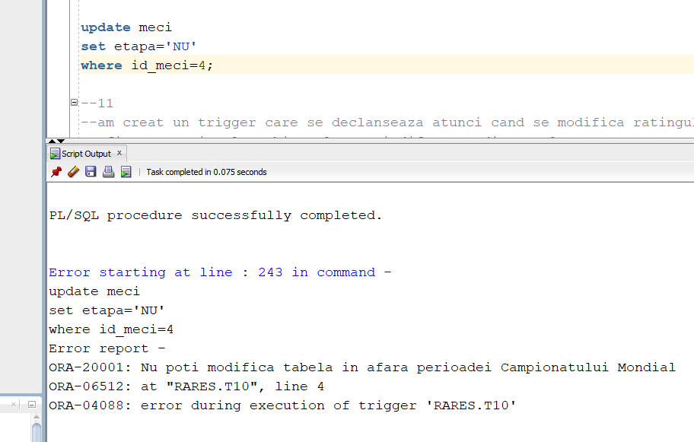

Cerinta 11

Am creat un trigger care se declanseaza atunci cand se modifica ratingul unui jucator si afiseaza ratingul vechi, cel nou si diferenta dintre ele

create or replace trigger t11

before insert or update or delete on jucatori

for each row

Declare

dif number;

begin

dif:=:New.rating-:Old.rating;

DBMS_OUTPUT.PUT_LINE('Old rating: '||:old.rating);

DBMS_OUTPUT.PUT_LINE('New rating: '||:new.rating);

DBMS_OUTPUT.PUT_LINE('Rating diference: '||dif);

End;

/

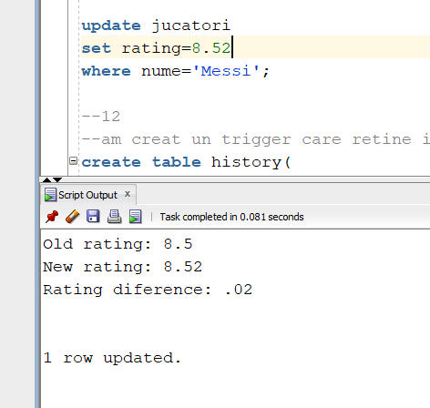

Cerinta 12

Am creat un trigger care retine in tabela history istoricul evenimentelor

create table history(

object_type varchar(20),

object_name varchar2(30),

event varchar2(30)

);

create or replace trigger t12

before create or alter or drop on schema

Begin

INSERT into history

values(SYS.dictionary_obj_type,SYS.dictionary_obj_name,SYS.sysevent);

End;

/

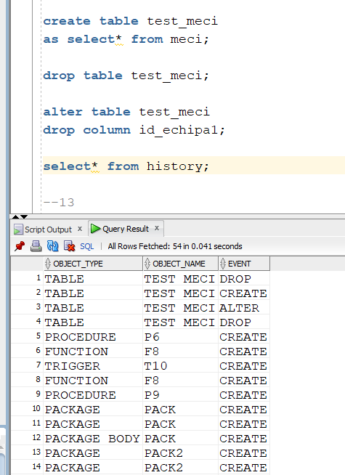

Cerinta 13

create or replace package pack

is

procedure p6(runda Meci.etapa%TYPE);

procedure p7(echipa tari.id_tara%TYPE);

function f8(sponsor sponsori.nume_sponsor%TYPE,nr_min number) return varchar2;

procedure p9(min number, max number);

End pack;

/

create or replace package body pack

is

procedure p6(runda Meci.etapa%TYPE)

is

type t_i is table of stadion%Rowtype index by pls_integer;

stadioane t_i;

type t is table of meci%rowtype;

meciuri t:=t();

type t_i2 is table of jucatori%rowtype index by pls_integer;

jucatori_tab t_i2;

numar number;

Begin

select count(*)

into numar

from meci

where etapa=runda;

meciuri.extend(numar+1);

select*

bulk collect into meciuri

from meci

where meci.etapa=runda;

select*

bulk collect into stadioane

from stadion;

for i in meciuri.first..meciuri.last loop

for j in stadioane.first..stadioane.last loop

if (meciuri(i).id_stadion=stadioane(j).id_stadion)

then

DBMS_OUTPUT.PUT_LINE('In meciul '||i||' pe stadionul '||stadioane(j).stadion||'au jucat:');

select*

bulk collect into jucatori_tab

from jucatori

where id_tara=meciuri(i).id_echipa1 or id_tara=meciuri(i).id_echipa2;

if(jucatori_tab.count!=0)

then

for z in jucatori_tab.first..jucatori_tab.last loop

DBMS_OUTPUT.PUT_LINE(jucatori_tab(z).prenume||' '||jucatori_tab(z).nume);

end loop;

else

dbms_output.put_line('niciunul');

end if;

end if;

end loop;

end loop;

End p6;

--7

--Afisati numarul de puncte al fiecarei echipe care a jucat in fazele eliminatorii impotriva unei echipe date ca parametru

procedure p7(echipa tari.id_tara%TYPE)

is

cursor c (echipa tari.id_tara%TYPE) is

select *

from meci

where meci.id_echipa1=echipa or echipa=meci.id_echipa2;

cursor c1 (echipa Meci.id_echipa1%TYPE) is

select numar_puncte

from tari

where id_tara=echipa;

cursor c2 (team Meci.id_echipa2%TYPE) is

select nume_tara

from tari

where tari.id_tara=team;

puncte number;

team tari.id_tara%TYPE;

nume tari.nume_tara%TYPE;

Begin

for meci in c(echipa) LOOp

if meci.id_echipa1=echipa

then

team:=meci.id_echipa2;

else

team:=meci.id_echipa1;

end if;

open c1(team);

fetch c1 into puncte;

open c2(team);

fetch c2 into nume;

DBMS_OUTPUT.PUT_LINE('Echipa '|| nume ||' a obtinut '|| puncte||' in faza grupelor');

close c1;

close c2;

end loop;

End p7;

--8

--Afisati echipa cu cele mai multe puncte in faza grupelor care au un sponsor dat ca parametru si un numar minim de puncte acumulate

function f8(sponsor sponsori.nume_sponsor%TYPE,nr_min number) return varchar2 is

tara_max tari.nume_tara%TYPE;

nr number;

max1 number:=nr_min-1;

max2 number:=-1;

v number;

nume tari.nume_tara%TYPE;

no_country exception;

too_many exception;

no_data_found exception;

Begin

select count(*)

into v

from sponsori

where nume_sponsor=sponsor;

if(v=0)

then

raise no_data_found;

end if;

for i in(select nume_tara,numar_puncte

from sponsorizeaza s1, sponsori s2, tari t

where sponsor=s2.nume_sponsor and s2.id_sponsor=s1.id_sponsor and s1.id_tara=t.id_tara)

loop

nr:=i.numar_puncte;

nume:=i.nume_tara;

if(nr>max1)

then

max1:=nr;

tara_max:=nume;

else

if(nr=max1)

then

max2:=nr;

end if;

end if;

end loop;

if(max1=nr_min-1)

then

raise no_country;

end if;

if(max1=max2)

then

raise too_many;

end if;

return tara_max;

Exception

when no_country then

return('No such country!');

when too_many then

return('More teams with same amount of points!');

when no_data_found then

return('No sponsor found');

End f8;

--9

--selectati toate canalele care au difuzat un meci de la sferturi in sus intr-un oras care

--sa aiba suprafata intr-un interval transmis ca parametru

procedure p9(min number, max number)

is

nume_oras orase.nume%TYPE;

Begin

select nume

into nume_oras

from orase

where suprafata>=min and suprafata<=max;

DBMS_OUTPUT.PUT_LINE('Canale:');

for canal in(select nume_canal

from canale_tv c, transmite t,meci m,stadion s,orase o

where c.id_canal=t.id_canal and t.id_meci=m.id_meci and m.id_meci>=9

and m.id_stadion=s.id_stadion and s.id_oras=o.id_oras and o.nume=nume_oras)

loop

DBMS_OUTPUT.PUT_LINE(canal.nume_canal);

end loop;

Exception

when No_data_found then

DBMS_OUTPUT.PUT_LINE('Nu exista oras cu suprafata ceruta');

when too_many_rows then

DBMS_OUTPUT.PUT_LINE('Prea multe orase cu suprafata ceruta');

End p9;

End pack;

/

execute pack.p9(1200,1500);

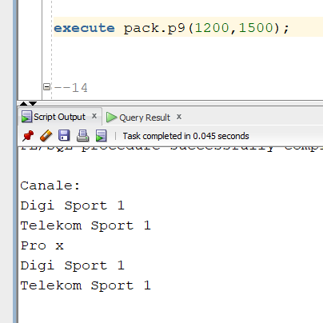

Cerinta 14

Pentru o tara introdusa de la tastatura sa se afiseze numarul de puncte, numarul de victorii din fazele eliminatorii, cati jucatori are in top 10

create or replace package pack2

is

type t_i is table of tari%Rowtype index by pls_integer;

tari_table t_i;

type t is table of meci%rowtype;

meciuri t:=t();

function get_points(id_tara tari.id_tara%TYPE) return number;

function get_id(nume tari.nume_tara%TYPE) return tari.id_tara%TYPE;

procedure top_10(id_tara tari.id_tara%TYPE);

procedure victorii(id_tara tari.id_tara%TYPE);

procedure get_details(nume tari.nume_tara%TYPE);

END pack2;

/

Create or replace package body pack2

is

function get_id(nume tari.nume_tara%TYPE) return tari.id_tara%TYPE

is

id1 tari.id_tara%TYPE;

begin

select id_tara

into id1

from tari

where nume_tara=nume;

return id1;

Exception

when no_data_found then

DBMS_OUTPUT.PUT_LINE('Nu exista tara');

return -1;

end get_id;

function get_points(id_tara tari.id_tara%TYPE) return number

is

begin

select*

bulk collect into tari_table

from tari;

for i in tari_table.first..tari_table.last loop

if tari_table(i).id_tara=id_tara

then

return tari_table(i).numar_puncte;

end if;

end loop;

end get_points;

procedure top_10(id_tara tari.id_tara%TYPE)

is

nr number:=0;

begin

for j in(select* from jucatori) loop

for i in tari_table.first..tari_table.last loop

if(j.id_tara=tari_table(i).id_tara and id_tara=tari_table(i).id_tara)

then

nr:=nr+1;

end if;

end loop;

end loop;

if(nr=0)

then

DBMS_OUTPUT.PUT_LINE('Nu are jucatori in top 10');

else

DBMS_OUTPUT.PUT_LINE('Are '||nr||' jucatori in top 10');

end if;

end top_10;

procedure victorii(id_tara tari.id_tara%TYPE)

is

nr number:=0;

victorii number:=0;

begin

select count(*)

into nr

from meci;

meciuri.extend(nr+1);

select*

bulk collect into meciuri

from meci;

for i in meciuri.first..meciuri.last loop

if(meciuri(i).id_echipa1=id_tara)

then

if(meciuri(i).goluri1>meciuri(i).goluri2)

then

victorii:=victorii+1;

else

if(meciuri(i).goluri1=meciuri(i).goluri2)

then

if(meciuri(i).penaltiuri1>meciuri(i).penaltiuri2)

then

victorii:=victorii+1;

end if;

end if;

end if;

end if;

if(meciuri(i).id_echipa2=id_tara)

then

if(meciuri(i).goluri1<meciuri(i).goluri2)

then

victorii:=victorii+1;

else

if(meciuri(i).goluri1=meciuri(i).goluri2)

then

if(meciuri(i).penaltiuri1<meciuri(i).penaltiuri2)

then

victorii:=victorii+1;

end if;

end if;

end if;

end if;

end loop;

DBMS_OUTPUT.PUT_LINE('Are '||victorii||' victorii');

end victorii;

procedure get_details(nume tari.nume_tara%TYPE)

is

puncte number;

id_tara tari.id_tara%TYPE;

begin

id_tara:=get_id(nume);

puncte:=get_points(id_tara);

DBMS_OUTPUT.PUT_LINE(nume||' a obtinut '||puncte||' puncte si:');

victorii(id_tara);

top_10(id_tara);

end get_details;

end pack2;

/

execute pack2.get_details('Germania');

