6. Experimental Modelling
This chapter presents the experimental design used to evaluate password strength meters for Romanian passwords. It defines the data sources, comparison methods, experiments, validation procedures, and mathematical model used in the evaluation. Table 6.1 identifies the section for each part of the design. Chapters 4 and 5 describe zxcvbn and the proposed Romanian-aware extension; in this chapter, they are evaluated as measurement tools. The thresholds, statistical tests, and decision rules are specified before data collection to reduce the risk that the observed results influence the evaluation criteria.
Table 6.1. Structure of the experimental chapter.
Question | Section
Which data are used? | 6.2
How are the measurements modelled mathematically? | 6.3 and 6.5
Which systems and methods are used for comparison? | 6.4
Which experiments are performed? | 6.6
How are the results validated? | 6.7

6.1. Overview
Each password strength meter is evaluated against an independent reference based on practical password-cracking attacks. For each test password, I record the number of guesses estimated by the meter and the earliest guess at which one of the selected attacks finds the password. Accuracy is considered in two ways. First, passwords that require more attack guesses should also receive higher meter estimates. Second, the score shown to the user should represent the observed difficulty of finding the password. Figure 6.1 summarises this process.
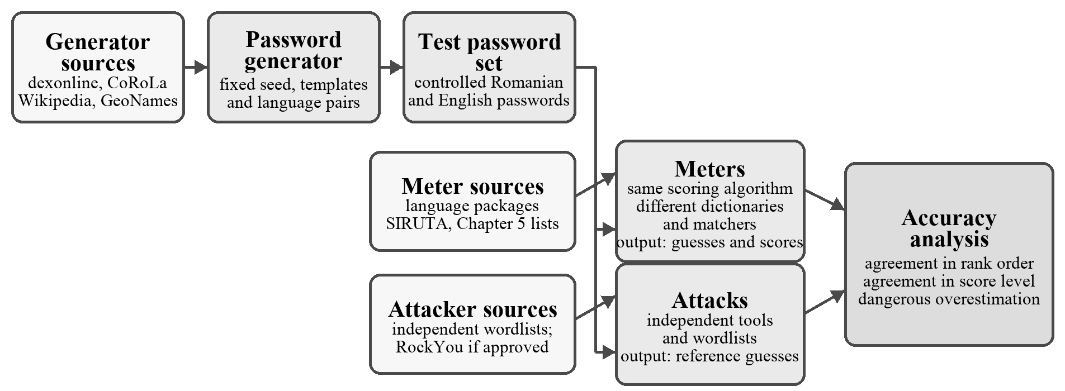
Figure 6.1. Experimental process and separation of data sources. Breach-derived data are included only with written approval from the supervisor and the faculty, as explained in Section 6.2.3.
The experimental design follows four main principles:
• Independent reference. The meters are evaluated with attacks configured separately from the meter dictionaries, following Ur et al. [7].
• Controlled language comparison. Each English control password is paired with a Romanian password that uses the same template and suffix and a base word from a similar frequency band. This design reduces structural differences between the two languages.
• Same algorithm. The main zxcvbn-ts variants use the same scoring algorithm. They differ only in the dictionaries, matchers, and text normalisation available to them.
• Separate sources. The generator, the meters, and the attacks use separate source files where independence is required. This reduces the risk that a meter receives prior knowledge of the test set.

6.2. Data

6.2.1. Separation of Data Sources
The generator, the meters, and the attack configurations all use word lists. To avoid a circular evaluation, the study applies three separation rules:
1. The generator and the meters do not share source files. Otherwise, a meter could know the test vocabulary by construction.
2. The meters and the attackers do not share source files. Otherwise, the reference could favour exactly the vocabulary already known to the meter.
3. The generator and the attackers may share source files. The attacks need suitable candidate words to find the generated passwords, so this overlap supports a usable reference without giving the meter prior knowledge.
Different source files may still contain some of the same common vocabulary. For example, vacanta may appear in several independent Romanian lists because it is a frequent Romanian word. I therefore calculate and report the overlap between each pair of lists. Table 6.2 presents the planned source for each component.
Table 6.2. Data sources for the generator, meters, and attackers. The meter uses the INS SIRUTA register for localities, whereas the generator uses GeoNames, in accordance with the first separation rule.
Resource | Generator inputs | Meter inputs | Attacker inputs
Romanian words | dexonline lexemes ranked with CoRoLa frequencies | published language-ro common words, cleaned and re-ranked | dexonline lexemes and inflected forms
First names | Romanian Wikipedia name lists | language-ro names, official name statistics, and manually compiled diminutives | the generator list
Phrases | frequent two-to-four-word sequences from Leipzig corpora [25] | manually compiled expressions such as teiubesc | the generator list
Localities | GeoNames | INS SIRUTA register | GeoNames
Cultural terms | Romanian Wikipedia list pages | manually compiled list described in Chapter 5 | the generator list
Leaked passwords | Not used | meter share M, subject to approval (Section 6.2.3) | attacker share A and RockYou, subject to approval
English words, names, and phrases | BNC frequency list, US SSA names, and English Leipzig corpora | language-en, identical in every zxcvbn-ts meter | the generator lists and RockYou
Localities and football clubs are closed categories, so complete lists still overlap and meters may know the test items. I report RO-place and RO-cultural separately and exclude them from pooled primary analyses. The remaining Romanian categories are open class.

