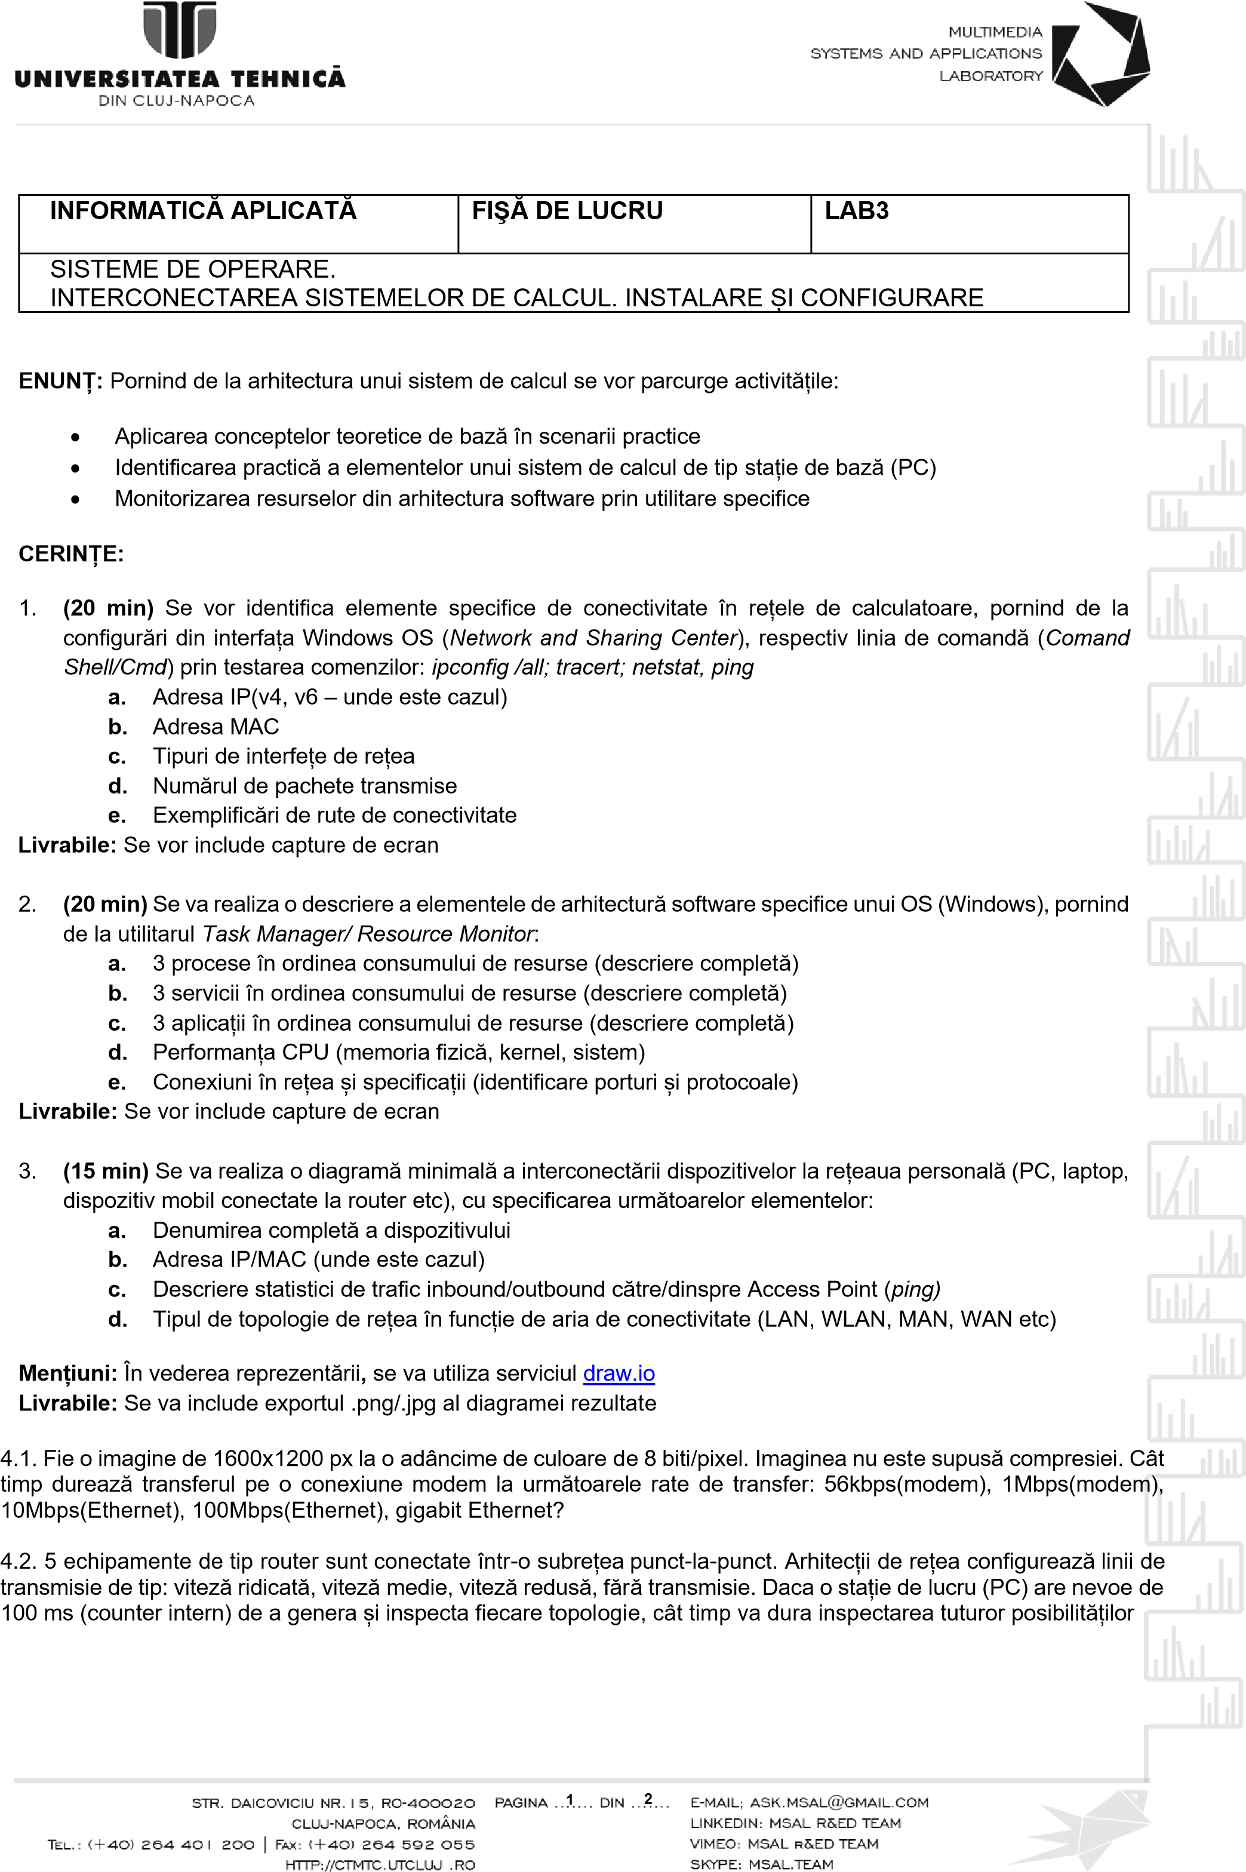

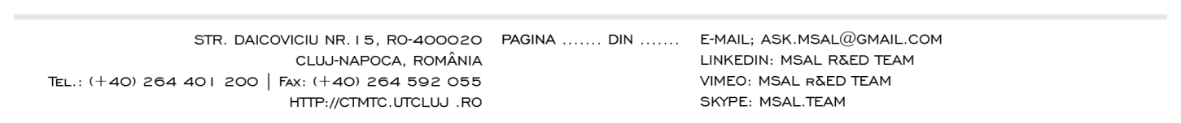

**2**

**2**

**LIVRABILE:**

1

document .docx /.pdf ce conține rezolvările exercițiilor

1

-

4

, încărcat prin intermediul funcționalității

**MS FORMS.**

TERMEN: Ziua desfășurării laboratorului (conform orar semi

-

grupă),

**11.45**

**PM**

1. **A) IPv4 Address. . . . . . . . . . . : 172.20.10.4**

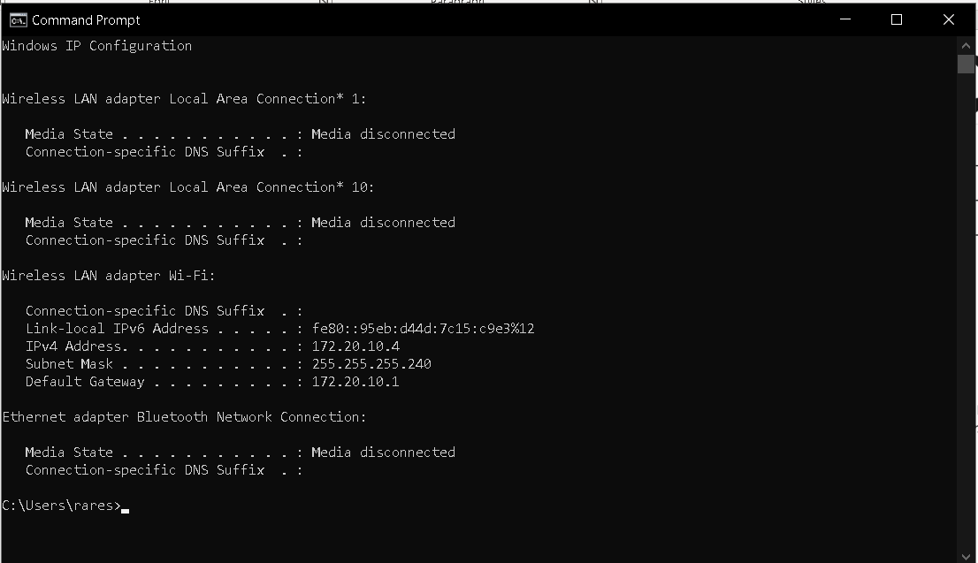

**b) Description . . . . . . . . . . . : Intel(R) Wireless-AC 9461**

**Physical Address. . . . . . . . . : 50-E0-85-37-84-D0**

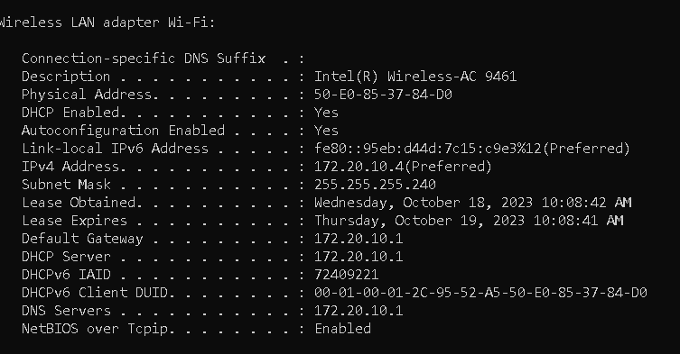

**c)**

**Ethernet adapter Bluetooth Network Connection:**

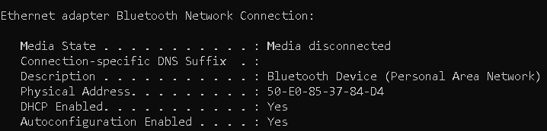

**d)**

**Packets: Sent = 4, Received = 4, Lost = 0 (0% loss),**

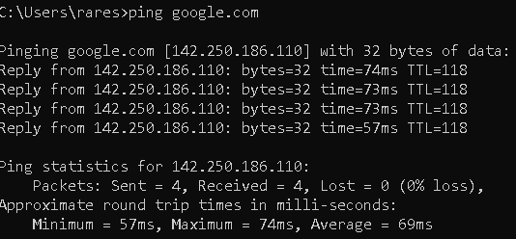

**e)**

**Tracing route to google.com [142.250.74.206]**

**over a maximum of 30 hops:**

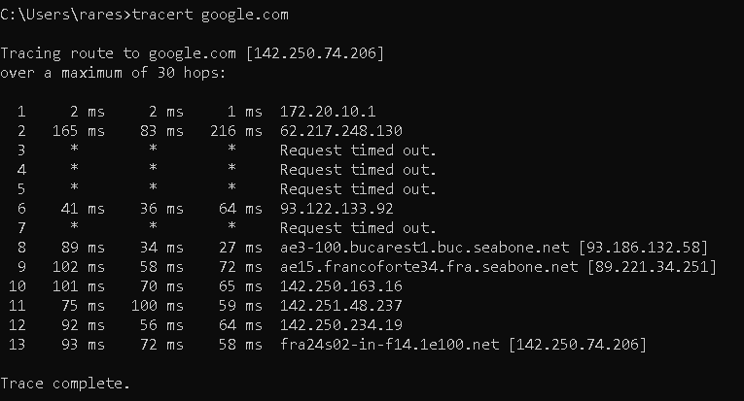

**2.**

**a) Procese**

**antimalware service executable**

**application frame host**

**asus app service**

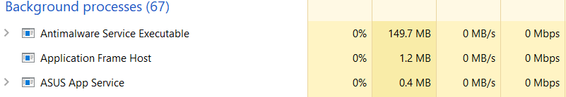

**b) Servicii**

**desktop window manager**

**registry**

**local security authority**

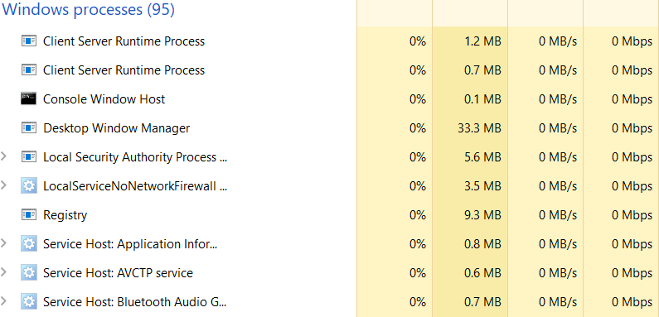

**c) Aplicatii**

**google chrome**

**Microsoft teams**

**Mircrosoft word**

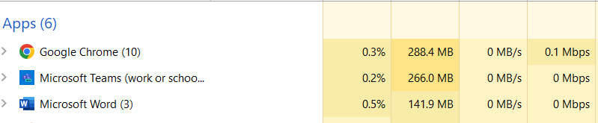

**d) Cpu**

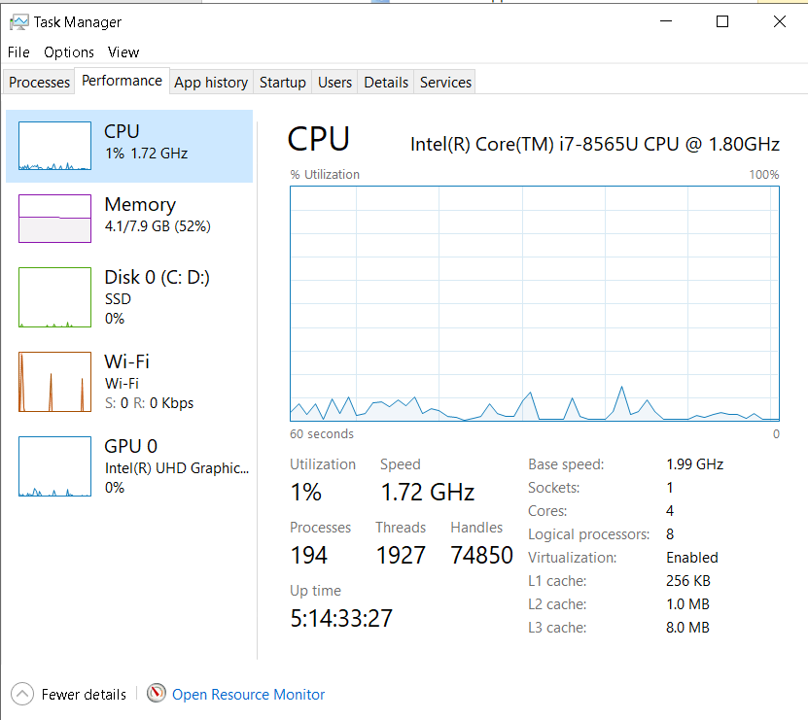

**e)**

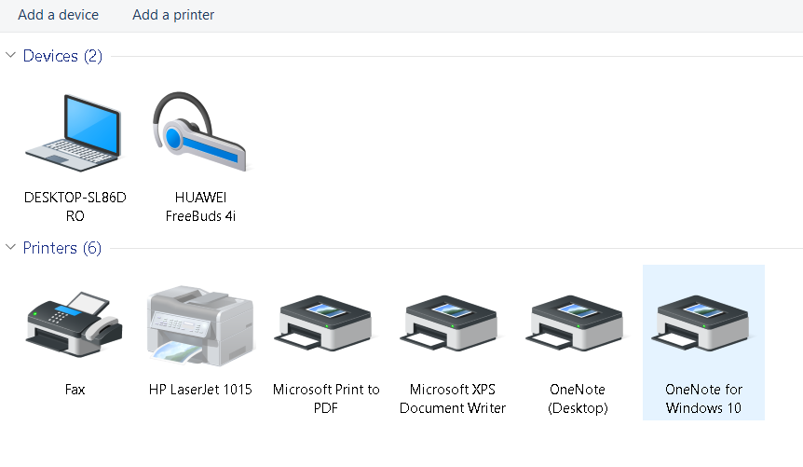

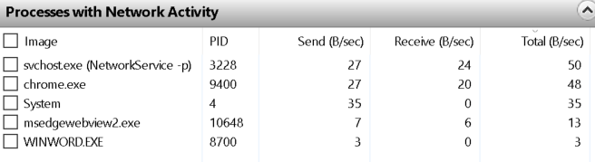

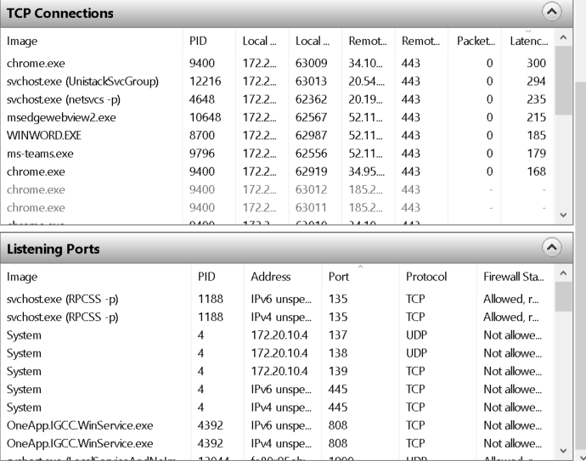

**3.**

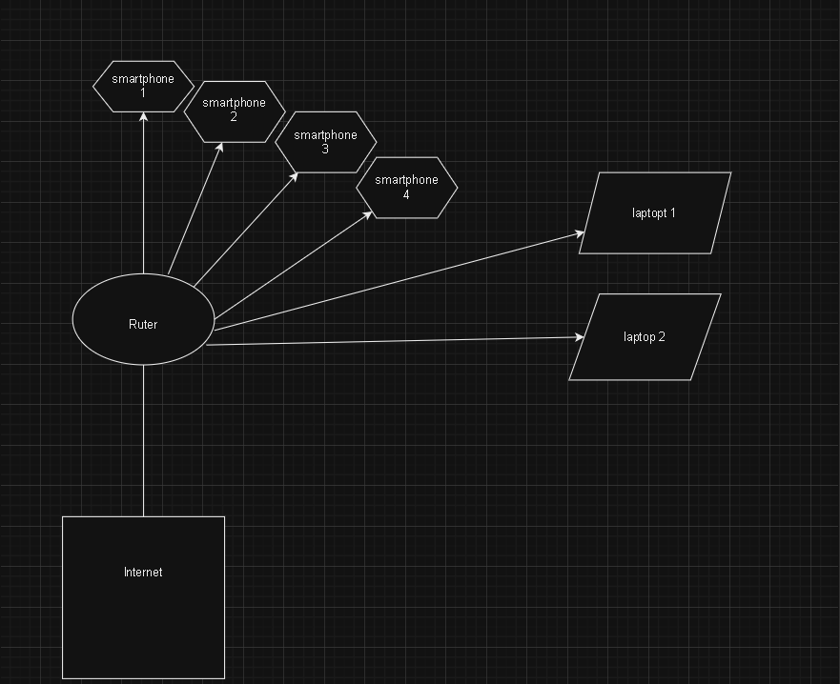

**b)**

**IPv4 address: 192.168.0.171**

**IPv4 DNS servers: 213.233.64.231**

**213.233.64.233**

**Physical address (MAC): 50-E0-85-37-84-D0**

**c)**

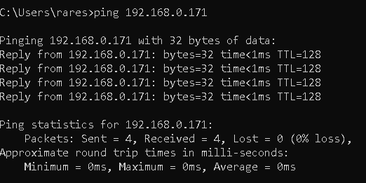

**d) wan**

**4.1.**

**1600x1200x8=15360000**

**a)56kbs=274 s**

**b)1mbps=15.36s**

**c)10mbps=1.536s**

**d)100mbps=0.153s**

**4.2.**

**10 linii diferite si 4 lini de viteze**

**100ms x 1048576=104857.6 s**