Homework #1 – Testing a Website
  - Tudose Rareș

Website #1 – Demo Blaze
Demo Blaze is a fictional e-commerce web application frequently used for practicing both manual and automated software testing. It simulates an online store selling products such as phones, laptops and monitors.

Additional Testing Techniques Used
- Exploratory testing is a hands-on software testing approach where testers simultaneously learn about the application, design tests, and execute them without using predefined scripts or test cases (practitest.com). I used this technique by freely navigating through the main flow of the site (viewing a product -> adding to cart -> checkout) to understand the platform’s architecture and identify atypical UI behaviors such as quantity management (Bug report #3).
- Error guessing is an informal, experience-based software technique where testers use their intuition, past bug history, and domain knowledge to anticipate where a system might fail (geeksforgeeks). I used this method to directly attack the input forms (contact and place order), trying to submit empty data or incorrect data types (letters instead of numbers), knowing that client-side data validation is a source of errors encountered on multiple websites (Bug report #1 and Bug report #2).

Bug reports
Bug report #1: Contact form allows sending empty messages
Summary: “Contact” form does not validate mandatory fields.
Steps to reproduce:
- Open the website and head to the home page https://www.demoblaze.com/index.html.
- Click on the “Contact” link in the top navigation menu.
- Leave the “Contact Email”, “Contact Name”, and “Message” fields completely empty.
- Click the “Send message” button.
Expected result: The system should display specific error messages (e.g. “Email is required”) and block the form submission.
Actual result: The system accepts the empty form and displays the success alert “Thanks for the message!!”.
Severity: High Impact
Evidence: Attached is a screenshot showing the unfilled form in the background and the success message.
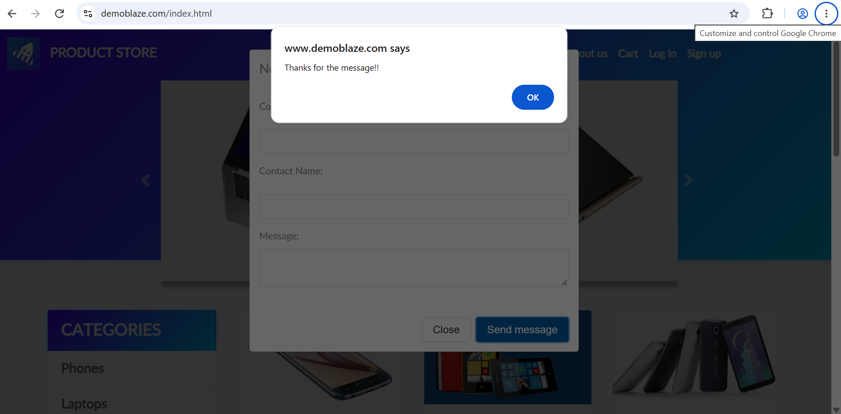

Bug report #2: Missing validation for the “Credit card” field when placing an order
Summary: ”Place order” form accepts alphabetical characters in the “Credit card” field.
Steps to reproduce:
- Open the website and head to the home page https://www.demoblaze.com/index.html.
- Navigate to the “Cart” section from the top menu.
- Fill in the “Name” field with whatever characters.
- Fill in the “Credit card” field with alphabetical characters (e.g. “sbdsa”).
- Click the “Purchase” button.
Expected result: The system must reject the alphabetical input, request a valid card number and block the checkout process.
Actual result: The order is successfully processed and the system displays the message “Thank you for your purchase!”
Severity: High Impact
Evidence: Attached is a screenshot showing the “Credit card” field with alphabetical characters in the background and the success message.
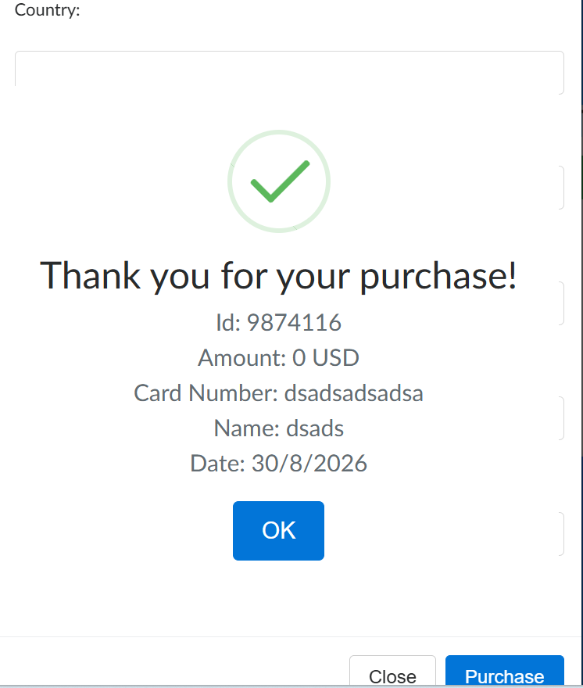

Bug report #3: Duplicated rows in the cart for the same product
Summary: Adding the same product multiple times creates separate cart entries instead of updating the quantity.
Steps to reproduce:
- Open the website and head to the home page https://www.demoblaze.com/index.html.
- Click on the “Samsung Galaxy S6” product.
- Click on “Add to cart” and accept the confirmation alert.
- Return to the homepage (Home button).
- Click again on the same “Samsung Galaxy S6” product.
- Click on “Add to cart” and accept the alert.
- Navigate to the “Cart” page.
Expected result: The “Samsung Galaxy S6” product should appear in a single row, with a visual indicator for “Quantity: 2”.
Actual result: The product appears on two separate rows in the shopping cart table, taking up unnecessary screen space.
Severity: Minor Impact
Evidence: Attached is a screenshot of the shopping cart table.
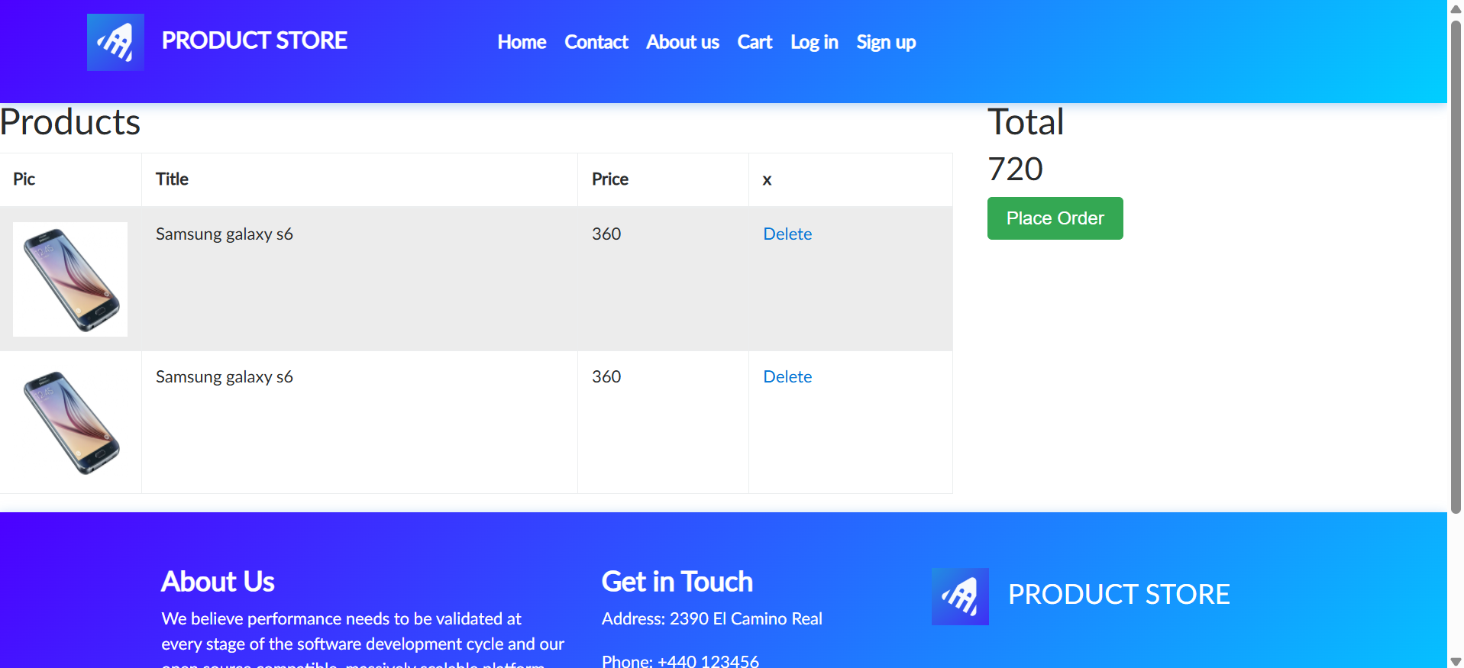

Test cases
Test case #1: Viewing the details of a specific product
ID: 001.
Purpose: Verify the correct display of the product page.
Preconditions: Internet access, browser (any browser, anu version available) open on the Demoblaze homepage, any device connected to the internet.
Steps:
- In the “Categories” section, click on “Laptops”.
- Click on the product title “Sony Vaio i5”
Expected result: The user is redirected to the product page. The displayed elements include: the laptop’s image, the exact title “Sony Vaio i5”, the price of “$790”, a detailed description of the technical specifications and the “Add to cart” button.
Test case #2: Filtering products by categories
ID: 002.
Purpose: Verify the functionality of the category sidebar menu.
Preconditions: Internet access, browser (any browser, anu version available) open on the Demoblaze homepage, any device connected to the internet.
Steps:
- On the homepage, locate the “CATEGORIES” menu on the left side.
- Click on the “Monitors” category.
Expected result: The product list displayed on the screen updates to exclusively show monitors (e.g. Asus FULL HD). Products from the “Phones” or “Laptops” categories disappear from the list.
Test case #3: Deleting a product from the shopping cart
ID: 003.
Purpose: Verify the functionality of removing a previously added item from the cart.
Preconditions: Internet access, browser (any browser, anu version available) open on the Demoblaze homepage, any device connected to the internet. There is at least one product added to the “Cart” page. In this test case, we’ll choose “Nokia lumia 1520” to be already added.
Steps:
- Click on the “Cart” section in the navigation menu.
- Identify the row corresponding to the “Nokia lumia 1520” product.
- Click the “Delete” button located on the same row.
Expected result: The row containing the product instantly disappears from the table and the cart’s total value is either recalculated or becomes empty if it was the only product.

Website #2 – Imgur.com
Imgur is an online image hosting, sharing and community platform founded in 2009. Beyond basic hosting, it functions as its own social media-style community where users can browse public galleries, post comments, and upvote content.

Bug reports
Bug report #1: Homepage footer disappears when scrolling and reappears only at the top of the page
Summary: The footer on the homepage disappears after scrolling down and reappears only after returning to the top. It should appear right after the user is starting to scroll up again.
Steps to reproduce:
- Open the website and head to the home page.
- Wait for the homepage to load and locate the footer.
- Scroll down until the footer disappears.
- Scroll partially upward without reaching the top.
- Check whether the footer is visible.
- Return to the top and check again.
Expected result: The footer should remain accessible while scrolling or should appear again when the user is starting to scroll up.
Actual result: The footer disappears when scrolling down and reappears only after returning to the top of the page.
Severity: Low impact
Evidence: Attached is a screen recording video showing the footer disappear.


Bug report #2: Deleting a post leaves a blank image area and requires a manual refresh
Summary: After deleting a post, the site displays a “Post deleted” confirmation banner, but the page remains in an empty state with a blank image area instead of automatically updating the view.
Steps to reproduce:
- Open the website and head to the home page.
- Log in to the platform.
- Prepare a valid JPG image named Image #1.jpg.
- Select “New post” and upload the image.
- Delete the post.
- Observe the page without refreshing it.
Expected result: After successful deletion, the page should automatically redirect the user back to the profile, or to the home page.
Actual result: The “Post deleted” banner appears, but the image area becomes blank and the page remains on the deleted post. The user must manually refresh the page.
Severity: Low impact
Evidence: Attached is a screenshot showing the blank image spot.
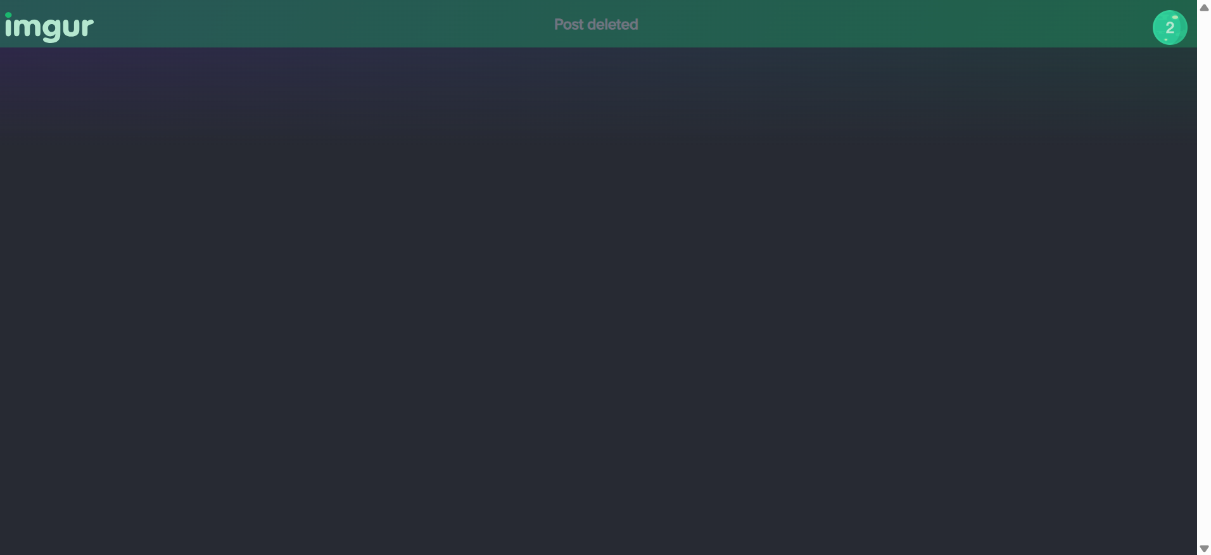

Bug report #3: Search suggestion extends beyond the viewport and cannot be scrolled
Summary: When using the search bar, the suggestion dropdown extends below the visible browser are.
Steps to reproduce:
- Open the website and head to the home page.
- Click the search field.
- Type “nice”.
- Observe the user suggestion near the bottom of the browser window.
- Attempt to scroll down using the mouse wheel or touchpad.
Expected result: After successful deletion, the page should automatically redirect the user back to the profile, or to the home page.
Actual result: All suggestions included in the dropdown should be fully viewable and selectable.
Severity: High impact

Evidence: Attached is a screenshot showing the dropdown.


Test cases
Test case #1: Upload an image with special characters in its filename
ID: 001.
Purpose: Verify that the same image can be uploaded under two different filenames.
Preconditions: Internet access, browser (any browser, anu version available), logged in the platform, two identical copies of a valid JPG image named Image1.jpg and Image #1.jpg
Steps:
- Open Imgur and select “New post”.
- Upload Image1.jpg and check the preview.
- Start a new upload.
- Upload Image #1.jpg and check the preview.
Expected result: Both files upload successfully and display the same image.

Test case #2: Verify the logic of the troubleshooting instructions
ID: 002.
Purpose: Verify that the support article provides logically correct troubleshoot instructions.
Preconditions: Internet access, browser (any browser, anu version available), logged in the platform, the article of “I’ve discovered an issue or bug” is accessible.
Steps:
- Open Imgur, open the article and locate “iOS App”.
- Read the question about whether the problem persists after reinstalling.
- Check the instruction associated with an affirmative answer.
- Check the instruction associated with a negative answer.
Expected result: An affirmative answer leads to further troubleshooting. A negative answer indicates that the problem has been resolved.

