CC - Tema 5

Vom folosi Python deoarece este un limbaj de programare slab restrictiv.

Vom folosi Flask , deoarece este light-weight si se foloseste pentru aplicatii mici si medii, developmentul fiind mult mai digerabil.

Vom folosi React deoarece este un framework de frontend foarte fiabil, foloseste virtual-dom astfel viteza de procesare este mult mai rapida decat in alte frameworkuri.

Totodata ne putem folosi si de elementele styled din React astfel scurtand timpul alocat pentru dezvoltarea unui frontend cu aspect agreabil.

Proiectul nostru va fi dedicat in totalitate oamenilor care au o pasiune pentru obiectele de arta, sau celor care doresc detina un astfel de obiect.

Gruparea tuturor obiectele in acelasi loc , pe o platforma web cred ca ar face mai usoara cumpararea acestora de catre client si in acelasi timp ar face si vanzarea mult mai simpla.

Architectural diagram:

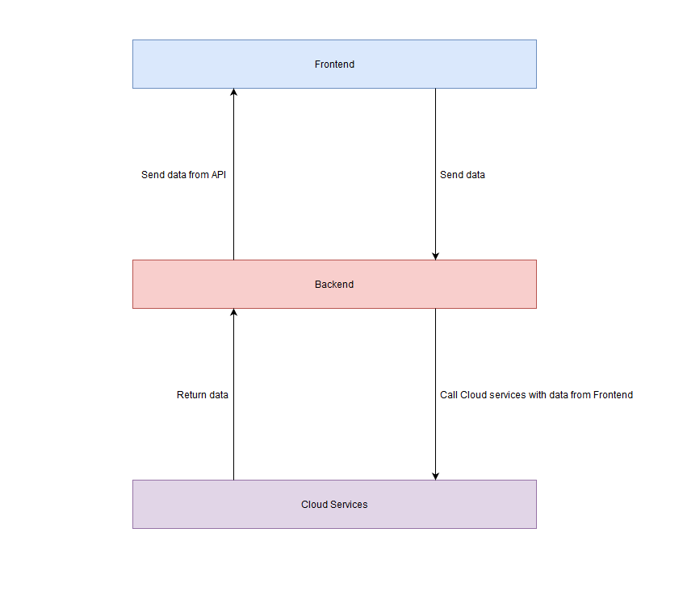

Pe langa aceste layere, vom folosi si o baza de date (google firebase) cu urmatorul design:

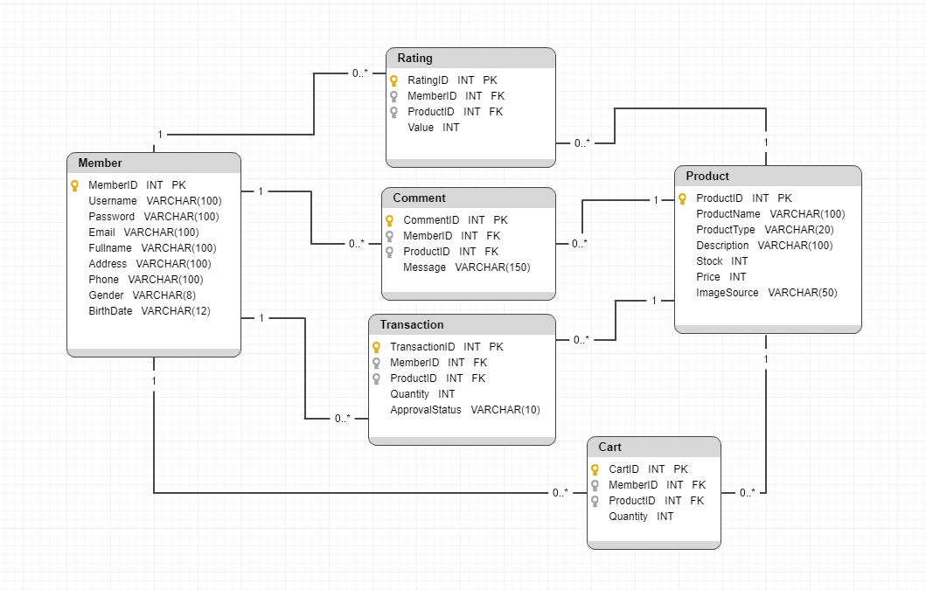

**Use-cases:**

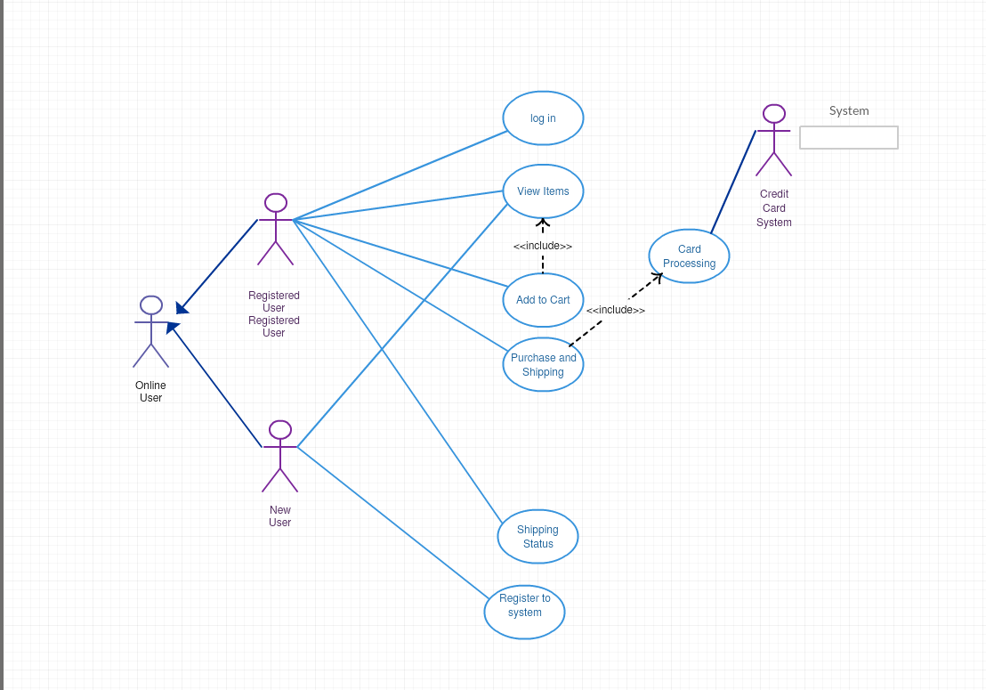

**APIs:**

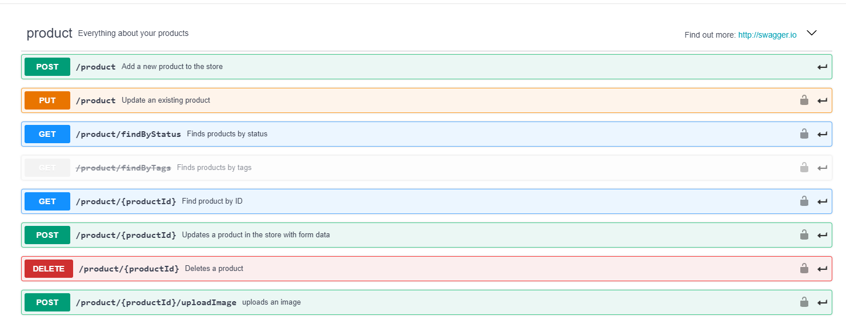

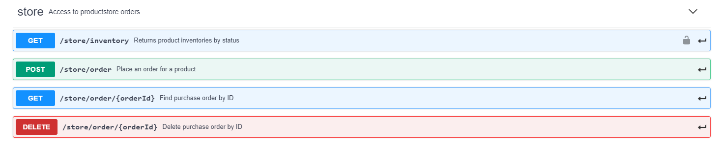

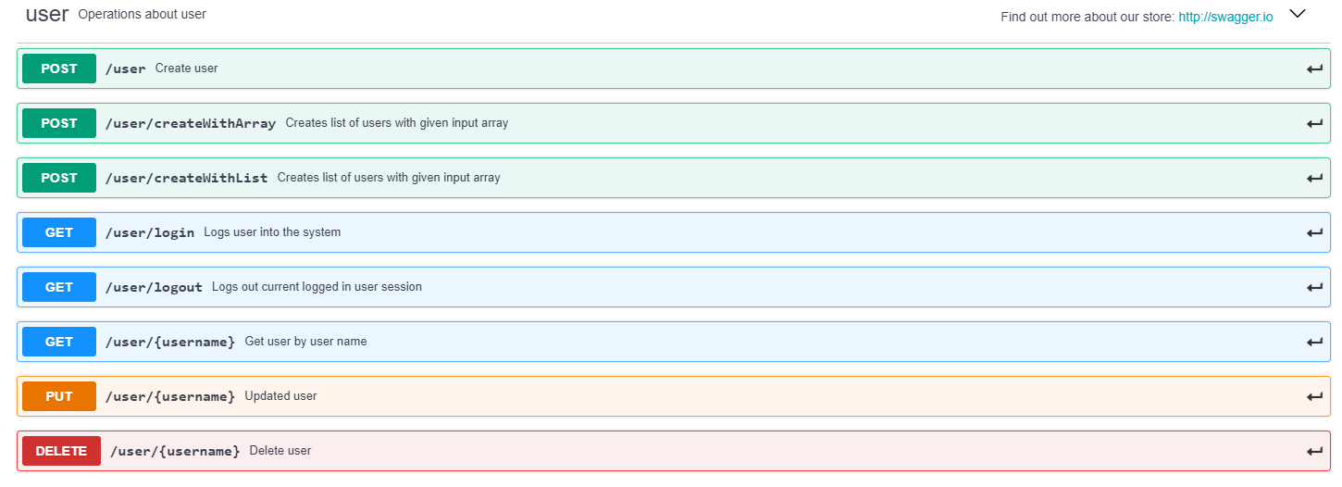

**Business Model**

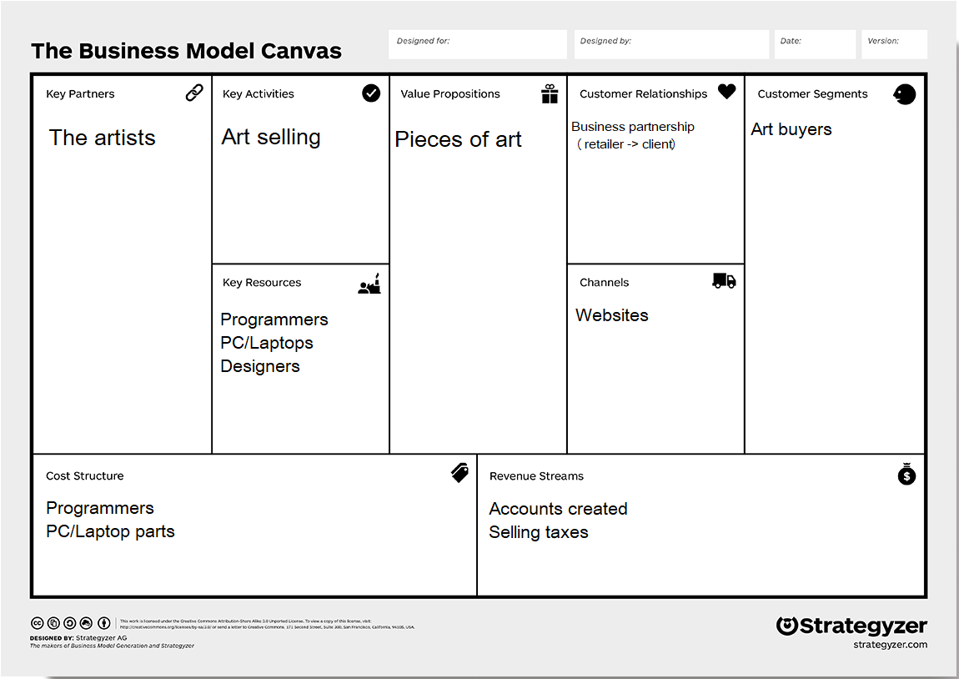

**Studiu de caz**

**AMAZON**

Amazon? Yes, that’s right. In 2013, the online retail giant entered the fine art fray, opening a special [Amazon Art](http://amzn.to/2pkY89g) section. They even have a selection of Guest Curators to bring a gallery feel to the digital market. In order to sell your art on Amazon, there is a pre-approval process. Note that only certain types of art are eligible. Original paintings, drawings, watercolors, and two-dimensional mixed media, as well as limited edition photography and prints are permitted. Unfortunately, sculptors will need to look elsewhere, as three-dimensional art is prohibited.

Selling crafts or other creative items instead? You can still sign up to become a seller on [Amazon Handmade](https://sell.amazon.com/programs/handmade.html), which specializes in makers and supports individual creators by giving them access to Amazon’s Professional selling plan, free of charge.

### ****ETSY****

Since its inception in 2005, [Etsy](http://tidd.ly/c00d266) has been the go-to online marketplace for handcrafted and vintage items. Its motto “Shop for anything from creative people anywhere,” sums it up. A budding fashion designer looking to easily sell clothing online? An artisan making handcrafted furniture or sculptural jewelry? This is the place for you. Etsy charges a nominal listing and transaction fee but makes it a breeze to open your own shop.

They also provide a huge number of resources to their sellers, from handbooks on branding and marketing to practical information on taking the stress out of bookkeeping. There’s definitely a reason that the site has over 1 million active sellers.

If you’re looking advice on how to succeed on Etsy, check out our interview with [successful shop owners](https://mymodernmet.com/etsy-secrets-tips-tricks/).

### ****STORENVY****

Like Etsy, [Storenvy](https://www.storenvy.com/" \t "_blank) is an online marketplace where emerging brands can launch a custom store in just minutes. Whether you’re a fine artist, jewelry designer, furniture maker, or even budding musician, there is a place for everyone here. It’s free to set up an online store, and there are two ways to sell: you can either list your products in a marketplace and get access to millions of shoppers or build a professional store that looks like your own business (similar to a Shopify store). In addition, there are paid monthly plans that give you access to helpful e-commerce tools like automated discounts and social media blasts.

### ****SOCIETY6****

Looking to sell art reproductions or get your creativity printed on a wide variety of products? [Society6](https://society6.com/?curator=mymodernmet) makes it extremely easy for you to upload artwork and photography and make them available as everything from [art prints](https://society6.com/product/frida-floral_print?curator=mymodernmet) to [iPhone cases](https://society6.com/product/soft-blue-gradient-cubes-36q_iphone-case?curator=mymodernmet). As the artist, you retain all rights to your artwork and Society6 takes care of all order fulfillment, meaning you don’t have to worry about any packaging or shipping. They even allow you to set your own royalty agreement on art prints and stretched canvases, with set fees in place for the other items they have for sale. If you want something quick and easy or ever dreamed of seeing your illustrations on apparel and home goods, Society6 is the way to go.