Assignment#3 Report

Team name: Yunfan Li, Haichao Zhang, Jingyuan Xu

Course: CS325-001

**Pseudocode for TASK 1:**

Method #1:

res <- INF

between(suml[n], tl, sumr[n], tr)

for i <- (tl-1) down to 0

for j <- 0 to (tr-1)

if abs(suml[i] + sumr[j]) < res

res <- abs(suml[i] + sumr[j])

start <- i

end <- j

Method #2:

res <- INF

between(suml[n], tl, sumr[n], tr)

sort(suml[n])

sort(sumr[n])

for i <- 0 to (tl-1)

min <- INF

for j <- 0 to (tr-1)

if min > abs(suml[i] + sumr[j])

min <- abs(suml[i] + sumr[j])

if res > min

res <- min

start <- suml[i]’s original position

end <- sumr[j]’s original position

Method #3:

res <- INF

between(suml[n], tl, sumr[n], tr)

sort(suml[n])

sort(sumr[n])

combine suml[n] with sumr[n] to a new array A[2n]

for i <- 1 to (2n-1)

if A[i] and A[i-1] are not in the same original array

if res > abs(abs(A[i]) - abs(A[i-1]))

res <- abs(abs(A[i]) - absA[i-1])

start <- A[i]’s original position

end <- A[i-1]’s original position

**Pseudocode for TASK 2:**

res <- INF

suml[10000] <- {0}

sumr[10000] <- {0}

conquer(a[n], s, e)

if s = e

if res > abs(a[s])

start <- s

end <- e

res <- abs(a[s])

return

else

m <- (e-s+1) / 2

mod <- (e-s+1) % 2

kl <- 0

kr <- m - 1

inl <- 0

inr <- 0

init sumr[n] and suml[n] to 0

conquer(a[n], s, s+m-1)

if mod = 1

conquer(a[n], e-m, e)

for i <- e-m to e

sumr[kr].pos <- i

sumr[kr].val <- sumr[[kr-1].val + a[i]

inr <- inr + 1

else

conquer(a[n], e-m+1, e)

for i <- e-m+1 to e

sumr[kr].pos <- i

sumr[kr].val <- sumr[kr-1].val + a[i]

inr <- inr +1

kr <- kr + 1

for i <- s+m-1 down to s

suml[kl].pos <- i

suml[kl].val <- suml[kl+1].val + a[i]

inl <- inl + 1

kl <- kl – 1

between(suml, inl, sumr, inr)

**Recurrence Relation & Solve:**

Method #1:

T(n) = 2T(n/2) + n^2

Method #2:

T(n) = 2T(n/2) + n^2

Method #3:

T(n) = 2T(n/2) + n

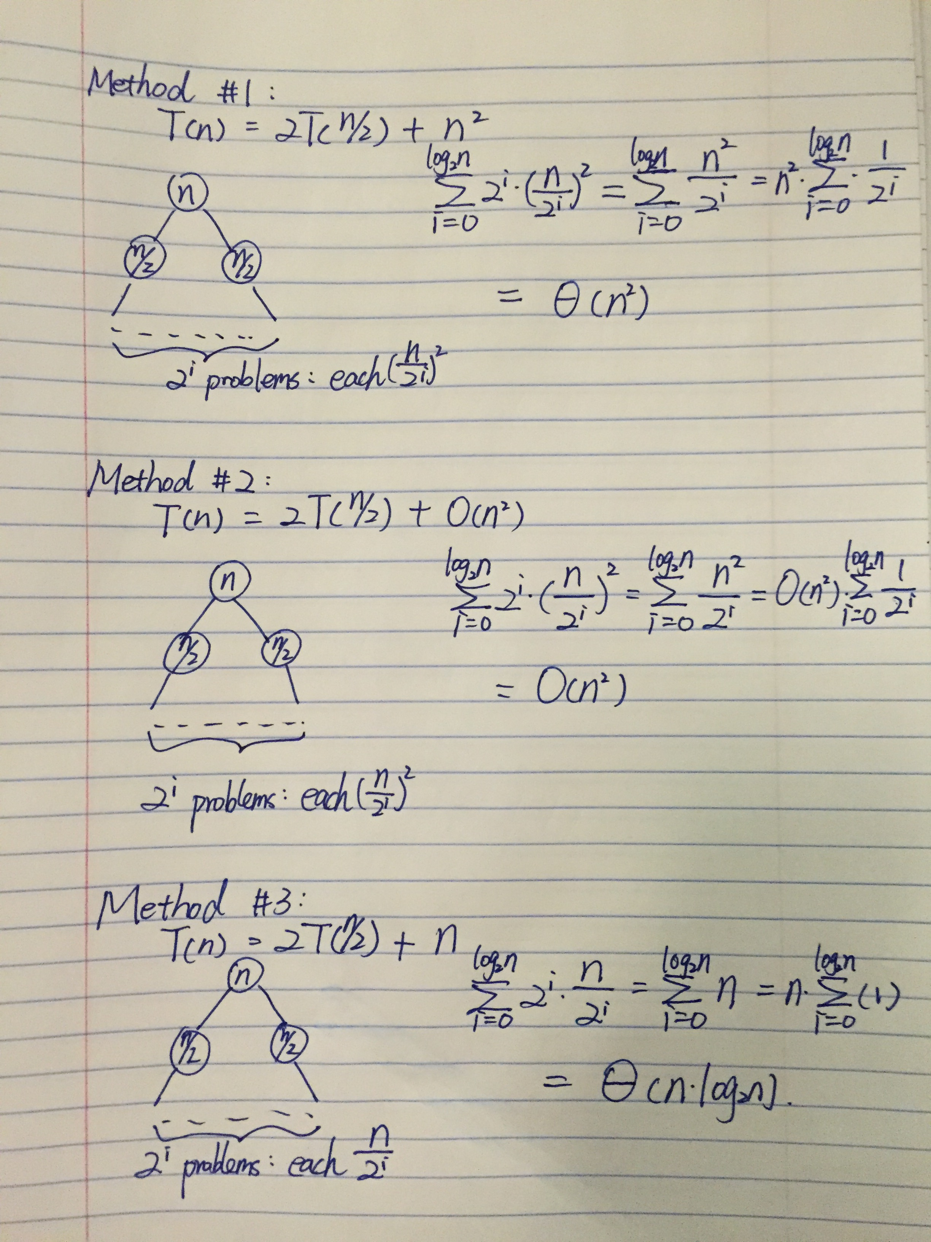

**Plot:**

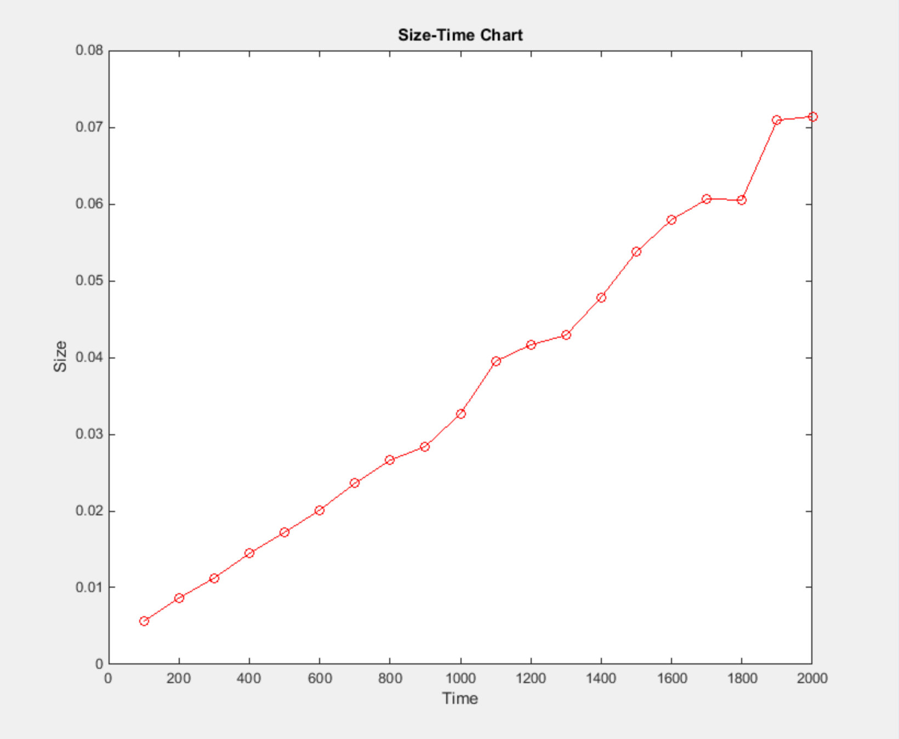

|  |  |
| --- | --- |
| size | time |
| 100 | 0.0056 |
| 200 | 0.00865 |
| 300 | 0.01125 |
| 400 | 0.01445 |
| 500 | 0.0172 |
| 600 | 0.0201 |
| 700 | 0.0236 |
| 800 | 0.0266 |
| 900 | 0.0284 |
| 1000 | 0.03265 |
| 1100 | 0.0395 |
| 1200 | 0.04165 |
| 1300 | 0.0429 |
| 1400 | 0.04785 |
| 1500 | 0.05375 |
| 1600 | 0.05795 |
| 1700 | 0.0606 |
| 1800 | 0.06055 |
| 1900 | 0.0709 |
| 2000 | 0.0714 |