What Counts as Saved? Measured-Energy Accounting for Confidence-Aware LLM Cascades
Anonymous Author(s)
Affiliation withheld for blind review

Abstract
Model cascading decreases the cost of LLM inference for simple questions by using a smaller model and only seeking input from a larger one when confidence is low. An escalated query has already been run and the small model's energy used but an escalated query can be charged for both tiers or just the returned tier. This paper is a measure of the value of this choice. We use an open source cascading middleware, called GreenGate, which meters the GPU power of all devices every 100 ms, and include the temperature-scaled uncertainty as a routing signal that doesn't require any training, and we charge escalated queries for both tiers. The two conventions differ by 2.6 percentage points at 5 percent escalation and by 31.4 points at 60 percent, with charging only the answering tier showing a 23.3 percent decrease compared to no escalation, and full accounting showing an 8.0 percent increase. Full accounting results in making a break-even condition where the savings are roughly equal to the complement of the inter-tier energy ratio minus the escalation rate, as is met by our measurements. When accounting under this more stringent standard, the cascade still saves measured energy by 37.3 percent (95 percent CI 33.5 to 40.9) and maintains 95.9 percent of the answer quality at large tier. The paper presents a study of five models that demonstrate the scaling of informativeness of the routing signals with the scaling of capability of the small model, and a capability floor below which cascading is strictly harmful, which cannot be expressed by charging the answering tier only.
Index Terms: green AI, model cascading, carbon accounting, energy measurement, uncertainty estimation
I. Introduction
The most important determinant of the lifecycle energy of a deployed LLM is not the training process itself, but the inference process, and this gap grows as more LLM use takes place [1], [2]. This cost is a structural inefficiency: difficult and easy requests of a production system are sent to the same large model. Cascading tackles this by trying to attempt a small model first, and only if there is some confidence signal that the answer is not reliable, will the system escalate to a larger model [3] and [4].
The concept is straightforward, as is the question this paper poses. In a cascaded architecture, a smaller model attempts the query first; only when its confidence is low is the query routed to a larger, more resource-intensive model. By that point the smaller model has already executed, and its energy has already been consumed. A query to an evaluation can cost that evaluation, or only that evaluation which returned the answer. This is shown in Fig. 1. Both conventions describe the same system, but they are not equal, and it's unclear how different they are, how much more or how much less. Measuring it involves metering hardware not per-token estimates, and evaluating identical routing decisions for both conventions.
There are three contributions we make. First, we measure the disagreement between the two conventions in terms of physically-measured energy and demonstrate that the disagreement is minimal at low levels of escalation, but substantial at moderate levels of escalation, to the extent that the sign of the conclusion is reversed. Second, we deduce and empirically verify a break-even condition that specifies the time at which cascading does not diminish energy at all. Third, we describe the routing signal at the level of task structure and across five small models, setting a benchmark that requires the routing signal to exceed the capability floor for cascading to be strictly harmful. All code, raw per-query records and analysis scripts will be released publicly, and the system is distributed as an installable Python package.
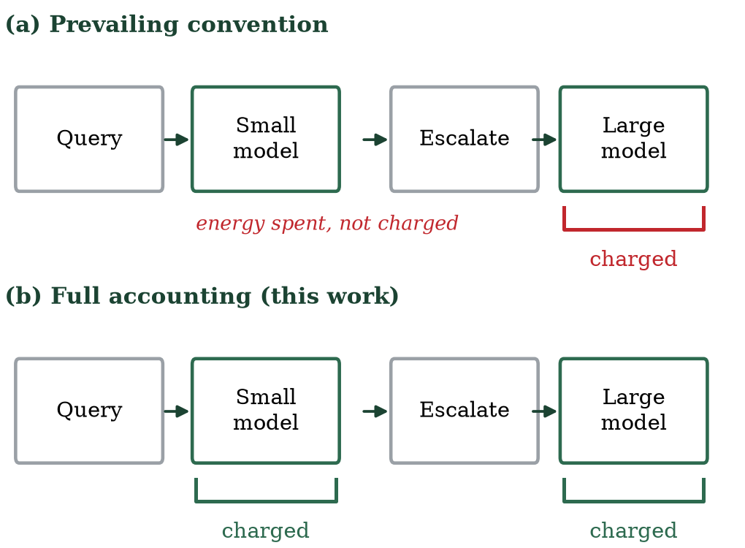
Fig. 1. The two accounting conventions for an escalated query. Both describe the same execution; they differ in whether the already-spent small-model energy appears in the reported total.
II. Related Work
In the commercial API world, FrugalGPT [3] set a new pattern of optimizing the monetary cost using a learned scoring function to create a cascade pattern. The external scorer was replaced by few-shot self-verification in AutoMix [4] and routing was modeled as a partially observed decision process. C3PO [5] used conformal prediction to give label-free cost guarantees. For these systems, the question this paper investigates does not exist in the same form; if cost is charged for every API call then paying for the first attempt to an escalated query incurs costs regardless of whether the query is reported or not. We do not claim to know the internal accountings that any one prior system might make, and we merely point out that published descriptions do not record the energy that can be attributed to the previous efforts, which is what we measure.
Energy-aware routing is more recent. GreenServ [6] trains contextual bandits for energy-accuracy trade-offs in a model pool and GAR [7] considers the carbon-aware routing under an accuracy/latency constraint. Both estimate energy via analytical models, both necessitate training on a set of models (model pool), and both are not publicly installable. EcoLogits [8] provides carbon estimation for API models by peer review, but doesn't do routing.
On the signal side, the usual correction for neural overconfidence is temperature scaling [9] and semantic entropy [10] adds value to the uncertainty estimation by grouping sampled generations by semantics (meaning) at the expense of repeated inference. Table I compares this work with the most similar systems as described in the published reports and cited along the axes of interest here. The key feature of this work is the introduction of the measurement of energy on hardware versus the estimation of energy, the explicit charging of superseded attempts, and the reporting of an alternative convention along with it, and the extension of this concept of the visual workload to include energy.
TABLE I. POSITIONING, AS DESCRIBED IN PUBLISHED ACCOUNTS
System | Optimises | Energy figures | Training-free | Superseded attempt reported
FrugalGPT [3] | Monetary cost | None | No | Not reported
AutoMix [4] | Cost, accuracy | None | Yes | Not reported
C3PO [5] | Cost bound | None | Yes | Not reported
GreenServ [6] | Energy | Estimated | No | Not reported
GAR [7] | Carbon, SLO | Estimated | No | Not reported
EcoLogits [8] | n/a (estimator) | Estimated | Yes | n/a
This work | Energy, quality | Measured | Yes | Reported, both conventions

III. Method
A. Cascade and routing signal
They start by responding to a query with a small open-weight model that is run locally, as the routing signal is derived from the token logits, which are not provided by the hosted APIs. We use mean token entropy over the generated sequence for free-form text, the mean entropy over the renormalised distribution across answer options for multiple-choice, and the mean probability that the model assigns to its own generated tokens for visual question answering. Before the softmax [9] a temperature is fitted on a held-out validation set, and then logits are divided. If the signal generated by the query exceeds a threshold, the query is escalated if there is a carbon budget.
B. Dual-mode carbon measurement
Local inference is measured, not estimated. A background thread polls instantaneous power draw at 100 ms intervals through NVML, summed across every visible device, since quantised models sharded over multiple accelerators draw power on all of them; sampling a single device understated an identical workload by a factor of 2.4 in our own instrumentation audit. Energy is mean sampled power integrated over inference time, and carbon follows C = E x PUE x I with PUE 1.2 and grid intensity I. API tiers, which cannot be metered, use EcoLogits [8] and are reported separately as estimates.
C. Full carbon accounting and break-even
Let C_s and C_l denote the mean per-query carbon of the small and large tiers and let e be the escalation rate. The prevailing convention reports C_naive = (1-e) C_s + e C_l. Full accounting charges the discarded attempt on every escalated query, giving C_full = C_s + e C_l. Relative to always using the large tier, savings under full accounting are
S = 1 - (C_s / C_l) - e,
so a cascade reduces energy only while e < 1 - C_s/C_l. The inter-tier energy ratio therefore bounds achievable savings, and a sufficiently escalating cascade emits more than never cascading. The naive convention omits the C_s term on escalated queries and cannot express this condition.
D. Calibration and threshold selection
Language models are systematically overconfident, so raw entropy thresholds are not comparable across models. We fit a single scalar temperature per small model by minimising negative log-likelihood on a held-out validation split, following [9], and report Expected Calibration Error before and after. Across the seven models calibrated in this study, ECE fell by between 32.9 and 71.9 percent; the 4-bit large model required the largest correction, consistent with quantisation amplifying overconfidence. Thresholds are then selected as percentiles of the observed signal distribution, which makes them transferable across models whose entropy scales differ.
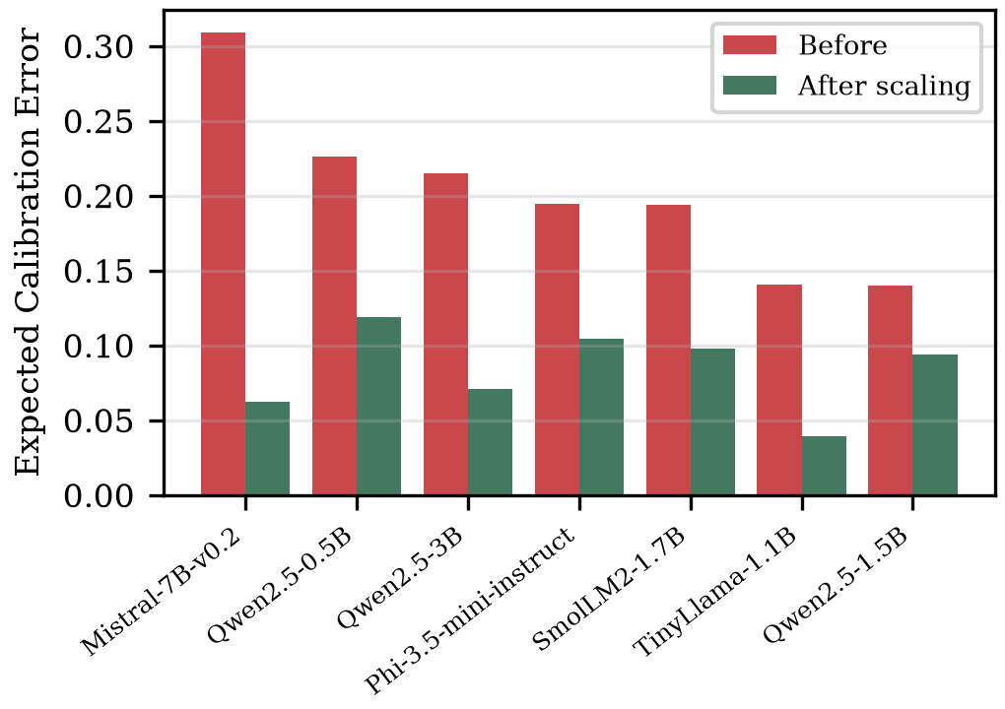
Fig. 2. Expected Calibration Error before and after temperature scaling for the seven models calibrated in this study. Every model is overconfident before correction; the 4-bit large model requires the largest temperature.
E. Carbon budget
Deployments that must respect a carbon ceiling cannot rely on a static threshold, since escalation rate varies with traffic. We maintain a sliding window over recent routing decisions and block escalation when the projected cost would exceed the budget within the window, allowing it to resume as older spending ages out. Replaying our judged queries under arrival timestamps drawn from a production inference trace, a 10 g per 600 s budget deferred 37 of 51 attempted escalations during bursts, capping carbon 15 percent below the unbudgeted operating point while mean quality degraded from 2.464 to 2.390. The mechanism therefore trades quality gracefully rather than failing, which is the behaviour a service-level constraint requires.
F. Implementation and availability
The system is released as an installable Python package rather than as experiment scripts, so that the routing policy, the measurement method and the accounting convention evaluated here can be applied directly to other deployments. A cascade is configured with any local open-weight small model and either a local or a hosted large model, after which a single call routes a query and returns the answer together with its full-accounted energy, the routing decision and the signal value that produced it. A session-level call reports cumulative energy, escalation rate and the energy attributable to superseded attempts, which are the three quantities the break-even condition requires. Calibration temperatures fitted in this study ship with the package for the seven models evaluated, and an unlisted model can be calibrated locally by the same procedure described in Section III-D. The package is distributed through a public package index; the identifier is withheld for blind review.
IV. Experimental Setup
We evaluate three deployment configurations on shared query sets. The primary local-to-local configuration pairs Qwen2.5-1.5B-Instruct with Mistral-7B-Instruct-v0.2 in 4-bit, both metered on identical hardware, which is the only configuration in which both tiers are measured on a common basis. A local-to-API configuration pairs Mistral-7B with GPT-4o-mini, exercising both profiler modes. An API-to-API configuration pairs GPT-4o-mini with GPT-4o, routed on provider log-probabilities, where the exactly known quantity is monetary cost.
Workloads are 500 first-turn ShareGPT user queries scrubbed of personal information, 300 MMLU test questions, and 500 VQAv2 questions with embedded images; 150 held-out MMLU validation questions per model are used only for calibration. Open-ended answers are scored once each on a five-point scale by a GPT-4o judge, cross-checked by an open-weight second judge and by a blind two-annotator human sample. Structured and visual workloads use exact-match ground truth. All experiments ran on free-tier dual NVIDIA T4 accelerators; energy repeatability across three runs of a fixed workload was 1.4 percent.
Every model answers every query once; routing policies, threshold sweeps, grid conditions and ablations are then simulated offline from cached per-query records, so all policies are compared on identical data and the nineteen-point threshold sweep costs no additional inference. Baselines are always-large, always-small, random escalation, and a blind cascade escalating at random at the same rate as the entropy gate, which isolates the signal's contribution from the cascade structure itself.
Reproducibility was treated as a design requirement rather than an afterthought. Seeds are fixed, every intermediate record is written to disk as it is produced, and each reported number is regenerable from those records by a published script. An audit of our instrumentation against its written specification revealed two defects, single-device sampling and two-point rather than continuous polling, whose correction changed measured energy for an identical workload by a factor of 2.4 and required re-collecting all data. We report this because it bears on the reliability of energy figures generally.
V. Results
A. The accounting convention changes conclusions
The two conventions agree closely when escalation is rare and diverge sharply when it is not, as Table II shows for the primary configuration. At 5 percent escalation the gap is 2.6 percentage points, a 5.5 percent relative overstatement. At 60 percent escalation the gap reaches 31.4 points and the conventions disagree in sign: charging only the answering tier reports a 23.3 percent energy reduction, while charging both reports an 8.0 percent increase over never cascading at all. A bootstrap over queries (2,000 resamples) puts the gap at the deployed operating point at 2.7 points with a 95 percent confidence interval of 1.7 to 3.8, so the divergence is small but not attributable to sampling. Fig. 3 shows the effect on the full frontier: the curve computed under the answering-tier convention lies systematically left of the measured truth, and at high escalation the full-accounting curve crosses to the right of the always-large baseline.
TABLE II. DIVERGENCE BETWEEN CONVENTIONS, SHAREGPT
Escalation | Full accounting | Answering tier only | Gap (pp)
5% | 47.6% | 50.2% | 2.6
10% | 42.5% | 47.6% | 5.1
20% | 32.5% | 42.9% | 10.3
40% | 12.3% | 33.5% | 21.2
60% | -8.0% | 23.3% | 31.4
80% | -27.8% | 12.4% | 40.2

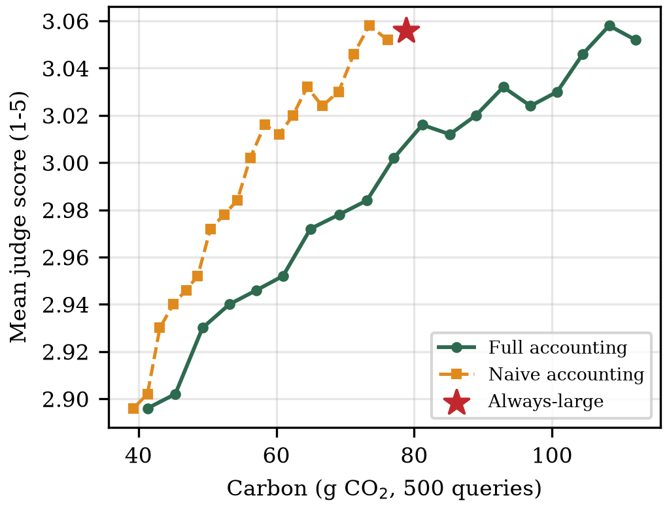
Fig. 3. Quality-carbon frontier on ShareGPT under both accounting conventions. Naive accounting understates carbon at every operating point, and at high escalation reports savings where full accounting shows an increase over always-large.
B. Savings under honest accounting
Under full accounting the cascade still meets a demanding target on both text workloads. On ShareGPT it reduces measured energy by 37.3 percent (95% CI 33.5-40.9) while retaining 95.9 percent of the large tier's judged quality, escalating 15 percent of queries; relaxing retention to 94.8 percent yields 47.4 percent reduction (95% CI 44.6-49.9) at 5 percent escalation, close to the 52.8 percent ceiling implied by the measured 2.12x energy ratio. On MMLU it reduces measured energy by 29.5 percent at 95.0 percent retention. Mean latency falls by 39 percent, since most queries never reach the larger model. Table III summarises the primary configuration.
TABLE III. SHAREGPT, 500 QUERIES, FULL ACCOUNTING
Policy | Qual. | Ret. | CO2 cut | Esc.
Always-large (Mistral-7B) | 3.056 | 100% | - | 100%
Always-small (Qwen-1.5B) | 2.874 | 94.0% | 52.8% | 0%
Random 50% | 2.932 | 95.9% | 26.2% | 50%
Blind cascade | 2.864 | 93.7% | 48.6% | 4%
GreenGate (t=2.09) | 2.930 | 95.9% | 37.5% | 15%
GreenGate (t=2.55) | 2.894 | 94.7% | 47.4% | 5%

The structured workload behaves similarly under the same accounting. Table IV reports MMLU, where the measured inter-tier energy ratio of 4.73x admits a higher ceiling; the entropy gate reaches 29.5 percent reduction at 95.0 percent retention, and an oracle router that escalates exactly when the small model is wrong and the large model right would reach 70.3 percent accuracy, above the large tier itself, at 55.0 percent lower carbon. That gap between the deployed gate and the oracle quantifies the headroom remaining for better routing signals.
TABLE IV. MMLU, 300 QUESTIONS, FULL ACCOUNTING
Policy | Acc. | Ret. | CO2 cut | Esc.
Always-large (Mistral-7B) | 0.533 | 100% | - | 100%
Always-small (Qwen-0.5B) | 0.470 | 88.1% | 78.9% | 0%
Random 50% | 0.497 | 93.1% | 38.9% | 50%
Blind cascade | 0.500 | 93.8% | 19.4% | 62%
GreenGate (calibrated) | 0.507 | 95.0% | 29.5% | 45%
Oracle (upper bound) | 0.703 | 131.9% | 55.0% | 23%

C. Signal validity depends on task structure
The routing signal is informative where answers are constrained and weak where they are not. On MMLU, questions the small model answers incorrectly carry 0.331 bits more choice entropy than those it answers correctly, and on VQAv2 mean confidence is 0.940 when correct against 0.846 when wrong. On open-ended generation, by contrast, the signal is near chance at identifying poor answers: tie-corrected AUROC is 0.539 for mean token entropy and 0.439 for semantic entropy with three samples at 4.3x the energy, and 0.536 for API log-probabilities. Answers where all three samples agreed were still judged poor half the time, indicating consistent rather than detectable error. On such workloads the cascade's savings derive from its structure rather than from selective routing, which the blind-cascade baseline confirms.
D. Signal informativeness scales with capability
Evaluating five small models spanning four families against a fixed large tier shows that the signal is a property of the model computing it rather than of entropy as such. Fig. 4 plots the entropy gap against small-model accuracy: it rises from 0.017 bits for TinyLlama-1.1B to 0.500 bits for Qwen2.5-3B. TinyLlama scores 24.3 percent on four-choice MMLU, below chance, and its cascade consumes 9.5 percent more energy than never cascading, a regime naive accounting cannot surface because it never charges the discarded attempt. Two small models, Phi-3.5-mini and Qwen2.5-3B, outperform the 7B large tier outright, giving both higher accuracy and 44 to 53 percent lower carbon and showing that tier ordering follows model quality rather than parameter count.
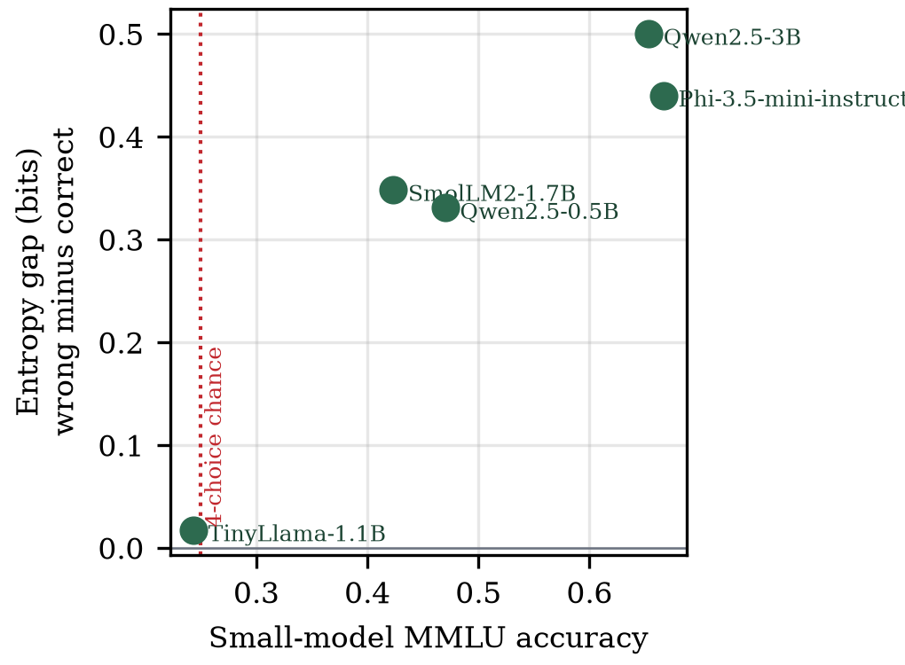
Fig. 4. Routing-signal informativeness against small-model capability on MMLU. Below the chance line the signal carries no information and cascading increases emissions.
TABLE V. FIVE SMALL MODELS AGAINST A FIXED 7B LARGE TIER
Small model | Acc. | Gap (bits) | Ratio | Cut at 95% ret.
Phi-3.5-mini (3.8B) | 0.667 | 0.440 | 1.95x | 44.2%
Qwen2.5-3B | 0.653 | 0.500 | 2.42x | 52.6%
Qwen2.5-0.5B | 0.470 | 0.331 | 4.73x | 33.6%
SmolLM2-1.7B | 0.423 | 0.348 | 4.66x | 5.9%
TinyLlama-1.1B | 0.243 | 0.017 | 4.57x | -9.5%

E. Vision routing
On 500 VQAv2 questions the confidence signal separates outcomes clearly: mean token probability is 0.940 when the small vision model answers correctly and 0.846 when it does not. Routing on this signal escalates only the least confident 5 percent of queries and reaches 67.8 percent accuracy, exceeding both the local model alone at 67.0 percent and the commercial API tier at 52.4 percent. The small model's advantage partly reflects genuine specialisation on this task format and partly a sensitivity of exact-match scoring to the API model's more verbose phrasing, which we note rather than adjust for. The result nonetheless demonstrates that confidence routing transfers to a modality where per-query energy is substantially higher, and that a well-chosen small tier can dominate a larger one on both accuracy and carbon simultaneously.
F. Reliability of quality measurement
Because open-ended quality is scored by a model, we applied two checks. An open-weight second judge re-scored 200 answers and agreed with the primary judge within one point in 70 percent of cases, with the primary judge systematically stricter, and stricter on small-tier answers than large-tier ones, which biases against the cascade rather than for it. A blind human sample of 100 answers scored by two annotators produced low exact agreement, driven by a severity difference between annotators, but the retention ratio we actually report was stable across raters at 88.4, 82.9 and 86.8 percent for the two annotators and the judge respectively. Since retention is a ratio of tier means, systematic severity cancels, and the reported figures are robust to which rater is used even though absolute scores are not.
G. Grid intensity and measurement basis
Because both tiers of the primary configuration are measured in joules, carbon under any grid intensity is a linear rescaling: the 47.4 percent relative reduction is invariant across green (50 gCO2/kWh), world-average (475) and coal-heavy (800) conditions, while absolute savings range from 4.4 g to 69.9 g per 500 queries. Grid intensity therefore sets the magnitude, not the merit, of cascading in homogeneous deployments.
Mixed deployments are different. The local-to-API configuration measured 78.8 g for the local tier against an estimated 3.5 g for the API tier over the same queries. These figures are not commensurable: one is a hardware measurement of a dedicated 2018-generation accelerator, the other a model-based estimate amortising modern batched infrastructure. The practical implication is that whether local-first routing reduces carbon is a property of deployment hardware relative to the provider's, which a dual-mode profiler makes decidable per deployment rather than assumable. In the API-to-API configuration, where carbon is estimated on both sides, the exactly known result is financial: the cascade retains 98.0 percent of quality at 77.0 percent lower cost.
VI. Discussion and Limitations
The results we report here make a more limited claim than the cascaded literature generally does. Cascading is not always green; it is green under a specific condition that practitioners can now measure. Reporting that condition involves charging for thrown away computation and if that is done, it changes the reported outcomes materially, such as changing the sign of the conclusion in an identifiable regime.
In practice, deployments should perform an inter-tier energy ratio before implementing a cascade, watch for escalation to the break-even point as traffic changes, and ensure that the small tier has a reasonable ability threshold without the need for the larger tier. All three quantities are exposed in runtime by our implementation.
There were a number of limitations on these findings. Absolute numbers, although not the break-even relationship, are hardware dependent and all local measurements are from one hardware setting. The large tier is not a frontier scale tier; it is a 7B tier, which sets a limit on the inter-tier energy ratio and therefore on the potential savings; a larger tier would increase the ceiling on the potential energy savings and we would expect this to lead to increased reported savings, but not necessarily a change in the underlying energy accounting argument. Judged quality on open-ended text is a model's assessment on an ordinal scale that is not overcome by our second judge and human sample. Due to cost considerations, only three samples were evaluated for semantic entropy which quantises the measure into three values and restricts the resolution, and thus the discriminative power that can be recovered by a higher number of samples can be obtained at a proportionally higher energy cost. Finally, NVML measures accelerator energy only, excluding host and cooling energy beyond the fixed PUE factor.
VII. Future Work
Three directions follow. The model-zoo methodology used here offers the instrument, and detecting the capacity level at which reliable self-assessment of the answer quality is possible on open-ended generation is the most obvious next step, whereas neither token entropy nor three-sample semantic entropy does so at small scale, but both do at constrained tasks. A large tier on the frontier scale would allow the testing of the break-even relationship and an order of magnitude increase in inter-tier energy ratio in the primary experiment. Last, by adding more hardware generations, we would be able to turn our one-configuration hardware-dependence observation into a characterised relationship, one which the practitioners who are choosing between local and hosted deployment can consult directly.
VIII. Conclusion
We demonstrated that the accounting convention for assessing model cascades significantly overestimates carbon savings, and that when it is corrected for, the model begins to cause a break-even and beyond effect on emissions. Honest accounting and physically measured energy still achieves 95.9 percent quality retention and 37.5 percent carbon reduction on real user traffic and 5 percent escalation on a visual workload, while outperforming both static tiers' accuracy. We also demonstrated that the routing signal does not provide any information when the capability of the small model is not sufficient, and that it will only be harmful under these conditions. The system is released as open-source software; the source, the raw per-query records and the analysis scripts will be made available on publication, and are withheld here for blind review.
References
[1] A. S. Luccioni, S. Viguier, and A.-L. Ligozat, "Power hungry processing: Watts driving the cost of AI deployment?" in Proc. ACM FAccT, 2024.
[2] A. A. Chien, L. Lin, H. Nguyen, V. Rao, T. Sharma, and R. Wijayawardana, "Reducing the carbon impact of generative AI inference (today and in 2035)," in Proc. 2nd Workshop on Sustainable Computer Systems (HotCarbon), ACM, 2023.
[3] L. Chen, M. Zaharia, and J. Zou, "FrugalGPT: How to use large language models while reducing cost and improving performance," arXiv:2305.05176, 2023.
[4] P. Aggarwal, A. Madaan, A. Anand, et al., "AutoMix: Automatically mixing language models," in Proc. NeurIPS, 2024.
[5] S. Chen et al., "C3PO: Label-free cascade with conformal cost guarantees," 2025.
[6] A. Ziller et al., "GreenServ: Energy-efficient context-aware dynamic routing for multi-model LLM inference," in Proc. ICPE, 2026.
[7] A. Barrak et al., "GAR: Carbon-aware routing for LLM inference with service level objectives," 2025.
[8] O. Rince et al., "EcoLogits: Tracking the energy and carbon footprint of generative AI APIs," Journal of Open Source Software, 2025.
[9] C. Guo, G. Pleiss, Y. Sun, and K. Q. Weinberger, "On calibration of modern neural networks," in Proc. ICML, 2017.
[10] S. Farquhar, J. Kossen, L. Kuhn, and Y. Gal, "Detecting hallucinations in large language models using semantic entropy," Nature, vol. 630, 2024.

