*Insert Document Name Here*

Saint Louis University

Rascal

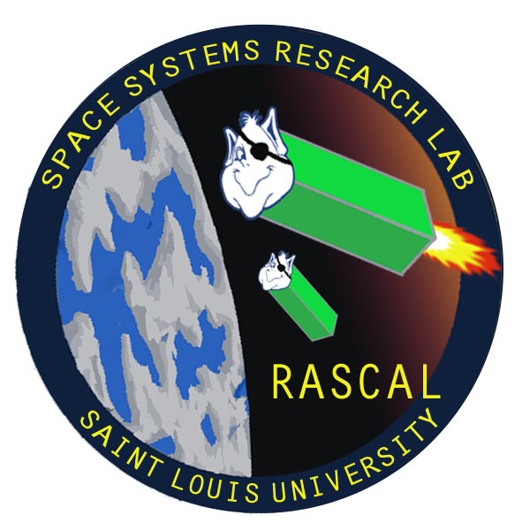

Last Updated: 10/7/13

Document No: RCL-X-XXXX

Copper Operational

Test Plan

|  |  |  |  |
| --- | --- | --- | --- |
| **Team Member** | **Position** | **Email** | **Phone** |
| Tom Moline | Program Manager | [tmoline@slu.edu](mailto:tmoline@slu.edu) | 630-401-0791 |
| Nate Richard | Propulsion Team | [nrichar8@slu.edu](mailto:nrichar8@slu.edu) | 608-732-7147 |
| Tyler Olson | Structures Team | [tolson6@slu.edu](mailto:tolson6@slu.edu) | 812-204-1098 |
| Bryant Gaume | Propulsion Team | [gbryant1@slu.edu](mailto:gbryant1@slu.edu) | 636-448-0378 |
| Jennifer Babb | Propulsion Team | [jbabb1@slu.edu](mailto:jbabb1@slu.edu) | 636-579-6816 |

**Revisions Summary**

|  |  |  |  |  |
| --- | --- | --- | --- | --- |
| **Revision** | **Description** | **Date** | **Prepared by** | **Approved by** |
| **-** | Description | 9/12/2013 | Insert Name Here | Insert Name Here |
|  |  |  |  |  |
|  |  |  |  |  |
|  |  |  |  |  |
|  |  |  |  |  |
|  |  |  |  |  |