Rascal Request For Proposal

Saint Louis University

Rascal

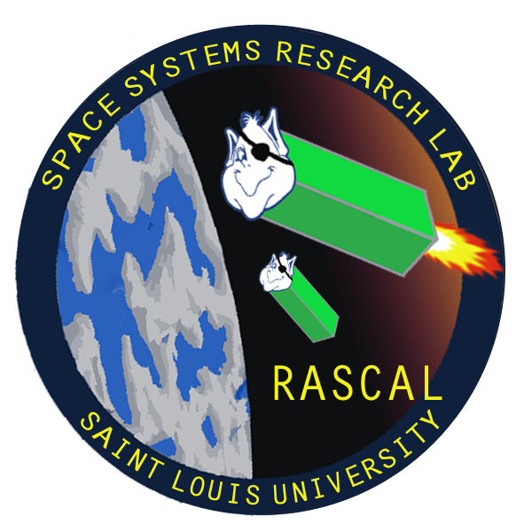

Last Updated: 9/7/13

Document No: RCL-P-CMQA2

Copper Operational

Test Plan

|  |  |  |  |
| --- | --- | --- | --- |
| **Team Member** | **Position** | **Email** | **Phone** |
| Tom Moline | Program Manager | [tmoline@slu.edu](mailto:tmoline@slu.edu) | 630-401-0791 |
| Nate Richard |  | [nrichar8@slu.edu](mailto:nrichar8@slu.edu) | 608-732-7147 |
| Tyler Olson | Power Lead | [tolson6@slu.edu](mailto:tolson6@slu.edu) | 812-204-1098 |
| Bryant Gaume | Structures Lead | [gbryant1@slu.edu](mailto:gbryant1@slu.edu) | 636-448-0378 |
| Jennifer Babb |  | [jbabb1@slu.edu](mailto:jbabb1@slu.edu) | 636-579-6816 |

**Revisions Summary**

|  |  |  |  |  |
| --- | --- | --- | --- | --- |
| **Revision** | **Description** | **Date** | **Prepared by** | **Approved by** |
| **-** | Initial Release | 9/12/2013 | Tom Moline | Tyler Olson |
|  |  |  |  |  |
|  |  |  |  |  |
|  |  |  |  |  |
|  |  |  |  |  |
|  |  |  |  |  |

Table of Contents

1. INTRODUCTION 3

2. Mission Overview 3

3. Concept of Operations 3

4. Team Organization 3

5. Conclusion 3

# Introduction

The Rascal mission consists of a 6U CubeSat-Class satellite that is to operate at any altitude above 300 km and inclination above 40⁰. Before describing the mission in further detail, it is important to establish the meanings of various terms that are associated with any given CubeSat mission, since most of such terms are not used outside of the small-satellite industry. Firstly, 1U, or one standard unit, is defined as a cube of a uniform edge length of 10 cm. A CubeSat-Class satellite (aka a “nanosatellite”) is a satellite whose dimensions derive from 1 or more of these standard units, a designation that was created by California Polytechnic University in the early 2000’s for describing the satellites being developed by various universities that met this definition. The reason for creating such satellites is twofold: it greatly reduces the time and monetary investment associated with developing custom satellite shapes and structures, while allowing the development of standard satellite deployers (such as the P-POD) for integration into any rocket configuration, thus allowing greater access to launch opportunities for university missions, such as Rascal. The largest deployer volume currently available is for 6U satellites, thus putting a design constraint on the Rascal structure as a whole.

The actual Rascal mission consists of two separate 3U spacecraft that will be mounted to a common base plate for flight-integration and early on-orbit operations. Both 3U spacecraft will have identical hardware and external structures, as to simplify development time and cost. Thus, each satellite will have its own infrared and image-based navigation tools, six-degree-of-freedom propulsive control from 6 or more thrusters, image processing capabilities for navigation, Commercial of the Shelf (COTS) power, command and data handling, radio, and solar cell systems, and satellite-to-satellite GPS communication.

**The ultimate goal of the Rascal mission is to demonstrate proximity operations technologies on a CubeSat class spacecraft: infrared/visible navigation, six-degree-of-freedom propulsive control, and navigation algorithms to use these capabilities**. This will be accomplished by having one of the two 3U satellites eject from Rascal’s common baseplate, achieve stability, move out 100 m from the remaining satellite, and return to a distance of at least 10 m, at which point the remaining satellite will go through the same process. If enough propellant is left in each satellite after this process, a docking maneuver between the two may then take place.

The parameters imposed upon this mission are listed in Table 1-1 below:

Table 1-1. Rascal Mission Parameters

|  |  |  |  |  |  |
| --- | --- | --- | --- | --- | --- |
| **Mass** | **Cube Size** | **Desired Orbit** | | **Acceptable Orbit Range** | **Desired Mission Life** |
| 8 kg | 6U | Altitude | 500 km | 300-900 km  40⁰-100⁰ | 6 Months |
| Inclination | 40⁰ |

# Mission Overview

## Minimum Success Criteria

# 4. Team Organization

# 5. Schedule