% First make an instance of the project class

problem = projectClass('DSPC monolayers');

% Define the parameters:

Parameters = {

% Name min val max fit?

{'Tails Thickness', 10, 20, 30, true};

{'Heads Thickness', 3, 11, 16, true};

{'Tails Roughness', 2, 5, 9, true};

{'Heads Roughness', 2, 5, 9, true};

{'Deuterated Tails SLD', 4e-6, 6e-6, 2e-5, true};

{'Hydrogenated Tails SLD', -0.6e-6, -0.4e-6, 0, true};

{'Deuterated Heads SLD', 1e-6, 3e-6, 8e-6, true};

{'Hydrogenated Heads SLD', 0.1e-6, 1.4e-6, 3e-6, true};

{'Heads Hydration', 0, 0.3, 0.5, true};

};

% Group these into layers:

H_Heads = {'Hydrogenated Heads',...

'Heads Thickness',...

'Hydrogenated Heads SLD',...

'Heads Roughness',...

'Heads Hydration',...

'bulk out' };

D_Heads = {'Deuterated Heads',...

'Heads Thickness',...

'Deuterated Heads SLD',...

'Heads Roughness',...

'Heads Hydration',...

'bulk out' };

D_Tails = {'Deuterated Tails',...

'Tails Thickness',...

'Deuterated Tails SLD',...

'Tails Roughness'};%,...

%'Tails Hydration',...

%'bulk in'};

H_Tails = {'Hydrogenated Tails',...

'Tails Thickness',...

'Hydrogenated Tails SLD',...

'Tails Roughness'};%,...

%'Tails Hydration',...

%'bulk in'};

% Add the parameters and Layers to the project:

problem.addParamGroup(Parameters);

problem.addLayerGroup({H_Heads; D_Heads; H_Tails; D_Tails});

% Increase the range for Substrate Roughness (param 1)

problem.setParameterLimits(1,2,13);

% Need two backgrounds - one for D2O and for H2O

% Change the name of the first and add a new one for the second

% Also need a new backsPar

problem.setBacksParName(1,'Backs value ACMW');

problem.setBacksParValue(1,5.5e-6);

problem.addBacksPar('Backs Value D2O',1e-8,2.8e-6,1e-5);

problem.addBackground('Background D2O','constant','Backs Value D2O');

problem.setBackgroundValue(1,'name','Background ACMW');

problem.setBackgroundValue(1,3,'Backs Value ACMW');

% Also need an additional bulk out

problem.addBulkOut({'SLD ACMW' -1e-6,0.0,1e-6,true});

% Add the data files

d13ACM = dlmread('d13acmw20.dat');

d70d2O = dlmread('d70d2o20.dat');

problem.addData('H-tail / D-head / ACMW', d13ACM);

problem.addData('D-tail / H-head / D2O', d70d2O);

% Add the contrasts

problem.addContrast('name','D-tail/H-Head/D2O',...

'background','Background D2O',...

'resolution','Resolution 1',...

'scalefactor', 'Scalefactor 1',...

'nbs', 'SLD D2O',...

'nba', 'SLD air',...

'data', 'D-tail / H-head / D2O');

problem.setContrastModel(1,{'Deuterated tails','Hydrogenated heads'});

problem.addContrast('name','H-tail/D-Head/ACMW',...

'background','Background ACMW',...

'resolution','Resolution 1',...

'scalefactor', 'Scalefactor 1',...

'nbs', 'SLD ACMW',...

'nba', 'SLD air',...

'data', 'H-tail / D-head / ACMW');

problem.setContrastModel(2,{'hydrogenated tails','deuterated heads'});

% Set the fitting fitting flag on some parameters we need to fit

problem.setBacksPar(1,'fit',true);

problem.setBacksPar(2,'fit',true);

problem.setScalefactor(1,'fit',true);

problem.setBulkOut(1,'fit',true);

% Display problem

problem

problem =

ModelType: 'Standard Layers'

experimentName: 'DSPC monolayers'

Geometry: 'air/substrate'

Parameters: ----------------------------------------------------------------------------------------------

**p** **Name** **Min** **Value** **Max** **Fit?**

**__** **________________________** **______** **_______** **_____** **_____**

1 "Substrate Roughness" 2 3 13 true

2 "Tails Thickness" 10 20 30 true

3 "Heads Thickness" 3 11 16 true

4 "Tails Roughness" 2 5 9 true

5 "Heads Roughness" 2 5 9 true

6 "Deuterated Tails SLD" 4e-06 6e-06 2e-05 true

7 "Hydrogenated Tails SLD" -6e-07 -4e-07 0 true

8 "Deuterated Heads SLD" 1e-06 3e-06 8e-06 true

9 "Hydrogenated Heads SLD" 1e-07 1.4e-06 3e-06 true

10 "Heads Hydration" 0 0.3 0.5 true

Layers: --------------------------------------------------------------------------------------------------

**p** **Name** **Thickness** **SLD** **Roughness** **Hydration** **Hydrate with**

**_** **____________________** **_________________** **________________________** **_________________** **_________________** **____________**

1 "Hydrogenated Heads" "Heads Thickness" "Hydrogenated Heads SLD" "Heads Roughness" "Heads Hydration" "bulk out"

2 "Deuterated Heads" "Heads Thickness" "Deuterated Heads SLD" "Heads Roughness" "Heads Hydration" "bulk out"

3 "Hydrogenated Tails" "Tails Thickness" "Hydrogenated Tails SLD" "Tails Roughness" <missing> "bulk in"

4 "Deuterated Tails" "Tails Thickness" "Deuterated Tails SLD" "Tails Roughness" <missing> "bulk in"

Bulk In: --------------------------------------------------------------------------------------------------

**p** **Name** **Min** **Value** **Max** **Fit?**

**_** **_________** **___** **_____** **___** **_____**

1 "SLD Air" 0 0 0 false

Bulk Out: -------------------------------------------------------------------------------------------------

**p** **Name** **Min** **Value** **Max** **Fit?**

**_** **__________** **_______** **________** **________** **_____**

1 "SLD D2O" 6.2e-06 6.35e-06 6.35e-06 true

2 "SLD ACMW" -1e-06 0 1e-06 true

Scalefactors: -------------------------------------------------------------------------------------------------

**p** **Name** **Min** **Value** **Max** **Fit?**

**_** **_______________** **____** **_____** **____** **_____**

1 "Scalefactor 1" 0.02 0.23 0.25 true

Backgrounds: -----------------------------------------------------------------------------------------------

(a) Background Parameters:

**p** **Name** **Min** **Value** **Max** **Fit?**

**_** **__________________** **_____** **_______** **_____** **_____**

1 "Backs value ACMW" 1e-07 5.5e-06 1e-05 true

2 "Backs Value D2O" 1e-08 2.8e-06 1e-05 true

(b) Backgrounds:

**p** **Name** **Type** **Value 1** **Value 2** **Value 3** **Value 4** **Value 5**

**_** **_________________** **__________** **__________________** **_______** **_______** **_______** **_______**

1 "Background ACMW" "constant" "Backs Value ACMW" "" "" "" ""

2 "Background D2O" "constant" "Backs Value D2O" "" "" "" ""

Resolutions: ---------------------------------------------------------------------------------------------

(a) Resolutions Parameters:

**p** **Name** **Min** **Value** **Max** **Fit?**

**_** **__________________** **____** **_____** **____** **_____**

1 "Resolution par 1" 0.01 0.03 0.05 false

(b) Resolutions:

**p** **Name** **Type** **Value 1** **Value 2** **Value 3** **Value 4** **Value 5**

**_** **______________** **__________** **__________________** **_______** **_______** **_______** **_______**

1 "Resolution 1" "gaussian" "Resolution par 1" "" "" "" ""

Data: ------------------------------------------------------------------------------------------------------

**Name** **Data** **Data Range** **Simulation Range**

**________________________** **______________________** **_____________________** **_____________________**

"Simulation" "No Data" "-" "[ 0.0050 , 0.7000 ]"

"H-tail / D-head / ACMW" "Data array: [51 x 3]" "[ 0.0518 , 0.5888 ]" "[ 0.0050 , 0.7000 ]"

"D-tail / H-head / D2O" "Data array: [51 x 3]" "[ 0.0518 , 0.5888 ]" "[ 0.0050 , 0.7000 ]"

Custom Files: ------------------------------------------------------------------------------------------------------

**Name** **Filename** **Language** **Path**

**____** **________** **________** **____**

"" "" "" ""

Constrasts: ----------------------------------------------------------------------------------------------

**p** **1** **2**

**_____________** **_______________________** **________________________**

"name" "D-tail/H-Head/D2O" "H-tail/D-Head/ACMW"

"Data" "D-tail / H-head / D2O" "H-tail / D-head / ACMW"

"Background" "Background D2O" "Background ACMW"

"Bulk in" "SLD air" "SLD air"

"Bulk out" "SLD D2O" "SLD ACMW"

"Scalefactor" "Scalefactor 1" "Scalefactor 1"

"Resolution" "Resolution 1" "Resolution 1"

"Model" "Deuterated tails" "hydrogenated tails"

"" "Hydrogenated heads" "deuterated heads"

% Make the controls class...

controls = controlsDef();

controls.parallel = 'points';

disp(controls)

controlsDef with properties:

parallel: 'points'

procedure: 'calculate'

calcSldDuringFit: 'no'

[problem,results] = RAT(problem,controls);

Starting RAT ________________________________________________________________________________________________

Elapsed time is 0.000927 seconds.

Finished RAT ______________________________________________________________________________________________

disp(results)

reflectivity: {2×1 cell}

Simulation: {2×1 cell}

shifted_data: {2×1 cell}

layerSlds: {2×1 cell}

sldProfiles: {2×1 cell}

allLayers: {2×1 cell}

calculationResults: [1×1 struct]

contrastParams: [1×1 struct]

fitNames: {15×1 cell}

figure(1); clf

plotRefSLD(problem,results)

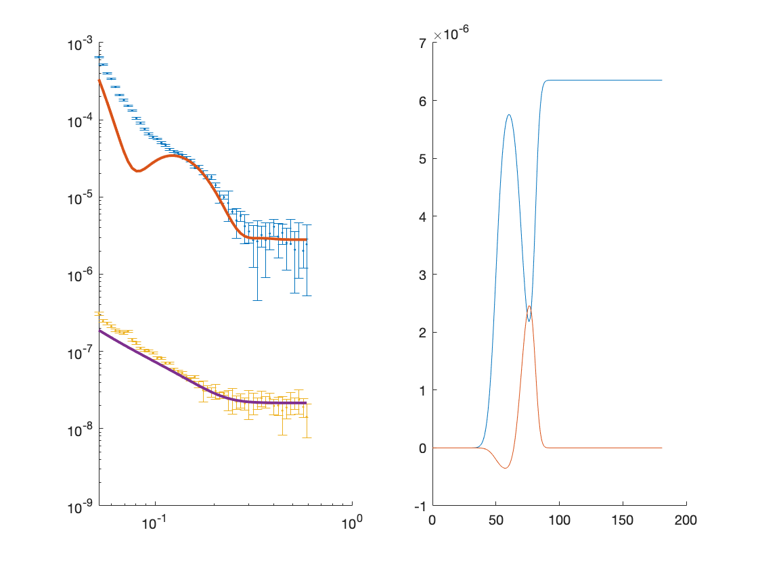

controls.procedure = 'simplex'

Warning: Negative data ignored

controls =

controlsDef with properties:

parallel: 'points'

procedure: 'simplex'

calcSldDuringFit: 'no'

display: 'iter'

tolX: 1.0000e-06

tolFun: 1.0000e-06

maxFunEvals: 10000

maxIter: 1000

[out,results] = RAT(problem,controls)

Starting RAT ________________________________________________________________________________________________

Running Sinplex

Exiting: Maximum number of iterations has been exceeded

- increase MaxIter option.

Current function value: 3.025091

Elapsed time is 2.634236 seconds.

Finished RAT ______________________________________________________________________________________________

out =

ModelType: 'Standard Layers'

experimentName: 'DSPC monolayers'

Geometry: 'air/substrate'

Parameters: ----------------------------------------------------------------------------------------------

**p** **Name** **Min** **Value** **Max** **Fit?**

**__** **________________________** **______** **___________** **_____** **_____**

1 "Substrate Roughness" 2 2.6309 13 true

2 "Tails Thickness" 10 20.046 30 true

3 "Heads Thickness" 3 7.099 16 true

4 "Tails Roughness" 2 5.1218 9 true

5 "Heads Roughness" 2 4.8559 9 true

6 "Deuterated Tails SLD" 4e-06 7.9636e-06 2e-05 true

7 "Hydrogenated Tails SLD" -6e-07 -1.8361e-07 0 true

8 "Deuterated Heads SLD" 1e-06 5.4844e-06 8e-06 true

9 "Hydrogenated Heads SLD" 1e-07 1.3357e-06 3e-06 true

10 "Heads Hydration" 0 0.45626 0.5 true

Layers: --------------------------------------------------------------------------------------------------

**p** **Name** **Thickness** **SLD** **Roughness** **Hydration** **Hydrate with**

**_** **____________________** **_________________** **________________________** **_________________** **_________________** **____________**

1 "Hydrogenated Heads" "Heads Thickness" "Hydrogenated Heads SLD" "Heads Roughness" "Heads Hydration" "bulk out"

2 "Deuterated Heads" "Heads Thickness" "Deuterated Heads SLD" "Heads Roughness" "Heads Hydration" "bulk out"

3 "Hydrogenated Tails" "Tails Thickness" "Hydrogenated Tails SLD" "Tails Roughness" <missing> "bulk in"

4 "Deuterated Tails" "Tails Thickness" "Deuterated Tails SLD" "Tails Roughness" <missing> "bulk in"

Bulk In: --------------------------------------------------------------------------------------------------

**p** **Name** **Min** **Value** **Max** **Fit?**

**_** **_________** **___** **_____** **___** **_____**

1 "SLD Air" 0 0 0 false

Bulk Out: -------------------------------------------------------------------------------------------------

**p** **Name** **Min** **Value** **Max** **Fit?**

**_** **__________** **_______** **__________** **________** **_____**

1 "SLD D2O" 6.2e-06 6.2736e-06 6.35e-06 true

2 "SLD ACMW" -1e-06 7.8727e-09 1e-06 true

Scalefactors: -------------------------------------------------------------------------------------------------

**p** **Name** **Min** **Value** **Max** **Fit?**

**_** **_______________** **____** **_______** **____** **_____**

1 "Scalefactor 1" 0.02 0.21153 0.25 true

Backgrounds: -----------------------------------------------------------------------------------------------

(a) Background Parameters:

**p** **Name** **Min** **Value** **Max** **Fit?**

**_** **__________________** **_____** **__________** **_____** **_____**

1 "Backs value ACMW" 1e-07 5.5815e-06 1e-05 true

2 "Backs Value D2O" 1e-08 4.207e-06 1e-05 true

(b) Backgrounds:

**p** **Name** **Type** **Value 1** **Value 2** **Value 3** **Value 4** **Value 5**

**_** **_________________** **__________** **__________________** **_______** **_______** **_______** **_______**

1 "Background ACMW" "constant" "Backs Value ACMW" "" "" "" ""

2 "Background D2O" "constant" "Backs Value D2O" "" "" "" ""

Resolutions: ---------------------------------------------------------------------------------------------

(a) Resolutions Parameters:

**p** **Name** **Min** **Value** **Max** **Fit?**

**_** **__________________** **____** **_____** **____** **_____**

1 "Resolution par 1" 0.01 0.03 0.05 false

(b) Resolutions:

**p** **Name** **Type** **Value 1** **Value 2** **Value 3** **Value 4** **Value 5**

**_** **______________** **__________** **__________________** **_______** **_______** **_______** **_______**

1 "Resolution 1" "gaussian" "Resolution par 1" "" "" "" ""

Data: ------------------------------------------------------------------------------------------------------

**Name** **Data** **Data Range** **Simulation Range**

**________________________** **______________________** **_____________________** **_____________________**

"Simulation" "No Data" "-" "[ 0.0050 , 0.7000 ]"

"H-tail / D-head / ACMW" "Data array: [51 x 3]" "[ 0.0518 , 0.5888 ]" "[ 0.0050 , 0.7000 ]"

"D-tail / H-head / D2O" "Data array: [51 x 3]" "[ 0.0518 , 0.5888 ]" "[ 0.0050 , 0.7000 ]"

Custom Files: ------------------------------------------------------------------------------------------------------

**Name** **Filename** **Language** **Path**

**____** **________** **________** **____**

"" "" "" ""

Constrasts: ----------------------------------------------------------------------------------------------

**p** **1** **2**

**_____________** **_______________________** **________________________**

"name" "D-tail/H-Head/D2O" "H-tail/D-Head/ACMW"

"Data" "D-tail / H-head / D2O" "H-tail / D-head / ACMW"

"Background" "Background D2O" "Background ACMW"

"Bulk in" "SLD air" "SLD air"

"Bulk out" "SLD D2O" "SLD ACMW"

"Scalefactor" "Scalefactor 1" "Scalefactor 1"

"Resolution" "Resolution 1" "Resolution 1"

"Model" "Deuterated tails" "hydrogenated tails"

"" "Hydrogenated heads" "deuterated heads"

results = *struct with fields:*

reflectivity: {2×1 cell}

Simulation: {2×1 cell}

shifted_data: {2×1 cell}

layerSlds: {2×1 cell}

sldProfiles: {2×1 cell}

allLayers: {2×1 cell}

calculationResults: [1×1 struct]

contrastParams: [1×1 struct]

fitNames: {15×1 cell}

figure; clf

plotRefSLD(out,results)

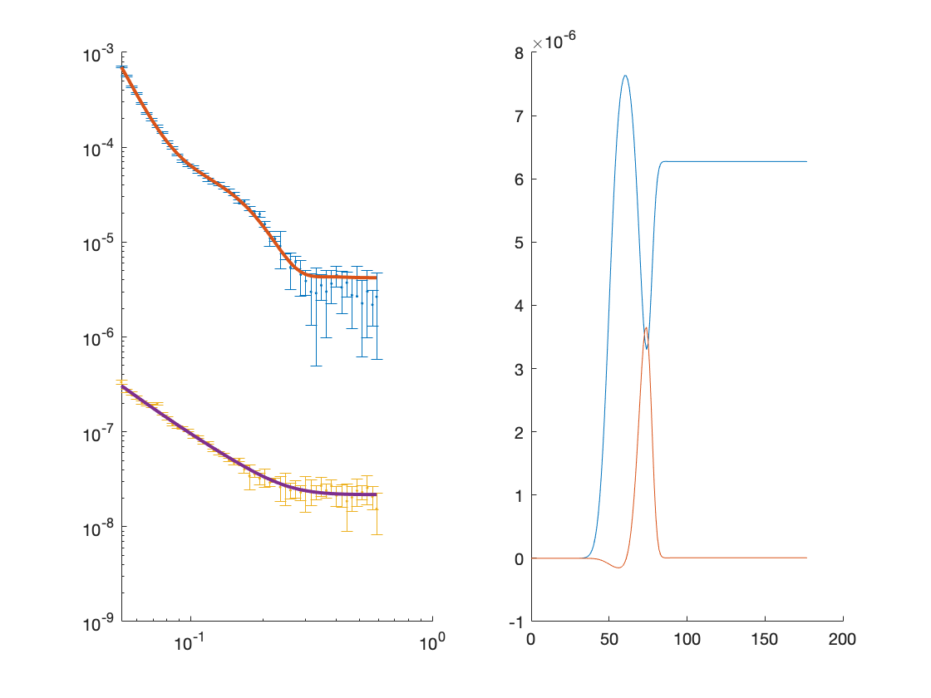

save('twoContrastExample.mat','problem');

Warning: Negative data ignored